**Math 331**

**Course Feedback Data Analysis**

**Introduction:**

Given Data is based on question and answers related to the academic courses. Questions are asked for as a feedback and effect of the course for batter course decision. Question were asked by author are:

1. Morgan Student or not?
2. Age?
3. Reason to choose this course?
4. Degree?
5. Do you love the class?
6. Would you take it again maybe as elective?
7. Would you take it again even if it not required?

so mostly answers are not same as string but has the same meaning so we need to convert the data into yes string if it is different string and has same meaning. that will help a lot for data visualization. Also if the come comments are creating the same meaning as yes , we will also deal it as yes to make our data more understandable. Starting indexes were filled with name so it means yes they are the student of the Morgan institute.

**Q1:**

Standard Deviationis is how far from the averageeach score is.

Mean tell us the middle position

Variance defined as number how spreas out data is

Mode: most commonly observed data

range: spread of data from lowest to highest data

**Code:**

state_data = read.csv('C:/Users/Talha/Downloads/state.csv')

library(ggplot2)

state_data$Morgan.student.or.not.=gsub('Morgan student','yes',state_data$Morgan.student.or.not.)

state_data$Morgan.student.or.not.=gsub('Morgan Student','yes',state_data$Morgan.student.or.not.)

state_data$Morgan.student.or.not.=gsub('Yes','yes',state_data$Morgan.student.or.not.)

state_data$Morgan.student.or.not.=gsub('Student','yes',state_data$Morgan.student.or.not.)

state_data$Morgan.student.or.not.=gsub('yes I am a yes','yes',state_data$Morgan.student.or.not.)

state_data$Morgan.student.or.not.=gsub('I am a yes','yes',state_data$Morgan.student.or.not.)

state_data$Morgan.student.or.not.=gsub('Perry Bennett','yes',state_data$Morgan.student.or.not.)

state_data$Morgan.student.or.not.=gsub('Shane','yes',state_data$Morgan.student.or.not.)

state_data$Morgan.student.or.not.=gsub('Brooke Price','yes',state_data$Morgan.student.or.not.)

state_data$Morgan.student.or.not.=gsub('yes ','yes',state_data$Morgan.student.or.not.)

state_data$Morgan.student.or.not.=gsub('No','no',state_data$Morgan.student.or.not.)

state_data$Morgan.student.or.not.=gsub('not','no',state_data$Morgan.student.or.not.)

ggplot(state_data, aes(x=state_data$Morgan.student.or.not., y=10)) +

geom_bar(stat="identity")+theme_minimal()

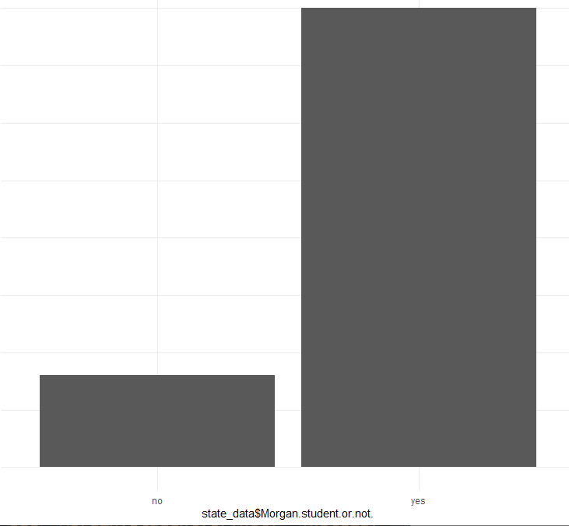

**Explaination:**

here we start from the check weather the student is from the Morgan state or not because its good to know that data has been come from the verified sources. after that, we have confermation that data has been gather correctly.

Now we check further on the base of Morgan’s students.

**Q2:**

**Code:**

state_data=state_data[-c(12),]

student_age=state_data[which(state_data$AGE.<=30),]

student_age$AGE.



**Explaination:**

Most of the people that filled out the survey were between the ages of 18-26. This makes sense because most of our audience is college students. A few outliers are over people above 30 years old.Now got only the target students data to get results pure. Students also belongs to the Morgan institute so we clear the data to find the only this institute student’s data

**Q3:**

Now, we will separate the dataset on the base of yes and no as we only need the Morgan institute Students to analysis data.

And then, check the reason why they need to register the math course.

Mostly student did not give the reason so we will not include it.we collect only who’s comments are given.

**Code:**

Morgan_student=state_data[which(state_data$Morgan.student.or.not.=='yes'),]

Morgan_student=na.omit(Morgan_student)

Morgan_student=Morgan_student[-grep('Na',Morgan_student$Give.a.reason.why.you.took.taking.math.331.if.have.not.taken.put.NA.),]

Morgan_student=Morgan_student[-grep('N/A',Morgan_student$Give.a.reason.why.you.took.taking.math.331.if.have.not.taken.put.NA.),]

Morgan_student=Morgan_student[-c(3),]

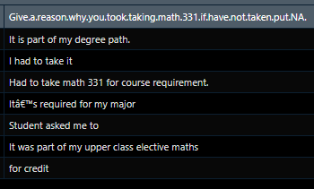

**Explaination:**

Every comment is different so we can’t analysis on the charts.

By given comments we can easily understand that they had to take as a part of degree and it was a core course for everyone, mostly like to not given about this feedback.

**Q4:**

**Degree(Major):**

Now, we will check out the Major portion of their degree.

**Code:**

Morgan_student=state_data[which(state_data$Morgan.student.or.not.=='yes'),]

Morgan_student=na.omit(Morgan_student)

Morgan_student=Morgan_student[-grep('Na',Morgan_student$Give.a.reason.why.you.took.taking.math.331.if.have.not.taken.put.NA.),]

Morgan_student=Morgan_student[-grep('N/A',Morgan_student$Give.a.reason.why.you.took.taking.math.331.if.have.not.taken.put.NA.),]

Morgan_student=Morgan_student[-c(3),]

major=state_data

major$YOUR.MAJOR.=gsub('Computer Science','computer science',major$YOUR.MAJOR.)

major$YOUR.MAJOR.=gsub('Computer Science ','computer science',major$YOUR.MAJOR.)

major$YOUR.MAJOR.=gsub('Computer science ','computer science',major$YOUR.MAJOR.)

major$YOUR.MAJOR.=gsub('Mathematics ','Maths',major$YOUR.MAJOR.)

major$YOUR.MAJOR.=gsub('Biology ','Biology',major$YOUR.MAJOR.)

ggplot(state_data, aes(x=major$YOUR.MAJOR., y=10),fill=major$YOUR.MAJOR.) +

geom_bar(stat="identity")+theme_minimal()

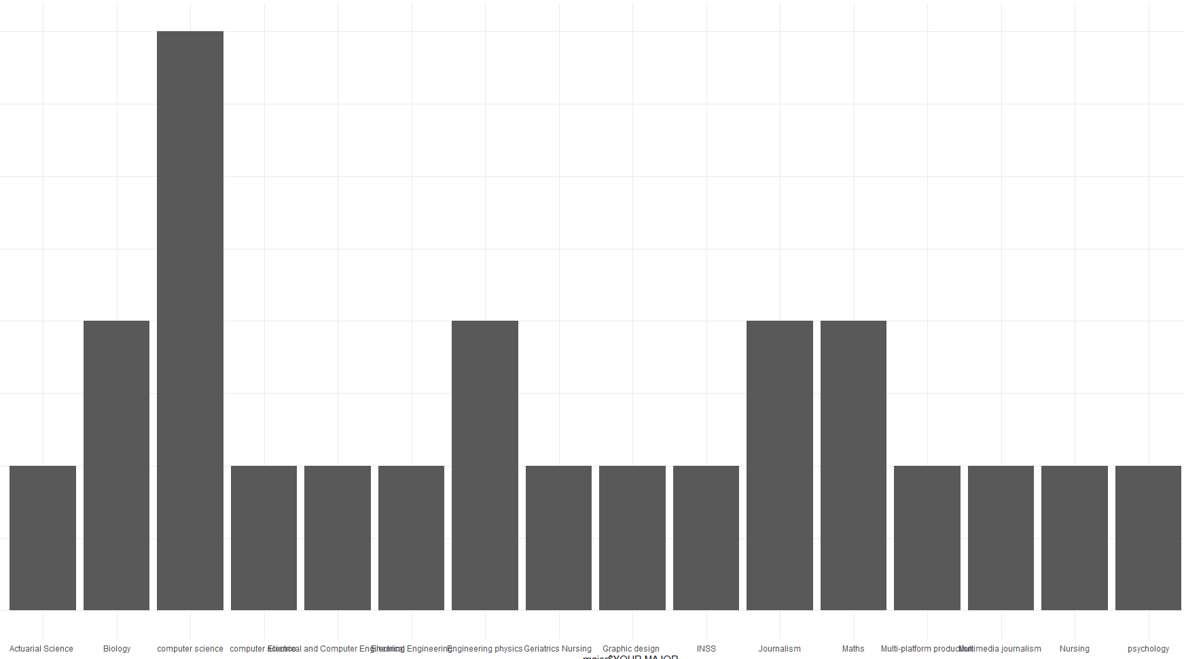

**Explaination:**

This bar graph shows that mostly feedback is belonging to the computer science department as appeared most. This course is also taught in other discipline and mostly feedback was given by computer science students. Other discipline also gives us the information about this course, science and engineering students mostly like it as its belongs to this field. other discipline is like biology don’t like it as they had to pass the course for credits hours.

**Conclusion:**

these results are telling us that mostly people enjoyed this course and but mostly don’t want to learn it again. If institute want to teach it again this course , they must offer some advancement in this course for not making it boring. That will help students to explore this course exactly what they want.given blow results are telling us what can we achievedfrom this data to make our course batter for future. Now , we checked that how many students like this class so after observation and visualization we make a conclusion that mostly students like this class as we visualized it and most portion was yes and some students give excited comments so we only observe the yes part and they like math that was good for them. So majority is happy with this course. Academic is doing well and can improve the course to make more yes.

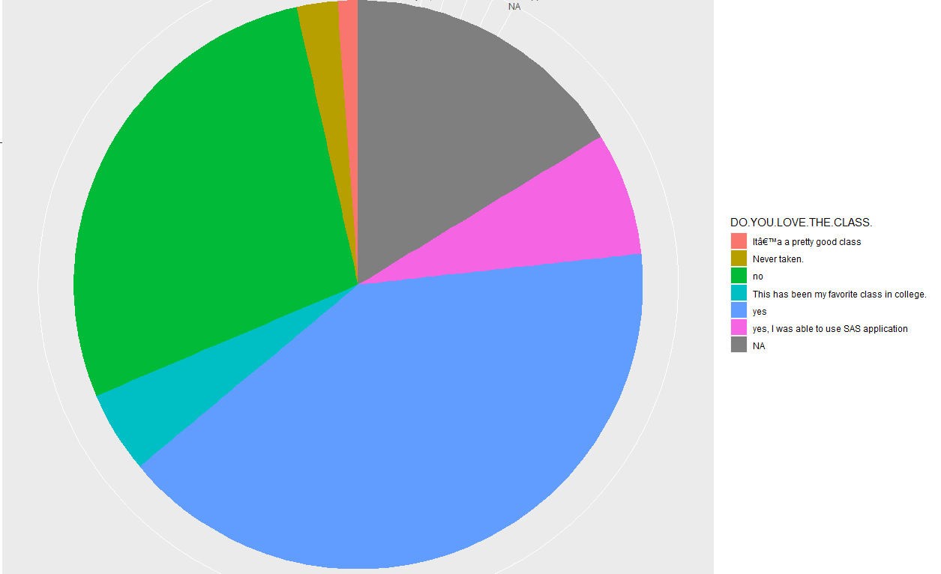

Now, we check out that its still love this course if offered this again as elective,

Mostly people say I no as they did not want to learn it again so offering this course again in institute for studying is not a good idea so the good decision is that institute will offer it again but in advance form or a little bit or some changes for those who want to make this field as profession and kame career using this field. Almost 25% data missing so there should be a reason for not giving the answers, we can drop as in mostly cases but we also observe that how many people are not interested in not giving the answer. And why they are not giving the answers.

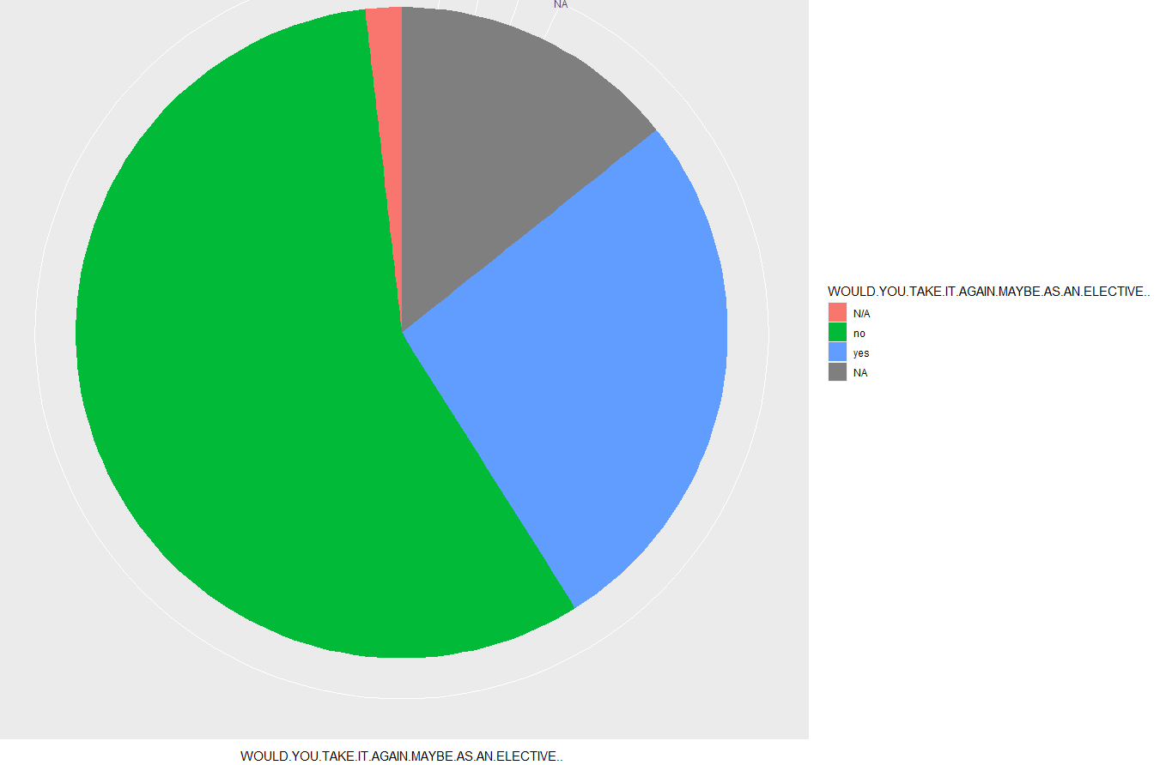

Last column will also produce the same result we did it for again offering the course so again mostly people again have the answer no as majority so student don’t want to take it again even if it is not required

