AureVon Master Technical Specification v2.0
Nov 4, 2026 · @Talha

Document control
MTS v2.0 is the implementation blueprint for AureVon. It supersedes v1.0 for development, while v1.0 stays preserved as the planning baseline. Development may start from this document once you approve it, beginning with the phases in section 16.
Item | Value
Document | AureVon Master Technical Specification (MTS)
Version | 2.0 (supersedes v1.0 of 3 November 2026; v1.0 is kept unchanged)
Status | Draft for product-owner approval
Project | Premium single-brand fashion e-commerce with interactive 3D product presentation
Initial market | Pakistan (PKR); global-ready architecture
Product owner | Talha: approves decisions, designs and acceptance
Implementation | Claude, following this MTS and milestone briefs
Architecture review | ChatGPT: specification upkeep, decision tracking, code and design review
Visual assets | Flow: generated assets, approved before use
Research support | Gemini: independent comparisons when requested

Status labels
Every decision in this document carries one of these labels.
Label | Meaning | Rule for implementation
APPROVED | Explicitly accepted by the product owner | Must be preserved; changes need a recorded reason and approval
PROPOSED | A recommended implementation detail | May be built as the default, but must be confirmed at the milestone named; it can still change
OUTSTANDING | A validation or test not yet done | Tracked in section 17; blocks only what it names
PENDING | A decision not yet made | Tracked in section 18; don't invent a final answer

What changed from v1.0
- Approved since v1.0: Django and Django REST Framework (P-02); PostgreSQL (P-03); Three.js with React Three Fiber, Draco support required (P-09 technology); production bundling of React, R3F and Three.js; the mobile colour-swatch layout.
- Modules: consolidated from 21 to 18. v1.0's Module 16 (Final Technical Architecture), Module 17 (Development Roadmap) and Module 21 (Global Readiness) become document sections: Module 16 is now sections 2, 5 and 8; Module 17 is section 16; Module 21 is built into sections 3, 6 and 14. None of their capabilities were removed. Section 7 maps old numbers to new ones.
- P-09: the v2 viewer is the reference implementation. Its physical-device and genuine-garment tests remain OUTSTANDING and don't block other modules (section 17).
- New in this version: frontend architecture, ER diagram, API catalogue, payment and shipping adapters, order state machine, folder structure and phased plan.

1. Decision register
Of 34 recorded decisions, 21 are approved, 9 are proposed for confirmation at a named milestone, and 4 validations are outstanding. Proposed items are the default that development builds toward; any one of them can change before its milestone without reworking approved items.

Approved
ID | Decision | Source
A-01 | Brand AureVon, tagline "Modern Style. Timeless Confidence.", Modern Heritage Luxury positioning | MTS v1.0 §3.1
A-02 | Single-brand fashion store; Pakistan first, PKR launch currency; global-ready architecture | MTS v1.0 §1
A-03 | Brand tokens: off-white #F9F8F6, charcoal #121212, stone #E5E0DB, deep brown #3B2F2F, champagne gold #C2A676 (gold mainly in 3D); Playfair Display headings with Inter or Satoshi interface text | MTS v1.0 §3.2 (final palette still P-19)
A-04 | Approved page designs are authoritative: homepage hero, Shop All, product detail, cart, checkout, login, registration Direction A, account | MTS v1.0 §3.3
A-05 | Modular monolith: one deployable backend with clear module boundaries | MTS v1.0 §6.1
A-06 | Backend: Django with Django REST Framework (REST API) | P-02, approved 4 Nov 2026
A-07 | Database: PostgreSQL (relational) | P-03 engine, approved 4 Nov 2026; provider still pending
A-08 | 3D technology: Three.js with React Three Fiber | P-09, approved 4 Nov 2026
A-09 | Draco-compressed GLB support is required | P-09 Phase 2
A-10 | The v2 viewer is the P-09 reference implementation; the v1 prototype stays preserved | P-09 Phase 2
A-11 | React, R3F and Three.js are bundled and self-hosted in production; no multi-CDN module loading | P-09 Phase 2
A-12 | On phones, colour swatches sit directly under the title and price | P-09 Phase 2
A-13 | No 3D file-size, triangle or texture limit is approved until real-device data exists | P-09 Phase 2
A-14 | 3D is isolated: if it fails, product information, cart and checkout keep working; a static image is always available | MTS v1.0 §3.4, §6.3
A-15 | The server is authoritative for price, discount, tax, shipping and stock | MTS v1.0 §6.3
A-16 | Raw card data is never stored; payments use provider-hosted or tokenized flows | MTS v1.0 Module 05
A-17 | Stock is tracked per variant (size × colour), with each sellable variant identified by its SKU | MTS v1.0 Module 02, 14
A-18 | English and Urdu, including right-to-left layout | MTS v1.0 Module 15
A-19 | Hybrid cloud: separately managed app hosting, relational database, object storage and CDN | MTS v1.0 §14
A-20 | Incremental delivery: one approved design and feature slice at a time, tested before the next | MTS v1.0 Module 17
A-21 | 18 business modules (section 7), with v1.0 Modules 16, 17 and 21 folded into document sections | 4 Nov 2026

Proposed (confirm at the milestone shown)
ID | Proposal | Confirm by
R-01 | Next.js (React, TypeScript) for the storefront and staff dashboard, with server rendering for SEO | P-01, before M1
R-02 | One monorepo: Next.js apps and shared packages managed with pnpm workspaces; Django in the same repository | M1
R-03 | Django 5.2 LTS on Python 3.12 or newer; exact versions pinned at M1 | M1
R-04 | Celery workers with Redis for background jobs; Redis also for caching and rate limits | M1
R-05 | Cookie-based sessions on one site (storefront and API on the same domain), with CSRF protection | M2
R-06 | A purpose-built staff dashboard; Django admin kept for superuser operations only | M2
R-07 | PostgreSQL full-text search for the catalogue at launch | M5
R-08 | Cash on delivery offered alongside online payment, through the same payment architecture | P-06, before M8
R-09 | WCAG 2.2 AA as the accessibility target | M3

Outstanding validations
ID | Validation | Blocks
V-01 | P-09 physical-device tests: iPhone Safari, mid-range Android Chrome, low-end Android Chrome | Production release of the 3D viewer only
V-02 | P-09 test with a genuine AureVon garment GLB | Production release of the 3D viewer only
V-03 | Re-run the v2 validation suite on the production versions of React, R3F and Three.js | M6
V-04 | KTX2/Basis texture evaluation, which may lower GPU memory use | The asset budget decision only

2. System architecture at a glance
AureVon is two Next.js web apps in front of one Django API, which owns every business rule and all data. The browser never talks to PostgreSQL, Redis or a provider directly. Payment, courier, email and SMS providers sit behind adapters, so swapping one doesn't touch business code.
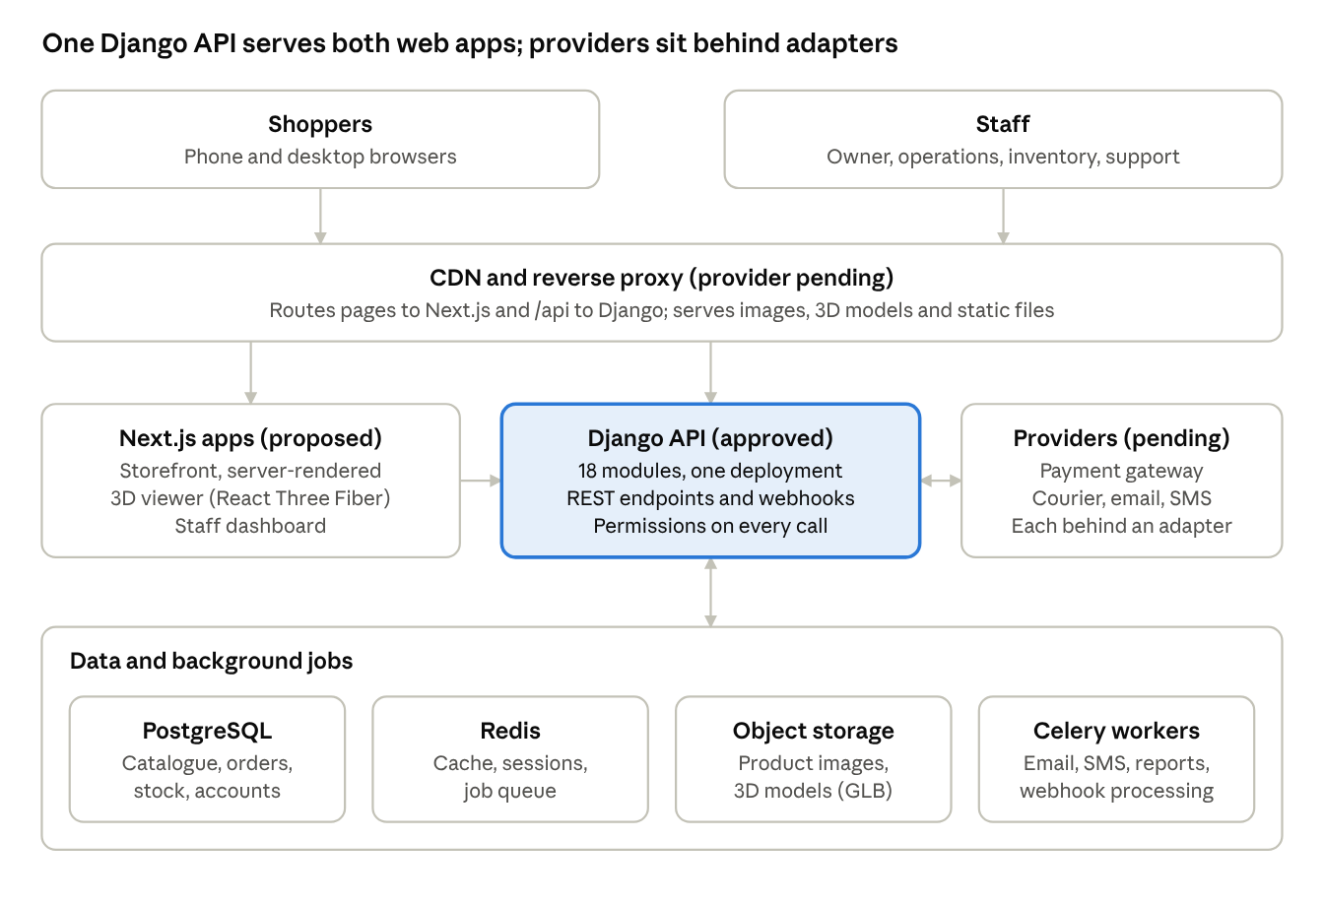
AureVon system architecture · 2 web apps, 1 API, 4 data and job services
A request flows top to bottom. The CDN serves pages, images and 3D models from the edge, sends /api traffic to Django, and sends everything else to Next.js. Providers call back into Django through signed webhooks.
Layer | Responsibility | Status
Next.js storefront | Server-rendered pages for SEO, client interactivity, the 3D viewer | PROPOSED (P-01)
Next.js staff dashboard | Catalogue, orders, inventory, support and CMS screens for staff | PROPOSED
Django API | All business rules, validation, permissions, pricing, stock, orders, payments | APPROVED
PostgreSQL | The single source of truth for business data | APPROVED (provider pending)
Redis | Cache, rate limits, Celery queue | PROPOSED
Celery workers | Email, SMS, webhook processing, reports, scheduled jobs | PROPOSED
Object storage + CDN | Product images, 3D models, documents, static files | APPROVED direction (provider pending)

3. Frontend architecture
PROPOSED (P-01): two Next.js applications in TypeScript, the public storefront and the staff dashboard, sharing design tokens, UI components, the API client and the 3D viewer as packages. The storefront is server-rendered for SEO and speed; the staff dashboard is client-rendered behind login and never indexed.

Applications
App | Audience | Rendering | Notes
apps/storefront | Shoppers | Server-rendered (Next.js App Router) with client components where interaction is needed | Public; SEO, structured product data, Urdu and English
apps/staff | Staff roles in section 9 | Client-rendered after sign-in | Not indexed; separate sign-in; shows only what the role's permissions allow, while the API enforces them

Rendering by page type (storefront)
Page | Strategy | Freshness rule
Homepage, collections, content and policy pages | Static generation, refreshed when staff publish in the CMS | Rebuilt on publish
Shop All, category, search | Server-rendered; filters and sorting live in the URL | Catalogue cached briefly; never caches price or stock decisions
Product detail | Server-rendered with structured product data; 3D viewer loads on the client | Price and stock fetched fresh on every view (A-15)
Cart, checkout, payment return | Client-rendered, no caching | Always live from the API
Login, registration, password reset | Server-rendered shell, client forms | No caching of personal data
Account and order history | Client-rendered after sign-in | Always live

Building blocks (all PROPOSED unless marked)
- Language: TypeScript in strict mode across apps and packages.
- Server data: a typed API client generated from Django's OpenAPI schema (drf-spectacular on the server, openapi-typescript on the client). The frontend never hand-writes request types.
- Client data: TanStack Query for cart, account and other live data; a small store (Zustand, already used by R3F) for UI state such as the cart drawer.
- Forms: React Hook Form with Zod schemas for instant feedback. The API validates again and is the final authority (A-15).
- Styling: AureVon tokens (A-03) as CSS custom properties in packages/design-tokens, with CSS Modules for components. CSS logical properties (margin-inline-start and similar) throughout, so Urdu right-to-left works without separate styles.
- Languages: locale routes /en and /ur with next-intl; dir="rtl" for Urdu (A-18). Currency and dates go through Intl, so PKR isn't hard-coded.
- Images: Next.js image optimisation through the CDN, serving AVIF or WebP at responsive sizes.
- Accessibility: WCAG 2.2 AA target (R-09), with keyboard support, focus states and reduced-motion handling as in the v2 viewer.
- Analytics: a consent-aware event layer feeding Module 11; nothing is sent before consent where consent is required.

Version alignment rule
React, React Three Fiber and Three.js must move together. Next.js App Router uses React 19, which pairs with React Three Fiber 9; the v2 viewer was validated on React 18 with R3F 8. V-03 re-runs the v2 validation suite on the exact production versions before M6. All versions are pinned at M1 and updated only deliberately.
No performance budgets are set here. They come from P-18 after real-device data.

4. Three.js integration architecture
APPROVED: Three.js with React Three Fiber, Draco support required, and the v2 viewer as the reference implementation (A-08 to A-14). Production moves the v2 code into a shared package, bundles it, and feeds it from the catalogue API. The behaviour validated in P-09 Phase 2 carries over unchanged.

The packages/viewer3d package (PROPOSED structure)
Part | Responsibility | Carried over from v2
ProductViewer | The public component: takes the product's 3D asset, poster image and selected variant | Poster-first loading, status messages, Show image / Show 3D
ViewerState | Loading, ready, failed, unavailable and lost states, outside React, so the page works if 3D never loads | D2 and D4 fixes; no fixed timer; "Try again"
Stage | Gallery environment, plinth, lights, gold accents (gold mainly in 3D, A-03) | Scene as approved in v1/v2
Controls | Rotate, zoom, two-finger tilt, touch-action: pan-y, keyboard controls, time-based camera moves | Mobile and keyboard fixes
loadModel | GLB header inspection, supported-extension check, Draco (WebAssembly, then JavaScript fallback) and Meshopt decoding, time limits, specific error messages | D1 fix and Draco integration
dispose | Releases geometry, materials, textures and decoded images on every model change | Cleanup verified in Phase 2
Render control | Renders only when 3D is shown, on screen and in a visible tab | D3 fix

How the storefront uses it
- The product page is server-rendered with the product's main image as the poster, so content appears before any 3D code loads (A-14).
- The viewer is loaded on the client only (next/dynamic without server rendering), after the poster is on screen.
- The API supplies the 3D asset record (below); the viewer never guesses file locations.
- Variant selection comes from the product page's state; the viewer only shows it. Price, stock and Add to bag never depend on 3D.

Decoder and library hosting (A-11)
- React, R3F and Three.js are bundled by the Next.js build; nothing loads from a public CDN.
- The Draco decoder files are copied from the installed Three.js version into public/3d/draco/<three-version>/ at build time. They are served from AureVon's own domain through the CDN, cached long-term, and versioned by path so a Three.js upgrade can't mix decoder versions.

3D asset record from the API (PROPOSED)
Field | Meaning
url | Versioned object-storage URL of the GLB, served through the CDN
poster_image | The static image used before and instead of 3D
compression | none, Draco or Meshopt
bytes, triangles, max_texture_px, est_gpu_mb | Measured at upload, for monitoring and the future asset budget
variant_map | Which model or material variant shows each colour (method pending, D-03)
status | draft, approved or retired; only approved assets reach the storefront
checksum | Integrity check; changes whenever the file changes

3D asset pipeline (PROPOSED)
- Staff upload a GLB in the staff dashboard (product publishing workflow, section 11).
- A Celery job validates it: Khronos glTF validator, the same supported-extension list as v2, then measurements.
- Optimisation with glTF-Transform: Draco or Meshopt, WebP textures. Texture resizing only once an asset budget is approved (A-13).
- The optimised file is stored under a versioned key. The record stays in draft until a staff member with permission approves it after checking it in the viewer.

Monitoring after launch
The viewer reports, with consent: time to 3D, load failures by reason, fallback use and device class. This gives the field data that the asset budget and any later limits should be based on.

Outstanding for 3D (section 17)
V-01 (physical devices), V-02 (genuine garment), V-03 (production library versions) and V-04 (KTX2). These gate only the public release of the 3D viewer. Product pages, catalogue and checkout ship with the poster image regardless.

5. Backend architecture
APPROVED: a Django + Django REST Framework modular monolith on PostgreSQL (A-05 to A-07). Each business area is a Django app with its own models, rules and API, and apps talk to each other only through each other's published service functions. That keeps one deployment simple, while letting a module be split out later if measured load ever justifies it.

Django apps and the modules they serve
App | Owns | Module (section 7)
accounts | Users, sign-in, sessions, roles, permissions, staff access | M03, M06
customers | Customer profiles, addresses, preferences, wishlist | M03, M01
catalog | Products, variants, SKUs, categories, collections, images, 3D assets | M02
inventory | Stock levels, movements, reservations, adjustments, locations | M14
suppliers | Suppliers, supplier products, purchase orders, supplier payments | M14
cart | Carts and cart items for guests and customers | M04
checkout | Price quotes, the order-placement transaction | M04
orders | Orders, order items with purchase-time snapshots, order states | M05
payments | Payments, refunds, provider callbacks, reconciliation | M05
shipping | Shipping zones, rates, shipments, tracking events | M04, M15
promotions | Coupons, promotion rules, usage records | M16
returns | Return and exchange requests, inspection outcomes | M13
support | Tickets, messages, assignment, priorities | M13
cms | Pages, banners, navigation, homepage sections, policy pages, SEO records | M07, M17
notifications | Templates, preferences, consent, delivery attempts | M12
analytics | Commerce events, daily metrics, report definitions, exports | M11
localization | Locales, currencies, exchange rates, tax rules, country rules | M15
reviews | Product reviews (FUTURE: the model is reserved, the feature comes later) | M01
audit | Audit log of sensitive actions | M06, M08
integrations | Provider adapters: payment, courier, email, SMS, storage | M05, M10, M12
common | Base models, money type, errors, pagination, utilities | All

Inside each app (PROPOSED convention)
File or folder | Rule
models.py | Data and database constraints only
selectors.py | Read queries other code may call
services.py | Every write and business rule, in database transactions where needed. Other apps call these, never another app's models directly for writes
api/ | DRF serializers, views and URLs. Views stay thin: validate, call a service, return
tasks.py | Celery tasks for this app
events.py | Domain events this app publishes (for example order.paid)
tests/ | Unit, service and API tests for this app
Boundary rules are checked automatically in CI with import-linter (PROPOSED), so an app can't quietly reach into another app's internals.

Cross-cutting patterns
- Money: NUMERIC(12,2) with a currency code on every amount; never floating point (MTS v1.0 §7.1). Amounts are calculated with Python Decimal.
- Time: stored in UTC, shown in local time (Asia/Karachi at launch).
- Identifiers: UUID primary keys on public-facing records; human-readable order numbers (for example AV-2026-000123) for customers and staff.
- Reliable side effects (transactional outbox): a service writes the business change and an outbox event in the same transaction. Workers send emails, SMS and webhooks from the outbox, so a crash never sends a message for an order that didn't commit, or loses one that did.
- Idempotency: payment callbacks, order placement and other retryable calls carry an idempotency key, stored with a unique constraint.
- Background jobs: Celery workers with Redis (R-04), and Celery Beat for schedules: releasing expired stock reservations, abandoned-cart reminders, payment reconciliation, daily metrics and scheduled reports.
- Settings: split into base, development, staging and production; secrets come only from environment variables, with a committed .env.example (MTS v1.0 §17.1).
- API schema: drf-spectacular generates the OpenAPI schema that the frontend's typed client is built from.
- Observability: structured JSON logs with a request ID on every line; error tracking and uptime monitoring through a provider chosen under P-10.
- Django admin: superuser-only operations and emergency fixes (R-06). Day-to-day staff work happens in the staff dashboard, where every action passes through services and the audit log.

6. PostgreSQL database architecture
APPROVED: PostgreSQL as the single source of truth for business data (A-07). PROPOSED: a currently supported PostgreSQL major version (17 or newer) on a managed service chosen under P-10, with the same major version in local development. The schema below is the implementation baseline; field-level details are finalised in each module's milestone.
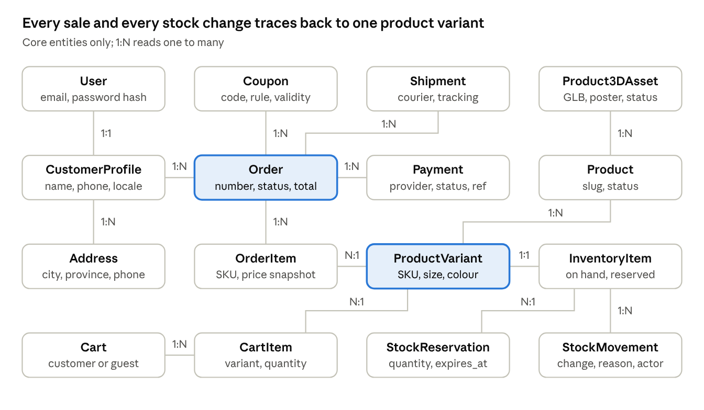
Core entity relationships · 16 entities, 15 relationships
Order and ProductVariant are the two hubs. Every order line points at the exact variant sold, and every stock change for that variant is a movement record, so sales and stock can always be reconciled.

Entities by domain
Domain (Django app) | Entities | Key rules
Identity (accounts, customers) | User, Role, Permission, StaffProfile, CustomerProfile, Address, Wishlist, WishlistItem | One profile per customer; staff roles explicit; customers see only their own records
Catalogue (catalog) | Product, ProductVariant, Category, Collection, CollectionItem, ProductImage, Product3DAsset, ProductTranslation | Unique SKU per variant; unique (product, size, colour); price lives on the variant
Inventory (inventory, suppliers) | InventoryItem, StockMovement, StockReservation, StockLocation, Supplier, SupplierProduct, PurchaseOrder, PurchaseOrderLine, SupplierPayment | Every change is an immutable movement; supplier edits never rewrite past purchase records
Commerce (cart, checkout, orders) | Cart, CartItem, Order, OrderItem, OrderStatusHistory, IdempotencyKey | OrderItem snapshots name, SKU, options and price at purchase
Payments (payments) | Payment, PaymentEvent, Refund | Every provider callback is stored before it is applied
Fulfilment (shipping, returns) | ShippingZone, ShippingRate, Shipment, ShipmentItem, TrackingEvent, ReturnRequest, ReturnItem, ExchangeRequest | States are traceable; courier callbacks are validated
Promotions (promotions) | Coupon, PromotionRule, CouponRedemption | Validated on the server and recorded against the order
CMS and SEO (cms) | Page, Banner, NavigationItem, HomepageSection, PolicyPage, SEORecord, Redirect, StoreSetting | Content is data; design system and code stay with developers
Support (support) | SupportTicket, TicketMessage, TicketAssignment | Timestamped, permission-controlled
Communication (notifications) | NotificationTemplate, NotificationPreference, ConsentRecord, OutboxEvent, DeliveryAttempt | Marketing respects consent and unsubscribe
Analytics (analytics) | CommerceEvent, DailyMetric, ReportDefinition, ReportRun | Aggregated wherever possible
Localization (localization) | Locale, Currency, ExchangeRate, CountryRule, TaxRule | Explicit precision and effective dates
Governance (audit) | AuditLog | Actor, action, before and after, IP address, time

Database rules (PROPOSED unless they repeat an approved v1.0 requirement)
- Keys: UUID primary keys; human-readable order numbers as a separate unique column.
- Money: NUMERIC(12,2) plus a 3-letter currency code (approved in v1.0 §7.1: never floating point).
- Constraints in the database, not only in code: CHECK (on_hand >= 0), CHECK (reserved >= 0 AND reserved <= on_hand), CHECK (quantity > 0) on lines, unique SKU, unique coupon codes, and one default address per customer (partial unique index).
- Deletes: financial and order records use ON DELETE PROTECT. Products are archived, not deleted, so past orders stay intact.
- Stock changes: only through inventory services, which lock the variant's row (SELECT … FOR UPDATE) and write a StockMovement in the same transaction. Available stock = on hand − reserved.
- Flexible data: JSONB only for genuinely variable data (product attributes, audit before/after, provider payloads), never for fields the business queries routinely.
- Search: PostgreSQL full-text search on product name and description per language, with GIN indexes (R-07).
- Indexes: added from observed query patterns, with the obvious ones from day one: order number, order status and date, customer, SKU, product slug.
- Migrations: Django migrations, reviewed like code. Schema changes that could break a running release use expand-then-contract (add the new column, deploy, migrate data, then remove the old one). Every migration notes how to roll it back.
- Local development: PostgreSQL in Docker Compose at the same major version as production (proposed answer to P-04).
- Retention and anonymisation of personal data: PENDING (P-11 and P-17), and must be decided before production.

7. The 18 business modules
All 18 modules and their capabilities are APPROVED scope (A-21); what changes between them is when they are built. Priority follows v1.0's release principle: first a complete, trustworthy shopping journey; advanced analytics, forecasting and international rollout later, without architecture that blocks them.
Priority key: Launch-critical = the shopping journey can't work without it. Launch = needed at launch, possibly in a simpler first version. Post-launch = later releases, with the data model and boundaries prepared from the start.
# | Module | Scope (capabilities kept from v1.0) | Django apps | Priority | Phase (section 16) | v1.0 #
M01 | Storefront & Shopping Experience | Homepage sections, Shop All, category and collection browsing, filters, product detail, cart and account pages, responsive layouts | Frontend + catalog, cms | Launch-critical | 3–5 | 01
M02 | Product Catalogue & 3D | Products, variants with their own SKU and stock, categories, collections, images, 3D assets, lazy loading, static fallback | catalog | Launch-critical (3D: release gated by V-01/V-02) | 5, 6 | 02
M03 | Authentication & Customer Accounts | Registration, login, logout, verification, password reset, profile, addresses, order history, preferences | accounts, customers | Launch-critical | 2, 7 | 03
M04 | Cart & Checkout | Cart add/update/remove, variant and stock validation, server-side totals, stock reservation, confirmation and retry states | cart, checkout, shipping | Launch-critical | 7 | 04
M05 | Payments & Order Management | Payment adapter, idempotent callbacks, reconciliation, order lifecycle, cancellation, refunds, admin order search | orders, payments | Launch-critical | 8 | 05
M06 | Administration & Role Permissions | Staff dashboard, role-based access, granular permissions, audit of sensitive actions, confirmation for high-risk actions | accounts, audit + staff app | Launch-critical | 2, then every phase | 06
M07 | Store Configuration & CMS | Homepage sections, banners, navigation, collections, content and policy pages, store settings, scheduled publishing | cms, localization | Launch | 4 | 07
M08 | Security & Performance | Authentication security, CSRF/XSS protection, validation, rate limits, secrets, backups, caching, CDN, graceful degradation | Cross-cutting | Launch-critical | 1, 14 | 08
M09 | Testing & Quality Assurance | Unit, integration, API, end-to-end, 3D, security, performance, accessibility, UAT | Cross-cutting | Launch-critical | Every phase | 09
M10 | Deployment & Hosting | Hybrid cloud, domain, SSL, automated deployment, monitoring, backups | Infrastructure | Launch-critical | 1, 15 | 10
M11 | Analytics & Business Intelligence | Sales, AOV, customers, products, conversion, campaigns, finance summaries, PDF/Excel exports, scheduled reports | analytics | Launch: core sales reporting. Post-launch: segmentation, lifetime value, forecasting | 13 | 11
M12 | Notifications & Communication | Order, payment, shipping, refund, verification and reset messages; staff alerts; email and SMS; preferences; templates; delivery monitoring | notifications, integrations | Launch: transactional. Post-launch: campaigns | 8, 11 | 12
M13 | Customer Support & Returns | Contact form, tickets, assignment, priorities, return and exchange requests, refunds, issue categories | support, returns | Launch: contact form and returns. Post-launch: full ticket analytics | 12 | 13
M14 | Inventory & Supplier Management | Stock per variant, adjustments, reservations, low-stock alerts, history, suppliers, purchase orders, receiving, valuation, reorder suggestions | inventory, suppliers | Launch-critical: stock and reservations. Post-launch: forecasting | 9 | 14
M15 | Internationalization, Localization & Global Readiness | English and Urdu with right-to-left, PKR, address and date formats; later currencies, countries, tax and shipping rules, with no hard-coded country assumptions (absorbs v1.0 Module 21) | localization, shipping | Launch: English, Urdu, PKR, Pakistan. Post-launch: other markets | 3, 10 | 15, 21
M16 | Promotions & Marketing Operations | Coupons, scheduled promotions, usage reporting, consented marketing and abandoned-cart flows | promotions, notifications | Launch: basic coupons. Post-launch: campaigns | 11 | 18
M17 | SEO & Content Publishing | SEO titles, descriptions and slugs, canonical tags, sitemap, robots, structured product data, redirects on URL changes | cms + storefront | Launch | 4, 5 | 19
M18 | Operational Reliability & Recovery | Automated backups with restore tests, error and job monitoring, payment and notification recovery, disaster recovery, runbooks | Cross-cutting | Launch-critical | 14 | 20

Where v1.0's other three modules went
v1.0 module | Now covered by
16 Final Technical Architecture & Integration | Sections 2 (system), 5 (backend) and 8 (API and integration layers)
17 Development Roadmap & Implementation | Section 16 (phases), with the working rules of v1.0 §17 unchanged
21 Global Readiness & Scalability | M15 above, plus sections 3, 6 and 14 (configuration, data rules, scaling)

8. API architecture and endpoint responsibilities
APPROVED: a REST API built with Django REST Framework (A-06). PROPOSED: the conventions and endpoint map below, with every endpoint enforcing permissions on the server. The API is the only way into business data, for both web apps.

Conventions (PROPOSED)
Topic | Rule
Base path and versioning | /api/v1/…; breaking changes go to /api/v2/ with a deprecation period
Format | JSON; snake_case fields; ISO 8601 times in UTC; money as a decimal string plus currency ({"amount": "48500.00", "currency": "PKR"})
Schema | OpenAPI 3 generated by drf-spectacular; the frontend's typed client is built from it, and CI fails if they drift
Errors | One shape everywhere (RFC 9457 problem details): type, title, status, detail, plus per-field errors for validation
Lists | Cursor pagination; filters and sorting as query parameters
Retries | Order placement, payment actions and refunds require an Idempotency-Key header; a repeat returns the first result
Authentication | Session cookie with CSRF token (section 9); webhooks authenticate with provider signatures instead
Rate limits | Per IP and per account on sign-in, password reset, registration, checkout and public search (Redis-backed)
Staff endpoints | Under /api/v1/staff/, with separate permission classes; never reachable with a customer session
File uploads | Direct to object storage with short-lived pre-signed URLs; the API records the upload and starts validation

Endpoint map
Area | Endpoints (method and path under /api/v1) | Responsibility | Access
Catalogue | GET /catalog/products, GET /catalog/products/{slug}, GET /catalog/categories, GET /catalog/collections/{slug} | Browse, filter and search; product detail with variants, images and approved 3D asset | Public
Availability | GET /catalog/products/{slug}/availability | Fresh price and stock per variant, never cached long | Public
Content | GET /cms/home, GET /cms/navigation, GET /cms/pages/{slug} | Published CMS content in the requested language | Public
Sign-in | POST /auth/register, POST /auth/login, POST /auth/logout, POST /auth/password-reset, POST /auth/password-reset/confirm, POST /auth/verify, GET /auth/session | Accounts, sessions, CSRF token | Public / signed in
My account | GET PATCH /me, GET POST PATCH DELETE /me/addresses, GET /me/orders, GET /me/orders/{number}, GET POST DELETE /me/wishlist | Profile, addresses, history, wishlist | Customer (own data only)
Cart | GET /cart, POST /cart/items, PATCH DELETE /cart/items/{id}, POST DELETE /cart/coupon | Cart for guests (cookie) and customers; validates variant, quantity and stock | Public / customer
Checkout | GET /shipping/options, POST /checkout/quote, POST /checkout/orders | Server-calculated totals; places the order, reserves stock and returns the payment next step | Customer or guest (per P-15)
Payment status | GET /orders/{number}/payment-status | Read after returning from the payment page | Order owner
Support and returns | POST /support/tickets, POST /returns/requests, GET /me/returns | Contact, return and exchange requests | Public / customer
Webhooks | POST /webhooks/payments/{provider}, POST /webhooks/shipping/{provider}, POST /webhooks/messaging/{provider} | Signature check, store the event, acknowledge, process in a worker | Provider signature
Staff: catalogue | /staff/products, /staff/variants, /staff/categories, /staff/collections, /staff/media/uploads, /staff/3d-assets/{id}/approve | Create, edit, publish, archive; image and 3D upload and approval | Catalogue permissions
Staff: inventory | /staff/inventory, /staff/inventory/adjustments, /staff/suppliers, /staff/purchase-orders, /staff/purchase-orders/{id}/receive | Stock levels, adjustments with reasons, suppliers, receiving | Inventory permissions
Staff: orders | /staff/orders, /staff/orders/{number}/status, /staff/orders/{number}/cancel, /staff/orders/{number}/refunds, /staff/shipments | Search, update, cancel, refund, create shipments | Operations / accountant permissions
Staff: customer care | /staff/tickets, /staff/returns, /staff/returns/{id}/decision | Ticket handling, return approval with a recorded reason | Support permissions
Staff: content and marketing | /staff/cms/*, /staff/seo, /staff/redirects, /staff/promotions, /staff/coupons | Content, SEO, promotions | Content / marketing permissions
Staff: reports | /staff/reports/{name}, /staff/exports | Dashboards and PDF/Excel exports (exports run in workers) | Report permissions; personal data restricted
Staff: administration | /staff/users, /staff/roles, /staff/settings, /staff/audit-log | Staff accounts, roles, store settings, audit reading | Owner / admin permissions
Operations | GET /health/live, GET /health/ready | Liveness and readiness for the platform | Internal
Each module's milestone brief turns its rows into a detailed contract: request and response fields, errors, permissions and tests.

9. Authentication and authorization
APPROVED: staff access is separate from customer access, and every permission is enforced on the server, not by hiding buttons (MTS v1.0 Module 03, §5). PROPOSED: the mechanisms below. PENDING: the final role list, permission matrix, two-factor policy and dual approval rules (P-05).

Customers (PROPOSED)
- Django's authentication with email as the sign-in name; passwords hashed with Argon2.
- Server-side sessions in a cookie marked HttpOnly, Secure and SameSite=Lax. Session storage in the database with a Redis cache. The session ID changes at sign-in; sign-out ends the session on the server.
- A CSRF token on every state-changing request (DRF with Django's CSRF middleware). Because the storefront and API share one site (R-05), no tokens are kept in browser storage.
- Email verification and password reset use single-use, time-limited links.
- Rate limits on sign-in, registration and password reset, with a generic response that doesn't reveal whether an email is registered.
- Phone OTP is possible later through the SMS adapter, once P-08 selects a provider.
- Guest checkout (P-15 pending): the architecture supports both answers. A guest order links to an email address and a private order-access link; if guest checkout is refused, checkout simply requires sign-in.

Staff (PROPOSED)
- A separate sign-in for the staff dashboard. Staff accounts carry a staff flag and one or more roles, and a customer session can never reach /api/v1/staff/.
- Two-factor authentication with an authenticator app, required for Owner, Store Admin and Accountant, and recommended for everyone else (final policy: P-05).
- Shorter staff sessions than customer sessions, with re-authentication before high-risk actions such as refunds, permission changes and price changes.
- Django admin limited to superusers (R-06).

Authorization model (PROPOSED)
- Role-based: roles are Django groups; permissions are named actions such as orders.refund, inventory.adjust, catalog.publish, cms.publish, reports.export_personal, staff.manage_roles.
- Default deny: every endpoint declares the permission it needs; anything undeclared is refused.
- Ownership: customer endpoints filter every query by the signed-in customer, so one customer can never read another's orders or addresses, even by guessing an ID.
- Two layers: DRF permission classes check the request, and services check again for high-risk actions, so a future endpoint can't skip the rule.
- Audit: permission changes, price changes, stock adjustments, refunds, order overrides, CMS publishing and setting changes are written to the audit log with the actor, before and after values, IP address and time (MTS v1.0 §9).

Candidate role matrix (PENDING approval under P-05)
Capability | Owner | Store Admin | Accountant | Inventory Manager | Support | Content / Marketing
Manage staff and roles | Yes | — | — | — | — | —
Store and security settings | Yes | Limited | — | — | — | —
Catalogue and 3D assets: edit, publish | Yes | Yes | — | Read | Read | Edit, no publish
Prices | Yes | Yes | Read | — | — | —
Stock adjustments, purchase orders | Yes | Read | Read | Yes | — | —
Orders: view, update status | Yes | Yes | Read | Read | Yes | —
Refunds | Yes | Request | Approve | — | Request | —
Returns decisions, tickets | Yes | Yes | Read | — | Yes | —
CMS, SEO, promotions | Yes | Yes | — | — | — | Yes
Financial reports and exports with personal data | Yes | Limited | Yes | — | — | —
Audit log | Yes | Read | Read | — | — | —
"Limited" and "Request" are placeholders for decisions in P-05, such as which settings a Store Admin may change and whether refunds above an amount need a second approver.

10. Payment and shipping architecture
APPROVED: provider-hosted or tokenized payments only, idempotent and signature-checked callbacks, reconciliation, and a manual fallback when a courier is unavailable (MTS v1.0 Module 05, §6.4). PENDING: the actual payment providers (P-06), couriers (P-07), shipping rules (P-13) and tax rules (P-11). The adapter design lets development and testing proceed with sandbox and fake providers before those choices are made.

Payment adapter (PROPOSED)
Every payment method implements one interface in integrations/payments/:
Operation | Purpose
start_payment(order, amount, return_url) | Returns the next step: redirect to a hosted page, show a provider form, or nothing (cash on delivery)
verify_callback(request) | Checks the provider's signature and returns a normalised, verified event, or rejects it
get_status(reference) | Asks the provider directly; used for return pages and reconciliation
refund(payment, amount, reason) | Full or partial refund where the provider supports it; otherwise records an approved manual refund
capabilities | What this provider can do: partial refunds, saved methods, settlement reports
A fake provider with the same interface is used in development and automated tests.
Candidate payment methods to research under P-06 (not decided): card payments through a Pakistani bank or payment aggregator, mobile wallets such as JazzCash and Easypaisa, and cash on delivery (R-08). Cash on delivery uses the same Payment records, with a "collect on delivery" status settled when the courier's remittance is confirmed.

Online payment flow (PROPOSED)
- POST /checkout/orders validates and prices the cart, creates the order as "awaiting payment" and reserves stock, all in one transaction (section 11).
- The adapter starts the payment and the shopper goes to the provider's page. Card data never reaches AureVon's servers, which keeps PCI scope to the minimum (A-16; confirm the exact obligation with the chosen provider).
- The provider calls POST /webhooks/payments/{provider}. The signature is checked, the event is stored once (unique on the provider's event ID), acknowledged at once, and processed by a worker.
- The worker moves the payment and order to their new states and queues notifications through the outbox.
- The shopper's return page reads GET /orders/{number}/payment-status. Return-URL parameters are never trusted on their own.
- A scheduled reconciliation job queries the provider about payments still pending, and compares the provider's settlement reports with AureVon's records.
- If payment fails or expires, the order follows the cancel path and its reservation is released. The expiry time is a store setting (default PENDING; 30 minutes proposed for online payment).

Shipping adapter (PROPOSED)
Operation | Purpose
quote(address, parcel) | Live rates where the courier offers them
book(shipment) | Creates the consignment and label, including any cash-on-delivery amount
track(tracking_number) and verify_webhook(request) | Tracking updates by polling or by courier callback
cancel(shipment) | Cancels a booking that hasn't been collected
- Rates at launch: zone-based table rates kept by staff (city or province zones, weight or order-value bands, free-shipping thresholds), so checkout doesn't depend on a courier being online. Zones, fees and thresholds are PENDING (P-13).
- Manual fallback (approved): staff can book with the courier outside the system and enter the tracking number by hand; the order flow continues normally.
- Couriers to evaluate under P-07 (not decided): established Pakistani couriers such as TCS, Leopards, M&P, Trax and PostEx, judged on API quality, cash-on-delivery remittance, return logistics and coverage.
- Tracking events update the shipment, notify the customer and, on delivery, settle cash-on-delivery payments.

Tax (PENDING P-11)
Tax is calculated on the server from configurable TaxRule records with effective dates. Whether prices are shown tax-inclusive, and the applicable rates, need local professional advice before M8.

11. Inventory and order workflows
APPROVED: stock is tracked per variant, reservations prevent overselling, every adjustment is a movement record, and order lines keep purchase-time snapshots (MTS v1.0 Modules 04, 14; §7.1). PROPOSED: the states and rules below.
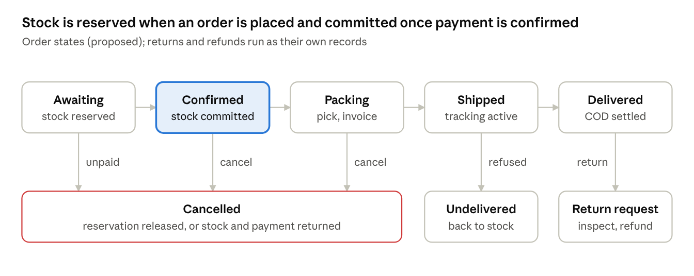
Order states · 5 forward states, 3 exits
"Awaiting" is skipped for cash on delivery: a COD order goes straight to Confirmed once accepted. Every state change is written to OrderStatusHistory with the actor and reason.

Stock rules (PROPOSED)
Event | Stock effect | Movement recorded
Item added to cart | None; availability is checked only | —
Order placed | reserved += quantity, inside the order transaction with the variant row locked; if any line is short, the whole order is refused with the exact item named | Reservation
Online payment fails or the reservation expires | reserved −= quantity | Reservation released
Payment confirmed or COD accepted | on_hand −= quantity and reserved −= quantity | Sale
Cancelled after confirmation | on_hand += quantity; refund started if paid | Cancellation
Undelivered and returned to the store | on_hand += quantity after inspection | Return to stock
Customer return inspected as resalable | on_hand += quantity | Return to stock
Return damaged or unsellable | No change to sellable stock; recorded for write-off | Damaged
Purchase order received | on_hand += received quantity | Receipt
Staff adjustment | Change with a mandatory reason; audited | Adjustment
Available to sell = on_hand − reserved. Low-stock alerts fire when it drops to a per-variant threshold that staff set.

Order placement transaction
- Validate the cart: product published, variant active, quantity allowed.
- Recalculate prices, promotion, shipping and tax on the server (A-15).
- Lock the variants' inventory rows in a consistent order, to avoid deadlocks, and reserve stock.
- Create the order and order items with snapshots, the status history row and the payment record.
- Write outbox events. Commit. Only then call the payment provider.
If any step fails, the whole transaction rolls back. The Idempotency-Key guarantees that a double click or a network retry can't create two orders.

Other workflows
- Product publishing: as in MTS v1.0 §8.1, with 3D assets adding a validation job and an approval step (section 4).
- Returns and refunds: as in v1.0 §8.3. A return request is checked against the return window (P-14), approved or rejected with a reason, inspected, then refunded through the payment adapter or recorded as an approved manual refund.
- Purchase orders: draft → sent → partly received → received, or cancelled. Receiving creates stock movements; supplier records never rewrite past purchases.

12. Security requirements
APPROVED baseline (MTS v1.0 §9 and Module 08), unchanged: server-side authorization on every endpoint, CSRF and XSS protection, validated input, rate limits, HTTPS, secrets out of source control, validated uploads, least-privilege credentials, audit logging, no raw card data, and minimal personal data. No critical or high-severity issue may remain at launch without a documented risk decision approved by the product owner.

Implementation requirements (PROPOSED)
Area | Requirement
Transport | HTTPS everywhere; HSTS with preload once the domain is stable; TLS 1.2 or newer
Content Security Policy | Production policy derived from the one verified in P-09 Phase 2: 'self' scripts (bundled, no inline scripts, so no hashes), 'wasm-unsafe-eval' for Draco and Meshopt, worker-src 'self' blob:, img-src 'self' data: blob: plus the CDN, connect-src 'self' plus approved analytics, object-src 'none', base-uri 'none', frame-ancestors 'none'. No public CDN entry once bundling is in place (A-11). Final approval with P-10
Other headers | X-Content-Type-Options: nosniff, Referrer-Policy: strict-origin-when-cross-origin, a restrictive Permissions-Policy
Cookies and sessions | HttpOnly, Secure, SameSite=Lax; session ID rotated at sign-in; staff sessions shorter, with re-authentication for high-risk actions
Passwords | Argon2 hashing; checks against common and breached passwords; no maximum below 64 characters
Input and output | DRF serializers validate every field; the Django ORM only (raw SQL only by reviewed exception); React escapes output by default, and any CMS rich text is sanitised on the server against an allow-list
Uploads | Pre-signed, time-limited upload URLs; type checked by content, not extension; size checked; images re-encoded; GLBs pass the validator job before approval; storage buckets private, served only through the CDN
Webhooks | Signature verified before anything is stored as trusted; replay protection by event ID and timestamp; unknown events logged and ignored
Secrets | Environment variables or the hosting platform's secret store; separate secrets per environment; .env.example only in the repository; rotation documented
Access | Least-privilege database users (the app can't alter the schema in production; migrations run with a separate role); staff two-factor (P-05); production access limited and logged
Dependencies | Lock files committed; automated vulnerability alerts; pinned versions upgraded deliberately (also V-03 for the 3D libraries)
Privacy | Collect only what's needed; consent for marketing and analytics; privacy notice, retention and deletion rules decided before launch (P-11, P-17)
Abuse | Rate limits (section 8); bot protection on registration and checkout if abuse appears; alerts on unusual refund or adjustment activity

Security testing (see section 13)
Automated dependency and static checks on every pull request; permission tests for allowed and denied access on every protected endpoint; an external penetration test before launch (M14).

13. Testing and quality assurance
APPROVED: the v1.0 test layers and Definition of Done (§13, §16). A feature is done only when its design matches the approved reference, server rules and permissions are tested (including denied access), all states are handled, tests pass, and nothing approved regresses. PROPOSED: the tools and pipeline below.

Test layers and tools (PROPOSED tools)
Layer | What it proves | Tools
Unit | Pricing, promotions, tax, stock arithmetic, state transitions, validation | pytest, pytest-django, factory_boy; Vitest for frontend logic
Service and database | Transactions, locking, constraints, idempotency, outbox | pytest against a real PostgreSQL (never SQLite)
API | Every endpoint: allowed and denied roles, validation errors, rate limits, the error format | DRF test client; Schemathesis fuzzing from the OpenAPI schema
Contract | Frontend and API agree | Generated client compiles in CI; schema drift fails the build
Integration | Payment, courier, email and SMS adapters | Fake providers in CI; provider sandboxes in staging
Component | UI components and states (loading, empty, error, disabled) | React Testing Library
End-to-end | Register, sign in, browse, product detail, cart, checkout, payment return, order history, returns | Playwright on staging, desktop and phone viewports
3D | Framing, touch, keyboard, loading strategy, failure paths, Draco and Meshopt, cleanup | The P-09 Playwright suite, ported to the production viewer; plus the section 17 device procedure
Concurrency | Two shoppers buying the last item: only one succeeds, with no negative stock | Parallel order-placement tests against PostgreSQL
Accessibility | WCAG 2.2 AA target (R-09) | axe-core in Playwright; manual keyboard, VoiceOver and TalkBack checks
Performance | Page speed, API response times, load on checkout and catalogue | Lighthouse CI, k6; targets from P-18
Security | Dependencies, static analysis, permissions, external penetration test | pip-audit, npm audit, Bandit, Semgrep; permission tests; external test at M14
UAT | Representative customers and store staff | Scripted sessions on staging; documented sign-off

Continuous integration (PROPOSED)
Every pull request runs, and must pass:
- Formatting and linting: Ruff for Python, ESLint and Prettier for TypeScript.
- Type checks: mypy (with django-stubs) and tsc --noEmit.
- Boundary check: import-linter for the backend's app boundaries.
- Unit, service and API tests with a PostgreSQL service container.
- Migration check: no missing migrations; migrations apply cleanly to an empty database and to a copy of the previous release's schema.
- OpenAPI schema generation and client build.
- Frontend tests and a production build of both apps.
- Dependency and static security scans.
Merges to the main branch deploy to staging automatically, where end-to-end, 3D and accessibility suites run. Production releases need those to pass, plus your approval (MTS v1.0 §14).

14. Deployment and infrastructure
APPROVED: hybrid cloud with separately managed application hosting, PostgreSQL, object storage and CDN; local, staging and production environments; automated deployment, monitoring and independent backups; start small and scale on measured demand (MTS v1.0 Module 10, §14). PENDING: provider, region, sizes, tooling and budget (P-10). The design below is provider-neutral, so it fits any major cloud or platform service.

Runtime services (PROPOSED)
Service | What runs | Scaling
storefront | Next.js storefront server (Node.js) | Horizontal, stateless
staff | Next.js staff dashboard | One small instance; private access rules
api | Django + DRF under Gunicorn | Horizontal, stateless
worker | Celery workers (notifications, webhooks, reports, 3D validation) | Horizontal, by queue
scheduler | Celery Beat, exactly one instance | Single
PostgreSQL | Managed service with automated backups and point-in-time recovery | Vertical first; read replica for reports later
Redis | Managed service | Vertical
Object storage | Private buckets for media, 3D assets and exports | Managed
CDN and reverse proxy | Routes / to the storefront and /api to Django; caches static files, images and 3D assets; TLS | Managed
All application services ship as Docker images built once in CI and promoted unchanged from staging to production.

Environments
Environment | Purpose | Rules
Local | Development | Docker Compose with PostgreSQL, Redis and S3-compatible storage (MinIO); fake payment and courier providers; seeded demo data
Staging | Integration, end-to-end tests, UAT | Production-like configuration; provider sandboxes; anonymised or synthetic data only
Production | Live store | HTTPS; restricted, logged access; monitoring and alerts; backups; release approval

Release process (PROPOSED)
- Merge to main: CI builds images and deploys to staging automatically.
- Staging suites pass (section 13).
- You approve the release.
- Database migrations run first, written expand-then-contract so the previous release keeps working.
- New images roll out with health checks (/health/ready). Rollback means redeploying the previous image, and is documented in the runbook.
- Larger features, including the public 3D viewer, ship behind feature flags, so code can be deployed before a feature is switched on.

Hosting considerations for the Pakistan launch
- Choose a region with low latency to Pakistan, and a CDN with points of presence in or near Pakistan. Confirm any data-residency obligations under P-11.
- Start with the smallest sizes that pass load testing, and scale from monitoring data, not guesses (A-19).

Operations (Module M18)
- Monitoring: error tracking, uptime checks, structured logs, worker queue depth, failed webhooks and notifications, and payment reconciliation results, with alerts to named owners.
- Backups: managed daily backups plus point-in-time recovery, and a separate copy outside the primary provider. Restore tested on a schedule. Frequency, retention, RTO and RPO are PENDING (P-17).
- Runbooks: deployment, rollback, incident response, payment-provider outage (pause online payment, keep COD if approved), courier outage (manual booking), database restore.

15. Project folder structure
PROPOSED (R-02): one repository holding both Next.js apps, the shared packages, the Django backend, infrastructure, end-to-end tests and documentation. The P-09 prototypes are kept in the repository for reference but are not part of any build (A-10).
aurevon/
├─ apps/
│ ├─ storefront/ Next.js storefront (public)
│ │ ├─ app/[locale]/ routes: home, shop, products/[slug], cart, checkout, account, auth, pages/[slug]
│ │ ├─ features/ feature folders: catalog, product, cart, checkout, account, cms
│ │ ├─ components/ storefront-only components
│ │ ├─ lib/ API calls, formatting, analytics
│ │ ├─ public/3d/draco/<three-version>/ Draco decoder, copied from three.js at build time
│ │ └─ tests/
│ └─ staff/ Next.js staff dashboard (private, not indexed)
│ ├─ app/ routes: catalog, inventory, orders, customers, support, cms, promotions, reports, settings
│ ├─ features/
│ └─ tests/
├─ packages/
│ ├─ design-tokens/ AureVon colours, type, spacing as CSS custom properties
│ ├─ ui/ shared accessible components
│ ├─ api-client/ typed client generated from the OpenAPI schema
│ ├─ viewer3d/ React Three Fiber viewer, from the P-09 v2 reference
│ ├─ i18n/ English and Urdu messages, locale helpers
│ └─ config/ shared TypeScript, ESLint and Prettier settings
├─ backend/
│ ├─ config/ settings/ (base, local, staging, production), urls, celery, asgi, wsgi
│ ├─ apps/ accounts, customers, catalog, inventory, suppliers, cart, checkout,
│ │ orders, payments, shipping, promotions, returns, support, cms,
│ │ notifications, analytics, localization, reviews, audit
│ ├─ integrations/ payments/, shipping/, messaging/, storage/ (base, fake, one file per provider)
│ ├─ common/ base models, money, errors, pagination
│ ├─ templates/ email templates
│ ├─ tests/ cross-module and concurrency tests
│ ├─ manage.py
│ └─ pyproject.toml
├─ e2e/ Playwright: shopping journey, staff journey, 3d/ (ported P-09 suite)
├─ infra/
│ ├─ docker/ Dockerfiles for storefront, staff, api, worker
│ ├─ compose.yaml local stack: PostgreSQL, Redis, MinIO, Mailpit
│ └─ deploy/ provider-specific files, added after P-10
├─ docs/
│ ├─ mts/ MTS v1.0 (preserved) and v2.0
│ ├─ decisions/ one short record per approved decision
│ ├─ milestones/ milestone briefs and completion reports
│ └─ runbooks/ deploy, rollback, incidents, restore
├─ prototypes/
│ ├─ v1/ P-09 v1 prototype, preserved unchanged
│ └─ v2/ P-09 v2 reference viewer, serve_v2.py, Draco files
├─ .github/workflows/ CI and deployment pipelines
├─ .env.example every setting, no real secrets
├─ package.json, pnpm-workspace.yaml
└─ README.md setup in under 15 minutes
Rule | Why
Apps may import packages; packages never import apps | Keeps shared code reusable and testable
api-client is generated, never edited by hand | The API schema stays the single contract
Each backend app follows the layout in section 5 | Predictable code, enforceable boundaries
Provider code lives only in backend/integrations/ | Changing a provider never touches business logic
Prototypes are reference only | Production code is rebuilt cleanly in packages/viewer3d

16. Development phases and implementation priorities
APPROVED: incremental delivery, one approved design and feature slice at a time, each tested and reviewed before the next (A-20). PROPOSED: the phase order below, keeping v1.0's milestone numbers. After the foundation, the four tracks can run in parallel where people allow. Only the public switch-on of 3D waits on the outstanding P-09 validations.
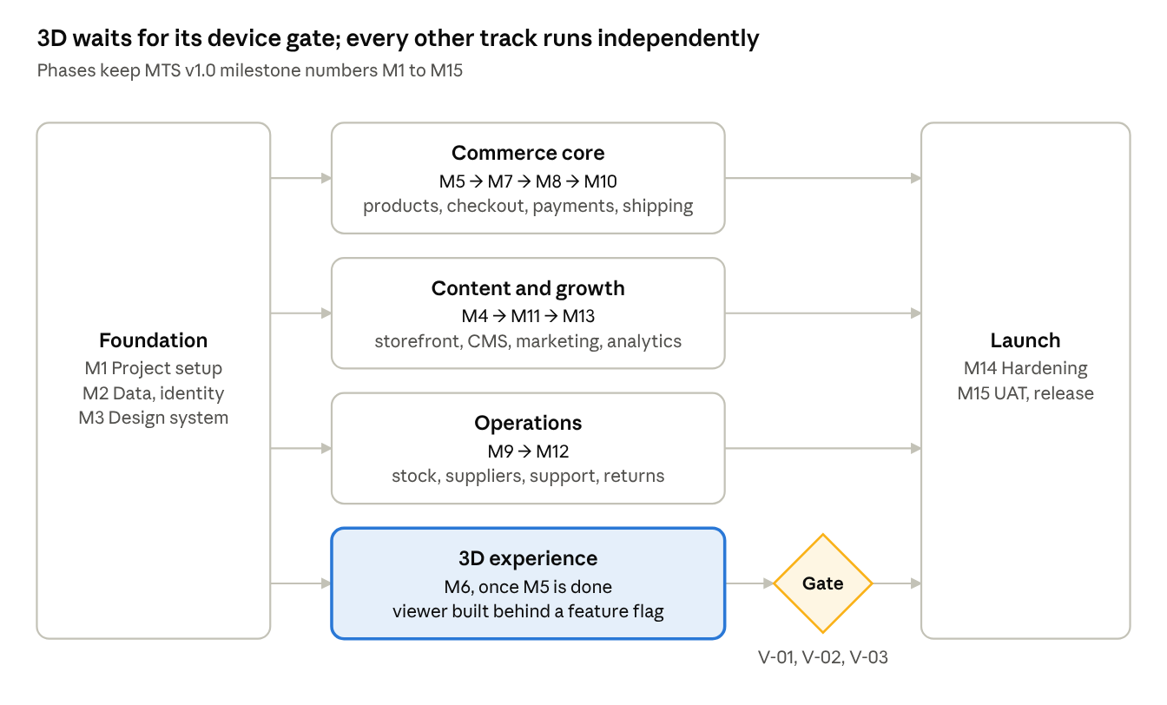
Development tracks · foundation, 4 tracks, 1 gate, launch
Commerce core is the critical path to launch. The 3D viewer is built in M6 like any other feature, but stays switched off for shoppers until V-01, V-02 and V-03 pass. If the gate isn't passed by launch, the store launches with product images and switches 3D on later.
Phase | Delivers | Needs first | Decisions needed before it starts
M0 Decision lock | Approval of this MTS v2.0 | — | P-01 (confirm Next.js), P-20 (launch scope)
M1 Project foundation | Monorepo, Docker Compose stack, CI pipeline, Django and Next.js skeletons, settings, health checks, staging environment | M0 | P-04 (local database, proposed in section 6), P-10 for staging hosting
M2 Data and identity | Core schema and migrations, accounts, customer profiles, staff roles and permissions, audit log, sign-in API | M1 | P-05 (roles, two-factor)
M3 Design system and shell | Tokens, shared components, layout, navigation, footer, Urdu right-to-left, accessibility baseline | M1 | P-19 (final palette and design references)
M4 Storefront and CMS | Homepage sections, collections, content and policy pages, CMS screens, SEO basics | M2, M3 | —
M5 Catalogue and product detail | Products, variants, SKUs, per-variant stock records, images, search and filters, product page with poster image | M2, M3 | P-12 (launch catalogue)
M6 3D product experience | viewer3d package, asset pipeline and approval, feature flag, ported test suite | M5 | D-01 to D-04 are inputs; public release gated by V-01 to V-03
M7 Customer journey | Registration and login screens, account, addresses, wishlist, cart, checkout, stock reservation | M5 | P-15 (guest checkout)
M8 Orders and payments | Order states, payment adapter with fake and sandbox providers, webhooks, reconciliation, refunds, transactional email | M7 | P-06 (providers), P-11 (tax), P-08 for email
M9 Inventory and suppliers | Adjustments, low-stock alerts, suppliers, purchase orders, receiving, valuation | M5 | —
M10 Shipping, tax and localization | Zones and rates, courier adapter, tracking, COD settlement, tax rules, Pakistan formats | M8 | P-07, P-13, P-11
M11 Marketing and communication | Coupons, scheduled promotions, SMS, abandoned-cart flows with consent, preferences | M8 | P-08
M12 Support and returns | Contact and tickets, returns and exchanges, refund workflow | M8 | P-14
M13 Analytics and reports | Event definitions, dashboards, exports, scheduled reports | M8 | P-16
M14 Hardening | Security review and penetration test, performance and load tests, accessibility audit, backup restore test, monitoring and runbooks | All launch features | P-17, P-18
M15 UAT and launch | Full regression, staff training, launch checklist, production release, post-launch monitoring | M14 | Release approval
Each phase is split into small vertical slices. Each slice goes through acceptance criteria, implementation, tests, review and approval, then merge, with a completion report listing changed files, setup steps, tests run and known limitations (MTS v1.0 §17.1).

17. Outstanding validations
Four validations are outstanding, all for the 3D experience. None of them blocks any other module. The catalogue, product pages, checkout, payments, inventory and every other track proceed regardless, and product pages always work with images alone (A-14).
ID | Validation | How | Blocks | Does not block
V-01 | Physical-device testing: an iPhone with Safari, a mid-range Android with Chrome, a low-end Android with Chrome | The 14-case procedure and exit criteria in the P-09 Production Readiness Report, section 7, using serve_v2.py --lan | Switching the 3D viewer on for shoppers | All other development, including M6 build work
V-02 | A genuine AureVon garment GLB | Same procedure, with the real model and its Draco and Meshopt copies | Switching 3D on; the asset budget (D-01); the colour-variant method (D-03) | All other development
V-03 | The v2 validation suite re-run on the production versions of React, React Three Fiber and Three.js (expected React 19 with R3F 9) | Port the P-09 Playwright suite into e2e/3d/ during M6 | Switching 3D on | M1–M5 and all non-3D work
V-04 | KTX2/Basis texture evaluation | Compare GPU memory and quality on the V-01 devices | The asset budget decision (D-01) only | Switching 3D on
These results are recorded as attachments to the P-09 report, and P-09 is closed only when you accept them. Until then, its technology decision (A-08) stands, but it is not marked production-ready.

P-09 defect record
All six defects found during P-09 are fixed in the v2 reference viewer, and their fixes become requirements for packages/viewer3d.
ID | Defect | Fix (now a requirement)
D1 | Endless spinner on corrupt, unsupported or Draco files | Read the GLB header first; check required extensions; catch errors that GLTFLoader throws as well as those it reports; time limits on decoding; a specific message for every failure
D2 | 3D that arrived late stayed hidden behind the fallback | No fixed switch-over; 3D takes over whenever it is ready, and "Show 3D" appears once it is
D3 | 3D kept rendering behind the image | Render only when 3D is showing, on screen, in a visible tab
D4 | A rigid 10-second loading timeout | Image first; loading continues; messages change with time, but failure is declared only for real errors, with "Try again"
D5 | "Try again" didn't recover after a network failure, because the browser caches failed module downloads | "Try again" reloads the page and keeps the shopper's selections. In production, a bundled build should make retries of individual chunks possible, which V-03 re-tests
D6 | Meshopt models showed a raw error, and logged a console error, where WebAssembly is blocked | A plain message; the Meshopt decoder loads only where WebAssembly is allowed; production policy allows 'wasm-unsafe-eval' (section 12)

18. Open decisions register
23 decisions remain open: 17 carried from v1.0 and 6 new ones from P-09. Each blocks only the milestone named beside it. Three v1.0 items are now closed: P-02 (Django with DRF), P-03 (PostgreSQL; the provider moves into P-10) and the P-09 technology choice (its validations stay open in section 17).
ID | Decision | Current proposal | Needed before | Status
P-01 | Frontend framework and build tooling | Next.js with TypeScript in a pnpm monorepo, bundling React, R3F and Three.js | M1 | Proposed
P-04 | Local development database and migration strategy | PostgreSQL in Docker Compose, same major version as production; Django migrations, expand-then-contract | M1 | Proposed
P-05 | Role names, permission matrix, two-factor policy, dual approval | The candidate matrix in section 9 | M2 | Proposed
P-06 | Payment providers and methods, including cash on delivery | Research candidates in section 10 | M8 | Pending
P-07 | Couriers and return logistics | Research candidates in section 10 | M10 | Pending
P-08 | Email and SMS/OTP providers | — | M8 (email), M11 (SMS) | Pending
P-10 | Cloud provider, region, sizes, budget, deployment tooling, monitoring; final security policy | Provider-neutral design in section 14 | M1 (staging) | Pending
P-11 | Tax, invoicing, privacy and consumer law, data residency | Needs local professional advice | M8 | Pending
P-12 | Launch catalogue: products, sizes, colours, SKUs, prices | — | M5 | Pending
P-13 | Shipping zones, fees, free-shipping thresholds, delivery promises | Table rates by zone (section 10) | M10 | Pending
P-14 | Return window, eligibility, exchange and refund policies | — | M12 | Pending
P-15 | Guest checkout | The architecture supports both answers | M7 | Pending
P-16 | Analytics definitions, consent model, report schedule | — | M13 | Pending
P-17 | Backup frequency, retention, RTO and RPO | — | M14 | Pending
P-18 | Supported browsers and devices; performance budgets | Set from V-01 device data | M14 | Pending
P-19 | Final global palette and page design references | — | M3 | Pending
P-20 | Launch scope versus post-launch | The priorities in section 7 | M0 | Proposed
D-01 | 3D asset budget: file size, triangles, textures, GPU memory | None until V-01 and V-02 report (A-13) | 3D switch-on | Pending
D-02 | Standard 3D compression | Draco, Meshopt or both, after V-02 | M6 | Pending
D-03 | Colour-variant method for real garments | Per-colour models, glTF material variants, or recolour in code | M5–M6 | Pending
D-04 | Who produces garment 3D models, and with what tools | — | M6 | Pending
D-05 | Desktop mouse-wheel zoom over the viewer | Keep, require a modifier key, or click to activate | M6 | Pending
D-06 | Reservation expiry for unpaid online orders | 30 minutes, as a store setting | M8 | Proposed
When a decision is made, its status changes here and it moves to the approved register in section 1, with the date and reason.

