Talia Martz-Oberlander

PHY3009 Final Project Paper

November 14th, 2015

Tiffany Timbers

**Effects of Carbon Dioxide on the Speed of Sound from a Pipe Organ**

**Abstract**

How do environmental factors affect the speed at which sound waves travel in gasses? The way in which sound travels is dependent on the media within which it travels. In gasses, characteristics such as the molecular composition, temperature and moisture content can alter the frequency, or wave motion, of sound waves.1 Musical instruments, such as pipe organs, depend on sound moving through air at certain speeds to produce desired musical notes at set pitches. Pipe organs particularly depend on their localized environment. Pipe organs are typically tuned by an organist while the building is empty, then played for an audience, whose presence introduces increased temperature, CO2, and water vapour. Do changes in the environmental conditions in the buildings in which organs are situated affect the pitch of the notes? There are known relationships between such air quality factors and speed of sound; however, there is a lack in research into changes in sound from an instrument. This investigation focuses specifically on examining the change in pitch in relation to changes in CO2 concentration. Using equations for frequency from CO2 concentration, I will compute predicted pitch and compare measured pitch to see whether, and how much, CO2 concentration affects pitch.

**Introduction**

Because sound travels via the movement of air, the characteristics and composition of air affect the speed of sound. Therefore, studying the effects of atmospheric conditions such as molecular composition of air can provide insights into the nature of sound travelling through an area.1 This directly applies to musical instrumentation construction, management, and use. Many mechanical instruments are adjusted or tuned to emit certain pitches, alternatively referred to as the frequencies of sound waves propagated from the instrument. Knowledge of ideal tuning depends on knowledge of the rate at which the sound waves will propagate through the air. Since sound waves are affected by the media within which they travel, location and environmental conditions surrounding instruments greatly affects their sound. Cramer provides documentation of the relationship between changes of sound speed and air characteristics such as temperature, relative humidity (RH), and carbon dioxide concentration.2 It has been seen that frequency of sound waves has a calculable relationship to these environmental factors. This relationship can provide insight into how much is musical pitch is affected by changing characteristics of ambient air.

We can examine change in pitch of musical instruments from the environmental characteristics of air by using previously calculated relationships between air characteristics and speed of sound outcomes. Mechanical pipe organs are especially vulnerable to changes in their environment because they are often located in large, heterogeneously-shaped buildings, with large audiences, which impact air characteristics.3 Additionally, the pipe and bellow system moves air throughout different parts of the organ chambers creating mixed air effects. If a muted tone is desired, shades are closed reducing the flow of air between sections of organ pipes. How much do these situational variables affect tuning of some pipes relative to others? If some pipes have a different change in pitch than others, this causes the instrument to sound off key. Traditionally, tuning adjustments on pipe organs are completed when the chapel is empty, however organs are typically played when the building is filled with an audience. Along with an increase in temperature and water vapour, the presence of people and the human respiratory process produces significant amounts of CO2, which is a heavier molecule than air, mostly comprised of N2 and O2. Therefore, its presence affects calculations of molar mass of air, particularly with high levels of air moisture, as is caused by breathing.4, 5 With pipe organs the effects of human presence on air quality is especially high due to the closed environment organs are located in. How much do changes in CO2 levels between air conditions during tuning versus during performance change the frequency of the notes played? Additionally, will the tuning of different sections of the organ change in relation to others, based on regional differences? This study looks to examine carbon dioxide concentration in the chapel containing a mechanical organ to examine the relationship between CO2 and speed of sound propagated from movement of air through organ pipes.

This computational investigation makes use of machine and hand collected data to make comparisons between CO2 concentration levels in parts per million (ppm) and frequency changes in Hertz (Hz) from notes played on an organ.

**Methods**

This study will use data that charts concentration of carbon dioxide (CO2) and pitch of notes played on the pipe organ at the chapel of St. Paul’s School in Concord, NH USA, collected by Dr. Ian Hoffman. Computational analysis of the data will make use of the mathematical relationship between CO2 concentration and changes to the speed of sound, as described by Cramer.2 The complete project repository can be found here: <https://github.com/taliamo/Final_Project>

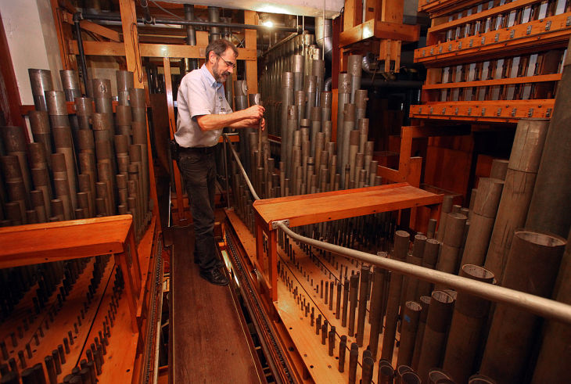The data was collected at chapel at St. Paul’s School in 2010 (Image 1). The organ apparatus is located within the smaller, pitched-roofed building that protrudes from the middle of the main chapel. The entire organ apparatus is made of multiple divisions or sections, each with their sets of pipes (Image 2).

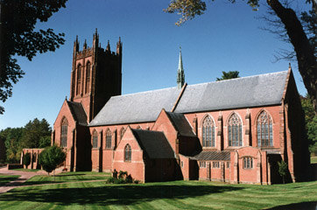**Image 1 and Image 2 (left to right).** St. Paul’s School (www.sps.edu). The exterior of the St. Paul’s School chapel.

**Image 2.** (http://www.pressofatlanticcity.com). The inside of a pipe organ

The CO2 data were collected within the choir division of the pipe organ apparatus. This region is located near the front of the organ room, towards the right hand side of the main chapel hall, near where the choir members sit (seen in Image 1). Image 3 shows the inside façade of the pipe organ. The CO2 sensor was placed behind the façade. The organ room, as seen in Image 1, protrudes behind the main chapel building behind the façade.

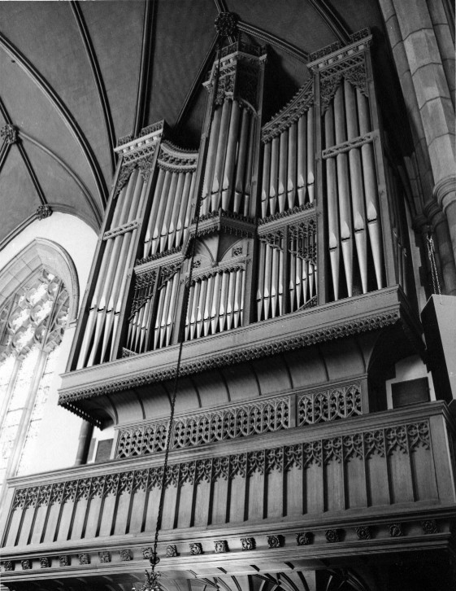

**Image 3. (**http://aeolianskinner.organsociety.org/Specs/Op00825a.html). The inside façade of the pipe organ in St. Paul’s School chapel.

Data of the frequency of sound produced by notes on the pipe organ were logged by hand. These were taken while the building was empty of visitors or filling up or emptying out, before or after a service. Environmental characteristics data was collected and recorded using Onset® U12-03 and Telaire 7001 HOBO® data logging devices for temperature and relative humidity (RH) and for CO2 (ppm) readings, respectively.

The environmental data will initially beconverted from .hobo to .csv files using HOBOWare® for analysis in Python. Using Python version 3.4.0, data will be arranged for computation, quantitative analysis, calculation of statistical significance, and formation of graphical presentations. Pandas, Numpy and Matplotlib Python libraries are used for computation and plotting operations. Two types of scripts are used, one for processing pitch and one for environmental data.

The data is first wrangled and cleaned in Python to create two data frames for each type; one to house environmental data and another type for pitch measurements. The environmental data files are kept for certain locations and consist of date and time, temperature, relative humidity, and CO2. The pitch data files consist of date and time, division of the pipe whose note is played, musical note played, and frequency values from multiple samplings taken at the same date time value. A mean frequency value for each time stamp was generated, as well as standard deviation.

In the environmental dataframes, CO2 data are run through the “cramer” function, as defined in a Python script, to generate values for calculated pitch, as per Cramer’s equation for frequency of sound from environmental characteristics.2 Here, a modified version of the equation is used to isolate for CO2 concentration, apart from temperature and humidity. The plotted points of measured pitch come from the average frequency data. To compare measured and calculated pitch values, documented pitches and environmental data are grouped by area in the chapel. Later, measured pitch points can be plotted over top of calculated pitch values. This comparison allows for examination of the correlation between change in calculated and measured frequency of sound from a note on the pipe organ. Unfortunately, data used for this project does not have overlapping timeframes for samples of measured pitch and of CO2 (which are used to generate expected pitch). Therefore, making a graphical comparison between measured and calculated pitch is not feasible. The two variables are not comparable because the hypothesis looks to examine how pitch changes as affected by CO2 concentration. Therefore, it is necessary to compare pitch changes at the same time and date that change in CO2 concentration is also being examined.

**Results**

The script to plot CO2, calculated frequency, and measured frequency did not succeed in Shell script form. Additionally, no comparisons could be made between calculated and measured pitch, due to the lack of time-overlapping data, as mentioned above. However, computational results do show the change in CO2 concentration in the air of the chapel over time, through the sample numbers, which were taken every 2 minutes (Figure 1). CO2 concentration within the choir division, the lower section within the organ room, varies greatly: from ~ 450ppm to ~ 1350ppm at the peak of the highest spike (Figure 1). Due to the times of those spikes and qualitative notes documented alongside the data collection, we can say that the spikes are indeed caused by the presence of an audience in the church.

Macintosh HD:Users:shubbymartz-oberlander:Desktop:t_final_project:organ_pitch:Scripts:CO2_figure.pdf

**Fig 1.** CO2 concentration over sample number. Samples are taken 2 minutes apart from one another. This figure displays CO2 sampled inside the pipe organ, near the choir division.

Additionally, samples of the C5 (C note one octave above middle C on the pipe organ) were taken over three days. Pitch of the note changes from ~ 423.9 Hz to ~ 524.7 Hz (Figure 2).

Macintosh HD:Users:shubbymartz-oberlander:Desktop:t_final_project:organ_pitch:Figures:fig_test.pdf

**Fig 2.** Change in pitch over time. Samples of the c5 note in the choir division of the pipe organ in St. Paul’s School chapel were taken over 3 days (April 13th, 16th, and 17th).

Measured sound frequency (Figure 2) and measured CO2 concentration (Figure 1) cannot be compared against one another because of the lack of overlap of timing. Therefore, statistical analysis of the relationship of rate of change of the two variables cannot be performed.

**Discussion**

This computational study’s major limitation is the comparability of measured and calculated pitch, or sound frequency. The analysis depends on relative pitch, not absolute values, since each organ is tuned slightly differently so that one middle C note on one instrument may be different in another location. Therefore, this study depends on comparing data from the same location at the same time. Since overlapping time for measured and calculated pitch (from measured CO2 data) was not available, limited conclusions on the affect of CO2 concentration on sound frequency can be made.

However, interesting observations can be made about the affect of human population in the chapel and change in CO2, which—based on Cramer’s equation—suggest a change in pitch from the introduction of additional heat, CO2, and water vapour from human bodies and breath.2 In Figure 1, the spikes of CO2 concentration can be attributed to people entering the church. These spikes follow similar trends, which is in keeping with the scheduling of the church. Members of the St. Paul’s School community attend regular prayer services, as well as special performances. According to notes taken during data collection, most of the audience enters the space within a few minutes of the rest of the attendees, and leave at the same rate, causing rapid change in CO2 concentration. CO2 spikes, up to ~1350 ppm, are quite intense. Normal air levels of CO2 are typically around 400ppm.6 The CO2 figures here are measured within the organ console, a small room-like area within the chapel. One reason why CO2 levels may be so extremely high could be because of air-trapping effects caused by the screen of pipes or the blinds that are part of the organ construction and sound creation. These control air flow for sound quality, but also act as a space divider between the smaller organ building, located off the main hall (Image 1), and the greater chapel.

Figure 2documents that pitch of organ notes do really change over time. The C5 note (C note one octave above middle C) values plotted in Figure 2 span five days. This is not enough time for a pipe organ to alter its tuning in the way that organs periodically need adjusting. Over the study period, frequency of the C5 note fluctuates by almost 1 Hz, which is approximately %3 of the difference between that C note and the note above, C sharp. Something is changing the frequency of the note. Using statistical tools to quantify the relationship between CO2 and change in pitch would provide deeper insight into the impact of air quality on sound.

Another factor worth examining is differences in changes in pitch from different sections of the organ room. If more CO2 is trapped within the organ apparatus, is the lingering in some places more than others? If there is indeed a causal relationship between changes in CO2 concentration, or other environmental factors, and change in sound frequency, it is beneficial to know whether structural characteristics of a pipe organ lead to varying air quality in different sections. Knowing differences in pitch change in regions of the organ can help organ mechanics and manufacturers better construct and maintain organs for more optimal sound.

Future study of change in pitch of organ notes with changes in the air environment could provide insight into a predicted pitch value, which can span any timeframe, so that measured pitch can be appropriately plotted and compared alongside a curve of calculated pitch. Ultimately, expanding the study to look at the effects of more environmental variables, such as temperature, would provide more scientifically meaningful insight into how pitch alters with changes in air characteristics. To do this, useful metadata consist of temperature and RH measurements taken at the same time, with the same sensors, in the same locations as CO2 concentration, as well as temperature readings outside the chapel. Additional meteorological information from nearby weather stations could be used to examine temperature and pressure changes. By continuing to study environmentally caused changes in the speed of sound produced by pipe organs, better tuning and construction can be employed. More broadly, this can provide insight into how changes in molecular composition and temperature can affect sound travel in partially enclosed environments.

**Works Cited**

1 O. A. Godein. “Passive acoustic measurements of wind velocity and sound speed in air”. Journal of Acoustical Society of America. 135(2); El68-EL74 (February, 2014).

2 O. Cramer. “Specific heat ratio and speed of sound”. Journal of Acoustical Society of America. 95(3); 2510-2516 (1992).

3 Jeon, Jin Yong, In Hwan Hwang, and Yong Hee Kim. 2014. "Investigation of the acoustical characteristics of organ pipes in a performing space." *Building And Environment* 77, 50-60. *ScienceDirect*, EBSCO*host* (accessed November 15, 2015).

4 A. Picard, R. S. Davis, M. Glaser, and K. Fujii. “Revised formula for the density of moist air (CIPM-2007)”. Meterologia ; 45; 149-155 (2008).

5 R. S. Davis. “Equation for the Determination of the Density of Moist Air (1981/91).” Meterlogia; 29; 67-70 (1992).

6 NOAA. “Recent Monthly Average Mauna Loa CO2”. *Trends in Atmospheric Carbon Dioxide.* November 5th, 2015. Web, accessed 17 Nov. 2915. http://www.esrl.noaa.gov/gmd/ccgg/trends/