Talia Muro &
Mariam Salim
420-311-VA Internet Programming
Project Proposal

Overview
Our online store aims to provide new parents with everything they could need for their newborn as they grow. The consumer can visit this website to buy clothes, strollers, highchairs, bath products, toys, and more. We aim to make it as easy as possible for our clients to navigate our site and place an order. There will be a home page, a contact page, a form for creating an account, a search feature, a checkout page, and a product listing page that separates the products into different categories.

Structure
We are aiming to make our website as easy to use as possible and this starts by appropriately separating the functionalities into different webpages.

Home Page
Our home page will contain bestsellers, any promotions we are having, and our mission statement. There will be a navigation bar to get anywhere the client desires, and there will also be a footer section with links for easy navigation from page to page.

Contact Us Page & Contact Form
This page will contain the necessary information to get in contact with the customer service of our store, such as phone number, email, and opening hours. In order to facilitate this for the client, there will also be a contact form that will send an email directly from the website to our customer service team. Additionally, there will be an embedded Google Map, showing the location of our in-person store.

Create an Account & Login Form
We have decided to put the create an account form and the login form on the same page since the two go hand-in-hand. The create an account form will ask the user to choose a username and password, as well as input some personal information, such as first name, last name, birthdate, address, etc. The login form will simply prompt existing-users for their username and password.

Product Listing Page
The product listing page will contain a catalogue of our available products with an image, brief description, and pricing. There will also be a sort feature (we called it search feature in our wireframe) where clients can filter items based on bestsellers, price low to high, price high to low, new arrivals, etc.

Product Details Page
From the product listing page, the client may click any listing and will be brought to that specific product’s detail page. Here, the client will find more information on the product, such as more images, a more in-depth description, and customer reviews.

Search Feature
On every page, in the navigation bar, there will be a search bar where the client can search for a specific product in the product listing page by name. This feature will bring the client to the product listing page with any products that match their search.

Shopping Cart Page
In this page, the client can edit what is in their cart. They may increase the quantity of a specific product or remove a product altogether. They can enter their billing information in this page. Once they are happy with the contents of their cart, they may proceed to the checkout button to place their order. They will then be redirected to an order confirmed page, containing an order number and their order summary.

Functionality & Features
On every page, except the account login/sign up page, the same footer and the same navigation bar will be present where the client can visit the home page, the contact page, the account page, the product listing page, the search feature, and the checkout page. This makes it easy for the client to navigate the website regardless of which page they are on without having to go back. Also, while developing this project, we might add more features.

Home Page: heading before nav with logo, grid for featured products, 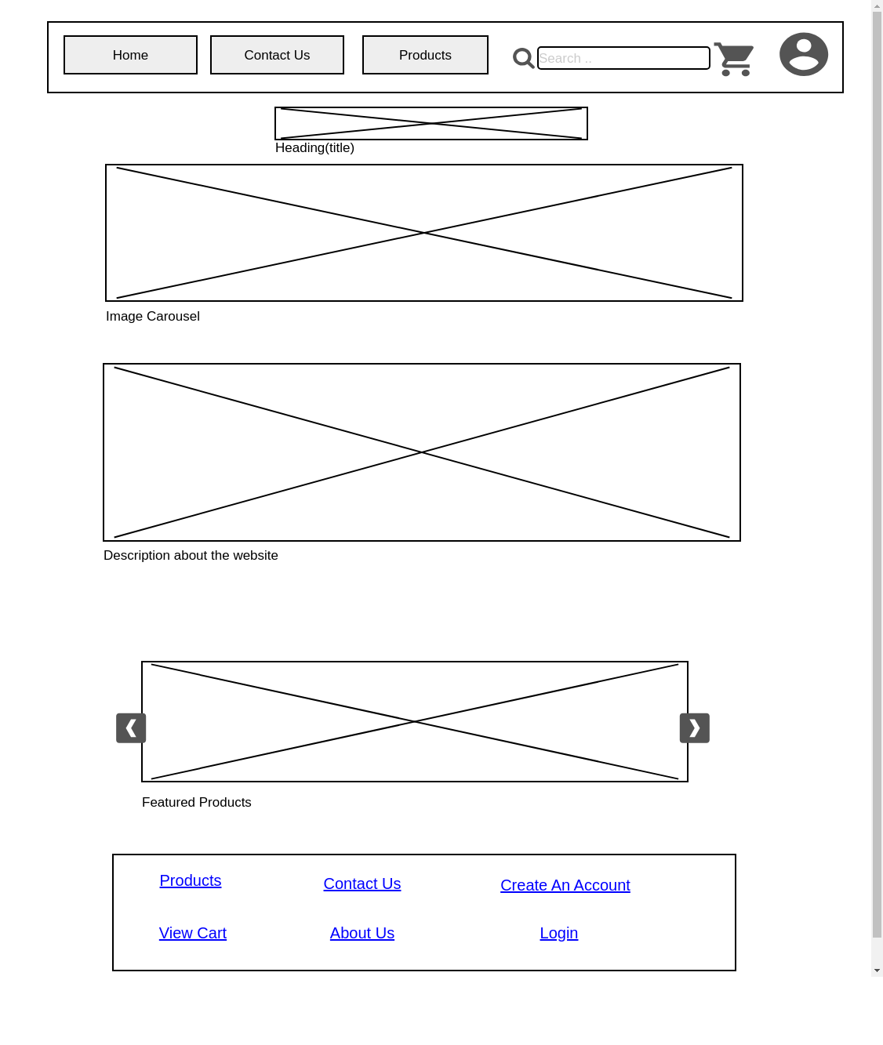

Contact Us Page: google maps or open street maps(easier)
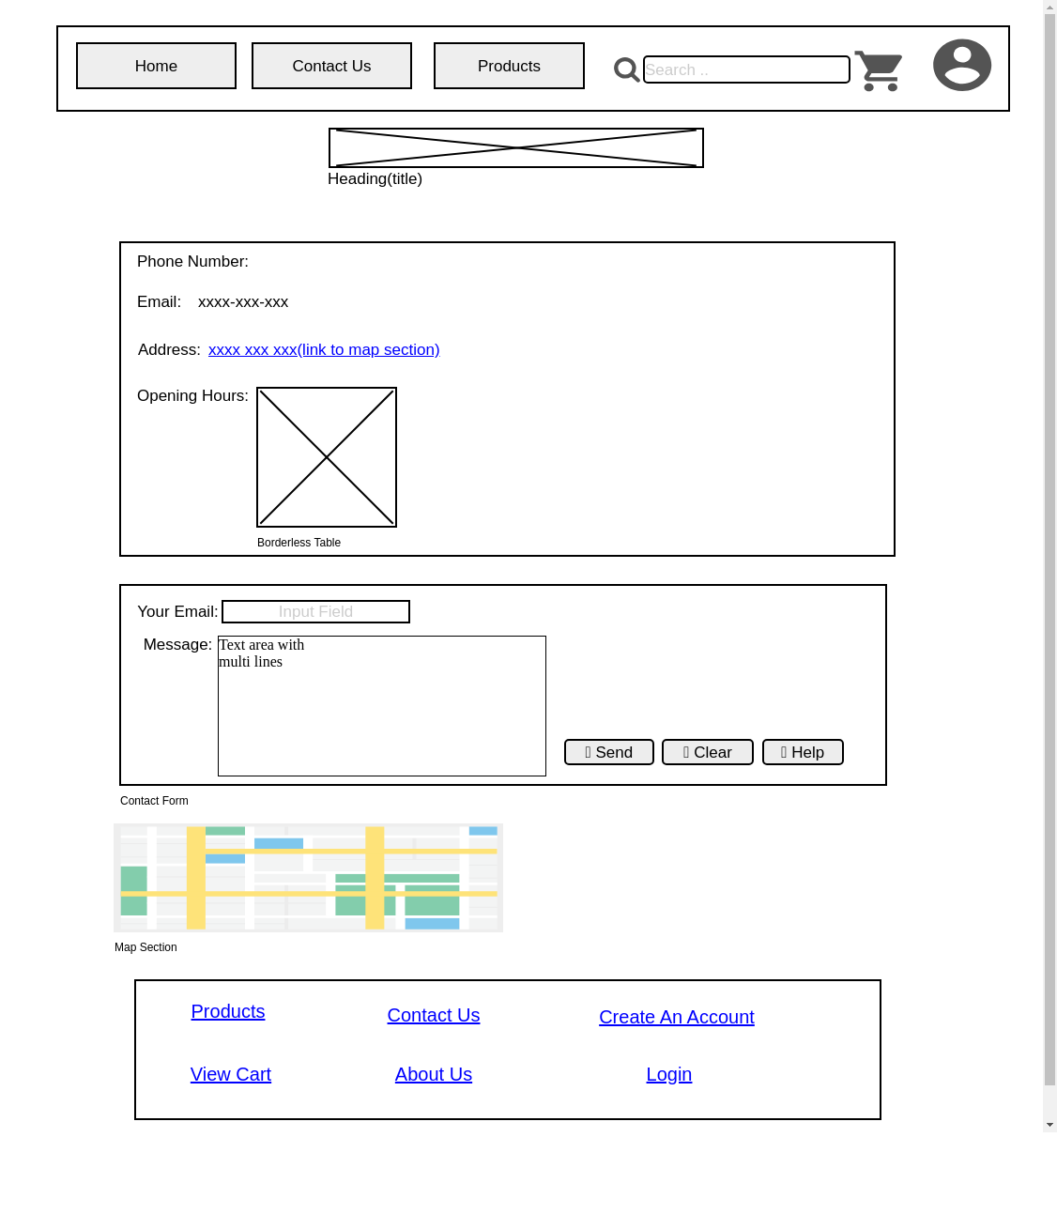

Products Listing Page: search bar only here (search can only access current page)
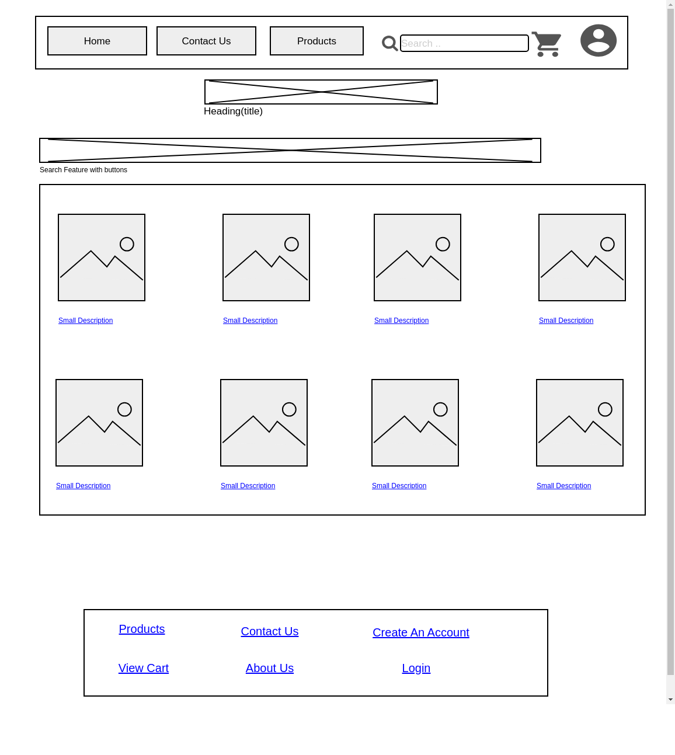

Product Detail Page:
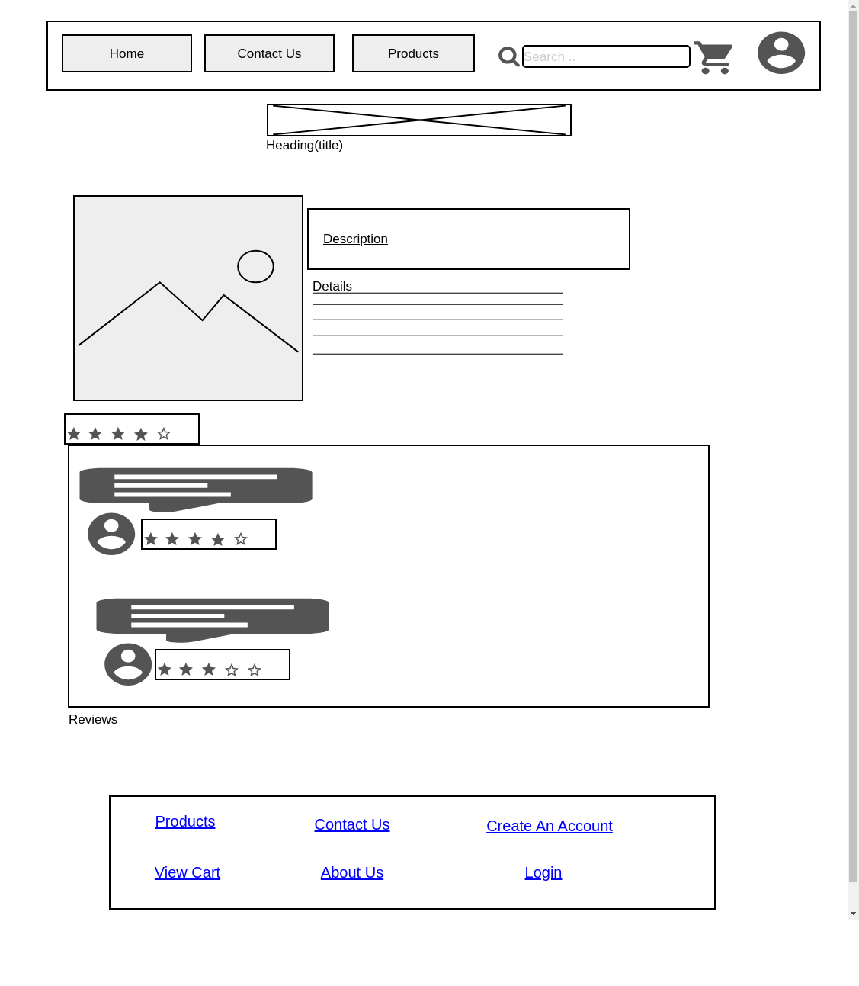

Shopping Cart Page:
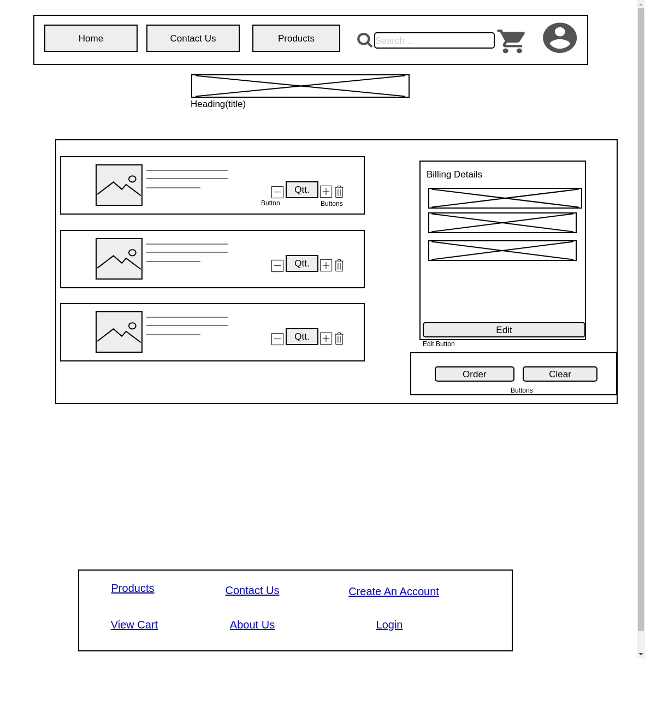

Order Confirmation Page:
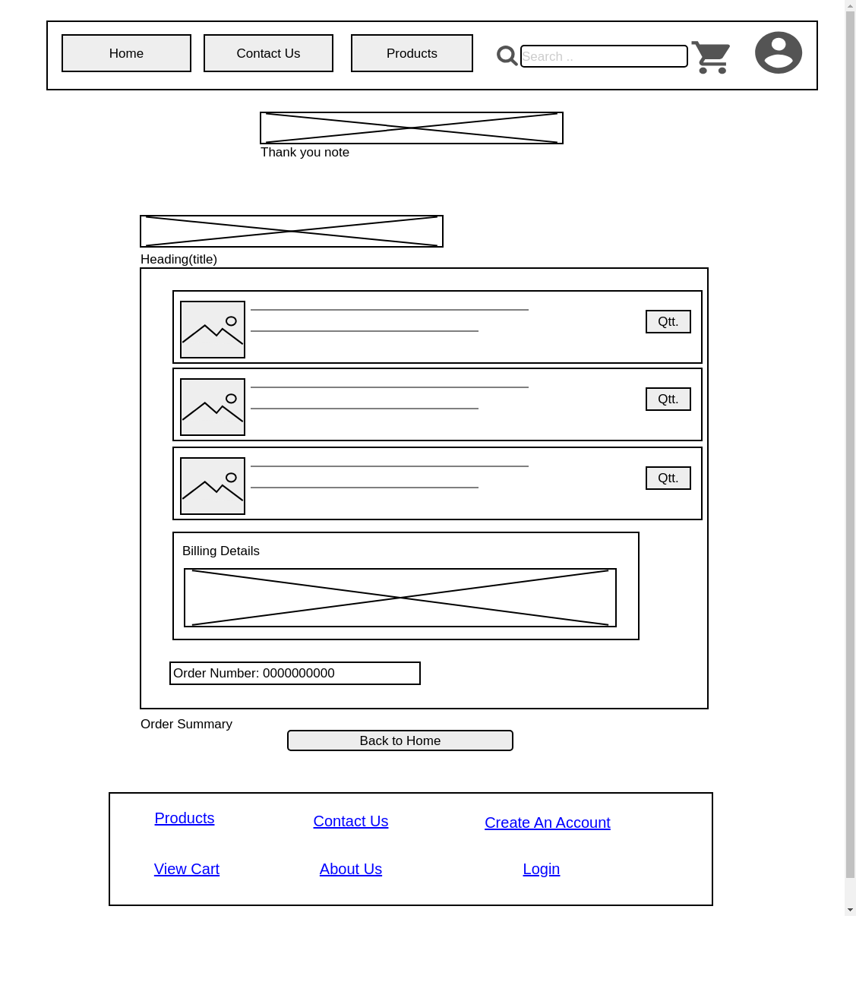

Account Login/Sign up Page: address should have more fields

