**Daily challenge: Real-world Data Analysis Scenarios**

# News story: How the Gaza Ministry of Health Fakes Casualty Numbers

https://www.tabletmag.com/sections/news/articles/how-gaza-health-ministry-fakes-casualty-numbers

what data was analyzed: Death toll of Gazans released by “Gaza health ministry” aka Hamas

analysis method:

* Regression analysis , statistical analysis

Findings:

* total reported deaths, which he shows climbed by 270 plus or minus about 15% every day. total deaths by date is increasing with almost metronomical linearity

(not this graph might be showing cumulative sum! Not starting at 0 axis)

* constant increase every day statistically impossible. Should be days with twice the average or more and others with half or less.
* should see a variation in the number of child deaths that tracks with the variation in women's deaths. on the days with many women casualties, there should be large numbers of children casualties, and on the days when just a few women are reported to have been killed, just a few children should be reported."

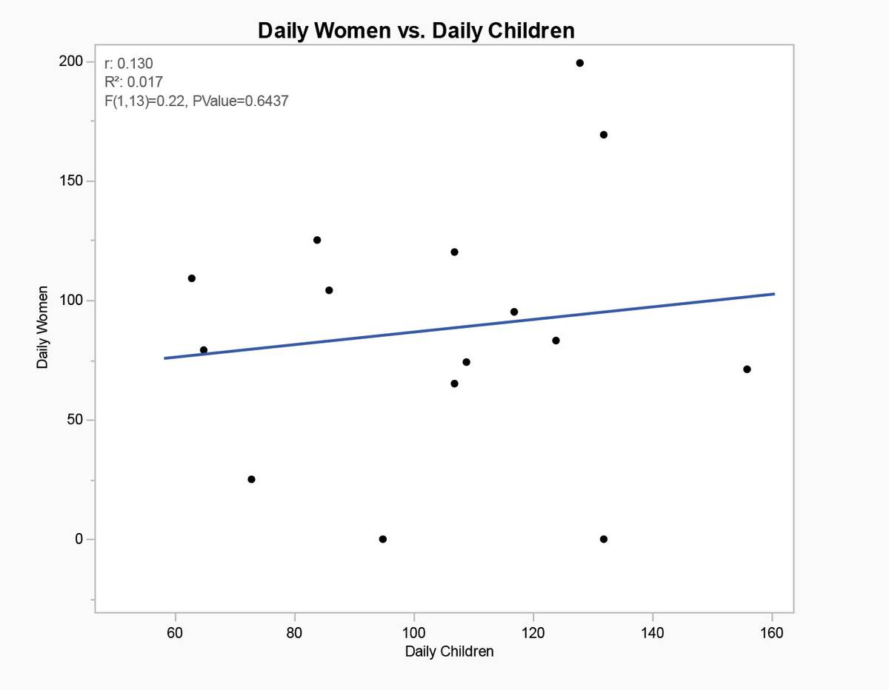

* strong negative correlation between deaths of men and women. Should be the opposite. on the three days when the men’s count is near zero, suggesting an error, the women’s count is high. In fact, the three highest daily women casualty counts occurs on those three days.

* by Hamas's own admission, 6,000 Hamas fighters have been killed, which if combined with Hamas's data on deaths, shows that 20% of the total deaths are combatant while 70% are women and children. This implies that "Israel is somehow not killing noncombatant men, or else Hamas is claiming that almost all the men in Gaza are Hamas fighters."

Conclusion:

* "The truth can’t yet be known and probably never will be. The total civilian casualty count is likely to be extremely overstated."
* "Most likely, the Hamas ministry settled on a daily total arbitrarily," he concludes. "We know this because the daily totals increase too consistently to be real. Then they assigned about 70% of the total to be women and children, splitting that amount randomly from day to day. Then they in-filled the number of men as set by the predetermined total. This explains all the data observed."

Critics on report:

* Only 15 day sample data

Data used:

Some interesting discussion points (redit): https://www.reddit.com/r/statistics/comments/1bedcfp/d_gaza_war_casualty_numbers_are_statistically/?rdt=38197