Lab 8 - Docker, Containers, and Images
EECE 435L | Solo work | Talia Semaan | AUB username: tts09
GitHub: https://github.com/taliasemaan/EECE435L-Lab8-Talia-Semaan

Activity 1 - Docker commands
The following screenshots show the requested Docker commands and their results. Docker stop and docker logs take a container name or ID, rather than an image name; therefore the running Lab 5 API container name is used below.

1. List all containers
docker ps -a
Lists all Docker containers, whether running or stopped. The output shows each container ID, image, status, published ports, and container name.
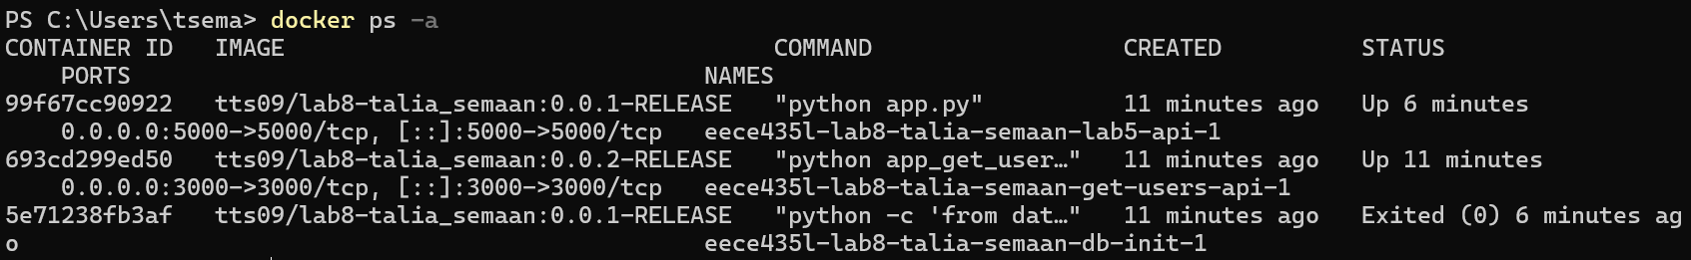
Figure: activity1-docker-ps-a.png

2. Stop the Lab 5 API container
docker stop eece435l-lab8-talia-semaan-lab5-api-1
Gracefully stops the named container. The command prints the container name when it stops successfully.
Figure: activity1-docker-stop.png

3. View the Lab 5 API container logs
docker logs eece435l-lab8-talia-semaan-lab5-api-1
Displays the container?s application output and request logs. The Flask development-server warning is expected for this lab application.
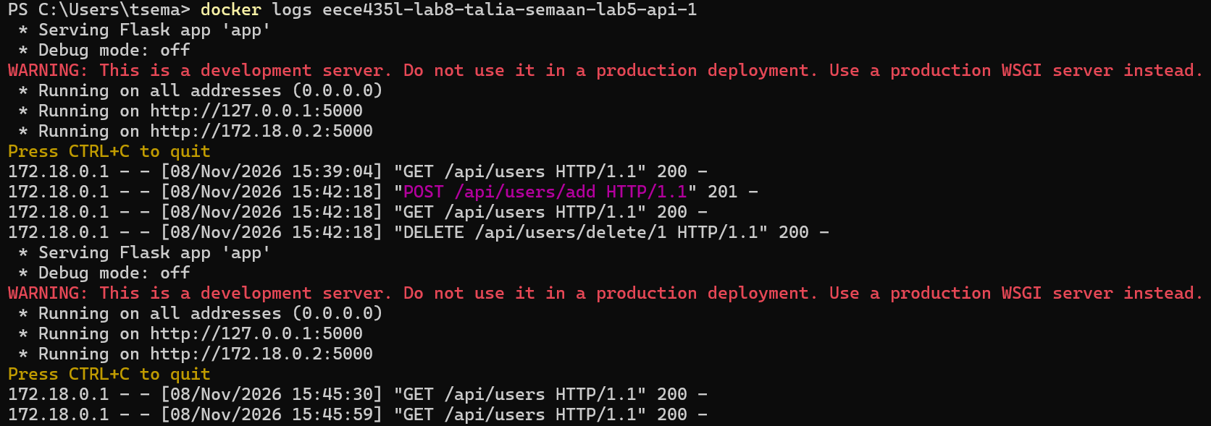
Figure: activity1-docker-logs.png

Activity 2 - Docker image screenshots
Both images were built with the required AUB username and release tags. The screenshots below show each image detail page in Docker Desktop.

Image 1 - Lab 5 API, port 5000
tts09/lab8-talia_semaan:0.0.1-RELEASE
Docker image for the Lab 5 user-management API, published on port 5000.
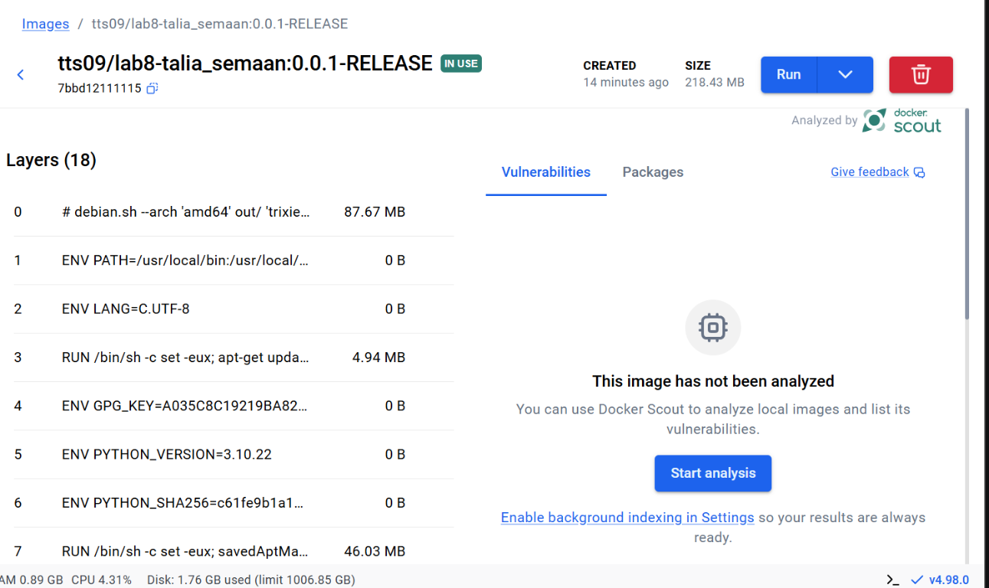
Figure: activity2-image-0.0.1-release.png

Image 2 - get_users API, port 3000
tts09/lab8-talia_semaan:0.0.2-RELEASE
Docker image for the GET /get_users endpoint, which returns the database user names on port 3000.
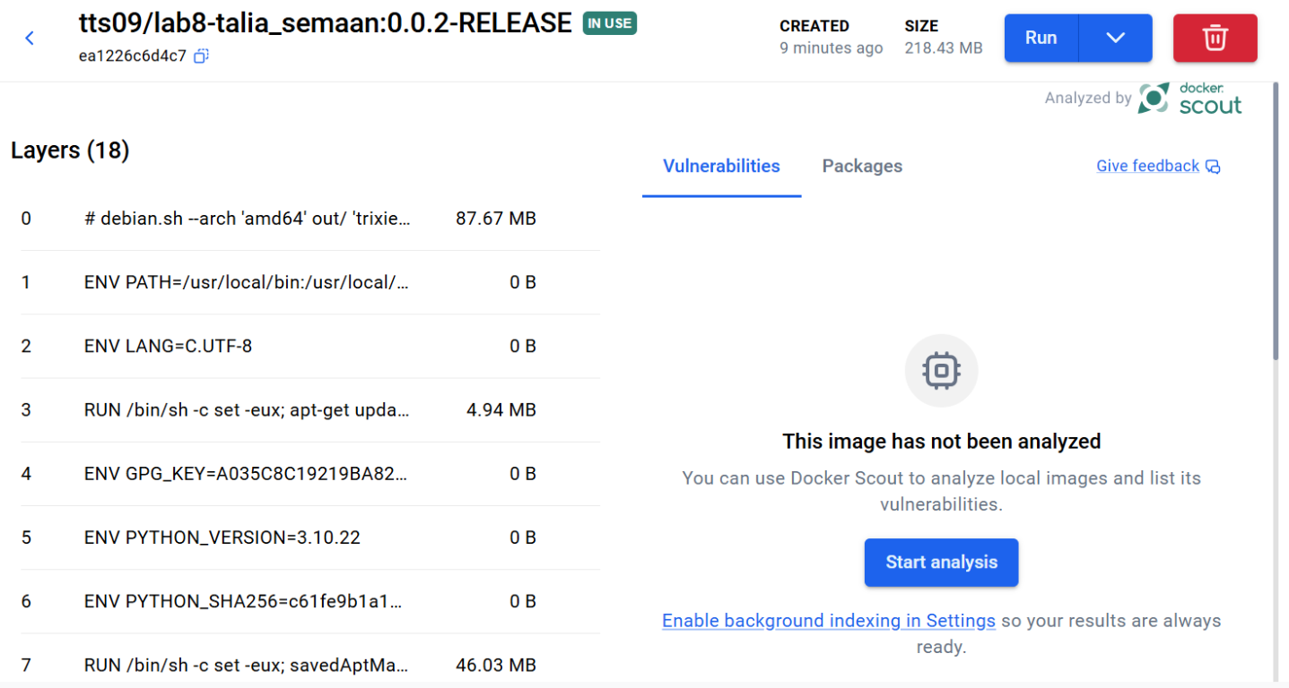
Figure: activity2-image-0.0.2-release.png

Verification
Both API containers were started and verified responding with HTTP 200. A user created through the Lab 5 API was visible by name through GET /get_users, confirming that the containers share the persistent database volume. The verification record was deleted afterward. The project test suite passed: 11 tests.

