Problem#01
//Inserting elements at position and then adding display function etc
#include<iostream>

//creating struct node for linked list
struct Node {

public:
int data;
Node* next;

Node(int dat = 0) {
data = dat;
}

};

//creating a linked list
class List {
Node* head;

public:
List(Node* h = NULL) {
head = h;
}
//methode declaration
Node* createNode(int val);
bool insert_pos(int val, int index);
void display();
bool isempty();

};

//funtion to create node
Node* List::createNode(int val) {
Node* n = new Node(val);
return n;
}

//to check is list is empty
bool List::isempty() {
if (head == NULL)
return true;
return false;
}

//Function to display the data
void List::display() {

Node* current = head;
int count = 0;
std::cout << "Displaying Data in Linked List\n";
//displayin data
while (current != NULL) {
std::cout << current->data << "->";
current = current->next;
count++;
}
std::cout << "\nTotal Items: " << count << std::endl;
}

//function to insert element at position
bool List::insert_pos(int val, int index) {

if (index <= 0) { return false; }

int currentIndex = 2;
Node* current = head;
//itertrating current in linked list
while (current != NULL && index > currentIndex) {
current = current->next;
currentIndex++;
}

if (current == NULL && index > 1) { return false; }

//Node* n = new Node(val);
Node* n = createNode(val);
if (index == 1) {
n->next = head;
head = n;
}
else {
n->next = current->next;
current->next = n;
}
return true;

}

//main driver code
int main() {
List l;
int choice = 0, elem, position;
while (choice != 5) {

std::cout << "1-Insert\n2-Isempty\n3-Display\n4-Exit\nChoose an Option: ";
std::cin >> choice;
if (choice == 1) {
std::cout << "Inserting data\n";
std::cout << "Enter Element: ";
std::cin >> elem;
std::cout << "Enter Position: ";
std::cin >> position;
std::cout << "Is inserted: " << l.insert_pos(elem, position) << std::endl;
}
else if (choice == 2) {
std::cout << "IsEmpty" << l.isempty() << std::endl;
}
else if (choice == 3) {
l.display();
}

else if (choice == 4) {
exit(1);
}
system("pause");
system("cls");
}
}
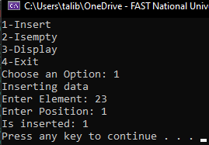
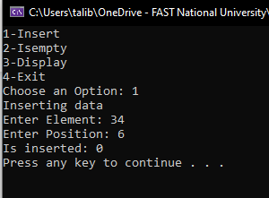
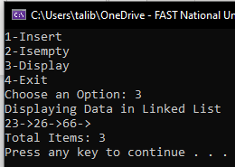
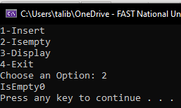

Problem#02
//Searching and deleting the element

#include<iostream>

//creating struct node for linked list
struct Node {

public:
int data;
Node* next;

Node(int dat = 0) {
data = dat;
}

};

//creating a linked list
class List {
Node* head;

public:
List(Node* h = NULL) {
head = h;
}
//methode declaration
Node* createNode(int val);
bool insert_pos(int val, int index);
void display();
bool isempty();
bool deleteElement(int val);

};

//funtion to create node
Node* List::createNode(int val) {
Node* n = new Node(val);
return n;
}

//to check is list is empty
bool List::isempty() {
if (head == NULL)
return true;
return false;
}

//Function to display the data
void List::display() {

Node* current = head;
int count = 0;
std::cout << "Displaying Data in Linked List\n";
//displayin data
while (current != NULL) {
std::cout << current->data << "->";
current = current->next;
count++;
}
std::cout << "\nTotal Items: " << count << std::endl;
}

//function to insert element at position
bool List::insert_pos(int val, int index) {

if (index <= 0) { return false; }

int currentIndex = 2;
Node* current = head;
//itertrating current in linked list
while (current != NULL && index > currentIndex) {
current = current->next;
currentIndex++;
}

if (current == NULL && index > 1) { return false; }

//Node* n = new Node(val);
Node* n = createNode(val);
if (index == 1) {
n->next = head;
head = n;
}
else {
n->next = current->next;
current->next = n;
}
return true;

}

bool List::deleteElement(int val) {
Node* current = head;
int c = 1;
Node* temp;
//iterating to find the element
while (current != NULL) {
if (current->data == val && c == 1) {
temp = current;
head = current->next;
delete current;
return true;
}

if (current->data == val) {
temp = current->next;
current->next = temp->next;
delete temp;
return true;
}
c++;
current = current->next;
}
return false;
}

//main driver code
int main() {
List l;
int choice = 0,elem,position;
while (choice != 5) {

std::cout << "1-Insert\n2-Isempty\n3-Display\n4-Delete\n5-Exit\nChoose an Option: ";
std::cin >> choice;
if (choice == 1) {
std::cout << "Inserting data\n";
std::cout << "Enter Element: ";
std::cin >> elem;
std::cout << "Enter Position: ";
std::cin >> position;
std::cout << "Is inserted: " << l.insert_pos(elem, position) << std::endl;
}
else if (choice == 2) {
std::cout << "IsEmpty" << l.isempty() << std::endl;
}
else if (choice == 3) {
l.display();
}
else if (choice == 4) {
std::cout << "Enter Element to Delete: ";
std::cin >> elem;
std::cout << "Is deleted: " << l.deleteElement(elem) << std::endl;
}
else if (choice == 5) {
exit(1);
}
system("pause");
system("cls");
}
}
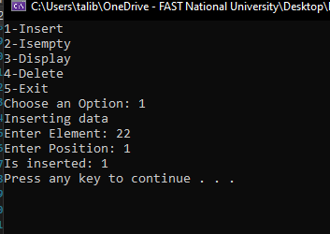
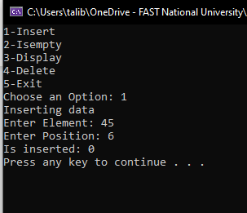
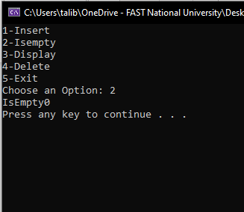
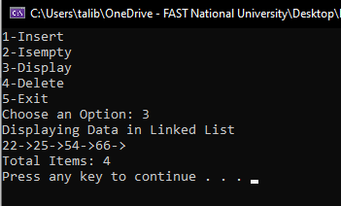

Problem#03
//error correction and then deleting after printing
#include<iostream>

struct linkedList {
int number;
linkedList* next;
};

void AddNode()
{
linkedList* head = NULL;
linkedList* current;
for (int i = 0; i < 10; i++) {
current = new linkedList;
current->number = i;
//error corrected
current->next = head;

head = current;
}
//printing the data in linked list
while (head->next != NULL) {
std::cout << head->number << std::endl;

//current = head->next;
//error corrected
current = head;
head = head->next;
delete current;

}

}

int main() {
AddNode();
}


Problem#04

#include<iostream>

struct myList {
int data;
myList* next;
};
int main() {
myList* head; // Pointer of myList
myList* cur;
myList* previous = NULL;

for (int i = 0; i < 4; i++) {
head = new myList; // making new list and assiging data.
head->data = 0;
head->next = previous;
for (cur = previous; cur != NULL; cur = cur->next) // loop will iterate until the end of list
head->data += 1 + 2 * cur->data; //
previous = head; // it will store the address of last node of list
}

while (previous != NULL) {
std::cout << previous->data << std::endl; //printing the data stored in a list
cur = previous; //
previous = previous->next;
delete cur; //deleting the list node after printing data
}
return 0;
}

Code Explanation
The list will store the elements and head will ne pointed to the end of list and after storing the list will be printed from the end because head is pointing at last.



Problem#05
//Concatenation of two lists
#include<iostream>

//creating struct node for linked list
struct Node {

public:
int data;
Node* next;

Node(int dat = 0) {
data = dat;
}

};

//creating a linked list
class List {
Node* head;

public:
List(Node* h = NULL) {
head = h;
}
//methode declaration
Node* createNode(int val);
bool insert_pos(int val, int index);
void display();
bool isempty();
bool deleteElement(int val);
void concatenate(List* l1, List* l2);
};

//funtion to create node
Node* List::createNode(int val) {
Node* n = new Node(val);
return n;
}

//to check is list is empty
bool List::isempty() {
if (head == NULL)
return true;
return false;
}

//Function to display the data
void List::display() {

Node* current = head;
int count = 0;
std::cout << "Displaying Data in Linked List\n";
//displayin data
while (current != NULL) {
std::cout << current->data << "->";
current = current->next;
count++;
}
std::cout << "\nTotal Items: " << count << std::endl;
}

//function to insert element at position
bool List::insert_pos(int val, int index) {

if (index <= 0) { return false; }

int currentIndex = 2;
Node* current = head;
//itertrating current in linked list
while (current != NULL && index > currentIndex) {
current = current->next;
currentIndex++;
}

if (current == NULL && index > 1) { return false; }

//Node* n = new Node(val);
Node* n = createNode(val);
if (index == 1) {
n->next = head;
head = n;
}
else {
n->next = current->next;
current->next = n;
}
return true;

}

bool List::deleteElement(int val) {
Node* current = head;
int c = 1;
Node* temp;
//iterating to find the element
while (current != NULL) {
if (current->data == val && c == 1) {
temp = current;
head = current->next;
delete current;
return true;
}

if (current->data == val) {
temp = current->next;
current->next = temp->next;
delete temp;
return true;
}
c++;
current = current->next;
}
return false;
}

//Function to concatente two strings
void List::concatenate(List* l1, List* l2) {
Node* List1_tail;
Node* current = head;
while (current->next != NULL) {
current = current->next;
}
List1_tail = current;
List1_tail->next = l2->head;
}

//main driver code
int main() {

List l1, l2;
l1.insert_pos(1, 1);
l1.insert_pos(2, 2);
l1.insert_pos(3, 3);
l1.insert_pos(4, 4);
l1.insert_pos(5, 5);
l2.insert_pos(10, 1);
l2.insert_pos(11, 2);
l2.insert_pos(12, 3);

std::cout << "List1 before concatanation\n";
l1.display();
std::cout << "List2 before concatanation\n";
l1.display();
l1.concatenate(&l1,&l2);
std::cout << "List1 after concatanation\n";

l1.display();

}

