Task-1
#include <iostream>
using namespace std;
class stack
{
private:
int top;
int *arr;
int s;

public:
stack(int size = 10) {
s = size;
arr = new int[size];
top = -1;

for (int i = 0; i < s; i++) {
arr[i] = 0;
}
}

bool isfull() {
if (top == s-1) {
return true;
}
else
return false;
}

bool isEmpty(){
if (top == -1) {
return true;
}
else {
return false;
}
}

void push(int val)
{
if (isfull()){
cout << "Stack Overflow\n";
}
else {
top++;
arr[top] = val;
}
}

int pop()
{
if (isEmpty())
{
cout << "Stack Underflow\n";
}
else
{
int popValue = arr[top];
arr[top] = 0;
top--;
return popValue;
}
}

int topElement() {

return arr[top];
}

void display() {

int c = 0;
while (c<top){
cout << arr[c] << endl;
c++;
}
}
};

int main(){

int val, choice;
stack st;

do {
std::cout << "1-Push\n2-Pop\n3-IsEmpty\n4-IsFUll\n5-Get Top\n6-Display\nChoose Option:";
std::cin >> choice;
switch (choice) {
case 1:
std::cout << "Enter a Value: ";
std::cin >> val;
st.push(val);
break;
case 2:
std::cout << "Value: " << st.pop() << "\n";
break;
case 3:
std::cout << "Isempty: " << st.isEmpty() << "\n";
break;
case 4:
std::cout << "IsFUll: " << st.isfull() << "\n";
break;

case 5:
std::cout << "Top Element: " << st.topElement() << "\n";
break;
case 6:
st.display();
break;

}
system("pause");
system("cls");

} while (choice != 0);

}
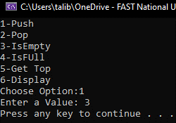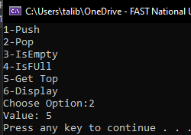
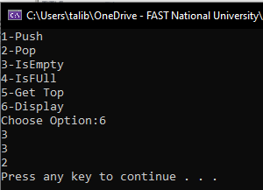

Task-2
#include<iostream>

struct Node {
int data;
Node* next;
};

class stack {
Node *top;
public:
stack() {
top = NULL;
}

bool Isempty() {
if (top == NULL)
return true;
else
return false;
}

int pop() {
if (Isempty()) {
std::cout << "Stack underflow\n";
return 0;
}
else {
int popvalue = top->data;
Node* curr = top;
top = top->next;
delete curr;
curr = NULL;

return popvalue;
}
}

void push(int val) {
Node* newNode = new Node;
newNode->data = val;
if (top == NULL) {
top = newNode;
top->next = NULL;

}
else
newNode->next = top;
top = newNode;
}

};

int main() {
int val,choice;
stack st;

do{
std::cout << "1-Push\n2-Pop\n3-IsEmpty\nChoose Option:";
std::cin >> choice;
switch (choice){
case 1:
std::cout << "Enter a Value: ";
std::cin >> val;
st.push(val);
break;
case 2:
std::cout << "Value: " << st.pop() << "\n";
break;
case 3:
std::cout << "Isempty: " << st.Isempty() << "\n";
break;

}
system("pause");
system("cls");

} while (choice!=0);
}
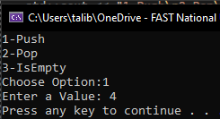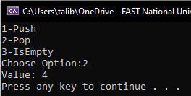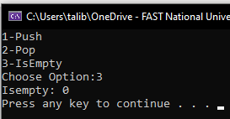

Task-3
#include <iostream>
#include<string>
using namespace std;
class stack
{
private:
int top;
int* arr;
int s;

public:
stack(int size = 10) {
s = size;
arr = new int[size];
top = -1;

for (int i = 0; i < s; i++) {
arr[i] = 0;
}
}

bool isfull() {
if (top == s - 1) {
return true;
}
else
return false;
}

bool isEmpty() {
if (top == -1) {
return true;
}
else {
return false;
}
}

void push(int val)
{
if (isfull()) {
cout << "Stack Overflow\n";
}
else {
top++;
arr[top] = val;
}
}

int pop()
{
if (isEmpty())
{
cout << "Stack Underflow\n";
}
else
{
int popValue = arr[top];
arr[top] = 0;
top--;
return popValue;
}
}

int topElement() {

return arr[top];
}

void display() {

int c = 0;
while (c < top) {
cout << arr[c] << endl;
c++;
}
}
};

bool ispalindrome(stack* stack1, stack* stack2) {
bool check = false;
while (stack1->isEmpty()!=1){
if (stack1->pop() == stack2->pop())
check = true;
else
{
check = false;
break;
}
}
return check;
}

int main() {
string str;
cout << "ENter String: ";
getline(cin, str);
stack stack1,stack2;
int size = str.size()-1;
int c = 0,end = size;
while (c<size+1){
stack1.push(str[c]);
stack2.push(str[end]);
c++;
end--;
}
cout<<"Ispalindrome: "<< ispalindrome(&stack1, &stack2);
}
