
Data structures
Lab-14


Name: Talib Husain
Roll# 21F-9070

Task-1
#include <iostream>
#include<queue>
#include<stack>
using namespace std;

//creating a Node for queue
struct Node {
int data;
Node* next;
};

//Making a Queue ADT
class Queue {
Node* front;
Node* rear;

public:
//Constructor to initialze with NULL
Queue() {
front = NULL;
rear = NULL;
}

//Functon to Insert a data in a queue
void enqueue(int x)
{

// Create new node
Node* temp = new Node;
temp->data = x;
temp->next = NULL;
// new node is front and rear both If queue is empty
if (rear == NULL) {
front = temp;
rear = temp;
}
else {

// Add the new node at end
rear->next = temp;
rear = temp;
}
}

// Function to remove
int dequeue()
{
// If queue is empty, return NULL
if (front == NULL) {
cout << "Queue is Empty";
return NULL;
}
else{

Node* temp = front;
front = front->next;
if (front == NULL)
rear = NULL;
int data = temp->data;
delete temp;
temp = NULL;
return data;
}
}

void display(){
Node *temp = front;
while (temp!=NULL)
{
cout<<temp->data<<" ";
temp = temp->next ;
}
cout<<endl;
}

bool isEmpty(){
if(front == NULL){
return true;
}
else{
return false;
}
}
};

//class graph
class Graph{
char**arr;
int count;
int no_vertex = 0;
public:
//constructor
Graph(int no_vertex = 9){
count = 0;
this->no_vertex = no_vertex;
//Dynamically allocating 2-d array

arr = new char*[no_vertex];

for(int i=0;i<no_vertex;i++){
*(arr+i) = new char[no_vertex];
}

//initialising array with 0
for(int i=0;i<no_vertex;i++){
for(int j =0;j<no_vertex;j++){
arr[i][j] = '-';
}
}
}

//Code for addinf vertex
void Addvertex(char x){
if(count<no_vertex){
arr[count][0] = x;
count++;
}
else
cout<<"Vertex can't be added\n";
}

//code for adding a connection between two vertex
void addedge(char vertex1,char vertex2){

for(int i=0;i<no_vertex;i++){
if(arr[i][0] == vertex1){
for(int j = 0;j<no_vertex;j++){
if(arr[i][j] == '-'){
arr[i][j] = vertex2;
break;
}
}
}
}
}

//Code for printig
void print(){
for(int i=0;i<no_vertex;i++){
for(int j =0;j<no_vertex;j++){
if(arr[i][j] !='-')
cout<<arr[i][j];
if(j==0)
cout<<": ";
else
if(arr[i][j] !='-')
cout<<" -> ";
}
cout<<"\n";
}
}

//BFS for fining a path
void BFS(char start, char goal){
//queue to mark
queue<char> q;
//visit array to mark visited ones
char visit[256];

bool x = true;
q.push(start);
visit[0] = start;
bool check = true;
//Loop while queue is not emty
while (!q.empty()){
for(int i=0;i<no_vertex;i++){
if(arr[i][0] == q.front()){
check = false;
for(int j=1;j<no_vertex;j++){
if (arr[i][j] != '-') {
for(int k=0;k<no_vertex;k++){
if (visit[k] == arr[i][j]) {
x = false;
}

}
if(x)
{
visit[i] = arr[i][j];
q.push(arr[i][j]);
}
x = true;

}
else
break;
}
}
if (i == no_vertex || !check) {
check = true;
break;
}
}

cout<<q.front()<<"->";
if (q.front() == goal)
break;
q.pop();
}
}

//dfs
void DFS(char start, char goal){
stack<char> q;
char visit[256];

bool x = true;
q.push(start);
visit[0] = start;
bool check = true;
while (!q.empty()){
cout << q.top() << "->";
if (q.top() == goal)
break;
for(int i=0;i<no_vertex;i++){
if(arr[i][0] == q.top()){
q.pop();
check = false;
for(int j=1;j<no_vertex;j++){
if (arr[i][j] != '-') {
for(int k=0;k<no_vertex;k++){
if (visit[k] == arr[i][j]) {
x = false;
}
}
if(x)
{
visit[i] = arr[i][j];
q.push(arr[i][j]);
}
x = true;
}
else
break;
}
}
if (i == no_vertex || !check) {
check = true;
break;
}
}
}
}

};

//Driver COde
int main(){
Graph g(13);
//Adding a vertex
g.Addvertex('a');
g.Addvertex('b');
g.Addvertex('c');
g.Addvertex('d');
g.Addvertex('e');
g.Addvertex('f');
g.Addvertex('g');
g.Addvertex('h');
g.Addvertex('i');
g.Addvertex('j');
g.Addvertex('k');
g.Addvertex('l');
g.Addvertex('m');

g.addedge('a','b');
g.addedge('a','c');
g.addedge('b','d');
g.addedge('b','e');
g.addedge('c','f');
g.addedge('f','j');
g.addedge('d','g');
g.addedge('d','h');
g.addedge('e','i');
g.addedge('i','m');
g.addedge('g','j');
g.addedge('g','l');

cout << "Adj List Graph\n";
g.print();
cout<<"\nBFS Path\n";
cout << "BFS Path from a--->g\n";
g.BFS('a','g');
cout << "\n\nDFS Path from a--->g\n";
g.DFS('a', 'g');

}

output
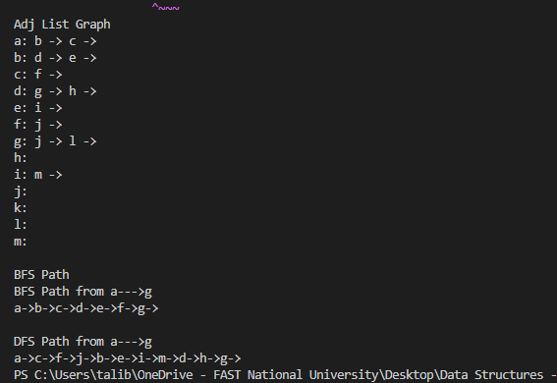
Task-2

