
DATA Lab
Lab-4


Name: Talib Husain
Roll# 21F-9070

Task-4
#include<iostream>
using namespace std;

struct node {
int data;
node* next;
};

//creating list class
class list {
node* head;
static int count;
public:

list(node *h = NULL) {
head = h;
}

//code to insert at any position in list
bool insert(int value,int pois) {
if (pois <= 0) return false;

int currIndex = 2;
node* current = head;
while (current && pois > currIndex) {
current = current->next;
currIndex++;
}
if (pois > 1 && current == NULL) return false;

node* newNode = new node;
newNode->data = value;
if (pois == 1) {
newNode->next = head;
head = newNode;
}
else {
newNode->next = current->next;
current->next = newNode;
}
return true;
}

//code to convert singly to circular
void con_to_circular() {
node* temp = head;
//moving to the end of list and pointing it's next to head
while (temp->next != NULL) {
temp = temp->next;
}
temp->next = head;
}

//code to display the both lists circular & singly
void display() {
node* current = head;

while (current->next != NULL && current->next!=head) {
cout << current->data << "->";
current = current->next;
}
cout << current->data << "\n";

}

};

int main() {
list l;
cout << l.insert(1,1) << endl;
cout << l.insert(2, 2) << endl;
cout << l.insert(3, 3) << endl;
cout << l.insert(4, 4) << endl;
cout << l.insert(5, 5) << endl;
l.display();
l.con_to_circular();
cout << "After converting in circular\n";
l.display();

}
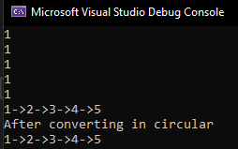
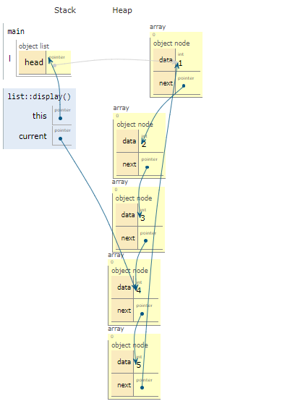

Task-5
#include <iostream>
using namespace std;

// Class for Node
class Node
{
public:
int data;
Node* next;
};

//class list for implementation of Linked list
class List {
Node* head;
Node* next;
public:
List(Node *h = NULL) {
head = h;
next = NULL;
}

// For insert a node at the beginning
void InsertAtBegin(int data)
{
// New node
Node* newNode = new Node;
newNode->data = data;
newNode->next = head;

// Set the null if the link is not NULL
if (head != NULL)
{

Node* temp = head;
while (temp->next != head)
temp = temp->next;
temp->next = newNode;
}
else
// For first node
newNode->next = newNode;

head = newNode;
}
//code for deleting at end
void DeleteAtEnd() {
Node* current = head;
Node* temp = NULL;
//Moving to end of list
while (current->next != head && current) {
if (current->next->next)
temp = current;
current = current->next;
}

if(temp)
temp->next = head;
delete current;
current = NULL;
}

// For printing
void printList()
{
Node* temp = head;
while (temp->next!=head)
{
cout<<temp->data<<' ';
temp = temp->next;
}
cout << temp->data << ' ';

cout << endl;
}

};

// Main
int main()
{
List l;

l.InsertAtBegin(1);
l.InsertAtBegin(2);
l.InsertAtBegin(3);
l.InsertAtBegin(4);

cout << "Before Deletion: ";
l.printList();

l.DeleteAtEnd();
cout << "After Deletion: ";

l.printList();

}
