**Project Testing Screenshots**

**Git clone whole project on git hub repositories**

**python -m unittest test_Recipe_Management_System.py (testing first unittest testcase file)**



**python -m unittest test_Recipe_Management_System_more.py (testing second unittest testcase file – only exception)**



**Git log**

**pytest -s -v –cov**

**python -m unittest discover .**

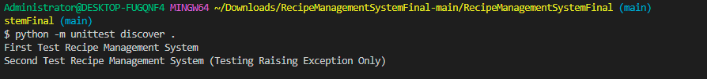

**Automating User Inputs for better quality testing using: from unittest.mock import patch**

**python -m unittest test_Recipe_Management_System.py (testing first unittest testcase file)**

**python -m unittest test_Recipe_Management_System_more.py (testing first unittest testcase file)**

**python -m unittest discover .**

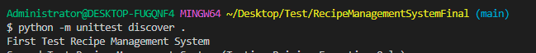

**pytest -s -v --cov**

