Changes in Coral Reef Lagoon Chemistry Dependent on Tide
Tali de Mestre
02/12/2022
Lab Assistants: Tod Fgor, Laura Liersch, Ingrid Smith

Graphical Abstract
<TBD>

Aim
In this study we wanted to investigate variation in the chemistry of the main lagoon at One Tree Island as the low tide isolated lagoon experienced inflow from the ocean towards high tide. An indicative understanding can be derived by comparing a spatial distribution of chemical properties in the lagoon at low tide and half way towards high tide. As no distributions were extant, in this report we create these distributions for comparison and conduct a visual comparison.

Introduction

Motivation
Coral reef ecosystems are being threatened by various by increased temperature and changes in ocean chemistry attributable to climate change (Lesser, 2007)⁠. Coral bleaching occurs when extreme temperatures lead to the breakdown of the symbiotic relationship between coral polyps and zooxanthellae (NOAA, 2021)⁠. The exact temperature at which coral bleaching occurs can be referred to as the “thermal tolerance” of the coral symbiosis. This thermal tolerance is influenced by the chemistry of water present in the system. Deoxygenation of ocean water can decrease thermal threshold of bleaching events by up to 1°C (Alderdice et al., 2022)⁠. Increased acidity in ocean water may inhibit photorespiration by zooxanthellae and thus disrupt the symbiotic relationship, reducing the thermal threshold of bleaching (Anthony et al., 2008)⁠. Ocean acidification is of additional concern as it inhibits the growth of coral as the energy required to calcify is increased, sufficiently low pH may cause coral skeletons to dissolve (NOAA, 2020)⁠. Understanding the tidal variation of these factors may inform reef sustainment efforts.

<maybe add a para on the isolated environment of one tree island being a good case study or smth, or find some literature more similar to my experiment>

Experimental Outline
We investigated the tidal variations of ocean chemistry by taking samples of an area adjacent to lagoon inflow (“the gutter”) at One Tree Island near low tide and half way to high tide. Two datasets were created using measurements of pH and dissolved oxygen. Digital analysis was conducted to compare these datasets.

Expected Outcomes
It is expected that the recorded levels of dissolved oxygen should decrease towards high tide. As measurements for low tide were taken at 10 am, the lagoon should be saturated with oxygen as the large quantities of zooxanthellae will be performing the photosynthetic reaction to produce oxygen. Ocean water should be lower in dissolved oxygen on average <citation>, thus as the ocean water flows in towards high tide the levels of dissolved oxygen should decrease.

We similarly expect that pH measurements should increase as the tide brings in ocean water. At low tide, the high level of photosynthesis should be removing CO₂ from the water. This reduction in CO₂ should drive a dissociation of carbonic acid back into H₂O and CO₂. Acidity levels will decrease and pH will go up accordingly.

Method

Field Work
It was desirable to collect samples from the main lagoon at One Tree Island as it experiences an isolation from the ocean at low tide, and should undergo changes due to its differing ecosystem from the surrounding ocean. As it was not feasible to collect a distribution of samples across the entirety of the lagoon with the resourcing available, a sample site was selected adjacent to the inlet of exchange between the lagoon and the ocean Figure 1.
The researcher then procured a kayak, a GPS device, a <> probe, and an assistant to raise the alarm in the event of danger. The kayak was used to paddle to the location of each individual measurement. Each individual measurement was captured by marking a GPS coordinate, and taking a record of probe readings. The first set of measurements was taken at approximately 10 am, which was 45 minutes after low tide. The second set of measurements was taken at approximately 2pm, which was about halfway to high tide. An imperfect coverage of the area was achieved by monitoring the current GPS track; it is visible in Figure 2 that the sampled points adequately covered the selected study site. There were 21 successful measurements at 10am and 20 successful measurements at 2pm.
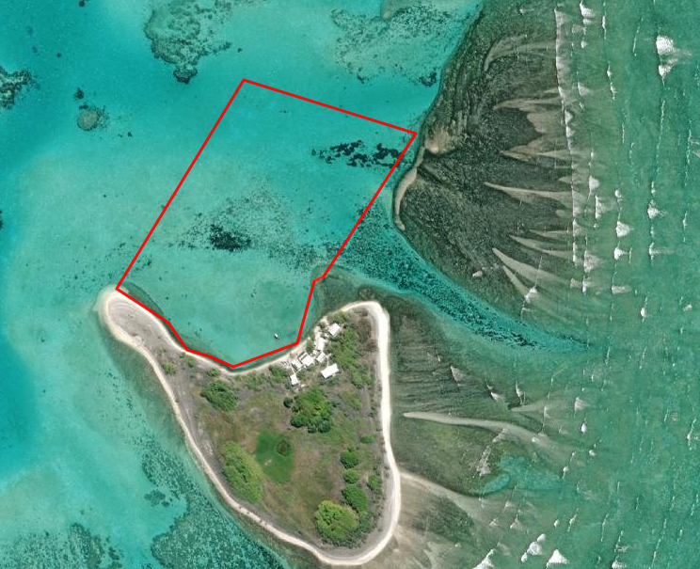Figure 1: Sample site (outlined in red) in relation to One Tree Island. The gutter (inflow and outflow to the ocean) is clearly visible to the right of the study area.
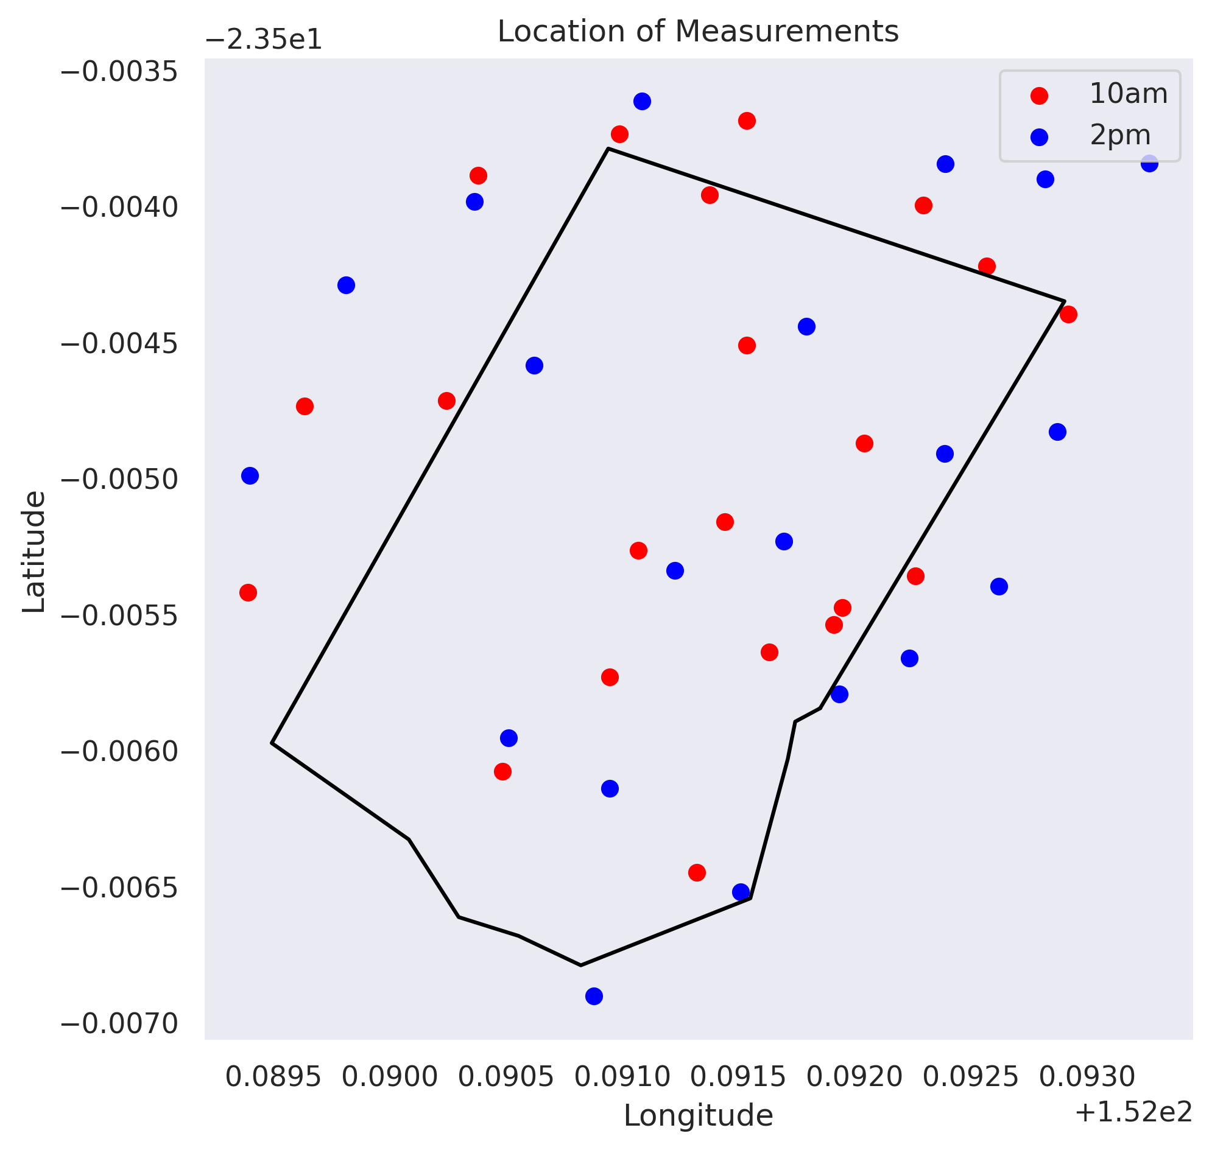Figure 2: Comparison between study site (outlined in black) and location of recorded measurements.

Data Processing
Each probe measurement was manually transcribed into digital format and then joined with location data recorded using the GPS device. As the probe was calibrated using a freshwater buffer, a conversion was necessary to derive the correct pH of Ocean Water. This was done… This provided us with a valid dataset of all measurements taken.

This data was then split into two distinct datasets, one for measurements taken at 10am and one for measurements taken at 2pm. For each measurement type in each dataset, a linear interpolation was performed to visualise the properties of the water over the study area. These interpolations could then be compared to infer the impact of tidal change on the lagoon. An average was also calculated to provide a numerical comparison.

Results

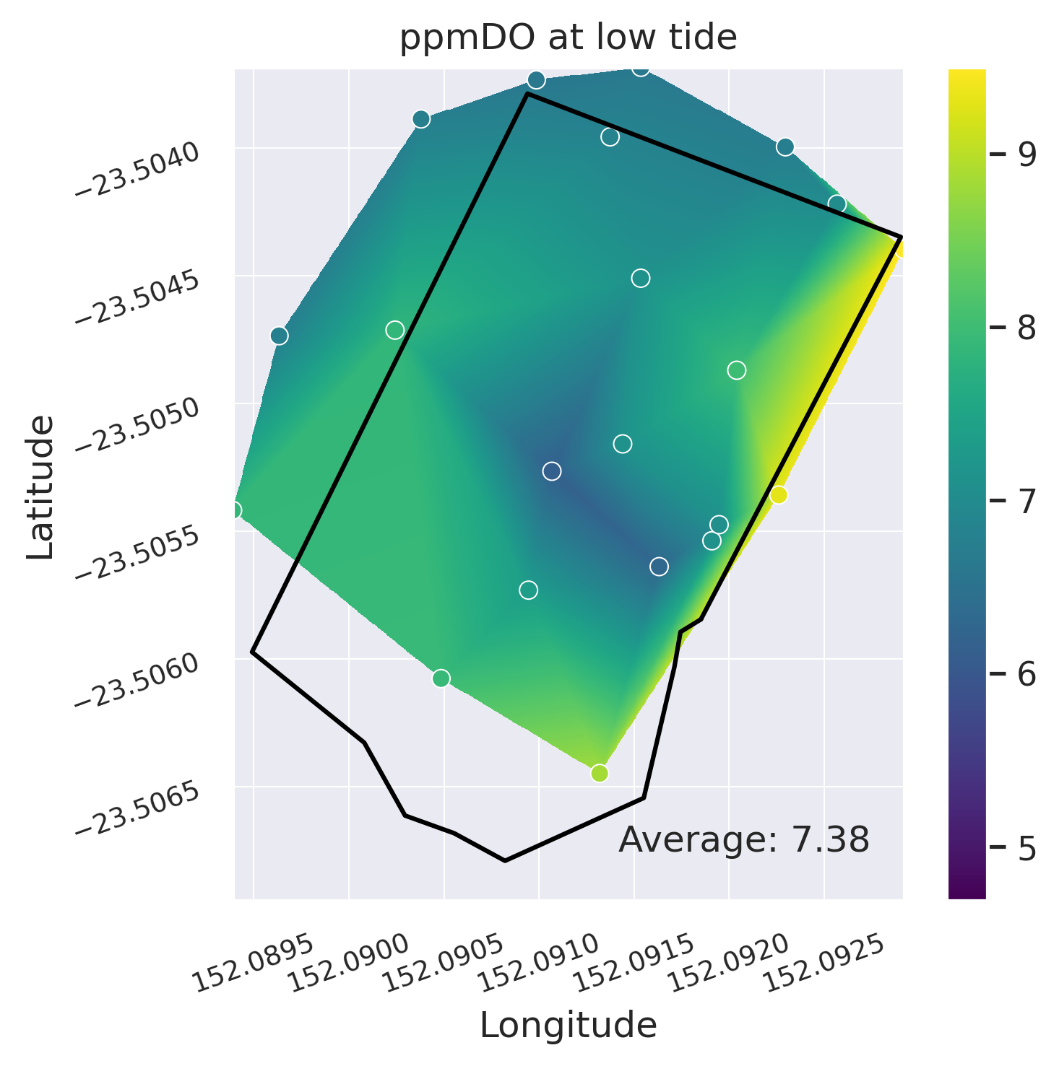
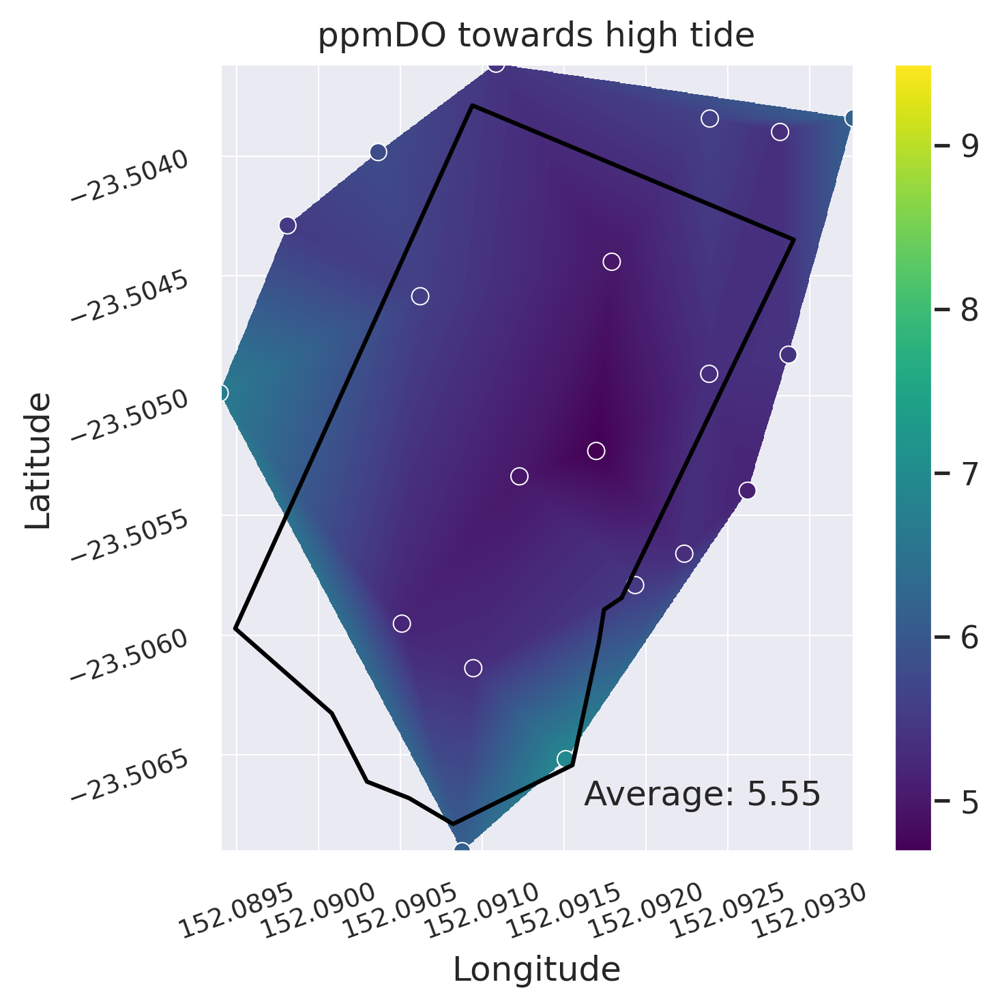
From Figure 3 it is apparent that dissolved oxygen lowered as the tide allowed exchange with the ocean. This is in line with expectations.
Figure 3: Comparison of levels of dissolved oxygen (DO) at low tide and towards high tide. The coloured circles are representative of the values at measurement sites, while the background represents the linear interpolation between data points to visualize distribution across the study area.
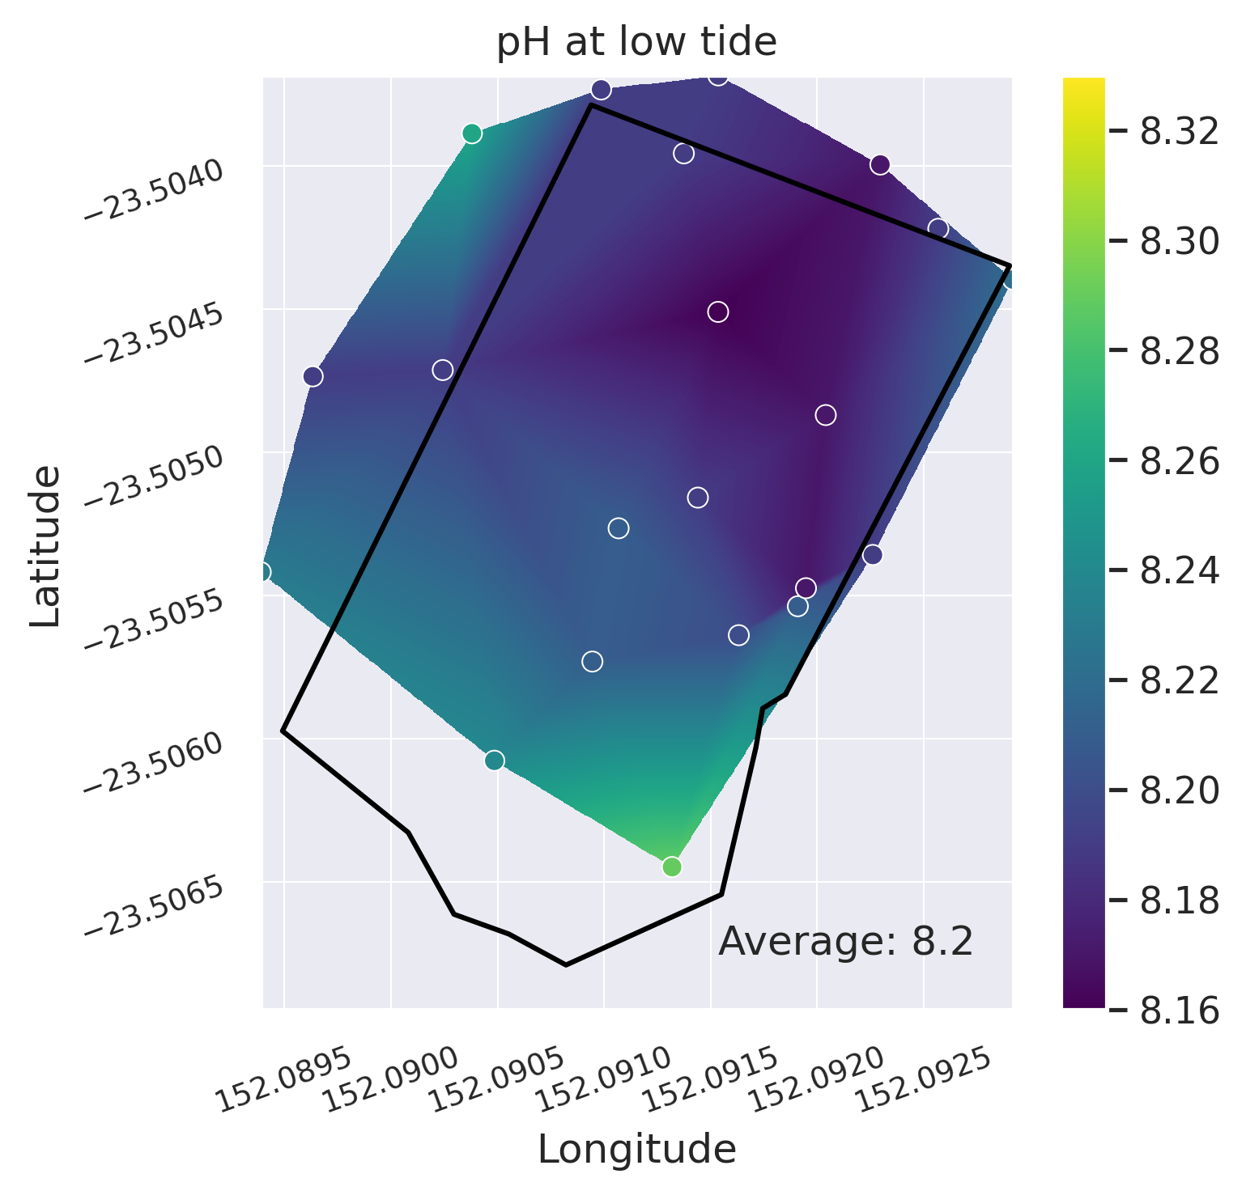
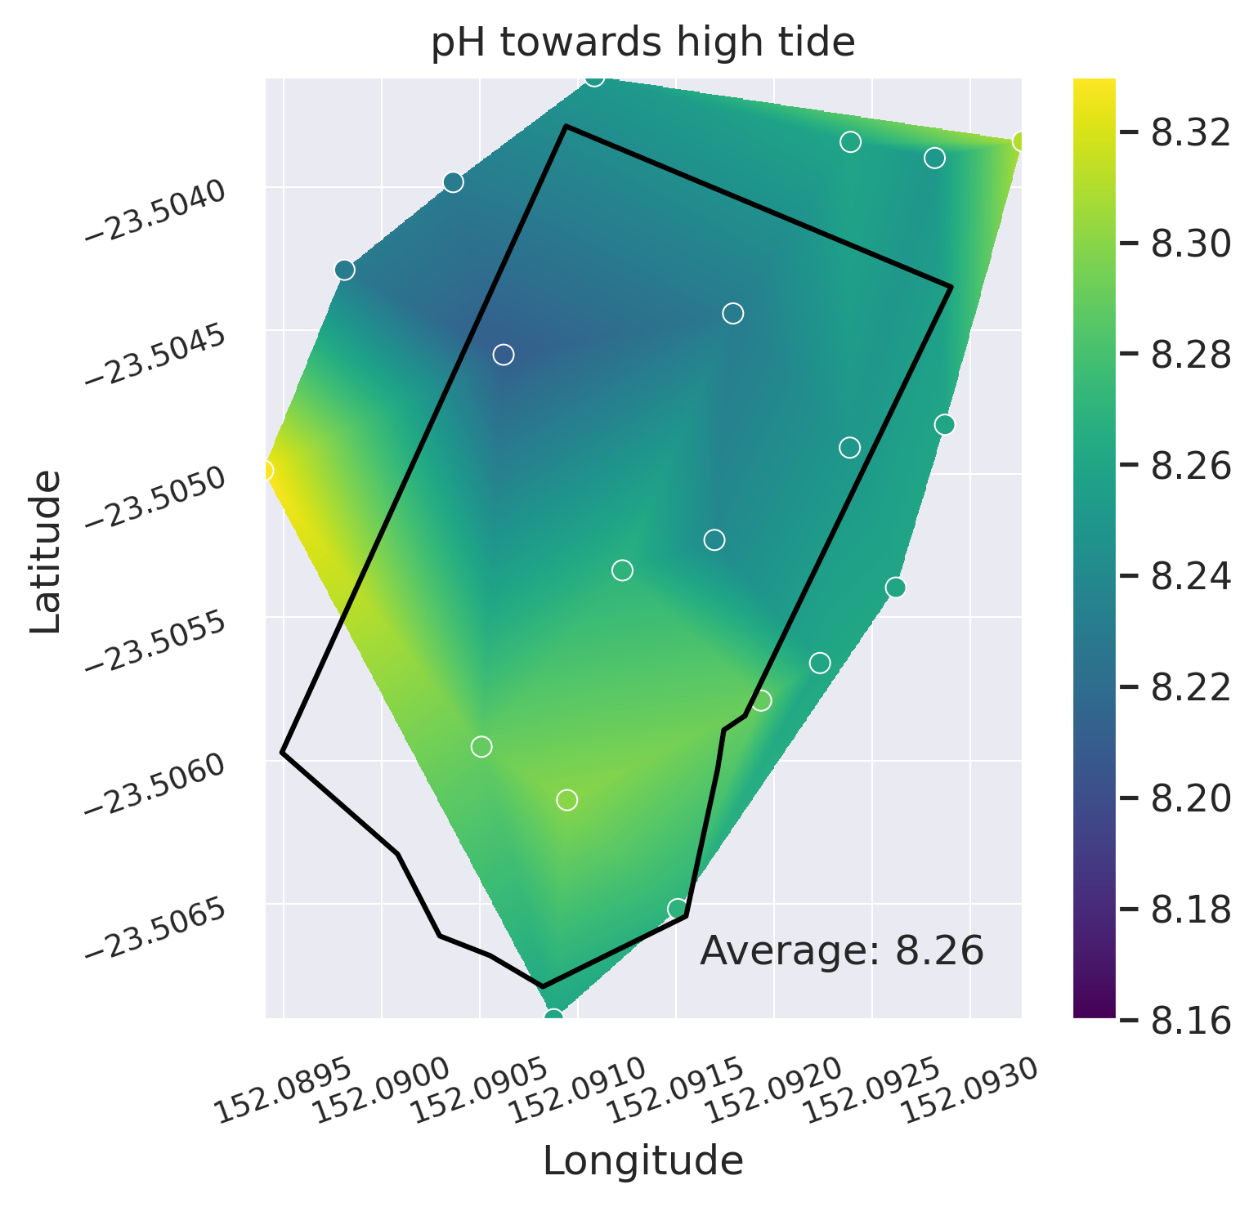
From Figure 4 it is apparent that the lagoon has become less acidic as water from the ocean has flowed in. This is also in line with our original expectations.
Figure 4: Comparison of levels of pH at low tide and towards high tide.

Discussion

Impact of Tide
<bleh>

Limitations
- Rainfall
- dodgy probe
- limited repeats (only one)
- salty readings

Conclusion

References

Alderdice, R., Perna, G., Cárdenas, A., Hume, B. C. C., Wolf, M., Kühl, M., Pernice, M., Suggett, D. J., & Voolstra, C. R. (2022). Deoxygenation lowers the thermal threshold of coral bleaching. Scientific Reports, 12(1), 18273. https://doi.org/10.1038/s41598-022-22604-3
Anthony, K. R. N., Kline, D. I., Diaz-Pulido, G., Dove, S., & Hoegh-Guldberg, O. (2008). Ocean acidification causes bleaching and productivity loss in coral reef builders. Proceedings of the National Academy of Sciences, 105(45), 17442–17446. https://doi.org/10.1073/pnas.0804478105
Lesser, M. P. (2007). Coral reef bleaching and global climate change: Can corals survive the next century? Proceedings of the National Academy of Sciences, 104(13), 5259–5260. https://doi.org/10.1073/pnas.0700910104
NOAA. (2020). Ocean Acidification. National Ocean Service Website.
NOAA. (2021). What is coral bleaching? National Ocean Service Website.

