Pickup ETA Copy
A label helps. The meaning is still unclear.
Passenger research · Five-second test on Lyssna · 25 October 2026
3,299  respondents | 9  ETA copies tested | 14.4%  read the ETA correctly | 11.7%  best copy, both answers right

01 Research Questions and Answers

RQ 1

Which ETA copy works best?
Six labeled copies tie at the top. V7 “Driver arrival: 3–5 min” is first: 11.7% got both questions right. The next five score 9.7–11.6%, and the gaps are not significant. Two copies with no label are clearly worse: V6 4.3% and V3 3.3%.
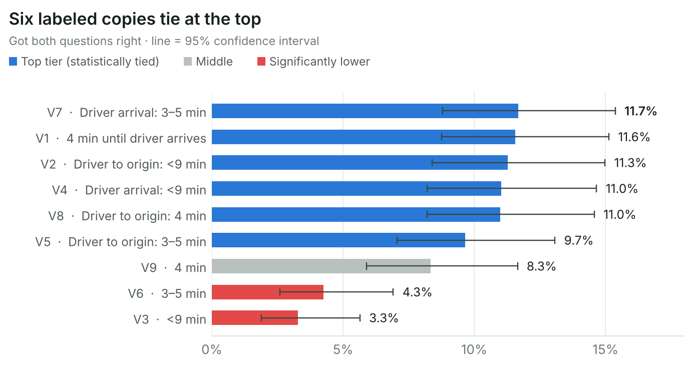

RQ 2

Does a label in front of the time help?
Yes, on every measure. Both answers right: 5.3% → 10.6–11.4% when a label is added. Correct meaning: 10.3% → 15.5–16.8%. Correct time: 32.4% → 39.7–40.1%. All three gains are significant (p < .001).

RQ 3

Do the label words or the time format matter?
No. “Driver to origin” and “Driver arrival” score the same (10.6% vs 11.4% both right, p = .62). “<9 min”, “3–5 min” and “4 min” also score the same (8.5%, 8.6%, 9.7%, p = .64).
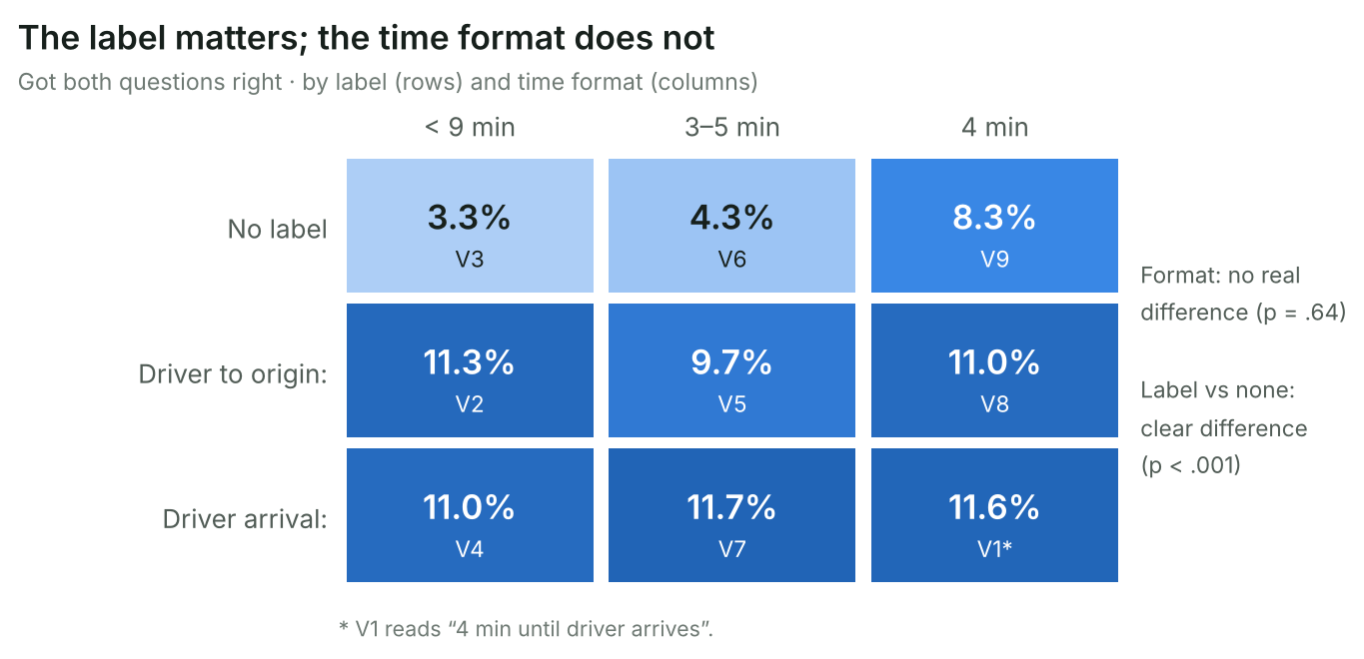

RQ 4

What do passengers think the ETA means?
Most think it is the total wait from tapping Request. Only 14.4% chose the correct meaning (the wait at the origin after a car is found). 20.6% chose “the wait after tapping Request”, the top reading in every copy. 20.8% did not notice the line.
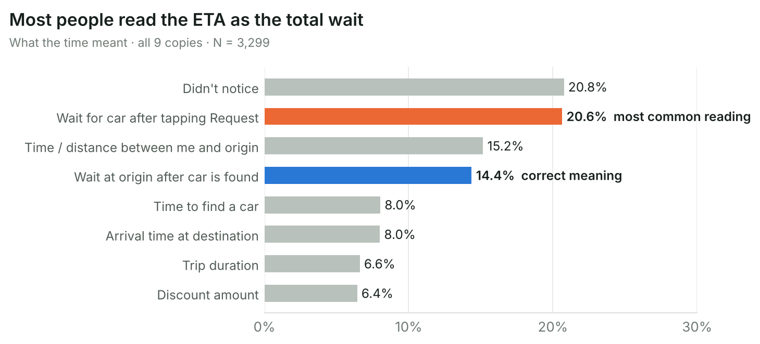

RQ 5

Do passengers remember the time?
About 4 in 10 do. Correct time by copy: 29.7–42.1%. About 3 in 10 said “I don’t remember”. People who understood the meaning remembered the time twice as often: 63.7% vs 32.7%.

02 Project Background
The ride-request screen shows a pickup ETA on the selected service card, for example “4 min until driver arrives”. The time means how long the passenger waits at the origin after a driver accepts the trip. It does not include the time to find a driver. We tested whether passengers read it this way, and which copy works best. We showed 9 versions of the screen in a five-second test on Lyssna: 3 labels (none, “Driver to origin”, “Driver arrival”) × 3 time formats (“<9 min”, “3–5 min”, “4 min”), with V1 using the wording “4 min until driver arrives”. 3,299 mobile users answered two questions. The results should guide which ETA copy to ship and what to test next.
COPY | SHOWN TEXT (PERSIAN) | ENGLISH | LABEL · FORMAT
V1 | ۴ دقیقه تا رسیدن راننده | 4 min until driver arrives | Suffix wording · 4 min
V2 | راننده تا مبدأ: کمتر از ۹ دقیقه | Driver to origin: <9 min | Driver to origin · <9 min
V3 | کمتر از ۹ دقیقه | <9 min | No label · <9 min
V4 | رسیدن راننده: کمتر از ۹ دقیقه | Driver arrival: <9 min | Driver arrival · <9 min
V5 | راننده تا مبدأ: ۳ تا ۵ دقیقه | Driver to origin: 3–5 min | Driver to origin · 3–5 min
V6 | ۳ تا ۵ دقیقه | 3–5 min | No label · 3–5 min
V7 | رسیدن راننده: ۳ تا ۵ دقیقه | Driver arrival: 3–5 min | Driver arrival · 3–5 min
V8 | راننده تا مبدأ: ۴ دقیقه | Driver to origin: 4 min | Driver to origin · 4 min
V9 | ۴ دقیقه | 4 min | No label · 4 min

03 Metrics
DECREASING  Passenger cancellations before pickup per 1,000 requests  Main KR metric. Shows whether the shown ETA matches the wait passengers expect. | DECREASING  Wait-time and “driver is late” support contacts per 1,000 completed rides  Shows ETA confusion that turns into support cost. | INCREASING  Ride requests per price-check screen view  Guardrail. A longer or clearer ETA line must not lower the request rate.
Research signal: 14.4% read the ETA correctly · best copy 11.7% both answers right.

04 Insights & Actions
Cost guardrail: every action below is a copy, layout or test change on the existing price-check screen. No new spend and no new features are needed.

Action principles
- Always show a label in front of the ETA.
- Fix the meaning first: tell passengers when the countdown starts.
- Choose the time format by how accurate the estimate is, not by test score.
- Test every new copy against V7 in the same five-second test before launch.

4.1 Ship a labeled ETA
FINDING | REASON | CONCRETE ACTION | OWNER
Remove copies without a label | No-label copies are worst: 5.3% both right vs 10.6–11.4% with a label. V3 and V6 are significantly lower than every top copy. | Drop V3, V6 and V9 from the candidates. Keep a label before the time on every service tab (car, motorbike, delivery). | DESIGN
Use V7 as the interim copy | V7 “Driver arrival: 3–5 min” ranks first (11.7% both right, 42.1% correct time) but is tied with five other copies. | If a launch decision is needed now, ship V7. Use V7 as the control copy in the next test. | PRODUCT
Pick the time format by accuracy | Formats score the same (p = .64). 9–14% of people who saw “<9 min” remembered “5–10 min”. | Show a range (“3–5 min”) when the estimate varies and one number (“4 min”) when it is reliable. Avoid “less than” formats. | PRODUCT

4.2 Make the meaning clear
FINDING | REASON | CONCRETE ACTION | OWNER
Say when the countdown starts | Only 14.4% chose the correct meaning. “Wait after tapping Request” (20.6%) was the top reading in every copy. Today’s labels name the end point, not the start. | Write and test a label that names the start point. Main option:  بعد از قبول سفر، ۳ تا ۵ دقیقه تا رسیدن راننده  (After the trip is accepted, 3–5 min until the driver arrives.) Short option:  رسیدن راننده پس از قبول: ۳ تا ۵ دقیقه | WRITING
Show the two waits separately | Passengers merge “finding a driver” and “driver on the way” into one wait. | If a matching-time estimate exists, test a two-part line:  یافتن راننده: ~۱ دقیقه · رسیدن راننده: ۳ تا ۵ دقیقه  Check that the longer line does not lower noticing. | DESIGN
Decide which wait the screen shows | Passengers expect the total wait. That is the question they bring to this screen. | Test both directions: pickup-only ETA with a start anchor vs total wait “from now”. Choose with cancellation and complaint data. | PRODUCT

4.3 Make the ETA easier to notice
FINDING | REASON | CONCRETE ACTION | OWNER
Make the time stand out on the card | 20.8% did not notice the ETA and about 3 in 10 could not recall the time. People who understood the meaning remembered the time twice as often (63.7% vs 32.7%). | On the selected card, set the time in bold and keep the label and the time on one line. Do not add icons or words that compete with it. | DESIGN

4.4 Validate and monitor
FINDING | REASON | CONCRETE ACTION | OWNER
Rerun the five-second test | The start-anchored labels are not tested yet. | Test 3–4 new copies plus V7 with the same two questions. About 370 people per copy can detect a rise from about 16% to 25% correct meaning. | UX RESEARCH
Track behaviour after launch | The test measures understanding and recall, not behaviour. | Compare cancellations before pickup, wait-time complaints and requests per view for 2 weeks before and after the change. | PRODUCT
Priority order: label every ETA → name the start point → choose the format by accuracy → make the time stand out → validate and monitor.

05 Detailed Findings

5.1 Six labeled copies tie at the top; two copies without a label fall behind
We ranked copies by the share who got both questions right. Differences inside the top six are small and not significant.
11.7%  best copy · V7 | 3.3%  worst copy · V3 | 3.5x  gap between best and worst

What the tiers mean
- Top tier (V7, V1, V2, V4, V8, V5): no two copies differ significantly.
- Middle (V9 “4 min”): not clearly different from either group on both answers; lower than V7 and V8 on remembering the time.
- Bottom (V6 “3–5 min”, V3 “<9 min”): significantly lower than every top-tier copy.
Both right = correct meaning and correct time · pairwise tests corrected for 36 comparisons (Holm)

5.2 Most passengers think the ETA is the total wait
The correct meaning was only the 4th most common answer. The “total wait” reading beat it in every copy.
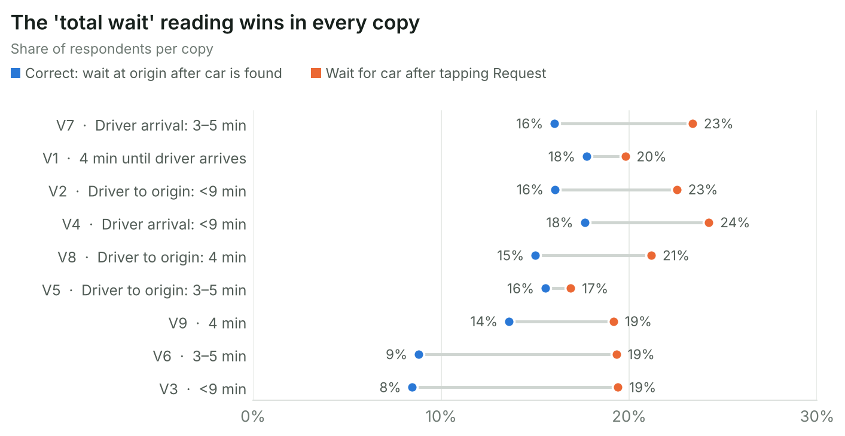

Interpretation
The tested labels say where the driver is going (“to origin”, “arrival”). They do not say when the time starts. Passengers fill this gap with the moment they tap Request.

5.3 A label lifts both understanding and recall
Copies with a label beat copies without one on every measure (p < .001). The two labels score almost the same.
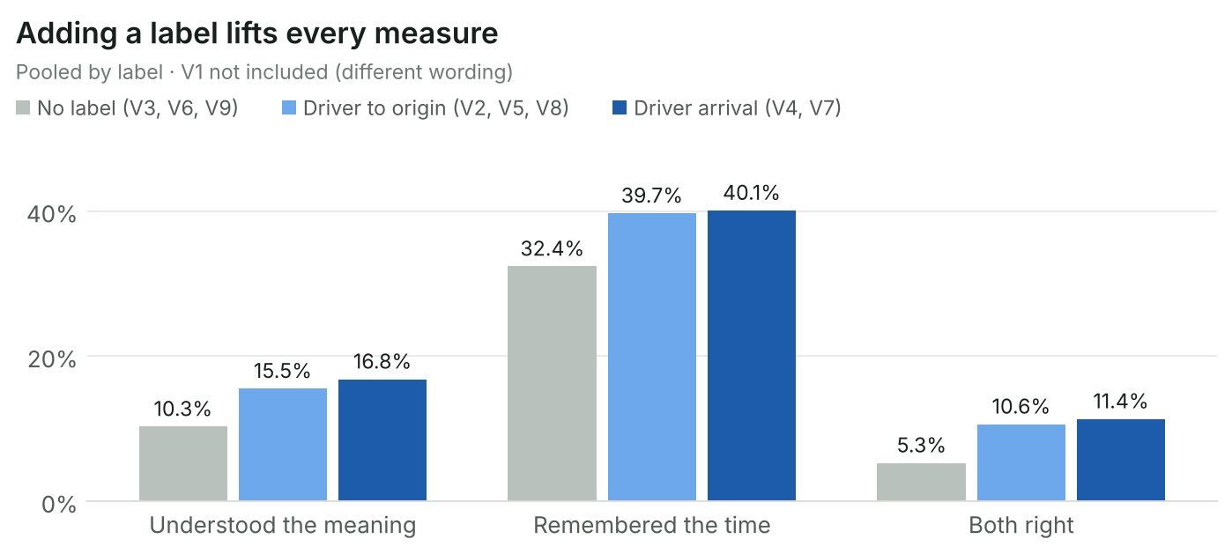
- Correct meaning: 10.3% → 15.5–16.8%
- Correct time: 32.4% → 39.7–40.1%
- Both right: 5.3% → 10.6–11.4%

5.4 The label words and the time format make no real difference
Once a label is present, the exact words and the number format barely change the result.
- “Driver to origin” vs “Driver arrival”: 10.6% vs 11.4% both right (p = .62).
- “<9 min” vs “3–5 min” vs “4 min”: 8.5%, 8.6%, 9.7% both right (p = .64).
- “<9 min” is often stretched: 9–14% of people who saw it remembered “5–10 min”.

5.5 About 3 in 10 cannot recall the time
The correct time was the top answer in every copy except V9 (“4 min” with no label), where “don’t remember” won (32.8% vs 29.7%).
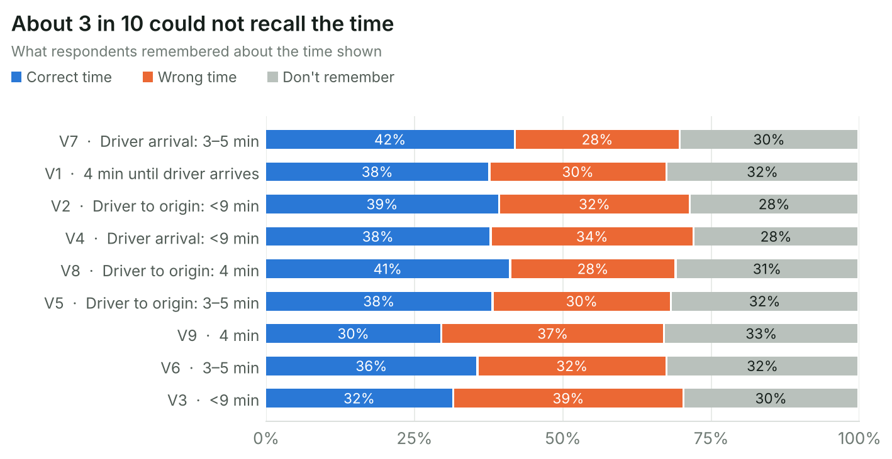

Understanding and recall go together
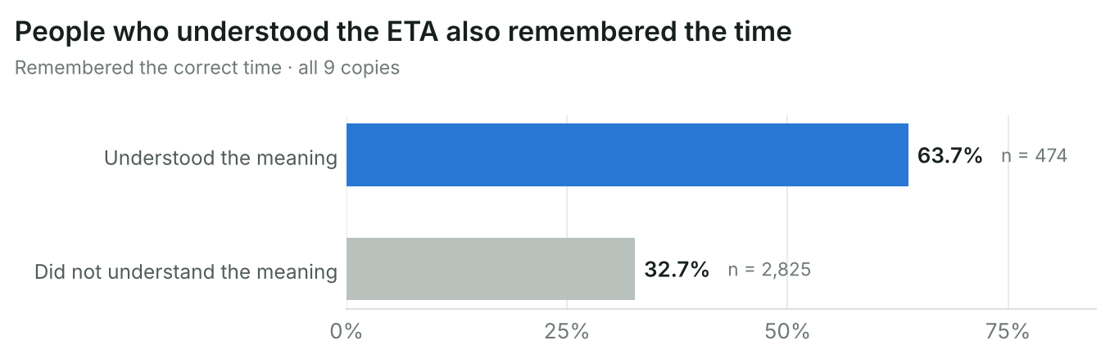
37.2%  remembered the correct time | 30.7%  said “I don’t remember” | 2x  recall when the meaning was understood

06 Methodology
Five-second test on Lyssna: each person saw one screen for 5 seconds, then answered what the time meant and what time was shown. Differences were checked with chi-square tests and pairwise tests.

07 Sampling
3,299  respondents · 25 Oct 2026 | 95%  confidence level | ± 5.1%  margin of error per copy (± 1.7% overall)
- 9 copies with 352–389 respondents each. Each person saw one copy only.
- Mobile devices only. The test and the screens were in Persian.
Source: Lyssna project “Price Check Pickup ETA”, tests Var 1–9.

