for="index in range(len(objects.company_address))"if="index < 40"function="objects.company_address[index]"/if/for

function="o_format_date(objects.period_from, lang_code=lang)[6]" function="o_format_date(objects.period_from, lang_code=lang)[7]" function="o_format_date(objects.period_from, lang_code=lang)[8]" function="o_format_date(objects.period_from, lang_code=lang)[9]"
if="objects.any_taxes_wth == True" X/if
if="objects.amended_return == False" X/if
if="objects.amended_return == True"X/if
if="objects.any_taxes_wth == False" X/if
if="objects.quarter == '1'" X/if
if="objects.quarter == '2'" X/if
if="objects.quarter == '3'" X/if
if="objects.quarter == '4'" X/if
if="objects.company_tin != False"
if="objects.company_tin and len(objects.company_tin) >= 9" function="objects.company_tin[0]" function="objects.company_tin[1]" function="objects.company_tin[2]" function="objects.company_tin[4]" function="objects.company_tin[5]" function="objects.company_tin[6]" function="objects.company_tin[8]" function="objects.company_tin[9]" function="objects.company_tin[10]"/if if="len(objects.company_tin) >= 15" function="objects.company_tin[12]" function="objects.company_tin[13]" function="objects.company_tin[14]"/ifif="len(objects.company_tin) >= 17" function="objects.company_tin[15]" function="objects.company_tin[16]"/if
if="objects.rdo_code" function="objects.rdo_code[0]" function="objects.rdo_code[1]" function="objects.rdo_code[2]"/if
if="objects.company_zip_code and len(objects.company_zip_code) == 4" function="objects.company_zip_code[0]" function="objects.company_zip_code[1]" function="objects.company_zip_code[2]" function="objects.company_zip_code[3]"/if
function="format(float(objects.tax_remit_prev), '.2f')"
function="format(float(objects.over_remit_prev), '.2f')"
function="format(float(objects.other_payments), '.2f')"
function="format(float(objects.first_month_quarter), '.2f')"
function="format(float(objects.second_month_quarter), '.2f')"
function="format(float(objects.total_tax_cr), '.2f')"
function="format(float(objects.surcharge), '.2f')"
function="format(float(objects.interest), '.2f')"
if="objects.company_email"for="index in range(len(objects.company_email))"if="index < 40"function="objects.company_email[index]"/if/for/if

if="objects.no_of_sheet and len(objects.no_of_sheet) == 2" function="objects.no_of_sheet[0]" function="objects.no_of_sheet[1]" /if

for="index in range(len(objects.company_id.name))"if="index < 40"function="objects.company_id.name[index]"/if/for
for="index in range(len(objects.company_address))"if="index > 39 and index < 71"function="objects.company_address[index]"/if/for

if="objects.company_phone"for="index in range(len(objects.company_phone))"if="index < 13"function="objects.company_phone[index]"/if/for/if
if="objects.wth_agt_categ == 'prv'"X /if
if="objects.wth_agt_categ == 'govt'"X /if

for="line in objects.bir_1601e_line"
function="line.atc" | function="line.atc" | function="formatLang(line.tax_base, monetary=True)" | function="line.tax_rate" | function="formatLang(line.tax_withheld, monetary=True)"
/for

function="format(float(objects.compromise), '.2f')"
function="format(float(objects.tax_due),'.2f')"
function="format(float(objects.surcharge + objects.interest + objects.compromise), '.2f')"
function="format(float(objects.total_amt_due), '.2f')"
function="format_multiline_value(objects.auth_rep.name)" / function="format_multiline_value(objects.auth_rep.function)" / function="format_multiline_value(objects.auth_rep.vat)"
function="format(float(objects.total_tax_wth_printout), '.2f')"
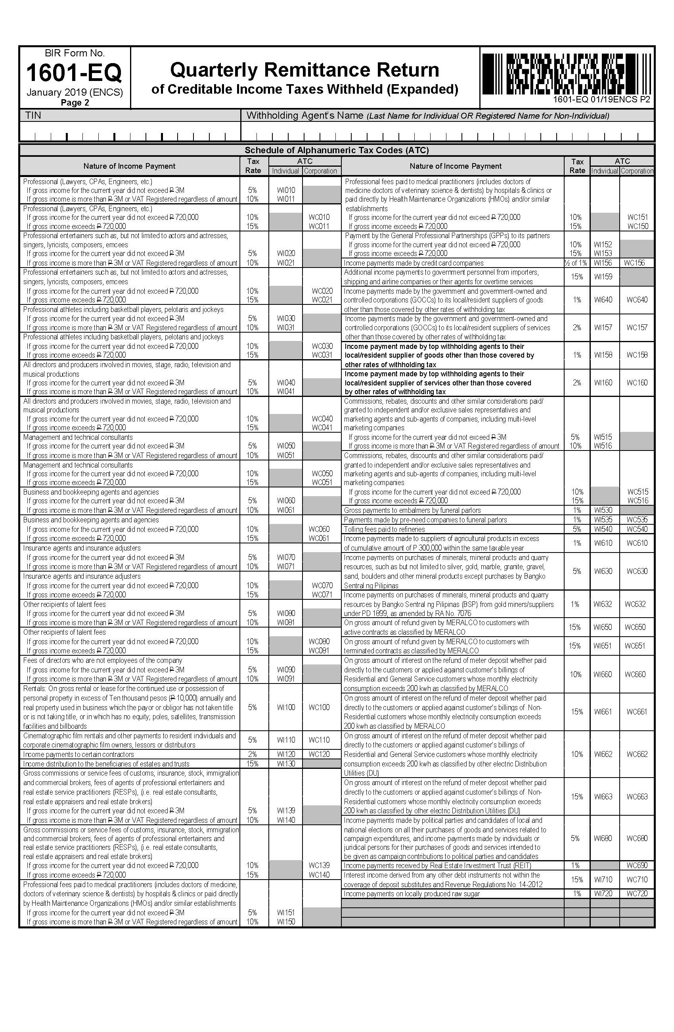

for="index in range(len(objects.company_id.name))"if="index < 26"function="objects.company_id.name[index]"/if/for
for="index in range(len(objects.company_tin))"if="objects.company_tin[index] != '-'"function="objects.company_tin[index]"/if/for

