Fiji:

Open data

Choose ROI

Mack a substack

Image-adjust- threshold

Analyze- set scale

#Image- properties- set the scale in um- better to do with the set scale

Plugin-bonej-slice geometry

Plot the Mean Thick 3D (¬µm) by slice from the csv file

In bone J do the thickness map (BoneJ-thickness)

#For 3d image use the second option-no needmaiA screenshot of a computer

AI-generated content may be incorrect.

Option for 3d image:

Plugin -3d viewer

Image-stack-3d project

After the thickness map to get scale bar:

Analyse-tools-calibration bar

To add ROI

### Step-by-step: Resample Z-spacing from 20 µm → 15 µm in Fiji

#### ✅ 1. Calculate the Z scale factor:

Old spacing/New spacing=2015=1.333\text{Old spacing} / \text{New spacing} = \frac{20}{15} = 1.333Old spacing/New spacing=1520​=1.333

So you’ll **scale Z by 1.333**, which means you’ll end up with **more slices**, spaced at **15 µm**.

### ✅ 2. Use **Image > Scale...**

1. Open your stack in Fiji.
2. Go to **Image > Scale...**
3. Set:
   * **X scale:** 1.0
   * **Y scale:** 1.0
   * **Z scale:** **1.333**
4. Make sure **"Interpolate"** is **checked** (this ensures smooth data between slices).
5. Confirm **“Process all slices”** is selected.
6. Click **OK**

### Step-by-step: Resample Z-spacing from 15 µm → 20 µm

#### ✅ 1. Install “TransformJ” plugin (if needed)

* Check if you have **TransformJ** installed (under Plugins > TransformJ > Scale).
* If not, install it via **Update Sites** or use the built-in Scale... from **Image > Scale**.

#### ✅ 2. Calculate the new Z scale factor:

New Z spacing/Old Z spacing=2015=1.333\text{New Z spacing} / \text{Old Z spacing} = \frac{20}{15} = 1.333New Z spacing/Old Z spacing=1520​=1.333

So you’ll scale the Z dimension by **0.75** (since you’re going **from 15 → 20**, you need **fewer** slices):

1520=0.75\frac{15}{20} = 0.752015​=0.75

#### ✅ 3. Use Image > Scale...

* Go to **Image > Scale...**
* Set:
  + **X scale:** 1.0
  + **Y scale:** 1.0
  + **Z scale:** **0.75**
* Check or uncheck **Interpolate** depending on whether you want smooth transitions.
* Make sure **"Process all slices"** is checked (if available).
* Click **OK**

After open the data I need to oriented to the same orientation.

Loot at the data with reslize option to make it all horizontal

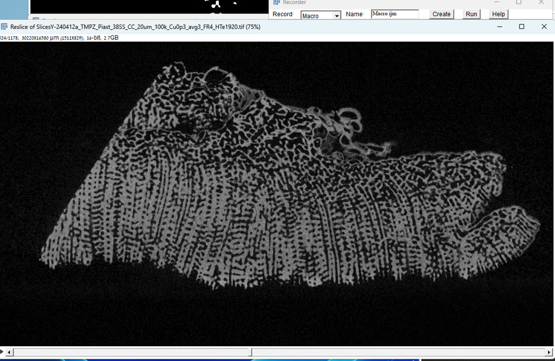

Save with ROI as Tif

Save substuck flip to vertical and threshold and run boneJ

