Supplemental Information

Table S1: Physical Conditions
Location | T (C°)  ± SD | S (psu)  ± SD | Chla (µg/L)  ± SD | pH  ± SD | DIC ± SD  (µmol/kg) | TA ± SD  (µmol/kg) | pCO₂  ± SD | HCO₃ ⁻  ion ± SD | CO₃ ²⁻  ± SD | Ωarag ± SD | Ωcal ± SD | NO₃⁻ ± SD  (μM) | PO₄³⁻± SD  (μM) | SiO₄⁴⁻ ± SD (μM)
Sámara | 28.6 ± 1.0 | 32.7±  0.3 | 3.6± 1.1 | 8.03 ± 0.041 | 1,811 | 2,133 | 338.6 | 1,576.7 | 225.2 | 3.7 | 5.6 | 1.10 ± 0.90 | 0.15 ± 0.12 | 2.14 ± 1.02
Papagayo | 25.5 ± 0.6 | 33.9 ± 0.1 | 12.5± 5.4 | 7.96 ± 0.05 | 1,967 ± 35 | 2,235 ± 10 | 435.9 ± 51.0 | 1,762.8 ± 48.9 | 192.0 ± 16.1 | 3.1 ± 0.3 | 4.7 ± 0.4 | 1.31 ± 1.2 | 0.20 ± 0.13 | 0.54 ± 0.62
Statistical Significance | *** | *** | *** | *** | N/A | N/A | N/A | N/A | N/A | N/A | N/A | NS | NS | ***

Table S1: Sampling in Sámara and Papagayo from 2/1/2025-2/8/2025. Temperature (T), Salinity (S), Chlorophyll-a (Chla) (n = 72 Sámara, n = 100 Papagayo); pH (n = 314 Sámara, n = 328 Papagayo); Dissolved Inorganic Carbon (DIC), Total Alkalinity (TA), Partial Pressure of Carbon Dioxide (pCO₂), Bicarbonate Ion (HCO₃⁻), Carbonate Ion (CO₃ ²⁻), Aragonite Saturation State (Ω_{arag}), Calcite Saturation State (Ωcal) ( n = 1 Sámara, n = 6 Papagayo); Nitrate, phosphate, Silicate (n = 15 Sámara, n = 18 Papagayo), Level of significance is indicated in third colllum, *** indicates a p-value < 0.001 and strong significance, NS indicates non-significance, N/A indicates that a statistical comparison is not applicable.

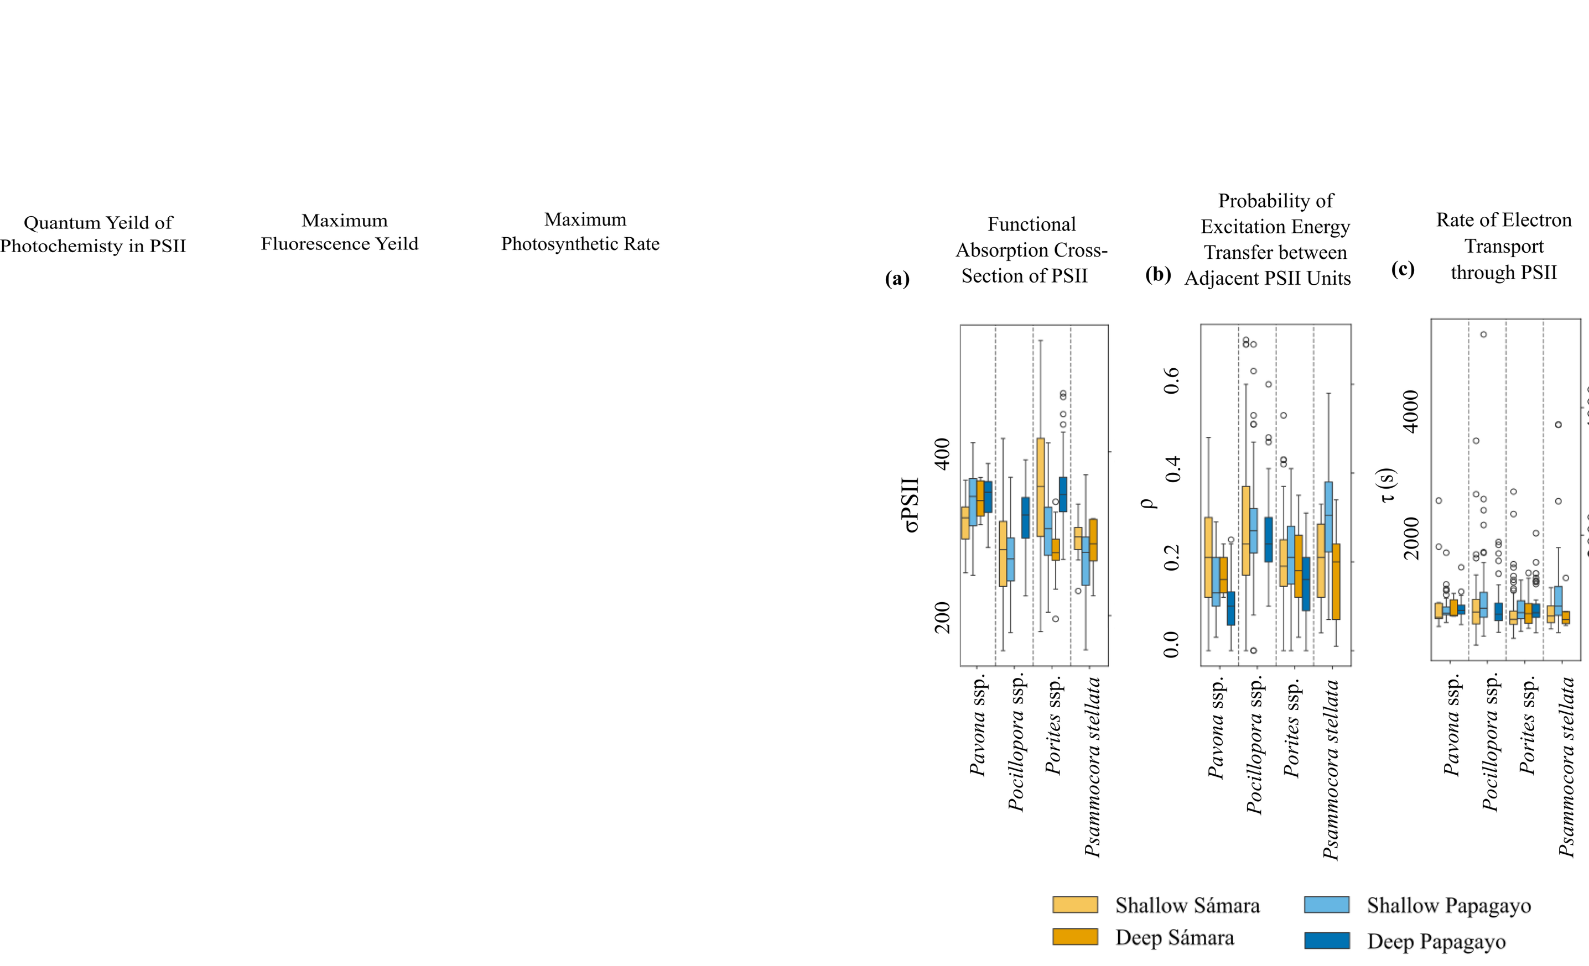
Fig. S1. Photophysiological data for coral species Pavona ssp., Pocillopora ssp., Porites ssp., and Psammocora stellata between shallow (< 8 m) and deep (> 8m) sites in Papagayo and Sámara. a) Sigma (σPSII) is the effective absorption cross-section. b) Rho (ρ) is the connectivity between photosystem II reaction centers. c) Tau (τ) is the rate of oxidation

 |  |  | Sámara (LU) | Papagayo (HU) | Pairwise
Pocillopora spp. | F_{v}′/F_{m}′ | Shallow | 0.372 ± 0.091  (N=89) | 0.444 ± 0.073  (N= 107) | ***
 |  | Deep |  | 0.506 ± 0.020  (N=89)
 | P_{max} | Shallow | 325.604 ± 204.446 (N=89) | 186.423 ± 65.660  (N= 107) | ***
 |  | Deep |  | 113.939 ± 27.874  (N=89)
 | F_{m} | Shallow | 80.637 ± 38.698  (N=89) | 75.502 ± 24.571  (N= 107) | NS
 |  | Deep |  | 90.227 ± 20.273  (N=89)
Porites spp. | F_{v}′/F_{m}′ | Shallow | 0.399 ± 0.069  (N=103) | 0.432 ± 0.050  (N=37) | *
 |  | Deep | 0.385 ± 0.025  (N=25) | 0.502 ± 0.014  (N=60) | ***
 | P_{max} | Shallow | 240.906 ± 121.408 (N=103) | 176.37 ± 59.444  (N=37) | ***
 |  | Deep | 157.196 ± 25.103  (N=25) | 84.448 ± 20.441  (N=60) | ***
 | F_{m} | Shallow | 142.61 ± 47.574  (N=103) | 91.354 ± 27.084  (N=37) | ***
 |  | Deep | 100.732 ± 11.025  (N=25) | 142.138 ± 27.682  (N=60) | ***
Psammocora stellata | F_{v}′/F_{m}′ | Shallow | 0.416 ± 0.014  (N=11) | 0.425 ± 0.01  (N=58) | NS
 |  | Deep | 0.424 ± 0.026  (N=5)
 | P_{max} | Shallow | 209.027 ± 16.038 (N=11) | 135.54 ± 8.591 (N=58) | ***
 |  | Deep | 197.06 ± 28.616  (N=5)
 | F_{m} | Shallow | 116.945 ± 7.224  (N=11) | 68.669 ± 3.608 (N=58) | ***
 |  | Deep | 99.94 ± 6.628  (N=5)
Pavona spp. | F_{v}′/F_{m}′ | Shallow | 0.328 ± 0.100  (N=13) | 0.474 ± 0.047  (N=53) | ***
 |  | Deep | 0.416 ± 0.058  (N=5) | 0.492 ± 0.079  (N=40) | ***
 | P_{max} | Shallow | 143.408 ± 27.500  (N=13) | 114.808 ± 53.192 (N=53) | **
 |  | Deep | 129.08 ± 63.987  (N=5) | 89.648 ± 65.426 (N=40) | **
 | F_{m} | Shallow | 115.192 ± 35.732  (N=13) | 124.713 ± 23.958 (N=53) | NS
 |  | Deep | 160.78 ± 14.821  (N=5) | 127.42 ± 27.477  (N=40) | ***

Table S2: Average photophysiological data for coral species Pocillopora ssp., Porities ssp., and Psammocora stellata and Pavona ssp, situated at shallow (< 8 m) and deep (> 8m) depth sites in Papagayo and Sámara. Pairwise tests (Mann-Whitney) indicate significant differences between Sámara and Papagayo for F_{v}′/F_{m}′, F_{m}, and P_{max} for each coral species. *** p < 0.001, ** p < 0.01, * p < 0.05. NS indicated non-significant differences.

