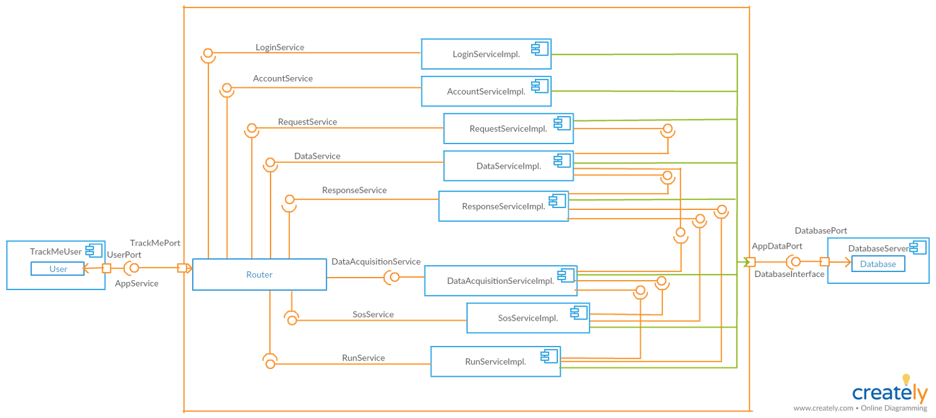

Component Diagram Services:

* LoginService: responsible for the authentication of the user.
* AccountService: provides functionalities to view his/her own history, track own data, update and delete own account for users.
* RequestService: responsible for receiving request and identifying the request type. Then sends request to data service for data preparation.
* DataService: provides functionalities fpr preparing to requested data.
* ResponseService: provides functionalities for receiving the prepared data from data service. Then sends this data.
* DataAcquisitionService: provides functionalities for normalizing the data coming from smart device and store data. Also, provides data for the other services.
* SosService: provides functionalities for getting individual data, comparing the data with threshold and informing hospital based on the results of the comparison.
* RunService: provides functionalities for registering run, defining a path and spectating runners.