**Component View**

In the component diagram shown below, the components in the project are examined in more detail together with the application server. In order to make the display more general and understandable, the interface provided by each component and the interface it requires are shown together. This will also help to better understand the relationship between the components. Other external services except for the database server and DBMS are not included in this diagram, because they are as black-boxes for this diagram and at this stage, their structure does not concern us. We are only interested in the services they provide.

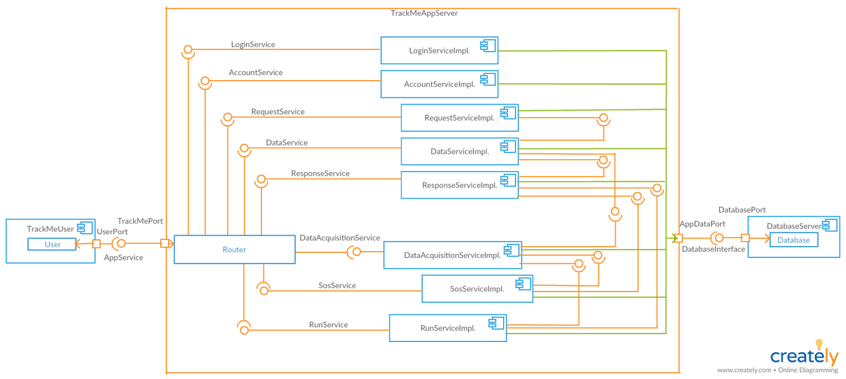

Component Diagram Services:

* LoginService: responsible for the authentication of the user.
* AccountService: provides functionalities to view his/her own history, track own data, update and delete own account for users.
* RequestService: responsible for receiving request and identifying the request type. Then sends request to data service for data preparation.
* DataService: provides functionalities fpr preparing to requested data.
* ResponseService: provides functionalities for receiving the prepared data from data service. Then sends this data.
* DataAcquisitionService: provides functionalities for normalizing the data coming from smart device and store data. Also, provides data for the other services.
* SosService: provides functionalities for getting individual data, comparing the data with threshold and informing hospital based on the results of the comparison.
* RunService: provides functionalities for registering run, defining a path and spectating runners.

The requests received by the user to the system are evaluated by the router. The router determines whether the received request is valid and if this request is intended to a component in the system, it sends the request to the component. Components in the diagram communicate with each other and work together to respond to requests from the user.

The following two diagrams, created from the component diagram, are designed to further describe the components in the application server. The relationship of the application server with the service components is clearly seen.