**Data Acquisition Sequence Diagram**

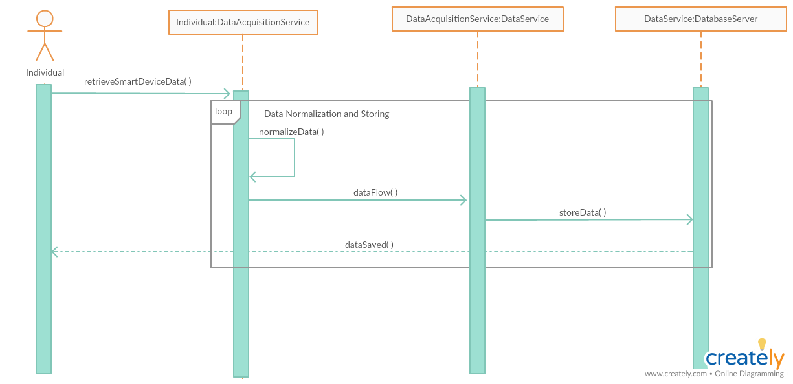

In the first part of the operation, data received via the smart device on the individual, it is transmitted to the DataAcquisitionService. The data received is normalized in the DataAcquisitionService. Then, it is sent to the DatabaseServer for storage. After that, the message of the received data is sent to the individuals.

The process of retrieving and saving the data is shown in a loop, because there will be a continuous flow of data from the smart device and the incoming data will be stored in the database.

**Request Individual Data Sequence Diagram**

**s**

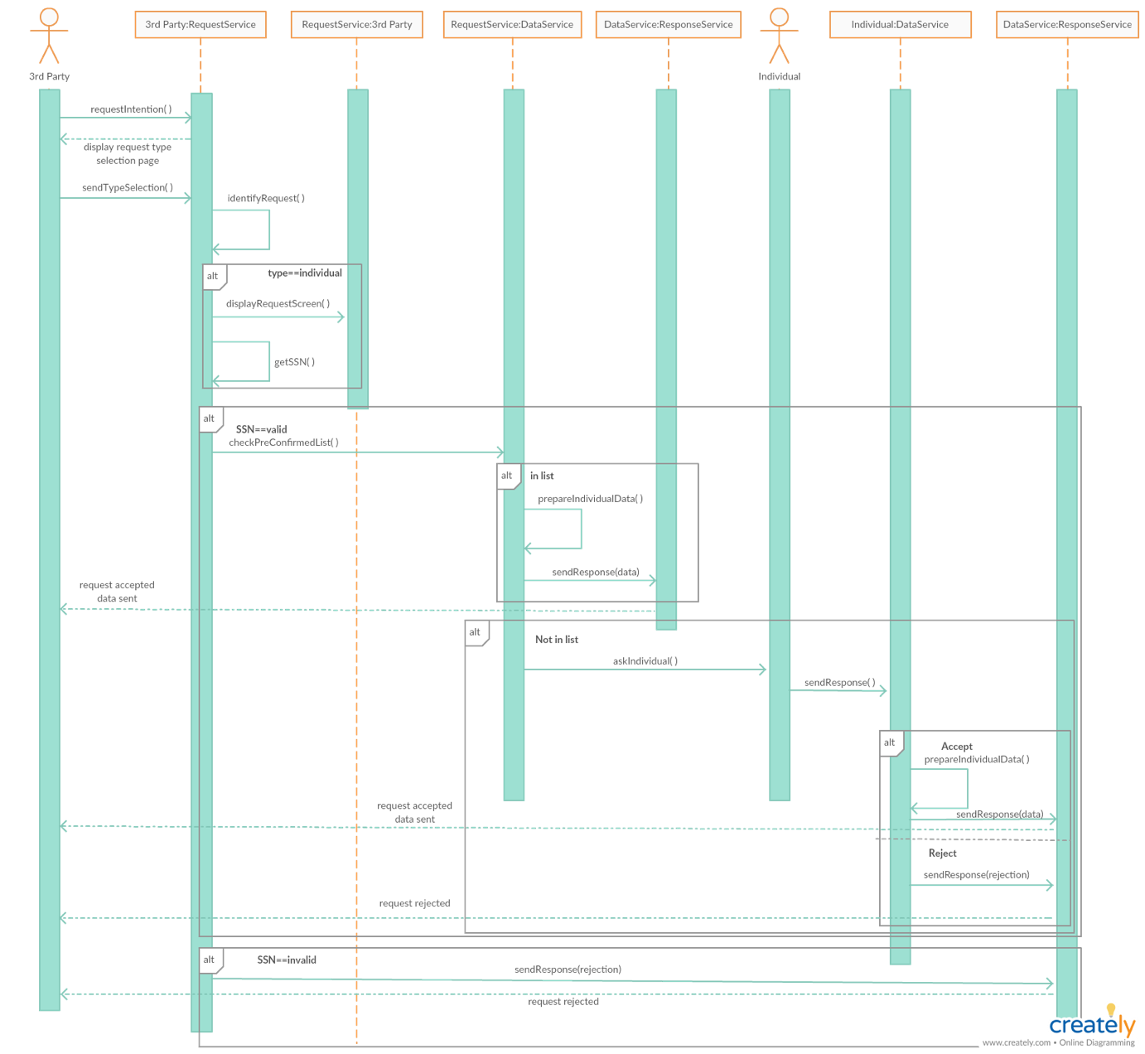

This diagram describes the section on the transfer of data from individuals to third parties. First of all, the request intention from the third party is sent to the request service. Then, request service shows the request type selection page to the third party. In request service, this request is identified, becuse this request can be individual or anonymous. In this diagram we are only interested in individual request. SSN of individual is checked whether it is valid or not in request service. If the SSN is not valid, a notification is sent to the third party that the request was rejected. If the SSN is valid, it should be checked whether the third party sending the request is on the individual's pre-confirmed list. If this third party is in this list, the data service prepares the requested data and sends it to the third party. If the third party is not in this list, the consent of the individual is required to send the data by the system. The response of the individual is sent to the data service. If the individual accept to submit his/her own data to the third party, the data is prepared and sent to the third party. Otherwise, if the individual rejects data sharing with them, this rejection is sent to the third party.