**Order of Component Integration *(6.2.4.)***

In this section, we have introduced the visual representations of our component integrations. For this purpose, we have positioned our components next to each other and connected them with an arrow which is pointing from left component to the right one. We have chosen the direction of arrow on purpose because, by creating an arrow from the first component to the second component, we tried to mean that; “the second (right) component” uses the methods provided by the first (left) component.” Also, by this representation, we have tried to say that the components that are given on the right side need to be implemented before the ones that are given on the left side.

The figures that are listed below shows the integration between the components.

Integration of Components with DBMS:

The figures that are given below show the integration between the DBMS and other components of the application. Each component that is given on the right side use the methods that are provided by DBMS. The way each component interact/use DBMS may differ from each other but at overall case, most of them use it for data storage. **????**

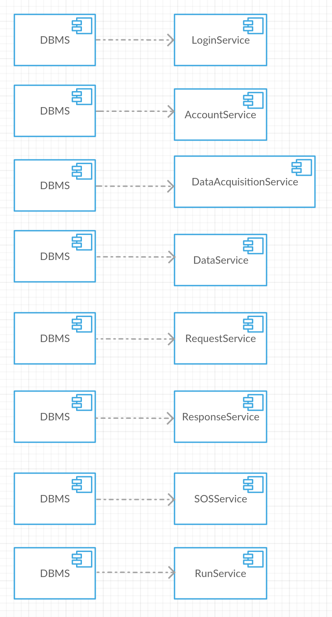

Figure 1 - Integration between DBMS and application components

Integration of Components with External Services:

The figures that are given below show the integration between the application components and the external services that that are being used by them.

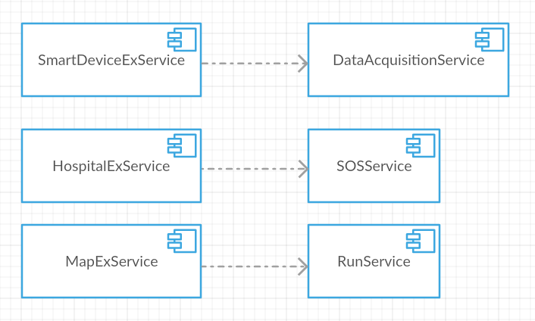

Figure 2 - Integration between the external services and application components

Integration of Components within the Application Server:

The figures that are given below show the internal integration of the components that are introduced under the application server. It is likely that this part will work as the brain of the application. After the integration of these components, it is possible to say that we will end p with a fully integrated application server.

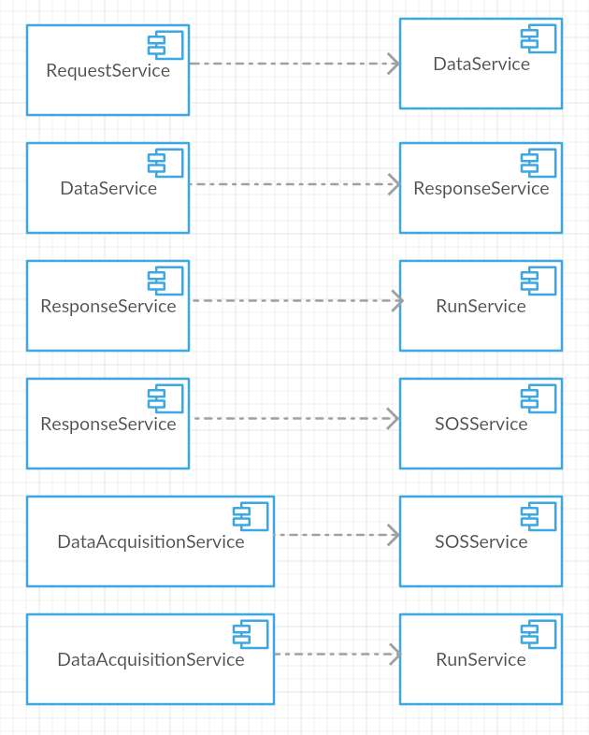

Figure 3 - Integration between the application server components

Integration of Client and Application Server:

The figure that is given below, shows the final component integration. After successfully integrating the internal application server components and application server with DBMS, we are now ready to integrate our client component with the application component.

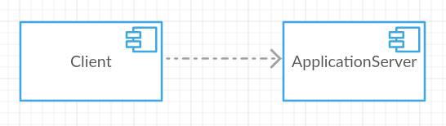

Figure 4 - Integration between the client and the application server