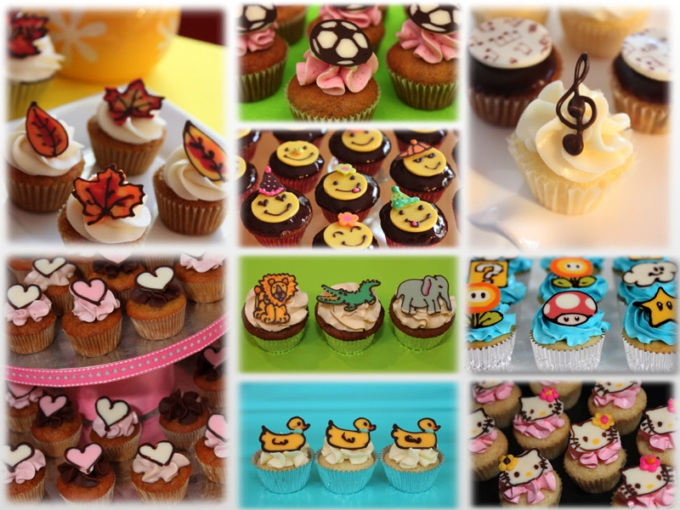

## We specialize in homemade and custom-made mini cakes with chocolate decorations

## We work with our customers to create custom designs that will fit ANY needs, taste and occasion.

## Popular cake flavors – chocolate, carrot, banana, pineapple

## Creams - Vanilla and Chocolate Buttercreams, Chocolate glaze, Cream Cheese frosting

## Additional flavors upon request

**tali@taliscakes**.**com**

* **Tali Kreindler**

# Handcrafted mini cakes and chocolates