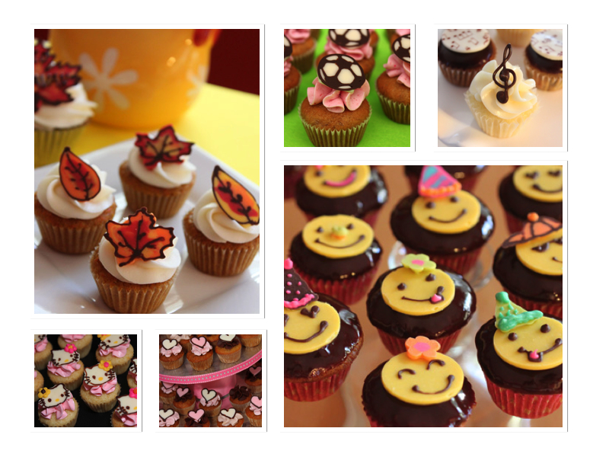

**tali@taliscakes**.**com**

* **Tali Kreindler**

## We specialize in home-made, custom-made mini cakes for ANY occasion.

## All chocolate decorations are hand made.

## Popular cake flavors – chocolate, carrot, banana, pineapple

## Creams - Vanilla buttercream, Chocolate buttercream, Chocolate glaze, Cream Cheese frosting

## Additional flavors possible

# Handcrafted mini cakes and chocolates