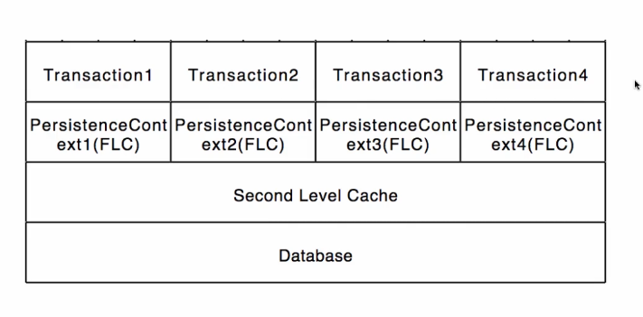

🡪first level cache is in each PersistenceContext. Each transaction has its own PersistenceContext. Now if transaction1 does a select where id = 1, the result will be saved in the first level cache. If the transaction1 needs this info again, it gets the result from the cache, preventing another query to the database

🡪second level cache is over multiple transactions / PersistenceContexts. Example: a list of countries, it will never change