# Read committed

Allows to read a column only if the update of another transaction has been committed

Meaning: the column is locked

# Repeatable read

Locks the entire row

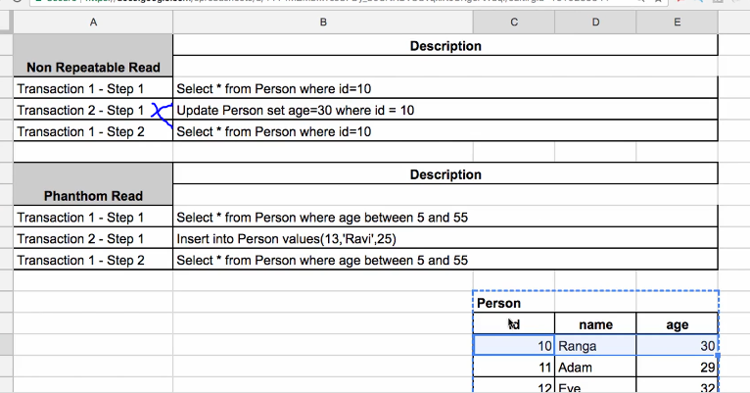

Transaction2 step1 not possible at that moment because the row is locked by transaction1

# Serializable

Locks the entire table

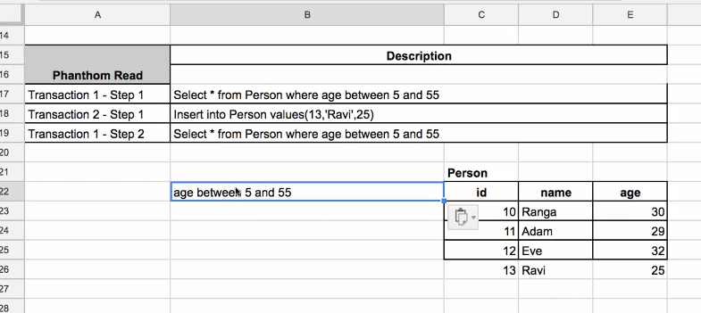

Transaction1 is locking entire table / multiple rows using condition ‘age between 5 and 55’. so the insert is not possible until transaction1 has finished because transaction2 tries to INSERT new record with age = 25, which is between 5 and 55

* Attention: can lead to poor performance of your application!

# Conclusion – when to choose which

Most of applications use read committed. Your are not locking a lot of stuff.

You can also use different isolation levels on different transactions