Inhalt

Section 4 css: default properties of some HTML éléments 1

Section 5 css: block and inline HTML elements 1

Section 5 css: positions 2

Section 5 css: font size parent values 2

Section 5 css: float img 2

Section 5 css: dotted hr 4

Section 5 css: increase range of a footer 5

# Section 4 css: default properties of some HTML éléments

Ein Bild, das Text enthält.

See also : [CSS Default Browser Values for HTML Elements (w3schools.com)](https://www.w3schools.com/cssref/css_default_values.php)

Das default CSS für ein Element sieht man auch in der Entwickler Konsole -> Elemente -> …

Ein Bild, das Text enthält.

# Section 5 css: block and inline HTML elements

[HTML Block and Inline Elements (w3schools.com)](https://www.w3schools.com/html/html_blocks.asp)

Change behavior with css prop ‘display’

For example <p> has default display of block, <span> has default display of inline

Block means that the element needs the whole width of a website

# Section 5 css: positions

* Static -> default
* Relative -> realtive from the natural position: move the element using top right bottom left and pixels
  + Relative position does not do anything, you have to define some px
  + It does not affect neighbour éléments. For example it does not push the element to the right if we define left : 50px
* Absolute
  + The margin set is relative to the parent element
  + It does effect neighbour éléments
  + This is much more easier to move elements around on the page
* Fixed
  + Element stays when scrolling

# Section 5 css: font size parent values

Example:

  the h1 has font size of 5em for example

  if we define also a font size in body element, for example 2em, the h1 will have 7em because these 2em are added to the 5em of h1

  this works also with %, but not with px

  in CSS3, there is also rem instead of em. with rem, parent font size is not added!

# Section 5 css: float img

We have an img, a title and a para

Then we float the img to left/right and it will look like this:

Ein Bild, das Text enthält.

…and now we want the para text beneath the img:

Ein Bild, das Text enthält.

…for this weh ave to use clear property on the para :

Ein Bild, das Text, Screenshot, Bildschirm enthält.

Ein Bild, das Text enthält.

# Section 5 css: dotted hr

Like this :

Ein Bild, das Text enthält.

We can do this with following CSS:

Ein Bild, das Text enthält.

Important is the auto margin left and right. This is needed to center the hr element

# Section 5 css: increase range of a footer

We have this :

Ein Bild, das Text enthält.

But we want this :

Ein Bild, das Text enthält.

We can do this using padding:

Ein Bild, das Text enthält.

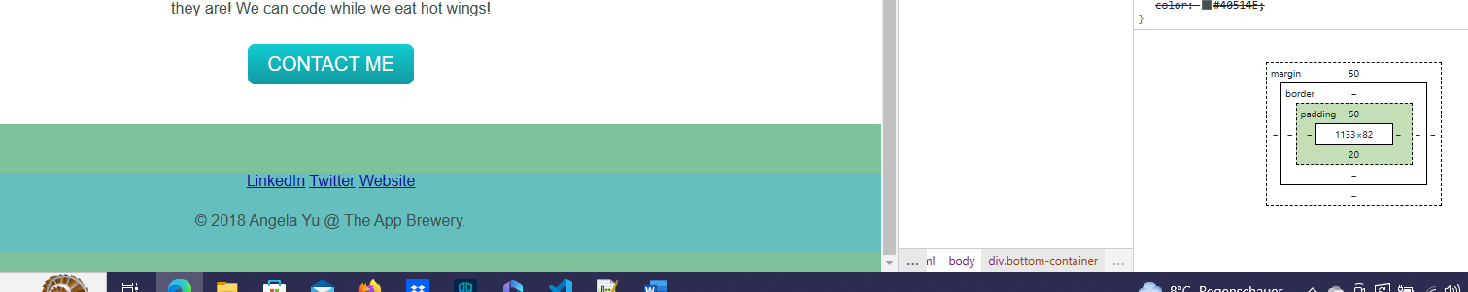

# Section 7 HTML: aria-hidden attribute

The aria-hidden attribute can be used to hide non-interactive content from the accessibility API.

Adding aria-hidden="true" to an element removes that element and all of its children from the accessibility tree. This can improve the experience for assistive technology users by hiding:

* Purely decorative content, such as icons or images
* Duplicated content, such as repeated text
* Offscreen or collapsed content, such as menus

The presence of the aria-hidden attribute hides content from assistive technology but doesn't visually hide anything.

aria-hidden="true" should not be used on elements that can receive focus. Additionally, since this attribute is inherited by an element's children, it should not be added onto the parent or ancestor of a focusable element.

Example: a screen reader can call the HTML elements of a webpage for a user with visual impairment. If an element has aria-hidden = true, the screen reader will skip this item

# Section 7 CSS: z-index

The z-index property specifies the stack order of an element. 🡪 only relevant if elements are stacked, for example stacked éléments using absolute position

An element with greater stack order is always in front of an element with a lower stack order.

**Note:** z-index only works on positioned elements (position: absolute, position: relative, position: fixed, or position: sticky) and flex items (elements that are direct children of [display:flex](https://www.w3schools.com/cssref/pr_class_display.php) elements).

…see web for further info

This was used for tindog to hide a part of the dog img behind the second div

Ein Bild, das Text, Hund, Im Haus enthält.

For this weh ad to:

Ein Bild, das Text, Bildschirm enthält.

Title-img = dog img

Ein Bild, das Text enthält.

#features = div after dog img