# Activity

Generate a random encryption dictionary and encode a message from the user then decode it back to the original message using dictionary comprehension.

Example:

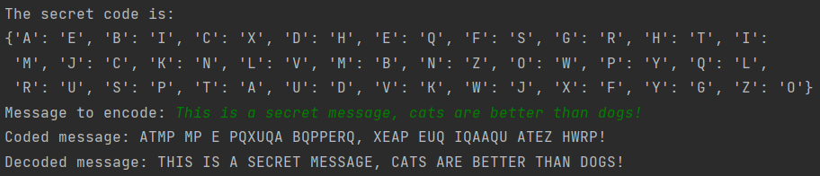

|  |
| --- |
| import random  ALPHABET = ['A', 'B', 'C', 'D', 'E', 'F', 'G', 'H', 'I', 'J', 'K', 'L', 'M', 'N', 'O', 'P', 'Q', 'R', 'S', 'T', 'U', ‘V', 'W', 'X', 'Y', 'Z']   def main():  ...  def generate_code(): """Return a random encrypting dictionary of characters {plain: cypher} """  ... def encode(plain_to_cypher, plain_text): """Encode plaintext using encrypting dictionary, return encoded string"""  ...  def decode(plain_to_cypher, cypher_text): """Decode cyphertext using the dictionary used to encrypt it, return decoded string"""  ...  main() |
|  |