**Comp 3020 - Human Computer Interaction**

**Project Group 21**

Matt Kralijevic

Uju Nnamani

Riley Siemens

Bryan Wodi

**Comp 3020 - Human Computer Interaction**

**Project Group 21**

Matt Kralijevic

Uju Nnamani

Riley Siemens

Bryan Wodi

**Part A Identifying the Project:**

Our group idea is to create a website to help people find whatever restaurant that they are in the mood for. The basic idea is this: the user goes to our website and the website would approximate their location (or the user could choose his/her location). Their location would appear on a map. The user would see a list of types of food options in the area, or manually enter the type of food they want to eat. The map would populate with the locations of all nearby restaurants as pins on a map and hide all other restaurants that don’t fit the criteria. From there, the user could click on any one of the restaurant pins and bring up more information, such as aggregate review scores, average price of an entree, and some pictures of food. If at any point the user changes his/her mind, they can go back, enter another food type, and continue searching.

Our main use case is someone who is hungry, and has already decided that they want to eat out, but doesn’t know exactly what they’re in the mood for. Sometimes all you need to make a decision is to see what options are out there and see if anything stands out. Our website isn’t trying to help the user decide where to eat, it is just giving information to speed up the decision making process.

When people decide to get takeout, sometimes it’s because they have specific craving for a food, but often times, it’s because they don’t have time or energy to make food for themselves. They’ve decided that they would rather just pay for someone else to cook for them, and skip the effort of cooking and cleaning up afterward. When this is the case, it can be hard to decide where to go. They’re not sure what they want to eat, they just know they don’t want to be the ones to cook it. Our website will help alleviate this by: first, suggesting a type of food to eat when they first sign on, and second, filtering out unwanted restaurants. A decision is much easier to make when there’s only a handful of options, instead of an entire city’s worth of choices.

**Part B Stakeholders:**

* A primary stakeholder is someone with a busy work schedule. They spend so much time working or travelling that they don’t have time to shop for groceries or cook for themselves. Their schedule may be shifting so they don’t know exactly when they’ll be home for supper from day to day. They have some experience with technology but not necessarily a lot of technical know-how. They would be in their twenties or thirties.
* Another primary stakeholder is a mother or father looking to take their family out for a treat. For the family, eating out would be more of a special occasion, a time when everyone can eat together without one person having to cook and clean. They may be in their thirties or forties and he/she is not the most technically minded person. They’re not sure what everyone would be in the mood for so they use our website as a tool to see what’s available. The secondary stakeholder in this case would the be the partner and kids of the user.
* A person who just moved to a new city, or someone who is travelling, would be another primary stakeholder of the system. It would be very useful for them to see what kind of food options they have at any given time in an unfamiliar location. When they want to immerse themselves into the foreign culture of their new location, the user can use our website to find where locals eat. The age range of this stakeholder can be very wide, anywhere from teens and twenty-somethings to seniors. Anyone who wants to avoid tourist traps or chain restaurants when they travel. However, it would also work in the opposite direction: if you want to avoid the risk of eating strange food and just want to find a familiar spot, search for a type of food you’re used to at home and find where the closest place is. The user wouldn’t have to have much experience with technology; just being able to use the map app on their phone would be enough.

**Part C User Research**

1. One of the methods we employed is the use of the survey/questionnaire to retrieve information from users. The reason we chose this was because we needed to retrieve enough information from a reasonable large amount of prospective users in the short window in order to gather representative data.

After conducting some historical analysis on other websites that offer facilities where users can order food from, we developed an initial scaffold of what our ordering system should look like, we then developed a paper prototype using conventional designs and analyzed what we had, then, we thought it was an important part of the building process to involve prospective users in order to understand their preferences and values and compare them to the idea that we had come up with. We used our initial observations from the websites we had examined and questions and features of our database to drive the questions of the survey.

Breakdown of the sampled data:

From the survey conducted, the majority of our sampled population falls between ages 20 – 25, which are typically students in the university, and a good percentage of them eat at restaurants. By analyzing these data, we have learned that price, distance and reviews factor into their decisions in finding where to eat. Also, that a good number of them would love to search for restaurants based on their cravings at the time. Although a reasonable amount of population is unsure about the frequency of use, we need to conduct more inquiries in finding out why this may be the case.

One thing we learned from this population is that price of the meals have the most bearing to making that decision, and every other thing can be a bonus; so, we will align to that value by making that our top priority while designing our system. Finally, our system will be considered a success if 70 – 80% of the users find it to be helpful enough to recommend it to at least one family member or friend. From the survey conducted, we had about 77% in recommendations, which was a really impressive.

2. A fly on the wall observation method was used along with a following small open interview. The research was conducted with a potential user and stakeholder. The individual in the research was a young professional who works full time. They were asked to find a restaurant they hadn't ate at before that they would be interested in by using with a similar service to the one we are in our project, Yelp.

In the research, their method of selecting was observed to determine any bottlenecks that occurred and to see what appeared to be criteria they were searching by. While using Yelp, the subject appeared to ignore a portion of the information that was presented to them. When the user selected the food section of Yelp, they ignored the top rated restaurants and restaurant features (Accepts credit cards, takeaway options, etc.) and had to spend time looking for the price range on the front page, which was what their first page they navigated to. The subject seemingly had a good idea of what their price range was and the system of “1-4 dollar signs” for price was intuitive and there was no hesitation in their choice. The page they were brought to showed restaurants in that price range. They did not scroll down and look at any of the restaurants that immediately appeared but rather focused on the top where there was the option to sort by style of food, which they promptly used as was their first action on the page. A list of restaurants appeared and they scrolled through 25 restaurants and their choice was number 20. They clicked on the restaurant were shown pictures, recommended reviews, the restaurant's location on a zoomed in Google maps picture, business information (whether or not they take reservations, if they do delivery) and other restaurants users had viewed. They went to the page of one of these other restaurants. They clicked on the pictures and spent some time looking at them, and after looked at the first 3 or 4 reviews. They then went back to the previous page (previous restaurant) and did the same actions for said restaurant. They looked at the pictures and then the reviews for longer than the last restaurant. They then said they made up their mind on the current restaurant being their choice.

The follow-up question was related to how they gauged the distance of the restaurant. The subject said they went by the address which was displayed on the restaurant page and not by the Google maps window. An important finding from this seems to be that the user had a good idea of what they wanted based on how they parsed through the information showed to them and in how promptly they made their decisions for price range and style of food. The research also showed the user was able to make their decision fairly quickly and finding a restaurant online is a valuable idea. Finding the restaurant could have just as easily been done on a smartphone while as a passenger in a car, potentially trying to decide on a place to eat. This supports our hope that this platform can help people who are busy in their day to day lives.

3.Historical Analysis:We can compare features of other websites through their various stages of development. We can do this by taking a look at the reviews from users of websites that are similar to ours, that is, websites where one can find a restaurant that serves a particular food and also gives reviews about the restaurant. This method will help us modify our idea and figure out the requirements needed to make the website and also what the user would need in order to make good use out of it.

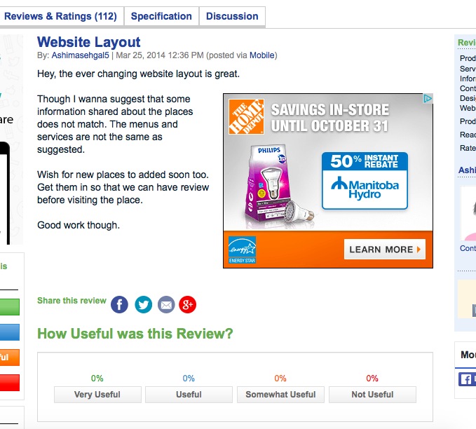

The above is an example of a review of zomato; a restaurant review website. This user’s review tells us that a caution we need to make when creating our website is to always have updated reviews of different restaurants because their ratings change frequently.

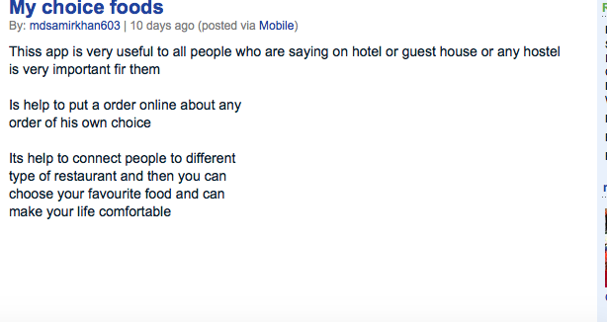

The above is another example of a review by a user giving us an idea of the user requirements for the website. This user states that the websites will be very useful to people visiting a particular place for the first time or even people living in a hotel or guesthouse

**Part D Requirements:**

1. Function:

* Recommend a good restaurant that has what the user wants to eat
* Recommend a restaurant close to the users destination, that is, track the location of the user.
* The user should be able to contact the restaurant and make a reservation.

1. Data:

* Type of food: The user should be able to know what kind of food they want to eat or be able to search for something new or different.
* Address: The address of the user will be needed in order to find a restaurant that is close to the user.
* Price range: The user should know their price range in order to narrow down the search of restaurants

1. Environmental:

* The system will be used by people who need food fast and do not want to have to waste time finding out what kind of food each restaurant sells.
* People who don’t want a lot of steps to get food to eat
* Also will be used by the general public which also may not be expert computer users

1. User:

* The user is someone who is computer literate but not necessarily an expert in using computers.
* Workers who come back home tired or late and do not have time to cook and want to go out to eat
* People who are lazy when it comes to cooking and eat out a lot so they might want to try something different
* From the above user research, we also found out that the user is also someone who is visiting that particular city and wants to try something new and different or just wants to find the city’s most popular restaurant.

1. Usability:

* Effectiveness: The website should be able to do what it is meant to do for the benefit of the users and stakeholders.
* Efficiency: The website should be able to convey the reviewers message in a clear way in order for the user to know which reviews are good and bad. Also the website should have updated reviews on restaurants as we found out in the above user research
* Learnability: The website should be easy to learn how to use because the user may not be an expert computer user so the website should be easy to use

The following are the most important requirements, in order of importance:

* Ease of use
* Filtering tools (sort by price, location, average review, etc)
* Quick processing
* Location tracking
* Suggestions based on previous encounters

**Part E - Scenarios**

Warren is sales rep for large pharmaceutical company. His job requires that he flies around to a different city around the country 1 or 2 times a week. Between all this travelling, and the often late nights he spends at the office means he is rarely home for meals. He doesn’t mind, because he hates cooking anyway. Since Warren likes to try new things, he is constantly looking for new places to eat, especially when he is in a strange city or neighbourhood. He likes all sorts of cuisines, from an American cheeseburger, to a bowl of Sudanese ful medames, but he likes to know what he’s getting into before he decides to eat somewhere.

After work, the first thing Warren is hungry. He doesn’t have the option of just going home and whipping something up when he’s on the road, so he pulls out his phone and goes to the site. It recognizes that he’s in a different city and automatically brings up a list of popular food in the area. He glances at the list and sees Italian, Mexican, pub food, and wings. None of these types of food stand out to him though, so types in Chinese into the search bar. After a second, it shows him 3 nearby Chinese restaurants. The top result is the highest rated, but it’s far enough away that he would need a taxi and he would rather something in walking distance. The second restaurant has a 4 stars average rating and it’s only 1.2km away. So he taps on it which drops a pin into a map of the area, showing him exactly where it is. He starts walking there according to the path the site has drawn out for him and arrives shortly.

After his meal, he pulls out his phone again and it’s still on the same site as before, only now there’s a window covering the home page asking him how he would rate his dining experience. He’s satisfied with the food and service, but thinks the price was a little too high. He thinks 4 stars is good rating so taps that on his phone. The window thanks him for his rating and fades away revealing the same map and cuisine list as before, ready for the next day’s meal.

Chris is a young professional who works in the downtown center of his city at a law firm as a paralegal. His commute to work is by bus and at least once a week, oversleeps and cannot prepare a lunch. He is in his mid twenties. He is not tech savvy, but is comfortable using his smartphone and standard office desktop software (microsoft office products, web browsers, etc.). When he can't make lunch, he usually goes for lunch at a restaurant within walking distance of his work with one of his many coworkers. He is not a picky eater, however he usually goes with one of his many coworkers and often has to go by their dietary restrictions or preferences.

Chris forgets his lunch one day and finds a coworker who would like to go for lunch with him. They take the stairs and he asks his coworker if they have any preference. His coworker is a vegetarian. Chris opens up the site and asks to see nearby vegetarian restaurants. His coworker has the same position he does so Chris filters by an appropriate price range for himself, assuming the coworker won't protest if they are making the same money. As they get to the bottom of the stairs, he sees two restaurants within a 5 minute walk that are similarly reviewed at 4 stars. He shows his co worker the menu to both of them and they decide which one they are going to based on a few appealing entrees that appeared for one of the restaurants.

The two get to their restaurant with the directions provided and have a good meal. On the way back they give an off the cuff review of the respective meals they ordered. Both enjoyed their meal more than they expected and Chris leaves a 5 star review when he returns to the restaurant, whose page is still up.