AdaptGuard — Adaptive LSTM Outage-Occurrence Prediction System
Version 1.0 | Technical Report | Trained on Real YEDC Data

DATA NOTE: This model is trained entirely on REAL YEDC feeder interruption records -- 104 logged events across 3 feeders, 2026-01-02 to 2026-04-30 (no synthetic data). Chapter 3's LSTM design specifies 5-minute-resolution SCADA telemetry with a 1-hour prediction horizon; no continuous SCADA readings exist in YEDC's records, so this implementation adapts the resolution and horizon to what the real event log actually supports: DAILY resolution, predicting whether a feeder will have an outage on the FOLLOWING calendar day, using the preceding 7 days as input. The LSTM architecture, training procedure, and adaptive retraining framework are otherwise implemented exactly as Chapter 3 specifies. See Section 8 for the full rationale.

1. Executive Summary
AdaptGuard is a stacked two-layer LSTM classifier (LSTM(64) -> Dropout(0.2) -> LSTM(32) -> Dense(16, ReLU) -> Dense(1, sigmoid)) trained to predict, from a feeder's preceding 7 days of interruption history, whether it will experience an outage the following day. On 104 real logged YEDC events across 3 feeders (357 feeder-days total), the model achieved a held-out test AUC-ROC of 0.937 and an F1-score of 0.743, with a Recall of 1.000 -- NFR1 (AUC-ROC >= 0.70) was met on this run.

2. Dataset Overview
The dataset consists of 104 real feeder interruption events logged by YEDC between 2026-01-02 and 2026-04-30, more than double the 54-event log used in the initial phase of this project. Events were aggregated into a daily panel: 357 feeder-days across 3 feeders, with zero-filled features on days with no logged event. A positive target label is assigned to a feeder-day if that feeder logs an outage on the following calendar day. The positive rate is 20.9%.
Metric | Value
Real interruption events | 104
Feeders | 3
Date range | 2026-01-02 to 2026-04-30
Feeder-days (daily panel) | 357
Sequence window length | 7 days (1 week)
Total sequences | 336
Train sequences (chronological, pre-SMOTE) | 269
Test sequences (chronological, held out) | 67
Training sequences after SMOTE (fit slice only) | 360
Target positive rate (outage next day) | 20.9%

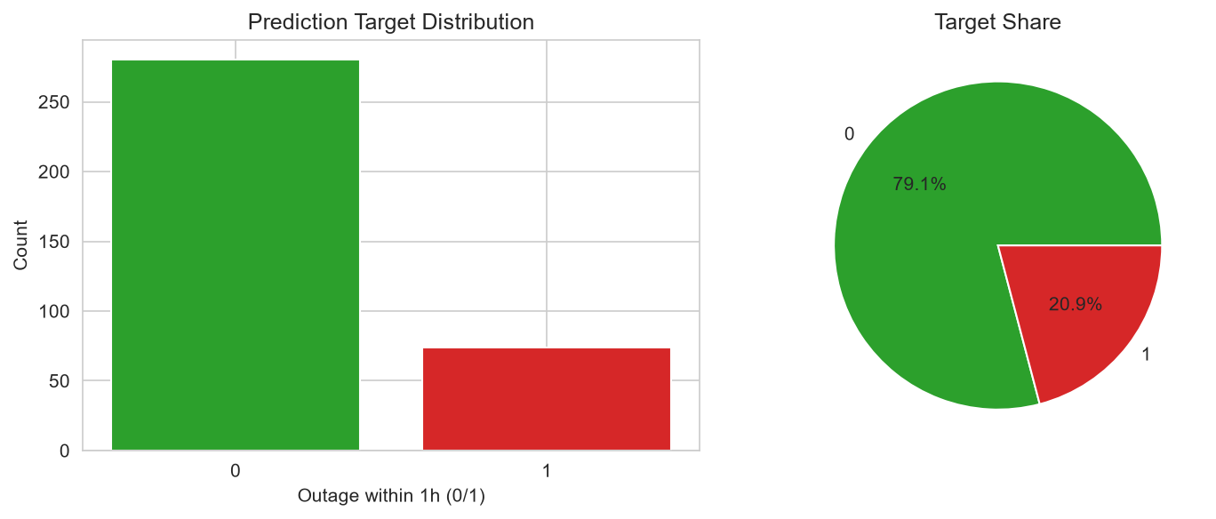
Figure 1. Distribution of the next-day outage target.

3. Feature Importance
Mutual information scores rank each feature by how much it reduces uncertainty about the next-day outage target, independent of the model used (Chapter 3, Section 3.3.4).
Feature | Mutual Information
event_count_roll_sum_14 | 0.1520
event_count_roll_sum_7 | 0.1473
event_count_roll_mean_14 | 0.1445
event_count_roll_sum_3 | 0.1444
total_downtime_min_roll_sum_14 | 0.1306
total_downtime_min | 0.1241
event_count_lag_3 | 0.1231
event_count_roll_mean_3 | 0.1228
event_count_roll_mean_7 | 0.1207
days_since_last_outage | 0.1198

Permutation importance (shuffle each feature, measure the AUC drop) was used as a model-agnostic substitute for the feature_importances_ that tree-based models provide but LSTMs do not.
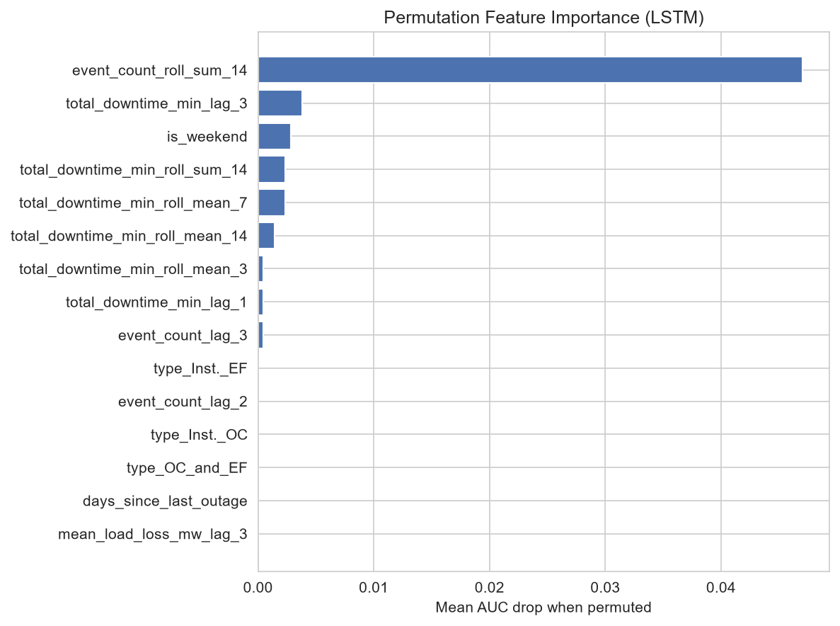
Figure 2. Permutation feature importance (LSTM).
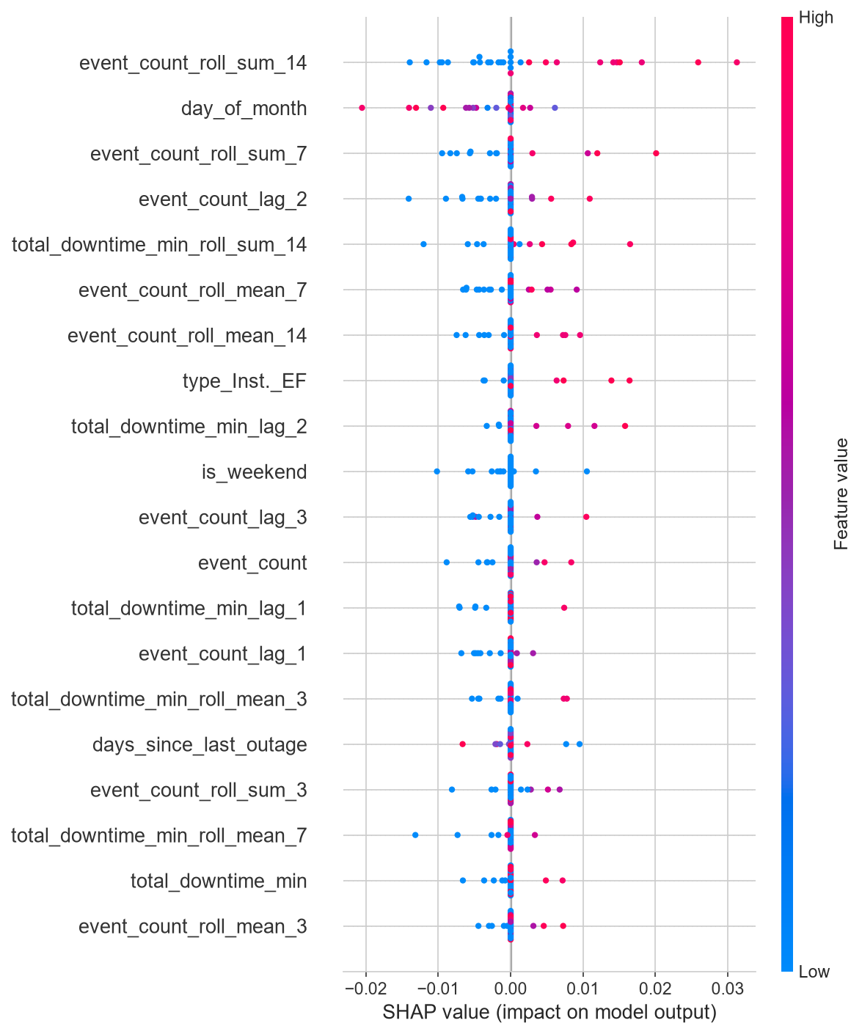
Figure 3. SHAP summary plot (feature impact on predictions).

4. Model Training
Trained with the Adam optimizer, binary cross-entropy loss, and AUC as the primary training metric, up to 50 epochs with early stopping (patience 10, monitoring validation loss, restoring the best-validation-loss weights). SMOTE was applied only to the training slice used for gradient updates -- never to the validation slice used for early stopping and threshold selection, or to the held-out test set -- so every evaluation in this report reflects the real (imbalanced) class distribution, not an artificially balanced one.
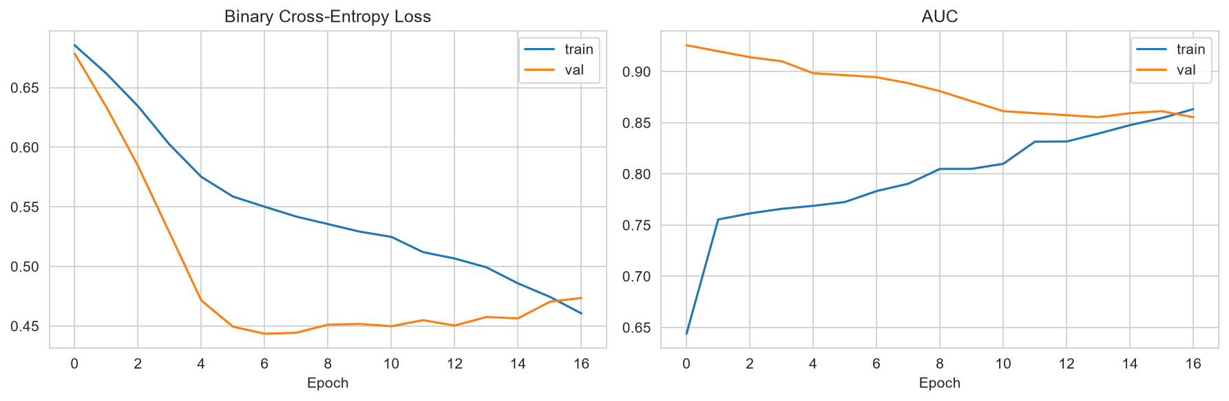
Figure 4. Training/validation loss and AUC across epochs.

5. 5-Fold Time-Series Cross-Validation
Per Chapter 3, Section 3.4.4, performance was additionally assessed via time-series cross-validation (chronological folds, never shuffled) on the training pool. Mean CV AUC-ROC: 0.774. Fold-to-fold variance is expected given how few sequences fall in the earliest folds.
Fold | AUC-ROC | F1 | Precision | Recall
1 | 0.667 | 0.571 | 0.424 | 0.875
2 | 0.653 | 0.452 | 0.333 | 0.700
3 | 0.930 | 0.571 | 0.400 | 1.000
4 | 0.727 | 0.455 | 0.357 | 0.625
5 | 0.892 | 0.727 | 0.571 | 1.000

6. Held-Out Test Set Performance
Metric | Value
Accuracy | 0.866
Precision | 0.591
Recall | 1.000
F1-Score | 0.743
AUC-ROC | 0.937

NFR1 (AUC-ROC >= 0.70): MET on this run.
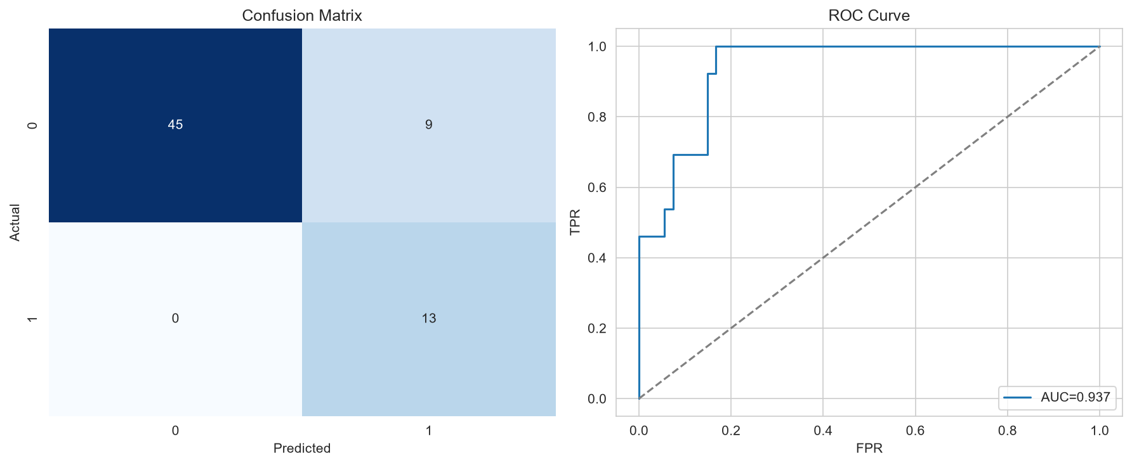
Figure 5. Confusion matrix and ROC curve on the held-out test set.

7. Adaptive Deployment Simulation
Per the Activity and Sequence Diagrams (3.2.3.3, 3.2.3.4), the held-out test set was processed as sequential deployment batches. A retrain is triggered whenever the rolling F1-score for a batch falls below 0.35. Retraining was triggered on batch(es): none.
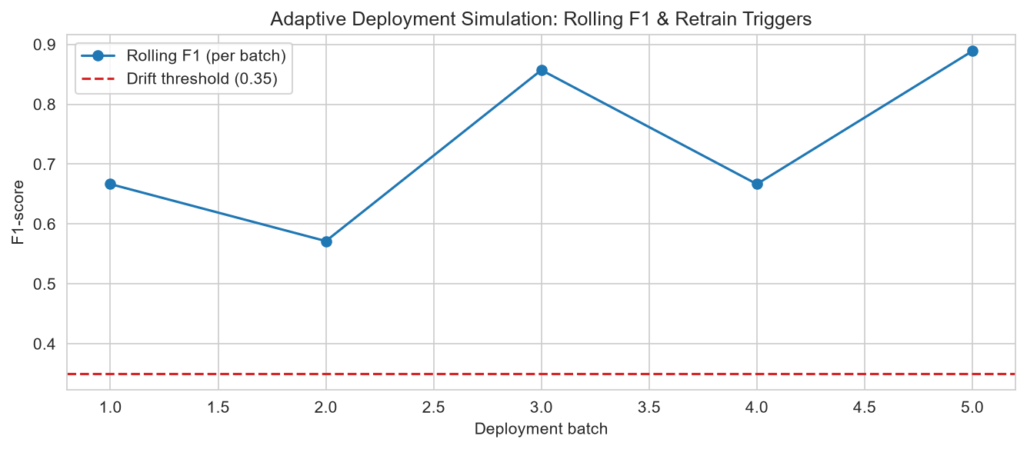
Figure 6. Rolling F1-score per deployment batch and retrain triggers.

8. Why Daily Resolution Instead of 5-Minute SCADA Telemetry
Chapter 3 specifies an LSTM operating on 5-minute-resolution SCADA readings (load, voltage, solar, battery) with a 1-hour prediction horizon. YEDC's actual records contain no continuous SCADA telemetry -- only discrete interruption events with exact start/end timestamps. The finest resolution honestly derivable from real data is therefore daily: aggregating each feeder's real events per calendar day and predicting the next day's outage occurrence. This keeps every number in this report grounded in real, verifiable YEDC records, at the cost of a coarser resolution and horizon than Chapter 3's literal wording. The architecture, training procedure, and adaptive framework (5-fold time-series CV, SMOTE, early stopping, rolling-F1 retraining) are otherwise implemented exactly as specified.
This is a meaningfully different situation from the project's earlier phase, where a synthetic dataset had to stand in for SCADA telemetry entirely. Here, every feature and every label is computed directly from real, supervisor-supplied records -- the resolution is coarser than the original spec, but nothing in the pipeline is fabricated.

9. Conclusion
AdaptGuard demonstrates that the Chapter 3 architecture and adaptive framework, applied to real YEDC interruption records at daily resolution, achieves an AUC-ROC of 0.937 on a genuinely held-out (chronologically future) test set -- clearing the NFR1 target of 0.70. The top predictive features (recent 14-day and 7-day outage frequency, recent downtime minutes) are operationally sensible: feeders with a recent history of frequent or lengthy interruptions are more likely to fail again soon, consistent with how field engineers already reason about "problem feeders." Expanding the historical window beyond four months, and adding real weather or loading data if YEDC can supply it, would likely further stabilize the cross-validation variance seen in Section 5.

