**PROJECT REPORT**

**ON**

**STUDENT RESULT MANAGEMENT SYSTEM**

**BACHELOR OF SCIENCE**

**IN**

**INFORMATION TECHNOLOGY**

**SUBMITTED BY**

**PRINCE CHAUDHARY - 16070124017**



**UNDER GUIDANCE OF**

**PROF. SAMADRITA GUHA**

**SYMBIOSIS INSTITUTE OF TECHNOLOGY**

**(A CONSTITUTENT OF SYMBIOSIS INTERNATIONAL UNIVERSITY)**

**PUNE - 412115**

**2018-19**

**TABLE OF CONTENTS**

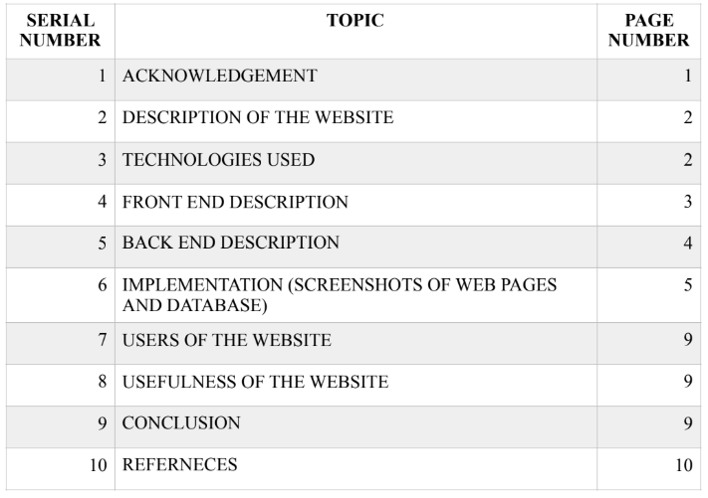

**ACKNOWLEDGEMENT**

I would like to thank Prof. Samadrita Guha at the Symbiosis Institute of Technology, Pune for giving me an opportunity to work on this project of developing a website in the laboratory of Internet Technologies. This project helped me enhance my skills and thoroughly increased my knowledge in the field of web development. Without constant guidance and support of Prof Samadrita Guha this project would not have been completed successfully.

**INTRODUCTION**

**Description of website**

**To Develop a system that will manage:**

* **Information about the various students**
* **Information about subjects offered in various semesters**
* **Marks obtain by Students in different semesters**
* **Generation of Reports**

**Student Result Management System divided in two modules:**

Student

* Admin
* Admin Features
* Admin Dashboard
* Admin can add/update/ Class
* Admin can add/update/ Subjects
* Admin can add/update/ Active/Inactive Subject combination with class
* Admin can register new student and also edit info of the student
* admin can declare/ edit result of a student.
* Admin can change own password

**Students:**

**Student can search their result using valid roll id.**

**Student gets to know the marks scored in each subject and his percentage.**

The application will have capability to maintain information about the students enrolled in the course, the subjects offered to students during different semesters, the marks obtained by the students in different subjects in various semesters. The software will also generate summary report regarding student information, semester wise marks list and performance reports .

**Context Report**

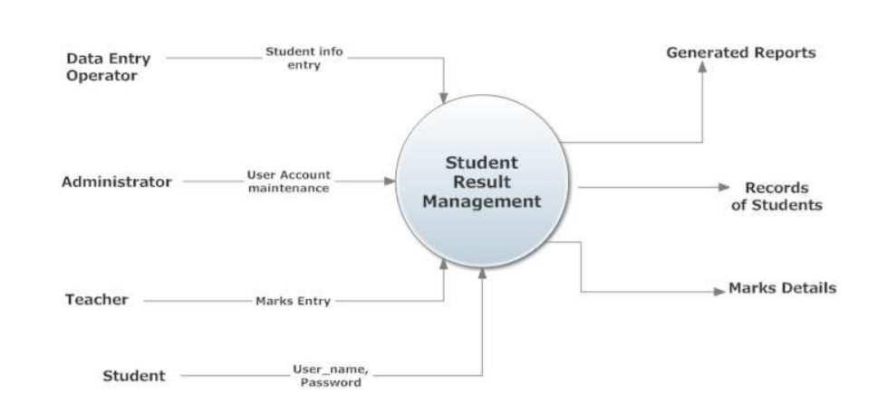

**TECHNOLOGIES USED :**

**The technologies used in the front end development are as follows :**

1. **HTML**

HTML stands for HyperText Markup Language. It is used to describe the structure of the

web page. HTML elements are the building blocks of HTML pages and are represented by

HTML tags.

1. **HTML 5**

HTML 5 is an updated version of the original HTML language with some interesting

updates like -

a. Semantic elements like <header>, <footer>, <article>, <section>

b. New attributes of form elements like number, date, time, range, calendar.

c. Graphic elements like <avg>, <canvas>

d. Multimedia elements like <audio>, <video>

1. **CSS 3**

CSS stands for Cascading Style Sheet. It is mainly used for describing how the HTML

elements are to be displayed laptop screen or any other media. CSS reduces a lot of work as

it can control the styling of multiple web pages at once. CSS can be included in the code in 3

ways -

a. At the start of the HTML code under the <style> tag.

b. Inline meaning along with the tag to be edited.

c. By creating an external CSS stylesheet.

1. **JavaScript**

Java Script is used to program the behaviour of the webpages. It is mainly used to make the

webpages responsive or dynamic.

**The technologies used in developing the backend are:**

1. **PHP**

PHP stands for Hypertext Preprocessor. It is an open source scripting language. It is executed

on a server. It can be used for collecting data, send and receive cookies, generate dynamic page

content. PHP supports a wide range of databases, can run on various platforms and is

compatible with almost all servers.

Database used for the website :

**MySQL**

MySQL is a database system used on the web. It is a database system that runs on a server and

compiles on a large number of platforms. MySQL is ideal for both small and large applications.

**FRONT END DESCRIPTION:**

The front end of the website has been developed by using HTML, HTML 5, CSS and JavaSCript

technologies. The front end mainly consists of web pages that have been designed using HTML and HTML5. Styling for the webpages has been done by CSS. The relocating and other behavioural patterns have been coded using Java Script.

**Some of the webpages that are a part of the front end are as follows:**

Login screen: This will be the first screen that will be displayed. It allows user to access different screens based upon the user role. Various fields available on this screen will be

1. Admin_ id: alphanumeric of length up to 10char.
2. Password: alphanumeric of length up to 10char
3. Role: Will have the following values: Administrator,Data entry Operator,student,teacher.

**Subject info Parameter Screen**: This screen will be accessible only to the Administrator. It will allow the user to enter the class number for which the user wants to access the subject information.

**Student info Parameter Screen**: This screen will be accessible only to the Administrator. It will allow the user to enter the Batch Year for which the user wants to access the student information.

**Student Information Screen**: This screen will be accessible only to the Administrator. It will allow the user to modify the information about new/existing student for particular batch year.

**Marks Entry Parameter Screen**: This screen will be accessible only to the Admin. It will allow the user to enter the class, the semester number and the subject for which the user wants to access the marks information.

**Marks entry screen: Screen**: This screen will be accessible only to the Admin. It will allow the user to add/modify/delete information about the marks obtained in the selected subject by different students. It includes student name, percentage, total marks.

**BACK END DESCRIPTION :**

The back end has been created by using the PHP language as the basic language. The front end has been linked to the backend using PHP. PHP has also been used to link the database to the front end.

When the user login’s to the website via the login page validation is done by matching the data in the database. Whenever a new user sign’s up to the website the data is stored in a database for future reference. This storing of data and validation of data is done via a PHP code.

**SCREENSHOTS OF IMPLEMENTATION:**

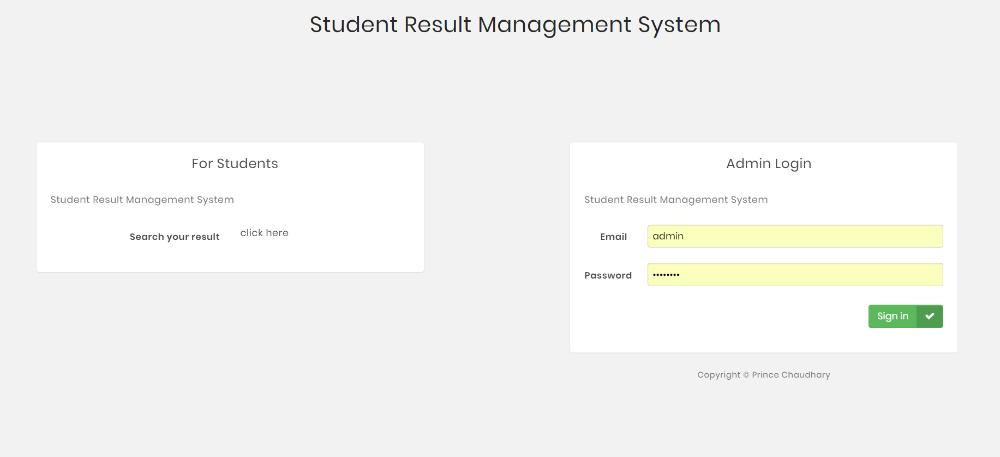

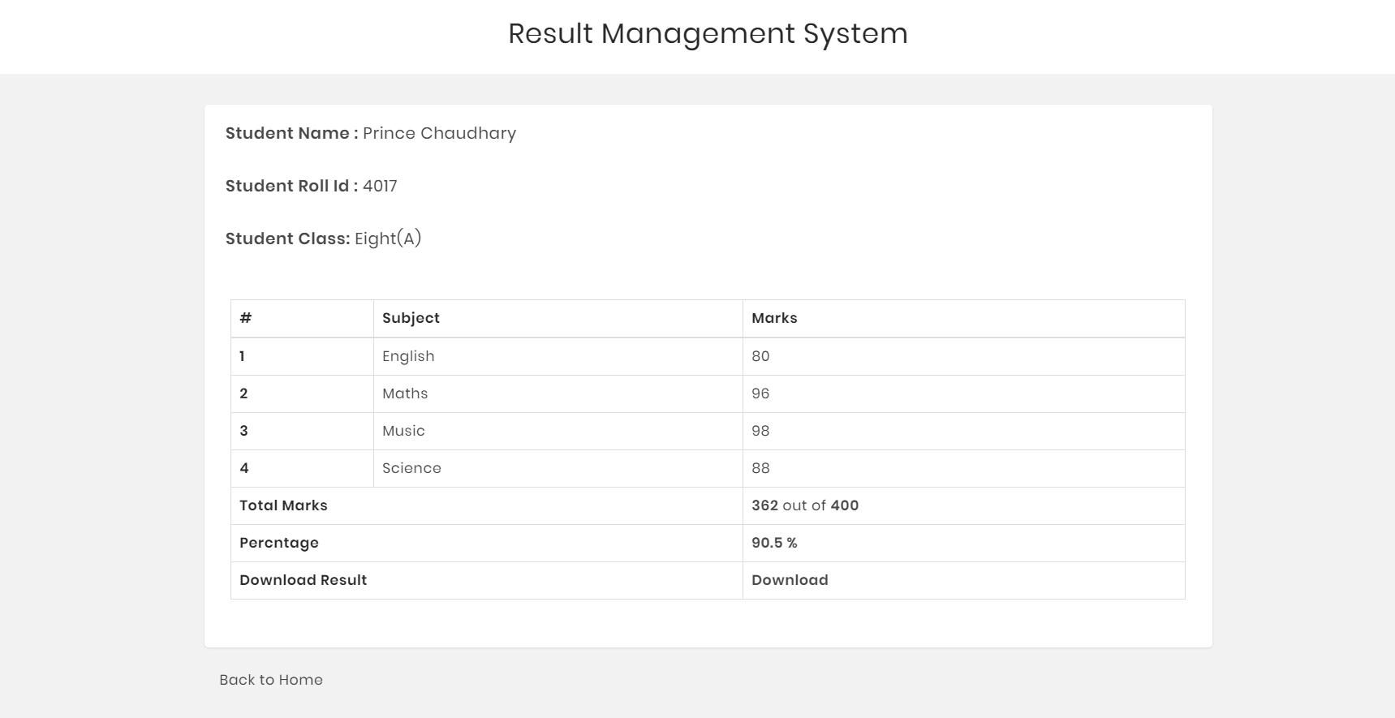

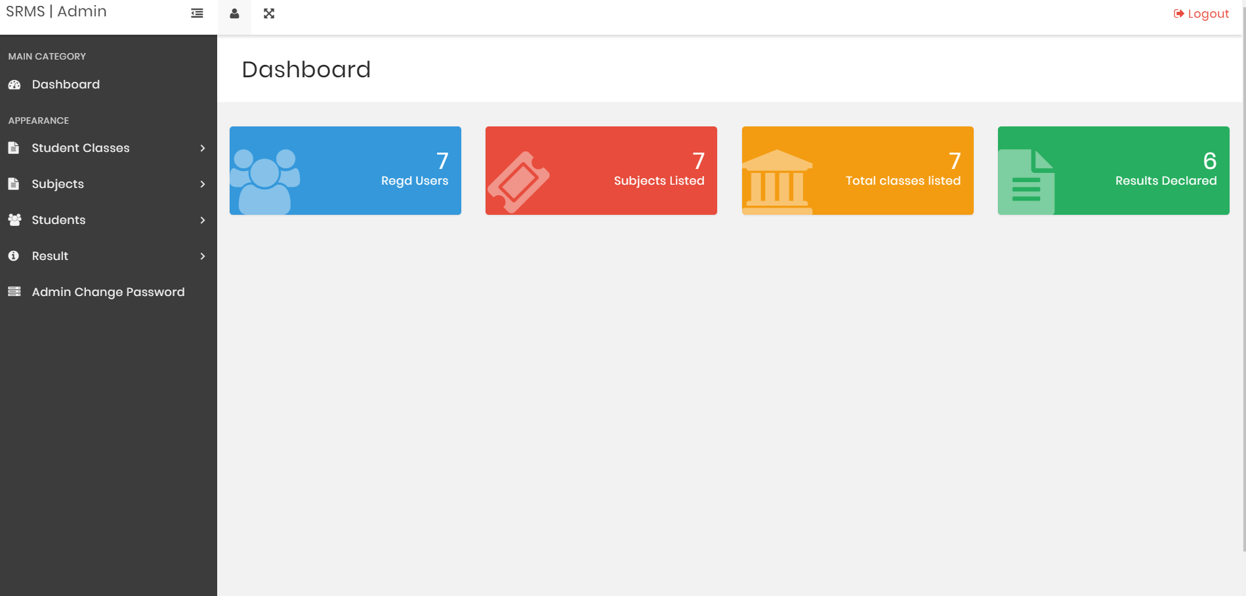

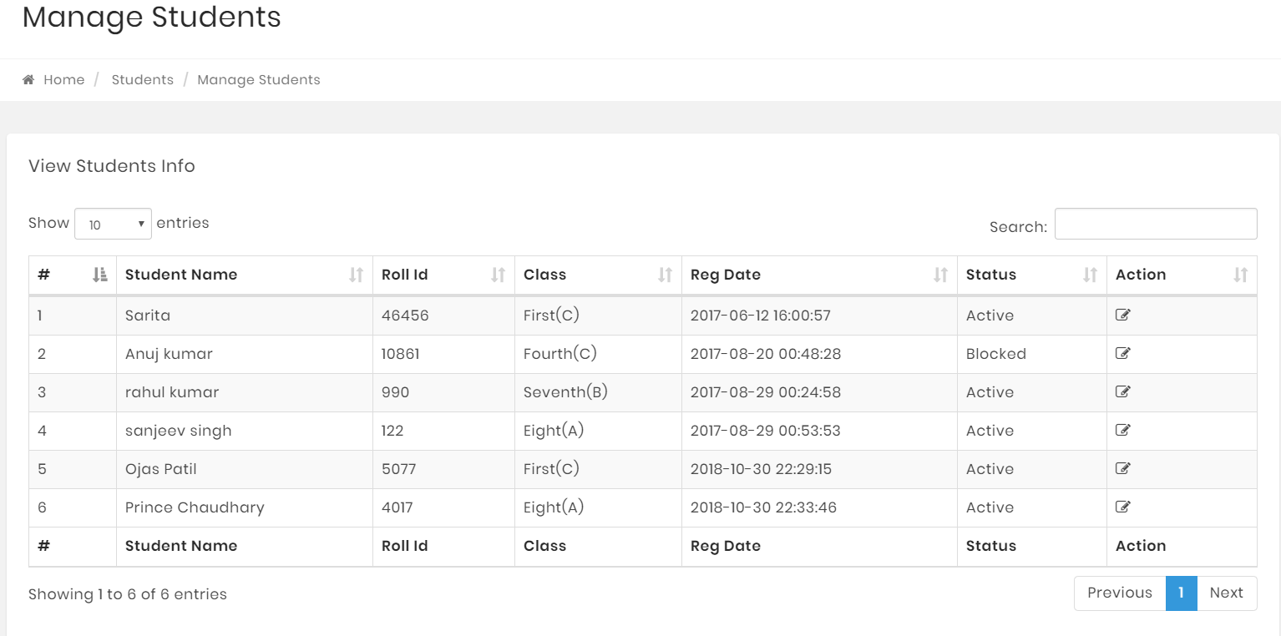

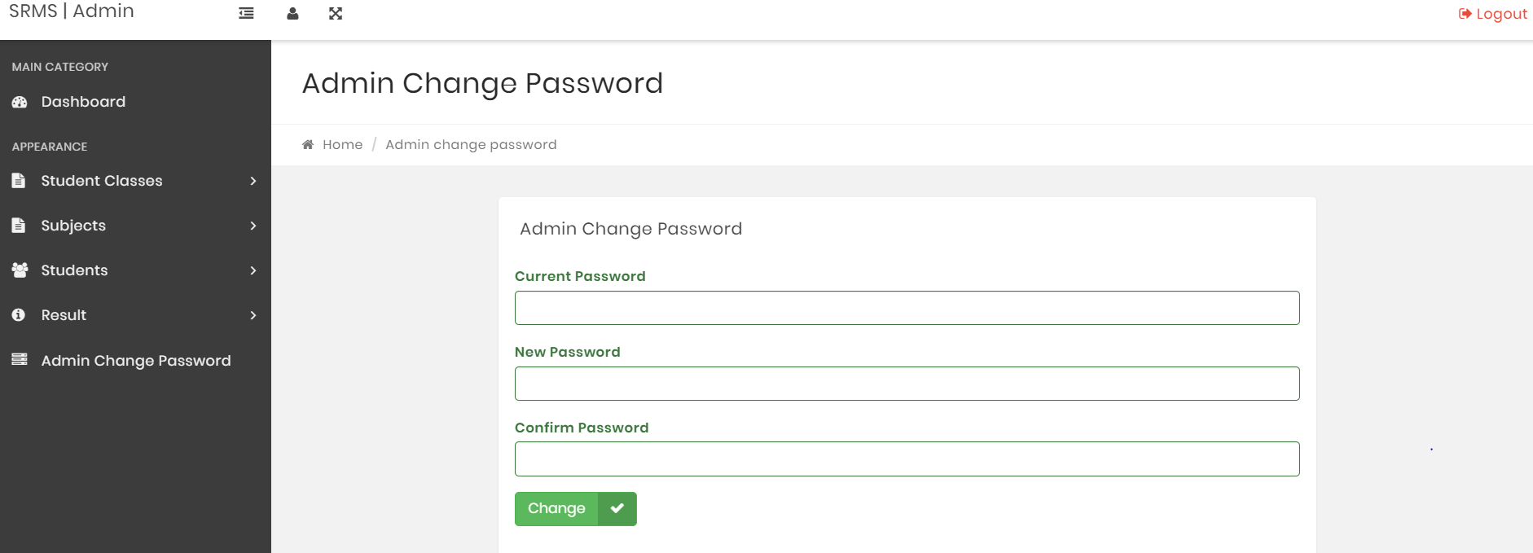

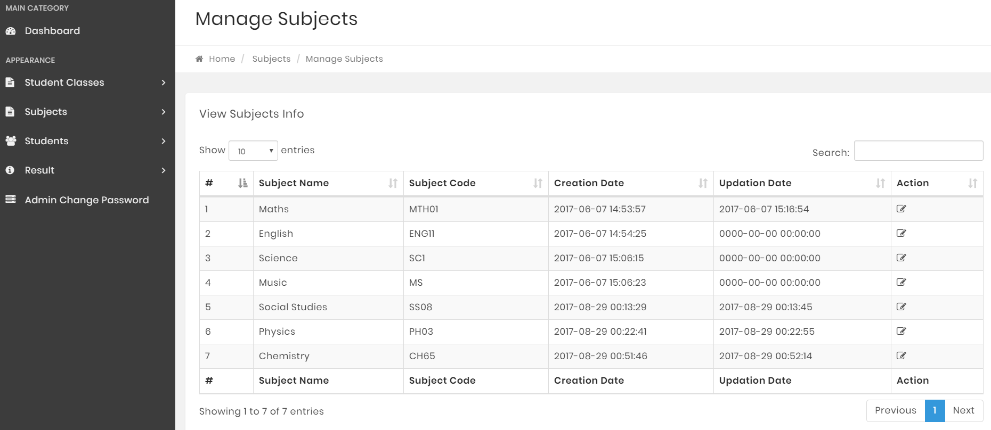

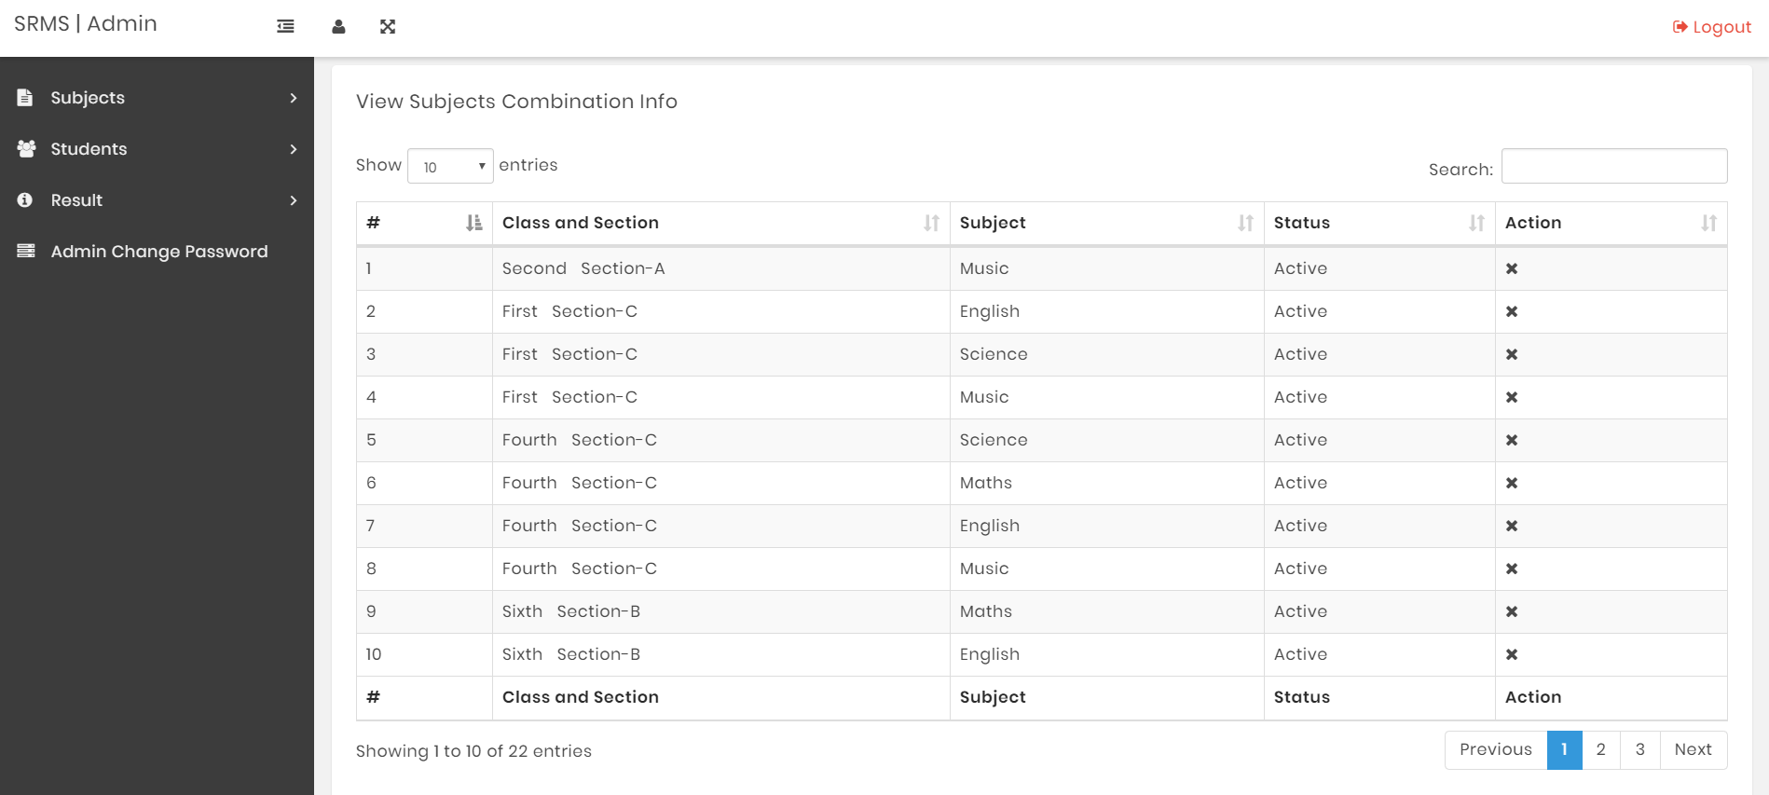

**USERS OF THE SYSTEM :**

**The main users of the system are as follows :**

1.Student:

The Student can login to the system.They can view their result obtained in various courses and also percentage by entering their roll no and class. The Student cannot make any changes to the backend or the database of the system.

2. Administrator:

The administrator plays a vital role in the development of the system. They control the entire database of the web system. The main role of the administrator is to manage the database and can add or delete the Student database that are present on the website.

**USE-FULLNESS OF THE WEBSITE:**

The system will maintain information about various students who will be able to access the system. The following information would be a maintained: roll id,password.

1. security: The application is password protected.students will have to enter correct information to access the application.
2. Maintainability: The application id designed in a maintainable manner. It will be easy to incorporate new requirements in individual module.
3. Portability: The application will be easily portable.

**CONCLUSION:**

The website was created successfully and implemented with all the web pages working and fully functioning. The creation of this website has reduced the load on both the Student and the Admin(User). Only the user with role of teacher will be authorized to access the Marks Information maintenance module and the system will maintain information about various users who will be able to access the system.

**REFERENCES:**

W3schools

Udemy course on web development

Easybib.com