**Task 1 – Predict COVID-19 from routine blood tests:**

3. - The first new feature will be the ratio between Hemoglobin and Red blood cells ($\frac{HGB}{RBC}$) because they are strongly related with the amount of oxygen in the blood.  
 - The second new feature will be the ratio between Leukocytes and Red blood cells ($\frac{WBC}{RBC}$) which is the ratio between white blood cells (the type that fight against infections) and red blood cells.  
 - Another new feature will be the ratio between Lymphocytes and Red blood cells ($\frac{LYM}{RBC}$), which is the ratio between white and red blood cells.  
 - Another new feature will be the ration between Monocytes and Red blood cells ($\frac{MONO}{RBC}$) which is the ratio between immune cells and red blood cells.  
 - Another new feature will be the ration between Neutrophils and Red blood cells ($\frac{NEU}{RBC}$) which is the ratio between immune cells and red blood cells.  
**Results:**

Results without new features:  
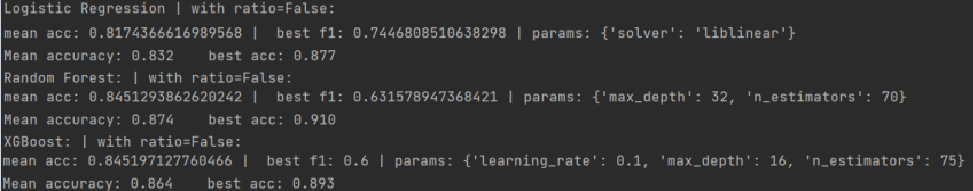  
Results with new features:

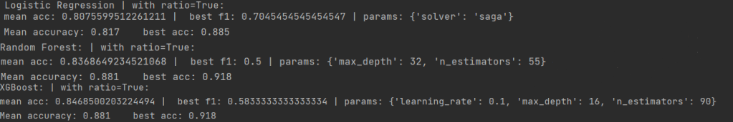  
The mean accuracy rate of the models are +-2% deviation from the results without the new features. However, the hyper-parameters changed.

4. Results:  
LightGMB:  
  
mean accuracy is 84.1%, while the best model with f1 score of 56% with the hyper parameters:  
learning rate = 0.1, max depth = 16 and number of estimators is 85.

CatBoost:



mean accuracy is 82.8%, while the best model with f1 score of 59.2% with the hyper parameter:  
learning rate = 0.05.

5. xgboost

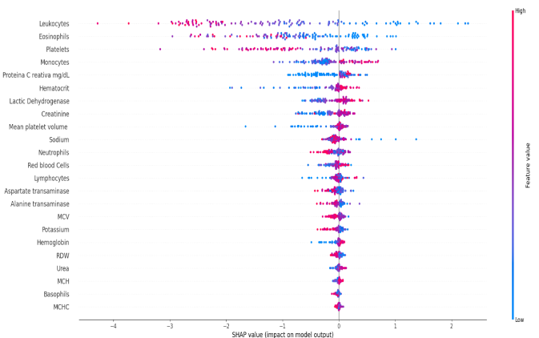

lightGBM:

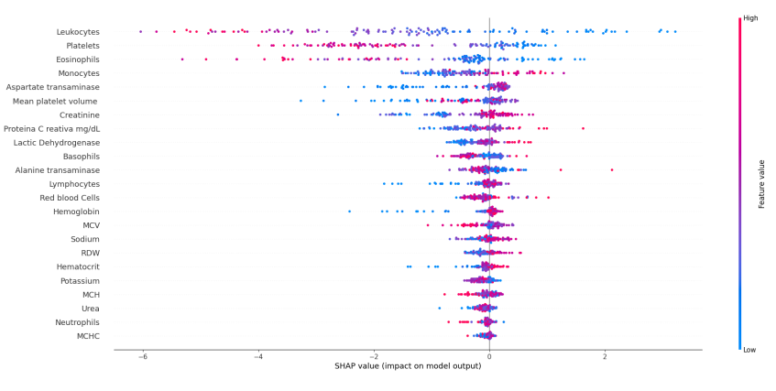

Random forest:

