**Assignment**

1. What are the top 5 hospitals currently have the greatest number of COVID-19 admitted cases (i.e. “Hospitalised”?

By conducting analysis we come to a conclusion of Top 5 hospitals having greatest number of COVID-19 admitted cases.

Below is the sample program for it.

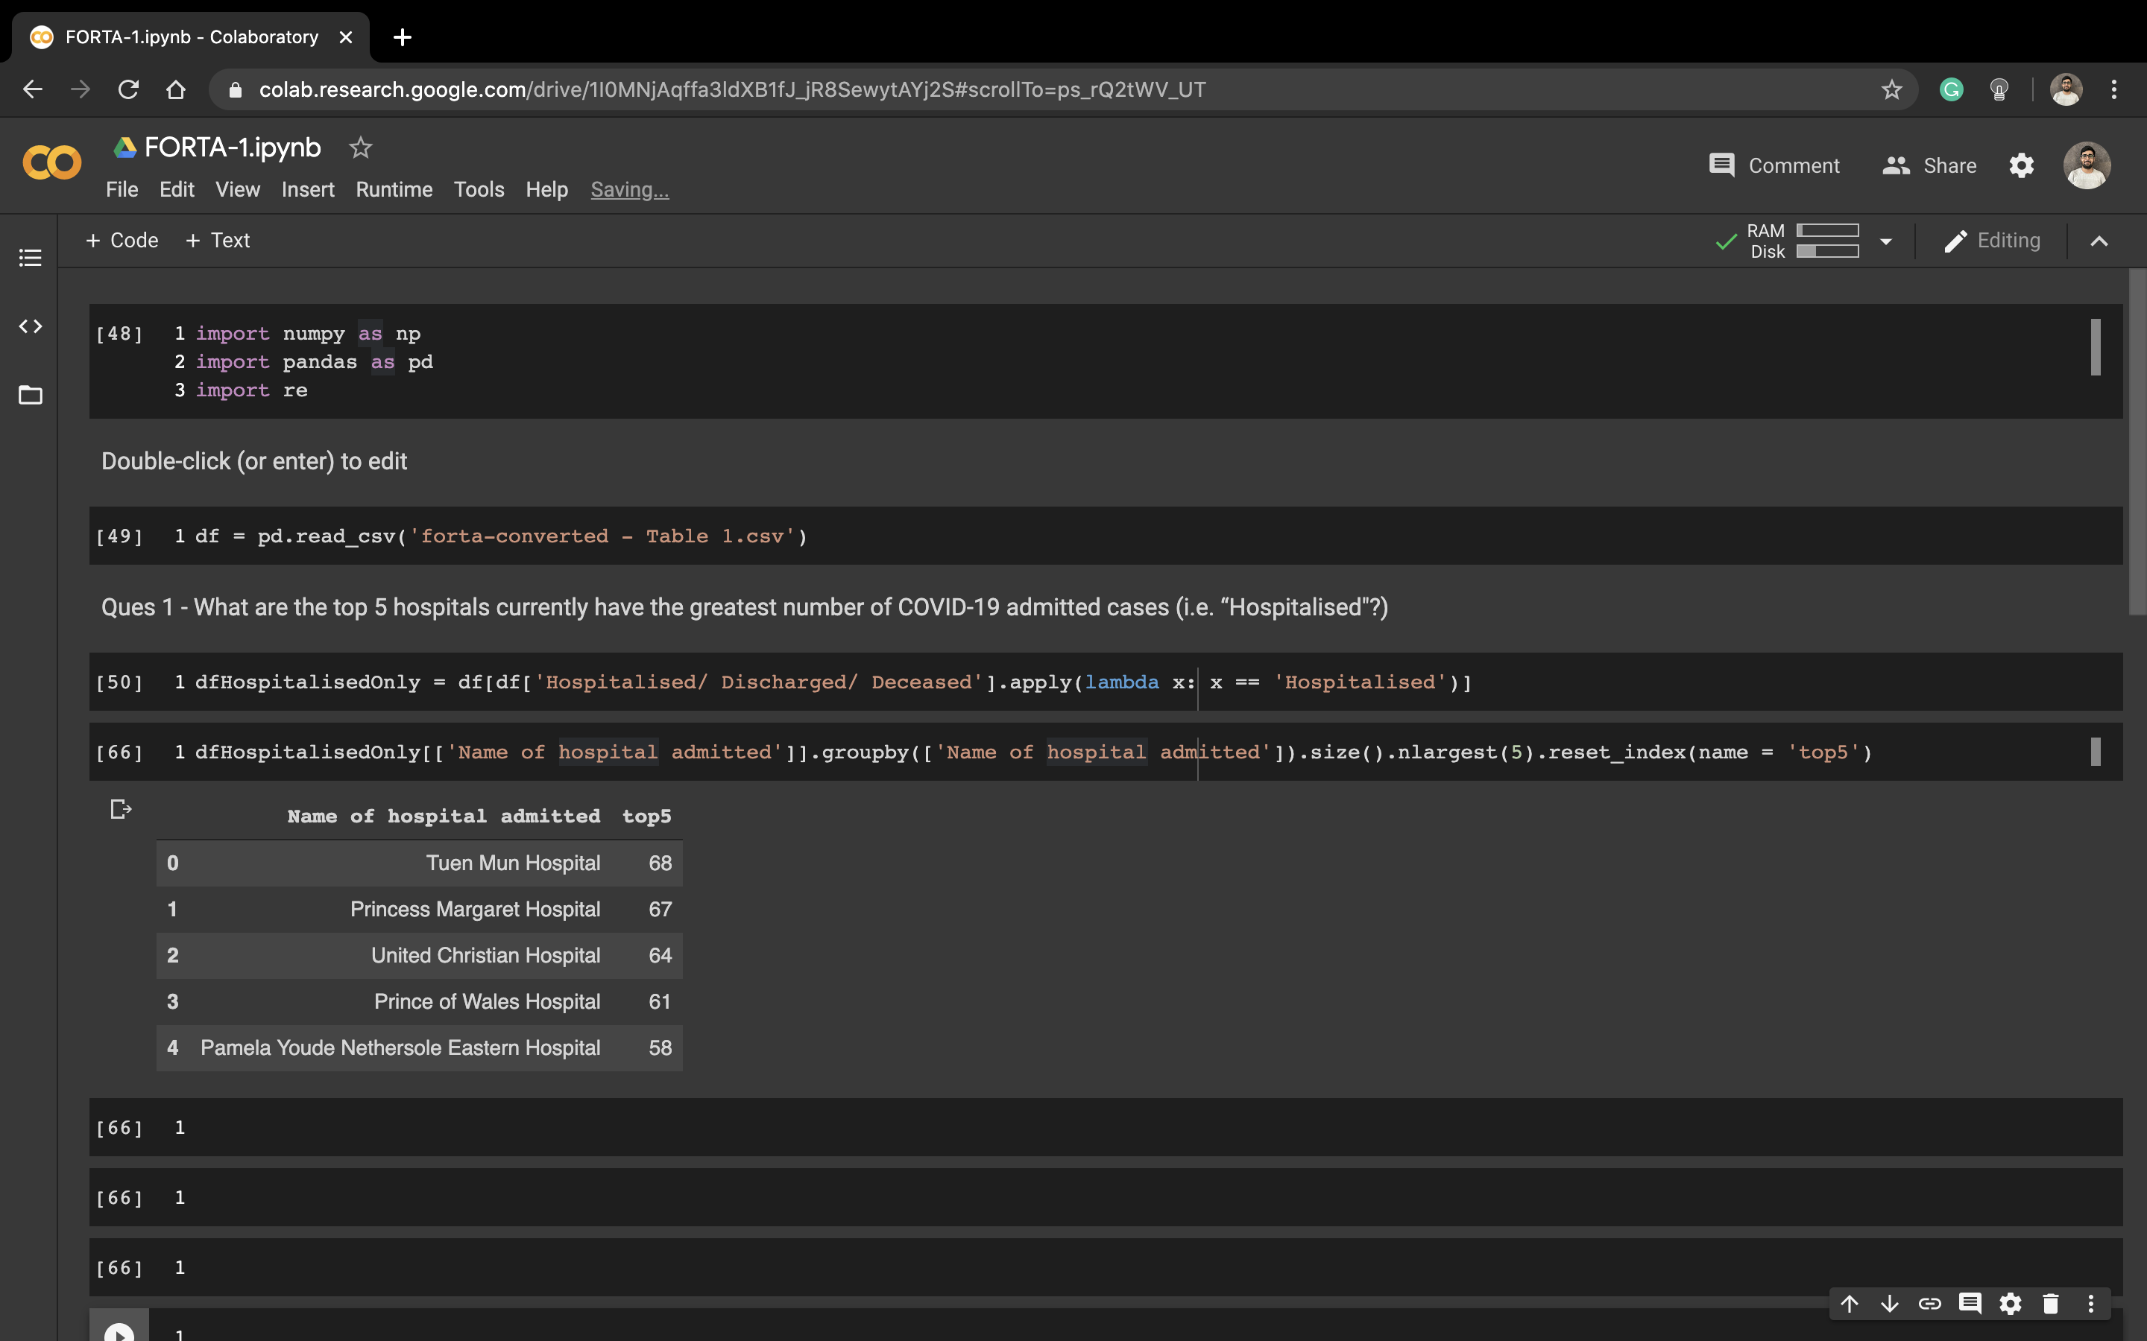

2) What is the average length of time between the date of onset and the report date?

We convert dates difference by converting to their number of days difference.

Below is the sample program for it.

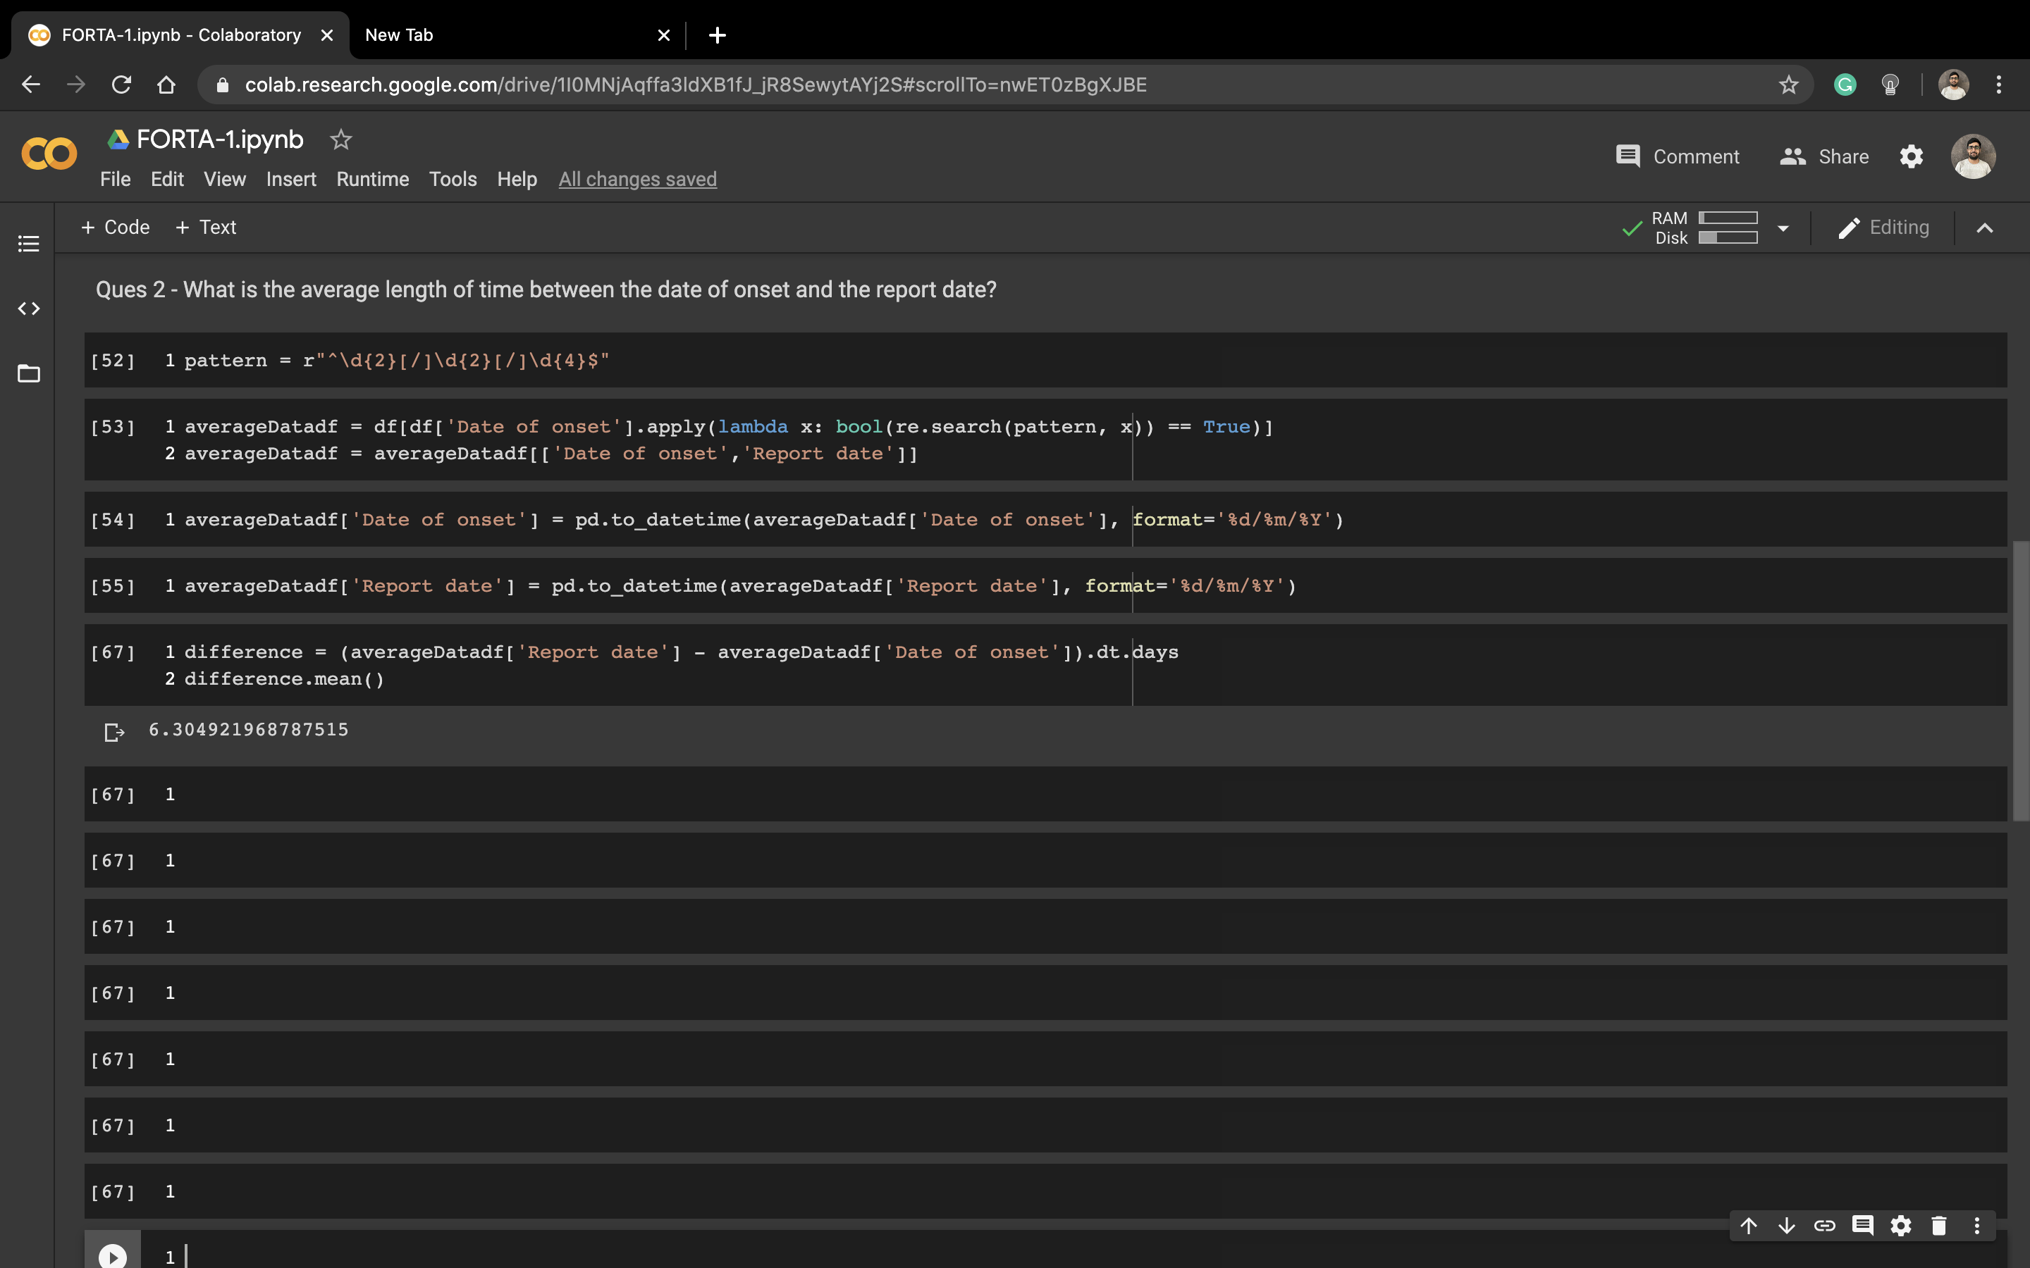

3) Are you able to sort these cases into 4 age brackets, 20-39, 40-59, 60-79 & 80-99 and identify the ratio of discharged to hospitalised in each?

Below is the sample program for it.

