1. Changes to **New Leave Application** from Employees SelfService – Actions to be done are in **red**
2. Changes to **Holiday Setup** - Actions to be done are in **red**
3. **Add New Holiday**
4. **REMOVE/DELETE Holiday**

**Note that location matching is not regarded/required in this removal.**

1. **UPDATE HOLIDAY**

DON’T ALLOW FOR UPDATEOF HOLIDAY – we will run into some complexities; if an update needs to be made, they should remove the holiday and add it again

1. MANAGE EMPLOYEE –

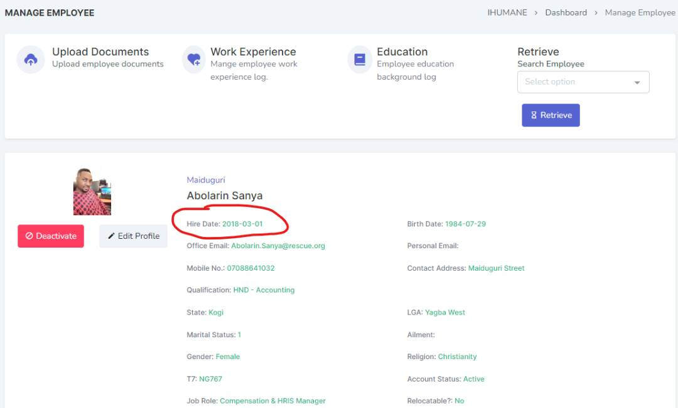

The date here should be gotten from **emp_employment_date** field of the employee table

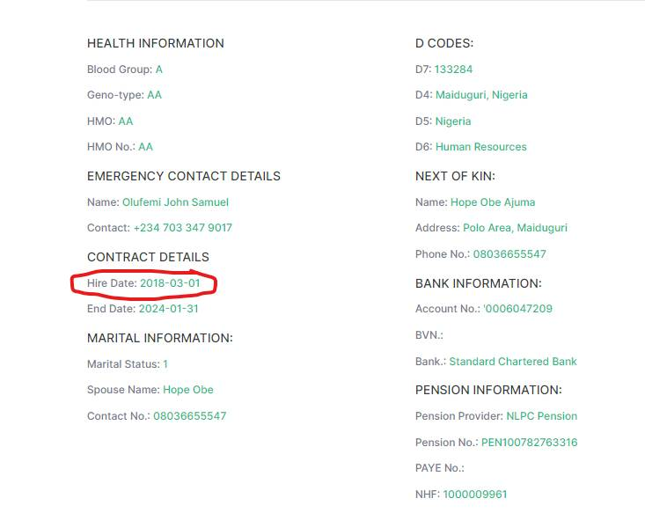

The label here **“hire date”** should be changed to **“Start date”**

1. Update Employee details should be properly logged in a table – it will show the details offormer and current values with date stamp  
   Date | By | EmpId | Activity