|  |  |  |  |
| --- | --- | --- | --- |
| **S/N** | **MODULE** | **REMARKS** | **ACTIONS & CLARIFICATIONS** |
| 1&2. | PROJECTS | Projects should be changed to Program & Activities, for projects is an exclusive term used by the procurement department. Therefore, Project should be a feature under procurement while program and activities should replace Project as seen now. | Duplicate Project, to build a new module “Program & Activities”  Units recommends programs/activities to Directorate which is approved by the DG  **Questions**  Template for recommendation? |
| 3. | PROCUREMENT | Procurements are meant to be specific to Procurement department, similar to Finance, Account and HR that does functions that are meant to be seen by them only and DG. Meanwhile the Legal Dir works with Procurement directly to balance contractor engagement. | To build user permission feature across the module and a setup for it at the Admin module.  **Questions**  What is their procurement sequence? |
| 4. | Contract of Employment | Contract of employment (A form) should be digitised for the legal department to work. Meanwhile, digitised signed docs are not admissible in court, so would always print the form for people to sign. | Will GDrive do this? As private |
| 5. | HR – Leave Form | HR dept should have a general leave form to be kept on the drive for everyone to access whenever they want it even without request. | Will GDrive do this? As private |
| 6. | ICT Department | All onboarding takes place at the ICT departments. | We have admin module for this |
| 7. | OFFER OF EMPLOYMENT | Offer of employment should be digitised for staff to fill and save in their registry. | Will GDrive do this? |
| 8. | PROFILE UPDATE | There are sub-units under unit, can we have staff fill in their Directorates, Units and an optional sub-units while they are being onboarded, this would help HOD’s to sometimes direct MEMO to specific units in the HQ or regions as the case may be. E.g. SSD kano, so I can create a group called SSD Kano and I can click on it for all staff in the SSD Kano units to receive specialised message. | We need and update on the proper structure for NSIB from Region, Dept, Unit and Sub-Unit etc |
| 9. | MEMO | We should change the memo sign on Initiator and reviewer addressed as —  FROM ---- THROUGH ------ TO | Creating new memo – Label Issues  Office Recipients = TO: Change Review to Through and make it multiple Change Signed By to From |
| 10. | MEMO | When you (staff) sends a memo and it is rejected by the HOD due to false info and the likes, where the HOD rejects the MEMO and won’t sign, there should be a comment section where the HOD meant to sign that is rejecting it to tell why through the comment section to the staff raising the MEMO. | Comment to reject memo to be added Rejection can be done by either the through(reviewer) or the From (Signee)  Memo recipients can a |
| 11. |  | In place of the workflow process, the term should be changed to proprietary NSIB terms used. Such as   1. Expense to be called cash refund / RETIREMENT 2. Purchase request to be called cash advance 3. Impress   Furthermore, the most important part of the workflow is called DTA. where request for fund, travel expense, training expense and the likes are requested and paid for. This would require we include a table button in the workflow section or easiest thing to do may be to upload the form as seen. | Provide template for all the type of requisition |
| 12 | FLEET | LOT is in charge of driver and vehicles, we need to be able to order for vehicles often, requesting for vehicle is a major problem in the organisation. So we need a button that allows us to request for vehicle or drive in the fleet section. | A new module, to get the parameter for logging this request  Template requested. |
| 13 |  | HOD should be able to see all projects, reports and the likes created by every member of their dept, if HOD does not approve it should never leave the system. Also, nobody should ever send a message to the DG or outside the Dept without the HOD approval. If the HOD disapproves, there should be a comment section where the HOD should state the reason(s) where he/she is rejecting it. |  |
| 14 |  | SSD have lots of files to be digitised, but investigation reports has to be done per state but it done one after the other without interference, then posted to the next supervising state to investigate and approve before it is posted finally. E.g. in the event of an accident, Lagos needs to be done entirely with their investigation without interference, then reports would be sent to supervising state (for example Kano), then Kano concludes theirs and then submit on the platform before Abuja approves and it is done. |  |

**BRIEF**

1. USER RIGHTS AND PERMISSION

1. To Create “User Permission” module in the ADMIN Module under “Employees” Module
2. List all Users with action icon/button to reset user account password and update permission (Username | Employee Name | Email | Directorate | Unit).
3. Permission list (toggle on or off) and tied to the modules  
   Memo | Circular | Notices | Workflow | Task | Training | Fleet Setup | Fleet Maintenance | G-Drive | Programs | Projects | Procurement | Contractors | Finance | HOD | Cash Retirement | Auth Cash Ret | Approve Cash Ret | Memo Approval |  
     
   Note that if a user doesn’t have memo permission, then you cannot be selected as a recipient of Memo.

2. HOD toggle makes you selectable as a Memo Signatory, Circular Signatory, Notice Signatory, Reviewer or Through…

3. Duplicate Projects module. Keep the duplicate copy under procurement module and change the original to Programs & Activity

The new Programs and Activity screen

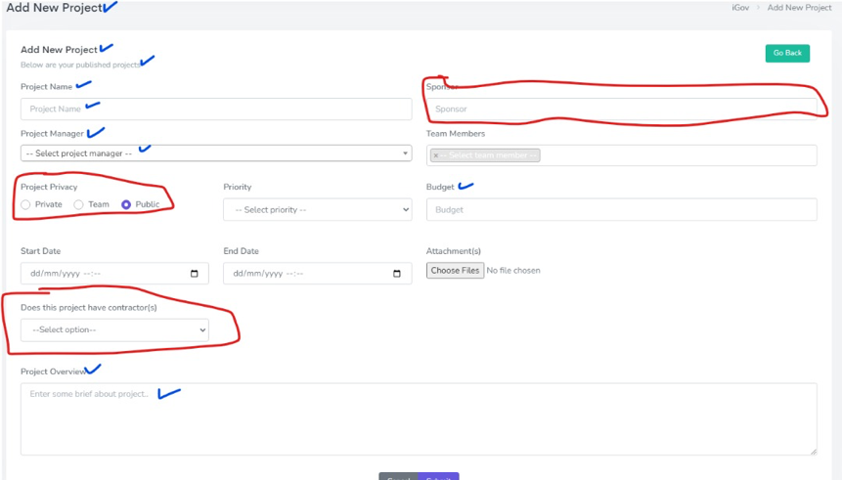Take off the field in red and change the labels of those ticked in blue to reflect programs not project anymore.

Budget to change to Estimated Budget.

Please use a new table keep and track this module. - don’t use the existing project table

The view option should be reorganized adequately to reflect program like the new program screen and ability to forward to the next responsible officer. Note that you can only be selected as next responsible officer here of u have HOD status

4. Memo

Change labels ticked in blue  
1. Offices/Recipients = To 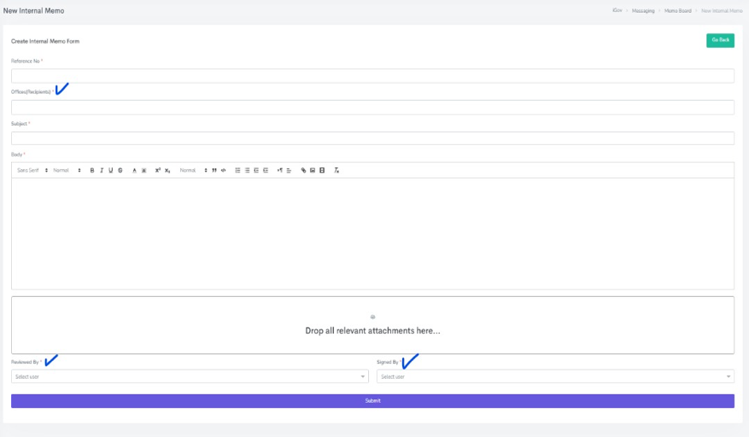

2. Reviewed By = Through (to allow multiple user selection; Note that they will all have the privilege of seeing this memo together with the signatory before broadcast to the recipients. The listed of users to show are all HOD status users as define in user permission)

3. Sign By = From(Signatory) (the list of user to show here is the HOD status holder of the initiators department – e.g cswitch - if you are the initiator, it checks your department and checks user in your department that has HOD status in permission and list them)

Some memo requires approvals (we can capture this at the point of signing. The user to compulsorily indicate if the memo requires approval or not)

The direct recipient of the MEMO has to approve or decline if the memo requires approval. Approval action will be possible when view the memo   
  
Under My Memo and Memo Board, we will now have Approval Status for such memos. Approval stamp for the “board”, text status for “My Memo”

5. Project module under procurement – submission of final report throwing errors

6. Procurement – Comment out the “Bids” submodule

7. To create a new Module called “Cash Retirement | Authorize | Approve” under e-Office.

Onclick, it gives you a list of retirements (data table) raised by the user that logged in and a button to raise new retirement.  
the list sample - [SN|TITLE|REQUEST DATE| STATUS|AMOUNT] with an action icon to view details.

New Form

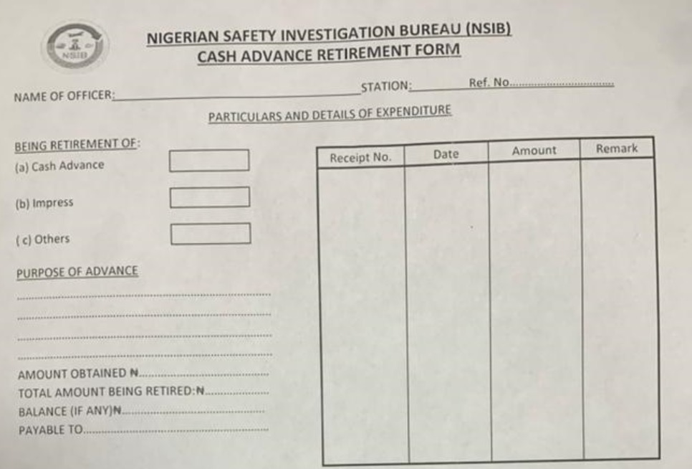Ignore Name and Station fields; SUBSTITUTE WITH SUBJECT.   
Note that the table in there is a line by line entry – meaning there will be master and details table.

Purpose will be a textarea

All other amount fields will be currency formatted

On submission it should have a status field (Pending|Authorised|Approved) – a new submission is pending.  
  
It moves to Authorization Module and then Approval Module – it can be declined in each of the stages.  
  
You can only have access to the modules if you are granted from the permission module.