LayIt Laser

Illustrated Assembly Guide
Never soldered before? No problem.
Every step has a diagram. Every wire has a color.
Every component looks like the real thing.

The Big Picture
Before diving in, here's how everything connects. We'll build it one piece at a time.
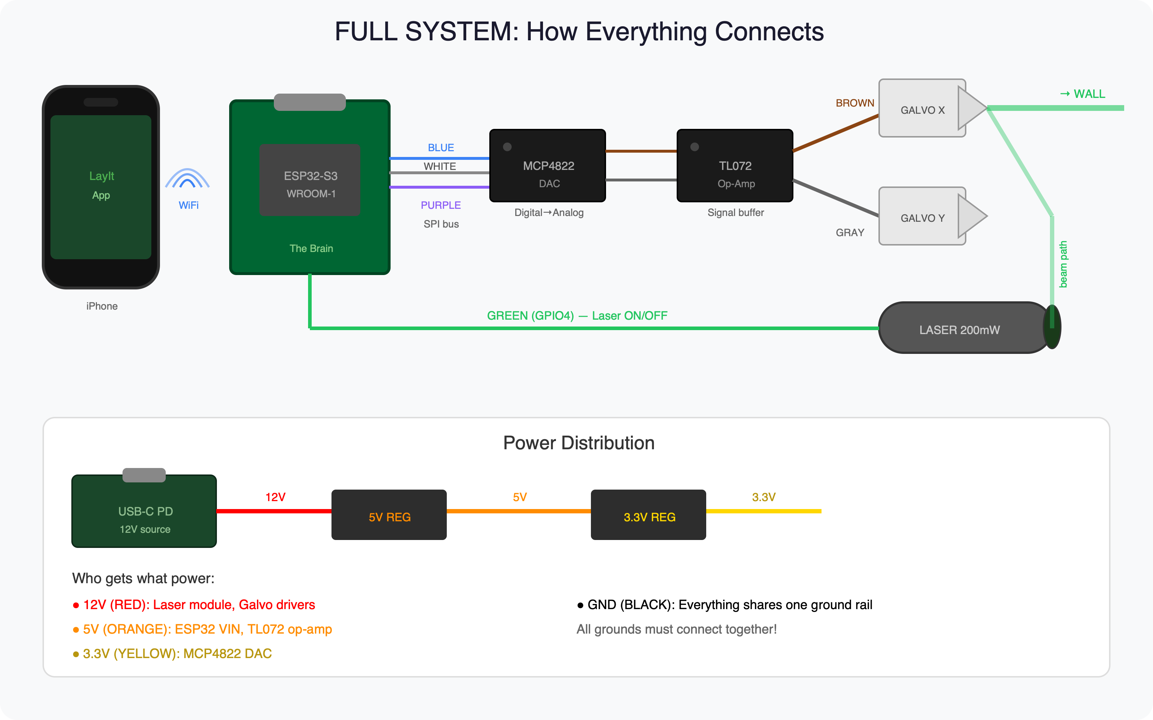

Step 1: Power Supply
Goal: Get 12V from USB-C, split into 12V, 5V, and 3.3V rails. Like a house with 3 electrical circuits.

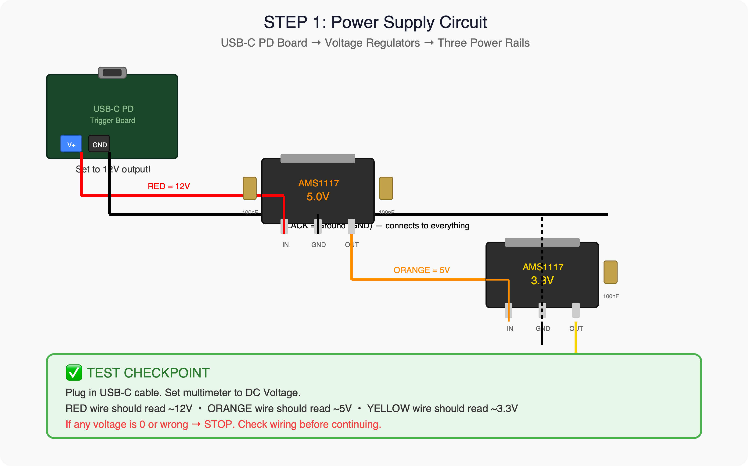

Voltage regulators are like water pressure reducers. 12V comes in, the regulator steps it down to 5V or 3.3V so it doesn't fry the ESP32 or DAC.

Step 2: The Brain (ESP32-S3)
Goal: Power up the ESP32 — the green circuit board that receives tile coordinates from your phone via WiFi and controls everything else.

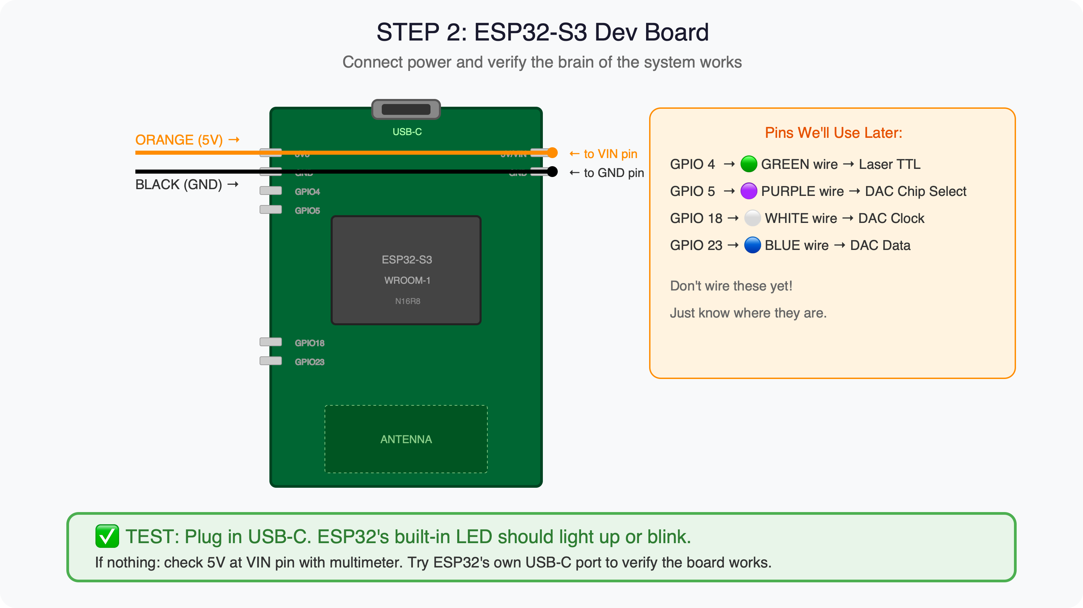

GPIO pins are the numbered pins you program to send signals. GPIO 4 = laser on/off. GPIOs 5, 18, 23 = talk to the DAC chip.

Step 3: DAC + Op-Amp (The Translator)
Goal: Convert digital numbers from the ESP32 into analog voltages that physically move the galvo mirrors. Two tiny black chips with 8 legs each.

⚠️ Find the pin 1 DOT on each chip before inserting! Backwards = fried chip.

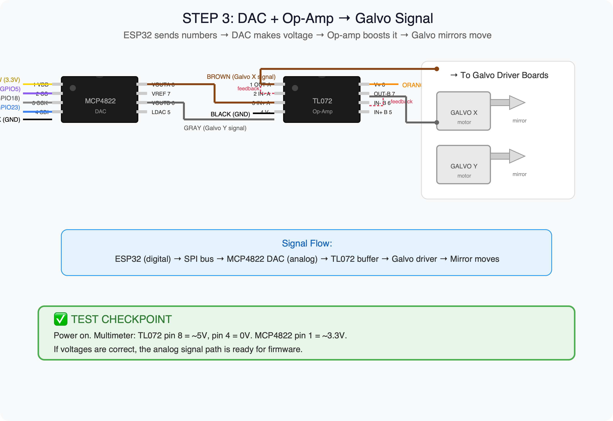

Step 4: The Laser
Goal: Wire the laser module — a metal cylinder the size of your thumb. Three wires: RED (12V power), BLACK (ground), GREEN (ESP32 on/off control).

⚠️ LASER SAFETY: 200mW causes instant eye damage. Goggles ON. Tape laser to table pointing at wall. Never look into beam.

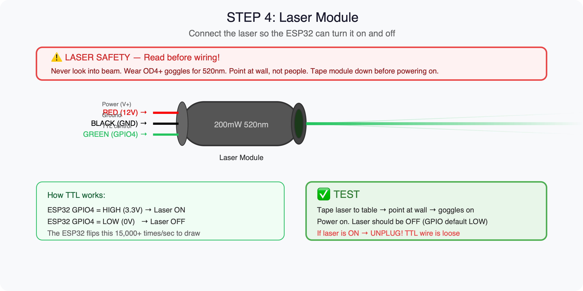

Step 5: Mount Galvo Scanners
Two small motors with mirrors. One steers left/right (X), one steers up/down (Y). Together they draw patterns.
- BROWN wire (from op-amp output A) → X driver signal input
- GRAY wire (from op-amp output B) → Y driver signal input
- RED (12V) + BLACK (GND) → each driver board power
Align mirrors so laser beam bounces: laser → mirror 1 → mirror 2 → out the hole in the case. Takes 10-15 min of nudging.

Step 6: Flash Firmware & First Test
Install Arduino IDE (free). Open the test firmware .ino file I'll write for you. Select ESP32S3 Dev Module. Click Upload. Put on goggles. Power on.

What you should see:
"Green SQUARE on wall" → 🎉 You built a laser projector!
"Green LINE" → One galvo axis dead — check BROWN or GRAY wire
"Green DOT" → Neither galvo responding — check DAC wiring
"Nothing" → Check power, check firmware upload, try ESP32 USB

Every tile in its perfect place.
SIMCO Inc. • Patent Pending

