Congratulations! You've built your first model, a neural network to predict bike share usage! As you saw in the project, the data was split into training, validation, and test sets. In this section we'll learn why this is needed, and how to find out how well your model is doing, and score it. In particular, you will cover:

* How to create a test set for your models.
* How to use confusion matrices to evaluate false positives, and false negatives.
* How to measure accuracy and other model metrics.
* How to evaluate regression.
* How to detect whether you are overfitting or underfitting based on the complexity of your model.
* How to use cross validation to ensure your model is generalizable.

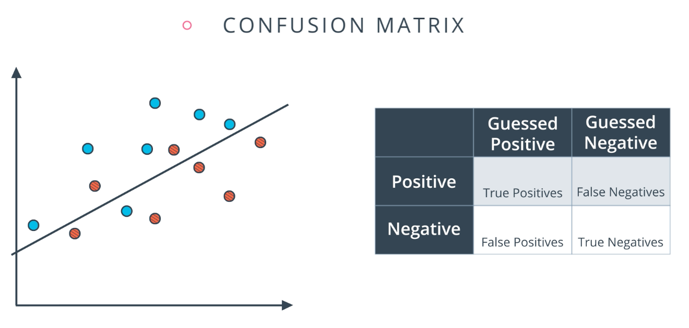

**Confusion Matrix Quiz**

What is the number of True Positives, False Negatives, False Positives, and True Negatives, in the model above? Please enter your answer as four numbers separated by a comma and a space. For example, if your answers are 1, 2, 3, and 4, enter the string 1, 2, 3, 4.

Remember, in the image above the blue points are considered positives and the red points are considered negatives.

6, 1, 2, 5

RESET

NEXT

# Sentiment Analysis

As you follow along this lesson, it's extremely important that you open the Jupyter notebooks and do the exercises. Much of the value in this experience will come from seeing how your solution is different from Andrew's and playing around with the code in your own way. Make this lesson count!

At the bottom of this page, you'll find a zip file that extracts into a folder with the following files:

* A notebook for each mini project.
* A notebook for the solution for each mini project.
* labels.txt.
* reviews.txt.

Before jumping to the next video, be sure to do the following:

1. Activate a python3 conda environment. In this environment, you'll need to have installed numpy, jupyter notebook, matplotlib, scikit-learn, and bokeh.
2. Download and unzip the file at the bottom of this page.
3. Change directories into the unzipped folder.
4. Start up your Jupyter notebook server.
5. Open Sentiment Classification - Intro.ipynb.

Read the introduction to see the lesson outline and the prerequisites.

#### Supporting Materials

# Dying RELU

<http://datascience.stackexchange.com/questions/5706/what-is-the-dying-relu-problem-in-neural-networks>

<https://www.quora.com/What-is-the-dying-ReLU-problem-in-neural-networks>