*Sports Nutrition Inventory System*

User Manual

Table of Contents

1. *Adding* (pg. 3 - 5)
   1. Adding a new Location (pg. 3)
   2. Adding a new Category (pg. 5)
   3. Adding a new Item (pg. 5)
2. *Deleting* (pg. 5 – 6)
   1. Deleting an Item (pg. 5)
   2. Deleting a Discarded Item (pg. 6)
3. *Discarding* (pg. 6 – 7)
   1. Discarding an Item (pg. 6)
4. *Moving* (pg. 7 - 8)
   1. Moving Product Between Locations (pg. 7)
5. *Navigation* (pg. 8)
   1. Searching/Sorting (pg. 8)

* *Adding*:

1. Adding a new Location
   1. To add a new location, the user must first toggle the side menu. This can be done by clicking the button with three vertically stacked lines located directly next to the home button in the top left corner.

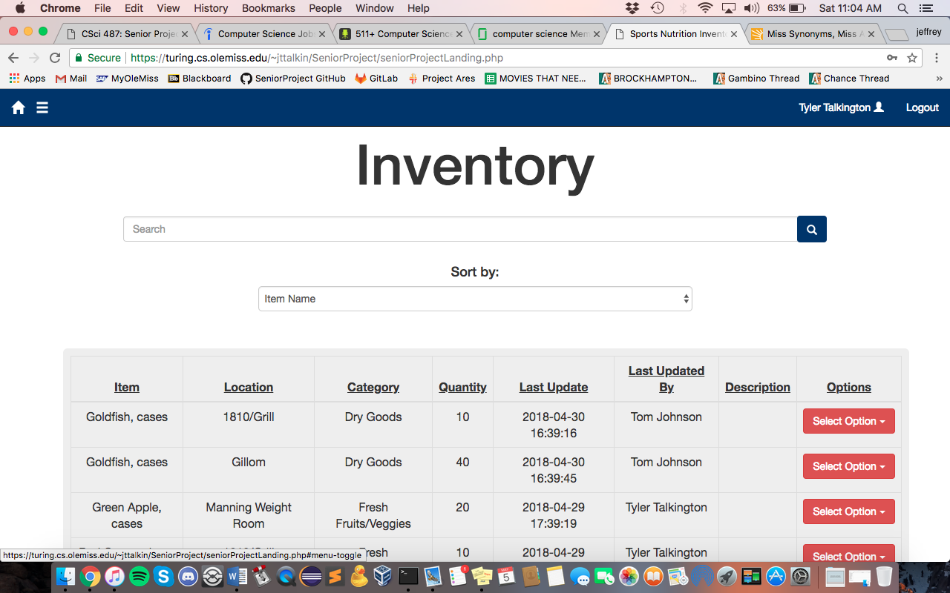

* 1. Now that the side menu, is toggled, the user should now see something like this.
  2. 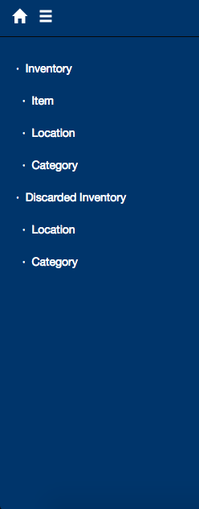Clicking on the location section under the Inventory tab will present a list of all of the current locations, along with an option at the bottom of the list to “Add Location”.
  3. Clicking this “Add Location” button should redirect to new page, where the user can enter the name of the new location to be added (\*Note: do not use apostrophes here. This causes a strange error in how the data is stored. Using just letters and spaces should work just fine. \*)
  4. Upon clicking the “add” button, the user should see an alert at the top, either confirming that their location has been added, or that there has been some type of error otherwise.

1. Adding a new Category
   1. Adding a category follows the same set of instructions as adding a location, instead of clicking the location tab and clicking “Add Location”, the user will use the category tab and “Add Category” button respectively. (\*Note: see Add Location instructions above for further elaboration \*)
2. Adding a new Item
   1. After toggling the side menu, there should be an Item located directly under the Inventory tab.
   2. Clicking this item tab will give a dropdown selection to “Add Item”.
   3. Clicking “Add Item” will redirect to a new page where the user can enter the item name, select the location and category from a dropdown menu, and of course the quantity of the item.
   4. Clicking the “Add” button will redirect to the main page, with an alert either confirming or denying the addition of the item.

* *Deleting*:

1. Deleting an Item
   1. When viewing the inventory tables, there are attributes such as name, location, quantity, etc. The furthest column to the right in this table is labeled “Options”. Clicking this “Select Option” button will trigger a dropdown menu, giving the ability to “Edit/Update”, “Move”, “Discard”, and “Delete”.
   2. 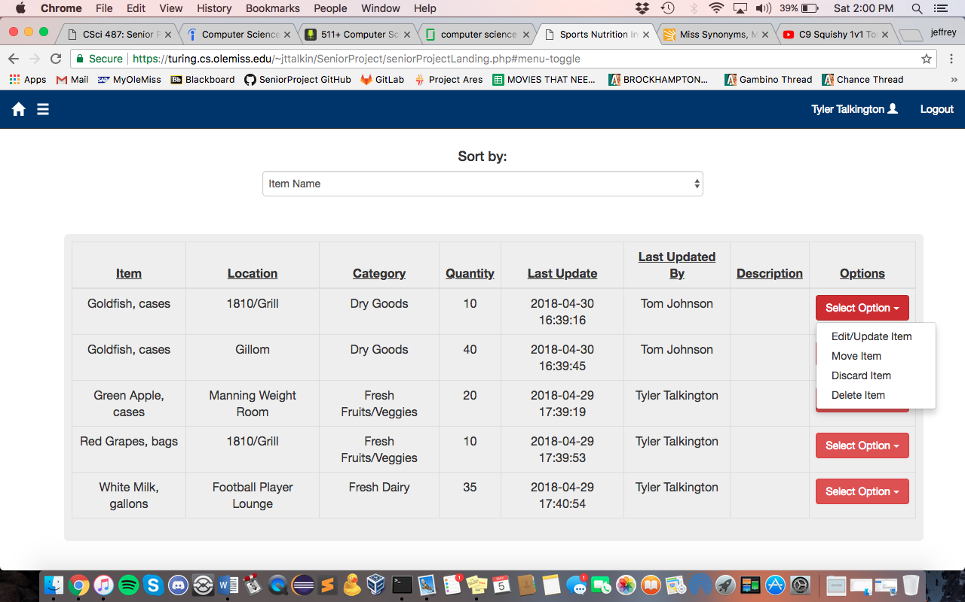Clicking the “Delete Item” button will refresh the page, with an alert either confirming or denying whether the delete action has been completed or not.
2. Deleting a Discarded Item
   1. Deleting a discarded item follows the same steps as deleting a regular item, with the only exception being that the user must first navigate to a Discarded page. This can be done by selecting the “Discarded Inventory” button on the side menu, or selecting a Discarded location or category listen underneath the “Discarded Inventory” option.

* *Discarding:*

1. Discarding an Item
   1. To begin to discard an item, navigate to the “Select Option” dropdown mentioned above in the “Delete” portion of the menu. Choose the “Discard Item” selection for the particular item to be discarded.
   2. Clicking this redirects to a new page, where the user will continue by inputting the discard amount and an optional description of why the item is being discarded if needed.
   3. Clicking the “Discard Item” button should redirect back to the home page, with an alert of whether the discard was confirmed or denied.

* *Moving:*

1. Moving Product Between Locations
   1. To begin to move some quantity of an item to a new location, navigate to the “Select Option” dropdown mentioned above in the “Delete” and “Discard” portions of the user manual. Choose the “Move Item” selection for the particular item to be moved.
   2. Clicking this should redirect to a page where the user can continue to select the new location of the moving product, the quantity desired to be moved, and an optional description of why the move has taken place, if so desired. (\*Note: moving quantities of an item will only work if there is another item of the same name already created but with a different location associated with it. If this is not the case, be sure to create a new item with the same name but place into a different location to proceed \*)
   3. Clicking the “Move Product” button should redirect the user back to the home page, with an alert that either confirms or declines the move request.

* *Navigation:*

1. Searching/Sorting
   1. On any page that is presenting a table of data, there is a search bar and dropdown selection at the top middle of the page.



* 1. The search bar is for filtering through the items in the inventory by searching for keywords. The dropdown is for selecting how the user would like the data to be sorted, such as by item name, location, category, quantity, or last update made. These can be used individually or compounded together to make filtering through the inventory system as straightforward and simple as the user desires. Both of these updates can be triggered by changing something and clicking the blue search button directly to the right of the search bar.