

UNIX

A quick introduction
Contents
Introduction to Unix 1
What is Unix? 1
Types of Unix 1
The Unix operating system 1
Files and processes 2
The Directory Structure 3
Starting a Unix terminal 3
Listing files and directories 4
Creating Directories 6
Changing to different directories 6
The abbreviated directories . and .. 6
Pathnames 8
Home directories and pathnames 8
Making links 9
Summary 10
Copying Files 11
Moving files 11
Deleting files and directories 11
Displaying to the screen 12
Searching the contents of a file 13
Summary 14
Redirection 14
Summary 17
Wildcards 17
Filename conventions 18
Getting Help 18
Summary 19
File access rights 19
Changing access rights 20
Processes and Jobs 21
Suspended and background processes 22
Killing a process 22
Summary 23
Other useful commands 24
Unix variables 26
Environment variables 26
Shell variables 27
The difference between PATH and path 27
Using and setting variables 27
Setting shell variables in the .cshrc file 28
Setting the path 28

Introduction
This workbook has been prepared to help users who [wish to use any variety of the Unix operating system.
This guide can be used as a reference or tutorial document. To assist your learning, a series of practical tasks are available in a separate document. You can download the training files used in this workbook from the IS training web site at: www.ucl.ac.uk/isd/common/resources
We also offer a range of IT training for both staff and students including scheduled courses, one-to-one support and a wide range of self-study materials online. Please visit www.ucl.ac.uk/isd/common/resources for more details.
Introduction to Unix

What is Unix?
Unix is an operating system designed for use on servers and workstations (whether these are PCs, dumb terminals or laptops, or any other computing device). It is a multi-tasking, multi-user system.
Some Unix systems have a graphical user interface (GUI) or Graphical Desktop Environment similar to Microsoft Windows or Mac OS. Nonetheless, to take best advantage of Unix it is worth knowing something about how to use the system without the GUI.
Many Unix systems are released under one or other of the ‘free’ software licences, such as the GPL. Because of this they provide a cheap way to get a powerful operating system.
Unix is also part of the underlying technology of the Internet. Although no operating systems has any exclusive claim to the Internet, many of the standard technologies, protocols and applications that make up the Internet were first developed on Unix systems. Unix is also an attractive tool for internetworking because it was designed to be a mult-user system from the outset. The vast majority of the web servers that serve up the World Wide Web for example run a program called Apache under Unix.

Types of Unix
There are many different flavours of Unix but they all have much in common and many of them have a standard core of functionality that is identical. Some popular flavours of Unix are
- Solaris
- GNU/Linux
- MacOS X
- BSD
The unity in diversity of Unix systems means that it is easy to develop applications which can run on many different hardware platforms. Although the different Unixen are not identical, programs can usually be easily adapted or simply cross compiled to run on systems other than that for which they were originally developed.

The Unix operating system
Unix is made up of three components
- the kernel;
- the shell; and
- programs.

The kernel
The kernel of Unix is the heart of the operating system. It allocates time and memory to programs and handles the filestructure and communication betweeen the different parts fo the computer system.
The shell and kernel work together like this:
- a user types rm myfile to delete a file;
- the shell finds the program rm;
- the shell instructs the kernel to run the program rm on myfile;
- When the program finishes the kernel passes control back to the shell and displays the Unix prompt.

The shell
The shell is an interface between the user and the kernel. It resembles the ‘dos box’ that Windows displays if you run the command cmd. When a user logs in the login program checks the username and password, and then starts another program called the shell. The shell is a command line interpreter (sometimes called a CLI). It interprets the commands the user types in and arranges for them to be carried out. The commands are themselves programs: when they terminate, the shell displays another prompt (%).
There are a variety of shells available for the various Unix systems. The expert user can customise their own shell and users can use different shells on the same machine.
The tcsh shell has certain features to help the user inputting commands and I will use it in this course. Two useful tcsh features are:
- Filename Completion - by typing part of the name of a command, filename or directory and pressing the [TAB] key, the tcsh shell will complete the rest of the name automatically. If the shell finds more than one name beginning with those letters you have typed, it will beep, prompting you to type a few more letters before pressing the tab key again.
- History - The shell keeps a list of the commands you have typed in. If you need to repeat a command, use the cursor keys to scroll up and down the list or type history for a list of previous commands.
You can start a tcsh shell by typing tcsh at the prompt. I assume in what follows that you are using tcsh.

Files and processes
Everything in Unix is either a file or a process.
A process is an program that is currently running and is identified by a unique PID (process identifier).
A file is a collection of data that can be refered to by name. Files are created by users using text editors, running compilers etc or indirectly by running some program (for example processing a text input file to produce a formatted file for printing).
Examples of files include:
- a text document (a report or essay etc.) ;
- the text of a program written in some programming language such as C++ or Java ;
- instructions comprehensible directly to the machine and incomprehensible to a casual user, for example, a collection of binary digits (an executable or a graphic file);
- a directory, containing information about its contents, which may be a mixture of other directories (subdirectories) and ordinary files. Directories can be thought of as the analogue of Windows’ folders.

The Directory Structure
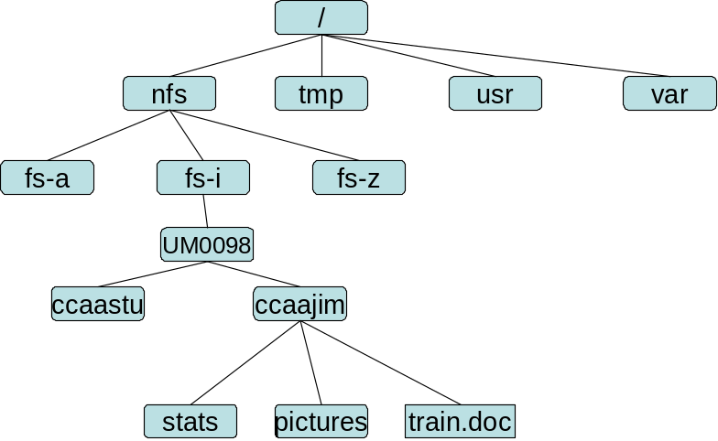
All Unix files are grouped together in a single directory structure. The file-system is arranged in a hierarchical structure like an inverted tree. The top of the hierarchy is traditionally called the root (written as a slash ‘/’ )

In the diagram above, we see that the home directory of the user ccaajim contains two sub-directories (stats and pictures) and a file called train.doc.
The full path to the file report.doc is /nfs/fs-i/UM0098/ccaajim/train.doc
This is rather different from the view you get of a Windows file structure. Unix integrates all the files into one directory structure rather than listing different physical storage devices each with its own root. The filestructure is logical rather than physical. If the computer had a CD ROM drive then it might appear as a folder under, say, nfs, called cd.
Listing files and directories

ls (list)
When you login you are in your home directory. This directory is associated with your userid, for example, ccaajim, and it is where your personal files and subdirectories are saved.
To find out what is in a directory, type
% ls
The ls command lists the contents of your current working directory. On WTS this is the same as your R drive.
You should find the file science.txt in the root of your R drive. Use the ls command to locate it.
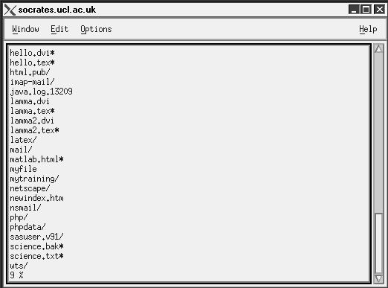
There may be no files visible in your home directory, in which case, the Unix prompt will be returned. Alternatively, there may already be some files inserted by the System Administrator when your account was created.
ls does not, in fact, cause all the files in your home directory to be listed, but only those ones whose name does not begin with a dot (.) Files beginning with a dot are hidden files and usually contain important program configuration information. They are hidden because you should not change them unless you are very familiar with Unix.
To list all files in your home directory including those whose names begin with a dot, type
% ls -a
As you can see, ls -a lists files that are normally hidden.
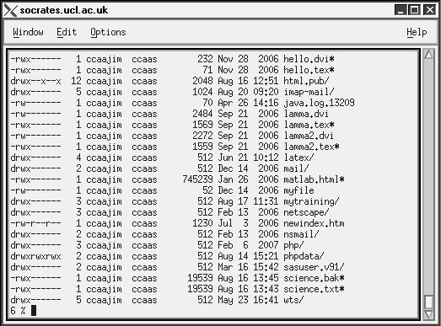
ls is an example of a command which can take options: -a is an example of an option. Options change the behaviour of command s. There are online manual pages that tell you which options a particular command can take, and how each option modifies the behaviour of the command. (See man and apropos later in this workbook) .
Creating Directories

mkdir or md (make directory)
We will now make a subdirectory of your home directory to hold the files you will be creating and using in the course of this workbook. To make a subdirectory called mytraining in your current working directory type
% mkdir mytraining
To see the directory you have just created, type
% ls
Now create a subdirectory of mytraining called archive.
You can also make a hidden directory if you want to. Use a dot as the first character of the directory name for it to be hidden.
Changing to different directories

cd (change directory)
The command cd somedirectory means change the current working directory to somedirectory. The current working directory may be thought of as the directory that you are currently in.
To change to the directory you made above, type
% cd mytraining
Type ls to see the contents. It should be empty.
The abbreviated directories . and ..
Still in the mytraining directory, type
% ls -a
As you can see, in the mytraining directory (and in all other directories), there are two directories listed called (.) and (..). These appear in all Unix directories.

Current directory (.)
In Unix . means the current directory, so typing
% cd .
means stay where you are (the mytraining directory).
This may not seem very useful at first, but you will often find it very useful – remember that it is a relative directory name.

Parent directory (..)
.. means the parent of the current directory, so typing
% cd ..
will take you up one directory , in this case back to your home directory.
Typing cd with no argument always returns you to your home directory. This is very useful if you are lost in the file system. Typing cd / takes you to the root.
Pathnames

pwd (print working directory)
Pathnames help you to work out where you are in relation to the whole file-system. For example, to find out the pathname of your home-directory, type cd to get back to your home-directory and then type
% pwd
The full pathname looks something like this -
/home/nfs/fs-i/UM0098/ccaajim
which means that ccaajim (your home directory) is in the sub-directory UM0098 (the group directory),which in turn is located in the fs-i sub-directory, which is in the nfs sub-directory, which is in the top-level root directory, called / .
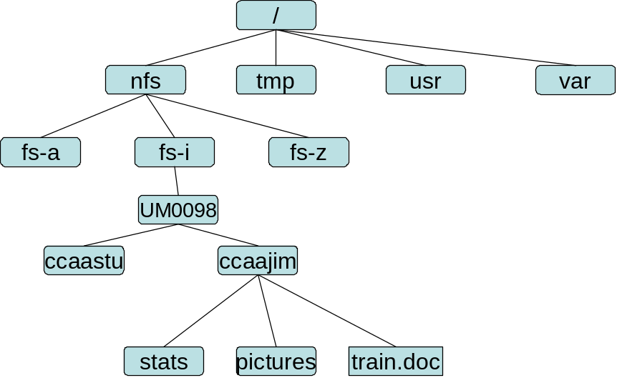
Home directories and pathnames

Understanding pathnames
In some Unix systems (including socrates on WTS) you will find it necessary to prefix pathnames with ~ if you want to ensure that they start from your home directory rather than the current directory or the root.
First type cd to get back to your home-directory, then type
% ls mytraining
to list the conents of your mytraining directory.
Now type
% ls archive
You will get a message like this -
archive: No such file or directory
The reason is that archive is not in your current working directory. To use a command on a file (or directory) that is not in the current working directory, you must either cd to the correct directory, or specify its full pathname. To list the contents of your archive directory you must type
% ls mytraining/archive
Since here the path is quite straightforward and relatively easy to type, using the full pathname will work reasonably well. It might be however, that the path is not so straightforwad and then you will find the ~ abbreviation useful.

~ (your home directory)
Your home directory can also be referred to by the tilde ~ character. It can be used to specify paths starting at your home directory. So typing
% ls ~/mytraining
will list the contents of your mytraining directory, no matter where you currently are in the file system.
What do you think
% ls ~
would list?
What do you think
% ls ~/..
would list?
Making links
Links from one file or directory to another can be created using the ln command. In some ways these are like shortcuts in Windows. For example,
% ln filename linkname
creates another directory entry for filename called linkname (called a hard link). The directory entries will be identical (and both now have a link count of 2). If either filename or linkname is modified, the change will be reflected in the other file (since they are just two different directory entries pointing to the same file). The hard link points to the exactly the same data as the original filename. On the other hand,
% ln -s filename linkname
creates a shortcut called linkname (i.e. linkname is a soft link). The shortcut appears as an entry with a special type ('l'):
% ln -s hello.txt bye.txt
% ls -l bye.txt
lrwxrwxrwx 1 will finance 13 bye.txt -> hello.txt
%
This softlink points to the filename only, not to the data.
The link count of the source file remains unaffected. Notice that the permission bits on a soft link are not used (always appearing as rwxrwxrwx). Instead the permissions on the link are determined by the permissions on the target (hello.txt in this case).
You can create a symbolic link to a file that doesn't exist, but not a hard link. Another difference between the two is that you can create symbolic links across different physical disk devices or partitions, but hard links are restricted to the same disk partition. Most varieties of Unix will not allow hard links to point to directories. If you remove the file to which a soft link refers you will be left with a dangling link. If you create a hard link to a filename and then delete the filename, the data itself remains where it is and the link still points to it.
Summary
Command | Meaning
ls | list files and directories
ls -a | list all files and directories
mkdir | make a directory
cd directory | change to named directory
cd | change to home-directory
cd ~ | change to home-directory
cd .. | change to parent directory
pwd | display the path of the current directory
ln filename linkname | makes a hard link to filename
ln -s filename linkname | makes a soft link to filename
Copying Files

cp (copy)
cp file1 file2 is the command which makes a new copy of file1 in the current working directory with the name file2.
Here is how to copy a file across directories.
First, cd to your mytraining directory.
% cd ~/mytraining
Then at the Unix prompt, type,
% cp ~/science.txt .
% cp science.txt science.bak
Don't forget to type the dot . at the end of the first command line. Remember, in Unix, the dot means the current directory.
Moving files

mv (move)
mv file1 file2 moves (or renames) file1 to file2.
To move a file from one place to another you use the mv command. This has the effect of moving rather than copying the file, so you end up with only one file rather than two.
You can also use mv to rename a file by moving the file to the same directory giving it a different name.
Now move the file science.bak to your archive directory. First, change directories to your mytraining directory, then, inside the mytraining directory type
% mv science.bak archive/.
Type ls and ls archive to see if it has worked.
Deleting files and directories

rm (remove) or rmdir (remove directory)
To delete (remove) a file you use the command rm. Create a copy of the science.txt file and then delete it. Inside your mytraining directory, type
% cp science.txt tempfile.txt
% ls
% rm tempfile.txt
% ls
You can use the rmdir command to remove a directory. If however, you try to remove your archive directory, you will not be able to since Unix will not let you remove a non-empty directory. The option –r on the rm as in
% rm -r directory
wil remove a directory even if files exist in that directory.
Displaying to the screen

clear (clear the screen)
You can clear the terminal window of the output from previous commands by typing
% clear
This will clear the screen and leave you with the prompt.

cat (concatenate)
The command cat can be used to display the contents of a file on the screen. Type:
% cat science.txt
As you can see, there are more lines in the file than can fit in a single window, so it scrolls past making it unreadable. You can avoid this by using the less command.

less
The command less writes the contents of a file onto the screen a page at a time. Type
% less science.txt
Press the [Space-bar] if you want to see another page, and type q if you want to quit reading. Less is more useful than cat for long files.

head
By default, the head command writes the first ten lines of a file to the screen.
First clear the screen then type
% head science.txt
You can specify how many lines are displayed as follows:
% head -5 science.txt

tail
The tail command writes the last ten lines of a file to the screen.
Clear the screen and type
% tail science.txt
You can try tail with a parameter to specify how many lines should be displayed as for head.
Searching the contents of a file

Simple searching using less
Using less, you can search though a text file for a keyword (pattern). For example, to search through science.txt for the word 'science', type
% less science.txt
then, still in less, type a forward slash [/] followed by the word to search
/science
As you can see, less finds and highlights the keyword. Type [n] to search for the next occurrence of the word.

grep
grep is one of many standard Unix utilities. It searches files for specified words or patterns. First clear the screen, then type
% grep science science.txt
As you can see, grep has printed out each line containg the word science but it is case sensitive. If we type
% grep Science science.txt
we see it it distinguishes between Science and science.
To ignore upper/lower case distinctions, use the -i option, i.e. type
% grep -i science science.txt
To search for a phrase or pattern (ie a string of characters with a space in it) you must enclose it in single quotes. For example to search for spinning top, type
% grep -i 'spinning top' science.txt
Some of the other options of grep are:
-v display those lines that do NOT match
-n precede each matching line with the line number
-c print only the total count of matched lines
Try some of them and see the different results. Don't forget, you can use more than one option at a time. For example, the number of lines without the words science or Science is
% grep -ivc science science.txt

wc (word count)
A handy little utility is the wc command, short for word count. To do a word count on science.txt, type
% wc -w science.txt
To find out how many lines the file has, type
% wc -l science.txt
Summary
Command | Meaning
cp file1 file2 | copy file1 and call it file2
mv file1 file2 | move or rename file1 to file2
rm file | remove a file
rmdir directory | remove a directory
cat file | display a file
less file | display a file a page at a time
head file | display the first few lines of a file
tail file | display the last few lines of a file
grep 'keyword' file | search a file for keywords
wc file | count number of lines/words/characters in file

Redirection
Most processes initiated by Unix commands write to the standard output (that is the terminal screen), and many take their input from the standard input (that is the keyboard).
We have already seen one use of the cat command to write the contents of a file to the screen.
We can use cat without specifing a file to read
% cat
If we now type some words and press the [Return] key.
Finally hold the [Ctrl] key down and press [d] (written as ^D for short) to end the input.
If you run the cat command without specifing a file to read, it reads the standard input and on receiving the 'end of file' (^D), copies it to the standard output.

Redirecting the Output
In Unix, we can redirect both the input and the output of commands.
We use the > symbol to redirect the output of a command. For example, to create a file called list1 containing a list of fruit, type
% cat > colours
Then type in the names of some colours. Press [Return] after each one.
pink
yellow
purple
^D (this means press [Ctrl] and [d] to stop).
What happens is the cat command reads the standard input (the keyboard) and the > redirects the output, which normally goes to the screen, into a file called colours
To read the contents of the file, type
% cat colours

Appending to a file
The form >> appends standard output to a file. So to add more items to the file colours, type
% cat >> colours
Then type in the names of more colours
red
^D (Control D to stop)
To read the contents of the file, type
% cat colours
Now we create a file colours2
% cat >> colours2
green
blue
^D (Control D to stop)

You should now have two files. One lists four colours, the other two colours.
We will now use the cat command to join (concatenate) colours and colours2 into a new file called allcolours:
% cat colours colours2 > allcolours
What this is doing is reading the contents of colours and colours2 in turn and combining the results in the file allcolours.
To read the contents of the new file, type
% cat allcolours

Redirecting the Input
We use the < symbol to redirect the input of a command.
For example, the command sort sorts a list alphabetically or numerically. Type
% sort
Then type in the names of some animals. Press [Return] after each one.
dog
cat
bird
ape
^D (control d to stop)
The output will be
ape
bird
cat
dog
Using < you can redirect the input to come from a file rather than the keyboard. For example, to sort the list of fruit, type
% sort < allcolours
and the sorted list will be output to the screen.
To output the sorted list to a file, type,
% sort < allcolours > sortedcolours
Use cat to read the contents of the file slist.

Pipes
To see who is on the system with you, type
% who
One method to get a sorted list of names is to type,
% who > names.txt
% sort < names.txt
This is a bit slow and you have to remember to remove the temporary file called names when you have finished. What you really want to do is connect the output of the who command directly to the input of the sort command. This is exactly what pipes do. The symbol for a pipe is the vertical bar |
For example
% who | sort
You could of course add a redirect to a file at the end if you wished. To find out how many users are logged on, type
% who | wc –l
Summary
Command | Meaning
command > file | redirect standard output to a file
command >> file | append standard output to a file
command < file | redirect standard input from a file
command1 | command2 | pipe the output of command1 to the input of command2
cat file1 file2 > file0 | concatenate file1 and file2 to file0
sort | sort data
who | list users currently logged in

Wildcards

The * wildcard
The character * is called a wildcard, and will match against none or more character(s) in a file (or directory) name. For example, in your mytraining directory, type
% ls list*
This will list all files in the current directory starting with list....
Try typing
% ls *list
This will list all files in the current directory ending with ....list

The ? wildcard
The character ? will match exactly one character.
So ?ouse will match files like house and mouse, but not grouse.
Try typing
% ls ?list
Filename conventions
Because a directory is merely a special type of file, remember that the rules and conventions for naming files apply also to directories. Avoid characters with special meanings such as / * & % and spaces when naming files. The safest way to name a file is to use only alphanumeric characters, that is, letters and numbers, together with _ (underscore) and . (dot).
File names conventionally start with a lower-case letter, and may end with a dot followed by a group of letters indicating the contents of the file. For example, all files consisting of C code may be named with the ending .c, for example, prog1.c . Then in order to list all files containing C code in your home directory, you need only type ls *.c in that directory.
Good filenames | Bad filenames
project.txt | project
my_big_program.c | my big program.c
fred_dave.doc | fred & dave.doc
Getting Help

On-line Manuals
There are on-line manuals which gives information about most commands. The manual pages tell you which options a particular command can take, and how each option modifies the behaviour of the command. Type man command to read the manual page for a particular command.
For example, to find out more about the wc (word count) command, type
% man wc
Alternatively
% whatis wc
gives a one-line description of the command, but omits any information about options etc.

Apropos
When you are not sure of the exact name of a command,
% apropos keyword
will give you the commands with keyword in their manual page header. For example, try typing
% apropos copy

Summary
Command | Meaning
* | match any number of characters
? | match one character
man command | read the online manual page for a command
whatis command | brief description of a command
apropos keyword | match commands with keyword in their man pages
File access rights
In your mytraining directory, type
% ls -l
You will see that you now get lots of detail about the contents of your directory.
-
rwxrw
-
r
--
1
ccaajim
700 Oct 1
st
2006
train.doc
file owner
d here for directories
9 lettesr code
symbolising
the access
rights to this
file
file size
date created
file name
-
rwxrw
-
r
--
1
ccaajim
700 Oct 1
st
2006
train.doc
file owner
d here for directories
Code
symbolising
the access
rights to this
file
file size
date created
file name
Each file (and directory) has associated access rights, which may be found by typing ls -l. Also, ls -lg gives additional information as to which group owns the file (istrain in the following example):
-rwxrw-r-- 1 ccaajim istrain 3210 Aug15 14:25 train.doc
In the left-hand column is a 10 symbol string consisting of the symbols d, r, w, x, -, and, occasionally, s or S. The important ones for you right now are r for read, w for write and x for execute. If d is present, it will be at the left hand end of the string, and indicates a directory: otherwise - will be the starting symbol of the string.
The 9 remaining symbols indicate the permissions, or access rights, and are taken as three groups of 3.
The left group of 3 gives the file permissions for the user that owns the file (or directory) (ee51ab in the above example).
rm The rightmost group gives the permissions for all others (called world in Unix speak).
The symbols r, w, etc., have slightly different meanings depending on whether they refer to a simple file or to a directory.

Access rights on files.
r (or -), indicates read permission (or otherwise), that is, the presence or absence of permission to read and copy the file
w (or -), indicates write permission (or otherwise), that is, the permission (or otherwise) to change a file
x (or -), indicates execution permission (or otherwise), that is, the permission to execute a file, where appropriate

Access rights on directories.
r allows users to list files in the directory;
w means that users may delete files from the directory or move files into it;
x means the right to access files in the directory. This implies that you may read files in the directory provided you have read permission on the individual files.
So, in order to read a file, you must have execute permission on the directory containing that file, and hence on any directory containing that directory as a subdirectory, and so on, up the tree.

Some examples
-rwxrwxrwx | a file that everyone can read, write and execute (and delete).
-rw------- | a file that only the owner can read and write - no-one else  can read or write and no-one has execution rights (e.g. your  mailbox file).
Changing access rights

chmod (changing file mode)
Only the owner of a file can use chmod to change the permissions of a file. The options of chmod are as follows
Symbol | Meaning
u | user
g | group
o | other
a | all
r | read
w | write (and delete)
x | execute (and access directory)
+ | add permission
- | take away permission
For example, to remove read write and execute permissions on the file allcolours for the group and others, type
% chmod go-rwx allcolours
This will leave the other permissions unaffected.
To give read and write permissions on the file biglist to all,
% chmod a+rw allcolours
Processes and Jobs
A process is an executing program identified by a unique PID (process identifier). To see information about your processes, with their associated PID and status, type
% ps
A process may be in the foreground, in the background, or be suspended. In general the shell does not return the Unix prompt until the current process has finished executing.
Some processes take a long time to run and hold up the terminal. Backgrounding a long process has the effect that the Unix prompt is returned immediately, and other tasks can be carried out while the original process continues executing.

Running background processes
To background a process, type an & at the end of the command line. For example, the command sleep waits a given number of seconds before continuing. Type
% sleep 10
This will wait 10 seconds before returning the command prompt %. Until the command prompt is returned, you can do nothing except wait.
To run sleep in the background, type
% sleep 10 &
[1] 6259
The & runs the job in the background and returns the prompt straight away, allowing you do run other programs while waiting for that one to finish.
The first line in the above example is typed in by the user; the next line, indicating job number and PID, is returned by the machine. The user is be notified of a job number (numbered from 1) enclosed in square brackets, together with a PID and is notified when a background process is finished. Backgrounding is useful for jobs which will take a long time to complete.

Backgrounding a current foreground process
At the prompt, type
% sleep 1000
You can suspend the process running in the foreground by typing ^Z, i.e.hold down the [Ctrl] key and type [z]. Then to put it in the background, type
% bg
Note: do not background programs that require user interaction e.g. vi
Suspended and background processes
When a process is running, backgrounded or suspended, it will be entered onto a list along with a job number. To examine this list, type
% jobs
An example of a job list could be
[1] Suspended sleep 1000
[2] Running vi
[3] Running matlab
To restart (foreground) a suspended processes, type
% fg %jobnumber
For example, to restart sleep 1000, type
% fg %1
Typing fg with no job number foregrounds the last suspended process.
Killing a process

kill (terminate a process)
It is sometimes necessary to kill a process (for example, when an executing program is in an infinite loop)
To kill a job running in the foreground, type ^C (control c). For example, run
% sleep 100
^C
To kill a suspended or background process, type
% kill %jobnumber
For example, run
% sleep 100 &
% jobs
If it is job number 4, type
% kill %4
To check whether this has worked, examine the job list again to see if the process has been removed.

ps (process status)
Alternatively, processes can be killed by finding their process numbers (PIDs) and using kill PID_number
% sleep 1000 &
% ps
PID TT S TIME COMMAND
20077 pts/5 S 0:05 sleep 1000
21563 pts/5 T 0:00 netscape
21873 pts/5 S 0:25 nedit
To kill off the process sleep 1000, type
% kill 20077
and then type ps again to see if it has been removed from the list.
If a process refuses to be killed, uses the -9 option, i.e. type
% kill -9 20077
You can kill all your processes with kill -9 0 which kill the shell(s) and force a logout.
Summary
Command | Meaning
ls -lag | list access rights for all files
chmod [options] file | change access rights for named file
command & | run command in background
^C | kill the job running in the foreground
^Z | suspend the job running in the foreground
bg | background the suspended job
jobs | list current jobs
fg %1 | foreground job number 1
kill %1 | kill job number 1
ps | list current processes
kill 26152 | kill process number 26152

Other useful commands

quota
All students are allocated a certain amount of disk space on the file system for their personal files, usually about 100Mb. To check your current quota and how much of it you have used, type
% quota userid

df
The df command reports on the space left on the file system. For example, to find out how much space is left on the fileserver, type
% df .

du
The du command outputs the number of kilobyes used by each subdirectory. Useful if you have gone over quota and you want to find out which directory has the most files. In your home-directory, type
% du -s *
The -s flag will display only a summary (total size) and the * means all files and directories.

gzip
This reduces the size of a file, thus freeing valuable disk space. For example, type
% ls -l science.txt
and note the size of the file using ls -l . Then to compress science.txt, type
% gzip science.txt
This will compress the file and place it in a file called science.txt.gz
To see the change in size, type ls -l again.
To expand the file, use the gunzip command.
% gunzip science.txt.gz

zcat
zcat will read gzipped files without needing to uncompress them first.
% zcat science.txt.gz
If the text scrolls too fast for you, pipe the output though less .
% zcat science.txt.gz | less

file
file classifies the named files according to the type of data they contain, for example ascii (text), pictures, compressed data, etc.. To report on all files in your home directory, type
% file *

diff
This command compares the contents of two files and displays the differences. Suppose you have a file called file1 and you edit some part of it and save it as file2. To see the differences type
% diff file1 file2
Lines beginning with a < denotes file1, while lines beginning with a > denotes file2.

find
This searches through the directories for files and directories with a given name, date, size, or any other attribute you care to specify. It is a simple command but with many options - you can read the manual by typing man find.
To search for all fies with the extention .txt, starting at the current directory (.) and working through all sub-directories, then printing the name of the file to the screen, type
% find . -name "*.txt" -print
To find files over 1Mb in size, and display the result as a long listing, type
% find . -size +1M -ls

history
The C shell keeps an ordered list of all the commands that you have entered. Each command is given a number according to the order it was entered.
% history (show command history list)
If you are using the C shell, you can use the exclamation character (!) to recall commands easily.
% !! (recall last command)
% !-3 (recall third most recent command)
% !5 (recall 5th command in list)
% !grep (recall last command starting with grep)
You can increase the size of the history buffer by typing
% set history=100
Unix variables
Variables are a way of passing information from the shell to programs when you run them. Programs look "in the environment" for particular variables and if they are found will use the values stored. Some are set by the system, others by you, yet others by the shell, or any program that loads another program.
Standard Unix variables are split into two categories, environment variables and shell variables. In broad terms, shell variables apply only to the current instance of the shell and are used to set short-term working conditions; environment variables have a farther reaching significance, and those set at login are valid for the duration of the session. By convention, environment variables have UPPER CASE and shell variables have lower case names.
Environment variables
An example of an environment variable is the OSTYPE variable. The value of this is the current operating system you are using. Type
% echo $OSTYPE
More examples of environment variables are
USER (your login name)
HOME (the path name of your home directory)
HOST (the name of the computer you are using)
ARCH (the architecture of the computers processor)
DISPLAY (the name of the computer screen to display X windows)
PRINTER (the default printer to send print jobs)
PATH (the directories the shell should search to find a command)

Finding out the current values of these variables.
ENVIRONMENT variables are set using the setenv command, displayed using the printenv or env commands, and unset using the unsetenv command.
To show all values of these variables, type
% printenv | less
Shell variables
An example of a shell variable is the history variable. The value of this is how many shell commands to save, allow the user to scroll back through all the commands they have previously entered. Type
% echo $history
More examples of shell variables are
cwd (your current working directory)
home (the path name of your home directory)
path (the directories the shell should search to find a command)
prompt (the text string used to prompt for interactive commands shell your login shell)

Finding out the current values of these variables.
SHELL variables are both set and displayed using the set command. They can be unset by using the unset command.
To show all values of these variables, type
% set | less
The difference between PATH and path
In general environment and shell variables that have the same name (including matching case) are distinct and independent. There are, however, exceptions.
Each time the shell variables home, user and term are changed, the corresponding environment variables HOME, USER and TERM receive the same values. However, altering the environment variables has no effect on the corresponding shell variables.
PATH and path specify directories to search for commands and programs. Both variables always represent the same directory list, and altering either automatically causes the other to be changed.
Using and setting variables
Each time you login to a Unix host, the system looks in your home directory for initialisation files. Information in these files is used to set up your working environment. The C and TC shells uses two called .login and .cshrc (note that both file names begin with a dot).
At login the C shell first reads .cshrc followed by .login
.login is to set conditions which will apply to the whole session and to perform actions that are relevant only at login.
.cshrc is used to set conditions and perform actions specific to the shell and to each invocation of it.
The guidelines are to set ENVIRONMENT variables in the .login file and SHELL variables in the .cshrc file.
Setting shell variables in the .cshrc file
For example, to change the number of shell commands saved in the history list, you need to set the shell variable history. It is set to 100 by default, but you can increase this if you wish.
% set history = 200
Check this has worked by typing
% echo $history
However, this has only set the variable for the lifetime of the current shell. If you open a new xterm window, it will only have the default history value set. To PERMANENTLY set the value of history, you will need to add the set command to the .cshrc file.
First open the .cshrc file in a text editor. An easy, user-friendly editor to use is nedit.
% nedit ~/.cshrc
Add the following line AFTER the list of other commands.
set history = 200
Save the file and force the shell to reread its .cshrc file buy using the shell source command.
% source .cshrc
Check this has worked by typing
% echo $history
Setting the path
When you type a command, your path (or PATH) variable defines in which directories the shell will look to find the command you typed. If the system returns a message saying "command: Command not found", this indicates that either the command doesn't exist at all on the system or it is simply not in your path.
If you wish to run a program called mycalculator that sits in a directory called myprograms for example, then you must either specify the full path or you need to list the path in the path variable.
You can add it to the end of your existing path (the $path represents this) by issuing the command:
% set path = ($path ~/myprograms/mycalculator)
To add this path permanently you add the following line to your .cshrc after the list of other commands.
set path = ($ ~/archive/science.txt)

