<Project Name>
Supplementary Specification

Version <1.0>

Revision History
Date | Version | Description | Authors
<08/11/1997> | <1.0> | <the first edition> | <Tallam Tharun Sai, T.Sai Satish, Parsi Tharun>

Table of Contents
1. Introduction 3
1.1 Purpose 3
1.2 Scope 3
1.3 Definitions, Acronyms and Abbreviations 3
1.4 References 3
1.5 Overview 3
2. Functionality 3
2.1 <Functional Requirement One> 3
3. Usability 3
3.1 <Usability Requirement One> 3
4. Reliability 3
4.1 <Reliability Requirement One> 3
5. Performance 3
5.1 <Performance Requirement One> 3
6. Supportability 3
6.1 <Supportability Requirement One> 3
7. Design Constraints 3
7.1 <Design Constraint One> 3
8. Online User Documentation and Help System Requirements 3
9. Purchased Components 3
10. Interfaces 3
10.1 User Interfaces 3
10.2 Hardware Interfaces 3
10.3 Software Interfaces 3
10.4 Communications Interfaces 3
11. Licensing Requirements 3
12. Legal, Copyright and Other Notices 3
13. Applicable Standards 3

Supplementary Specification

Introduction
The purpose of this document is to collect, analyze, and define high-level needs and features of the Active City Administrative system. It focuses on the capabilities needed by the stakeholders and the target users, and why these needs exist. The details of how the Active City Administrative system fulfills these needs are detailed in the use-case and supplementary specifications.

Purpose
The purpose of this system is to meet the citizen need and to do the city administration in a very effective and efficient manner. This is also developed for the clean and green maintenance of the major cities in India.

Scope
The scope of this system is that it will make the city administration in a peaceful manner so that the city and the citizens in it are in a complete shared network which will helps them to solve their problem in their areas or in the roads. This may also be useful to do take care of any emergency situations in the city.

Definitions, Acronyms and Abbreviations
The subsections in this project are, it contains an admin, citizen, and department members. The citizen are the people how lives in the city and how are having problem with their surroundings. The admins are the people who maintain and direct definite things to the system. The department people are the people who will maintain the area maintenance with differences in their work like electricians, municipality workers etc.

References
This document is the new project which refers no other document. But this is the system which is an extended one to the app which is already any existed one for the administration of the Telangana government.

Overview
This overview of this document is that it covers all about positioning, Stakeholder and User Descriptions, Product Overview, Product Features, Constraints, Quality Ranges, Precedence and Priority etc.

Functionality
The functionality was discussed in the product prospective. The one more feature which makes all other products in the market with this product is that, when the problem’s status was in unsolved within that given time by the department people then, the problem is posted in the spotlight of the web which can be visible by whole city. This will be posted by admins. By this the department people will get alerts to solve the problem in the given time.

< Login >
Anyone who lives in the city can register for free of cost with the linking of the Adhar card. But for Admins specified and qualified persons from government are appointed which the login id and password are given by the government initially. For the each department one login id and the password are given initially.

< Complaint register >
This can be done separately in the complaint column. Anyone can file a complaint. In this “STATUS BAR” will be there, in which we can see the status of the previously registered complaints can be viewed.

< Change password>
This contains the changing of the password. In this one has to enter the previous password correctly then the new password correctly for two times. Hence the password can be changed.

<Spot-light >
This can be viewed by every citizen who is logged in. this is controlled by the admin. In this all the problems which are not been solved in the given time are posted.

< About >
About the system and its purpose can be seen in this column.

Usability
This describes about the usability of the system like, the session timeouts, login devices management etc. For this system the usability are as follows below:

<Session timeout>
Every session will be given the time limit which is given as 5 minutes. If the system which is using the application, is not responding more than 5 minutes continuously, then it will we automatically logged out.

<Logging off>
If the user didn’t properly logged-off then he/she should wait until the system automatically logged-off i.e. for 5 minutes.

<Notifications>
The notifications are given of the status of the complaints.

Reliability
Requirements for reliability of the system are:

< Availability>
The time availability is 100%. The hours of the use of this system are 20 hours. And the maintenance access is given to the government or the admin.

<Mean Time between Failure (MFBT)>
This is usually specified in hours, but it could also be specified in terms of days, months, or years. The maintenance of the system is must because it was used by whole city will be using it. The failure should be less.

<Mean Time to Repair (MTTR)>
This tells about the how long is the system allowed to be out of operation after it has failed? For this system this will be for 3-5 minutes.

<Accuracy>
For sure the accuracy of the system should be more and should be quick. This will be indirectly affecting the user-friendliness of the system.

<Maximum Bugs>
The maximum bugs of the system should be less which will have to be more specific as it will be a government website.

Performance
The performance characteristics of the system should be are:

<Response time>
The response time should be more accurate and should be less.

<Throughput>
This will tell about the no of users using the app or web in the same time. This should be more.

<Capacity>
Capacity of the server to the system should be more. And it should be more compactable with increase in number of users.

Supportability
This indicates any requirements that will enhance the supportability or maintainability of the system. These are:

<Coding Standards >
The coding standards should be strong and it should not be hack able. And the errors should be rectified before use.

<Class libraries>
Class libraries under the java, we can use package and when we use the html we can use html, head, body, title tags must be used.

<Maintenance access>
The login page must be accessible only for the admin of the supervisor of the active city administration.

<Maintenance utility>
The user who wants to use this page should create an account by filling the details in the sign in page. So they can see the updates and implementation in the city by this page.

Design Constraints
This indicates any design constraints on the system being built. They are:

<Software languages>
The Software languages which are used in building this system are PHP for building the web pages. And java for the app as it was used in android studio for the building of the app.

<Software Process Requirements>
This was all about the use of the tools for developing the system and about the use of developmental tools, architectural and design constraints, purchased components, class libraries, etc. All the software design concepts like JSP, JSD, HOOD, SAD, SAAD etc. are drawn to this system to known about the design of the system clearly and accurately.

Online User Documentation and Help System Requirements
Any online help will be available in the government official website so that it will be easy to use it or go through it online. The links will be provided in the coming forth documents.

Purchased Components
This describes any purchased components to be used with the system, any applicable licensing or usage restrictions, and any associated compatibility/interoperability or interface standards. In this system the purchased components are the database like cloud services.

Interfaces
This defines about the interfaces that must be supported by the application. It contains adequate specificity, protocols, ports and logical addresses, etc, so that the software can be developed and verified against the interface requirements.

User Interfaces (UI)
The user interfaces are required to make the system easy (self-explanatory), efficient, and enjoyable (user-friendly) to operate a machine in the way which produces the desired result. This system is totally good and enjoyable to use. This is very much user-friendly because the user should get addicted to the system and must be actively participate in the city’s friendly and green administration.

Hardware Interfaces
This includes logical structure, physical addresses, expected behavior, etc. The physical addresses are to be known when the software is installed in the system. The expected behavior of the system is user-friendly. The logical structure of this system is defined in the following ER-diagram:
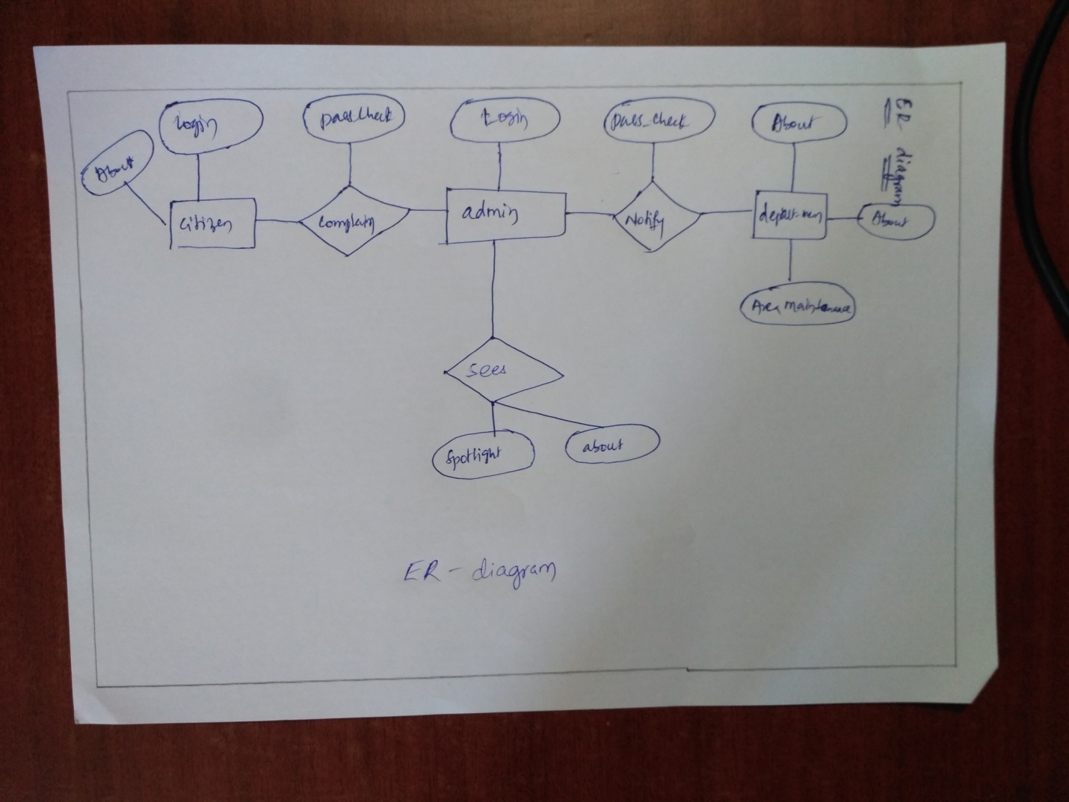

Software Interfaces
These may be purchased components, components reused from another application, or components being developed for subsystems outside of the scope of this SRS, but with which this software application must interact, which are discussed in the above columns.

Communications Interfaces
This describes about the communication interfaces to other systems or devices such as local area networks, remote serial devices, etc. For this system the communication is must as it is purely depends on the active city’s administration.

Licensing Requirements
Licensing requirements are those which defines the licensing terms and conditions. In this system the licenses are totally given to the government as it was about the city administration. The licenses are the main thing to do with. The requirements are it should only be the confidential one as it deals with the government administration.

Legal, Copyright and Other Notices
This includes legal disclaimers, warranties, copyright notices, patent notice, word-mark, trademark, or logo compliance issues for the system. All the legal rights and the copy rights are with the city government.

Applicable Standards
The standards of the product are very high as it has to be feasible or compatible in every form of Operating systems like IOS, Android, BlackBerry, etc. These also include legal and regulatory (FDA, UCC) communications standards (TCP/IP, ISDN), platform compliance standards (Windows, UNIX, and so on), and quality and safety standards (UL, ISO, CMM).

