]SCHOOL OF COMPUTER SCIENCE AND ARTIFICIAL INTELLIGENCE |  |  |  |  | DEPARTMENT OF COMPUTER SCIENCE ENGINEERING
ProgramName:M. Tech |  |  |  | Assignment Type: Lab |  |  | AcademicYear:2025-2026
CourseCoordinatorName |  |  |  | Venkataramana Veeramsetty
rCourseCode |  |  | 24CS002PC215 | CourseTitle |  | AI Assisted Problem Solving Using Python
Year/Sem |  |  | II/I | Regulation |  | R24
Date and Day  of Assignment |  |  | 10.11.2025 | Time(s)
Duration |  |  | 2 Hours | Applicableto  Batches
AssignmentNumber:9.3(Present assignment number)/24(Total number of assignments)
 | Q.No. | Question |  |  |  |  |  | ExpectedTime  to complete
 | 1 | Lab 9: Documentation Generation: Automatic documentation and code comments  Lab Objectives:  - To understand the importance of documentation and code comments in software development.  - To explore how AI-assisted coding tools can generate meaningful documentation and inline comments.  - To practice generating function-level and module-level docstrings automatically.  - To evaluate the quality, accuracy, and limitations of AI-generated documentation.  - To develop a small automated tool for documentation generation in Python..  Lab Outcomes (LOs):  After completing this lab, students will be able to:  - Apply AI-assisted coding tools to generate docstrings and inline comments for Python code.  - Critically analyze AI-generated documentation for correctness, completeness, and readability.  - Create structured documentation (function-level, module-level) following standard formats.  - Design and implement a mini documentation generator tool to automate code commenting and docstring creation.  Task Description#1 Basic Docstring Generation  - Write python function to return sum of even and odd numbers in the given list.  - Incorporate manual docstring in code with Google Style  - Use an AI-assisted tool (e.g., Copilot, Cursor AI) to generate a docstring describing the function.  - Compare the AI-generated docstring with your manually written one.  Expected Outcome#1: Students understand how AI can produce function-level documentation.  Prompt: •  write a Python function that should return the sum of even and odd numbers from a given list.  write a manual docstring for this function using Google Style.  Then, use ai tool (the AI tool — Copilot, Cursor AI, etc.) to generate your own version of the docstring for the same function.  Finally, compare between my manually written Google-style docstring and the AI-generated docstring, highlighting differences in clarity, detail, and formatting.  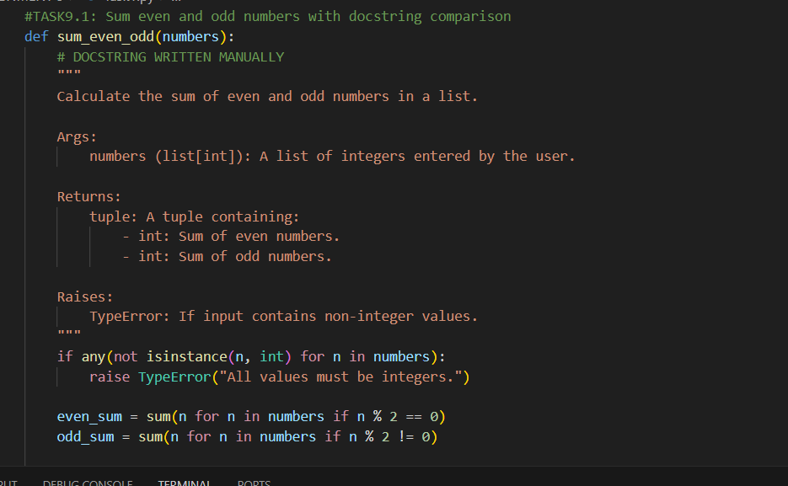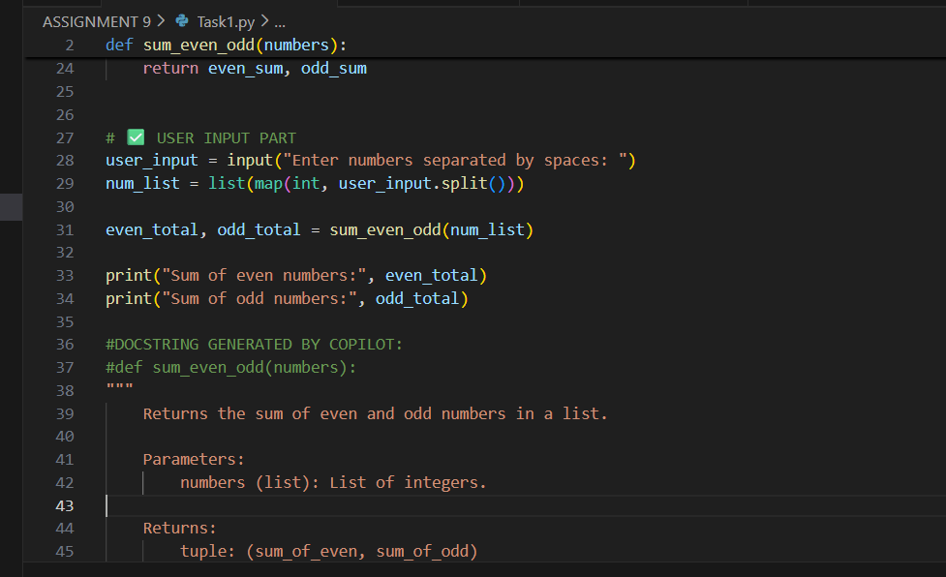  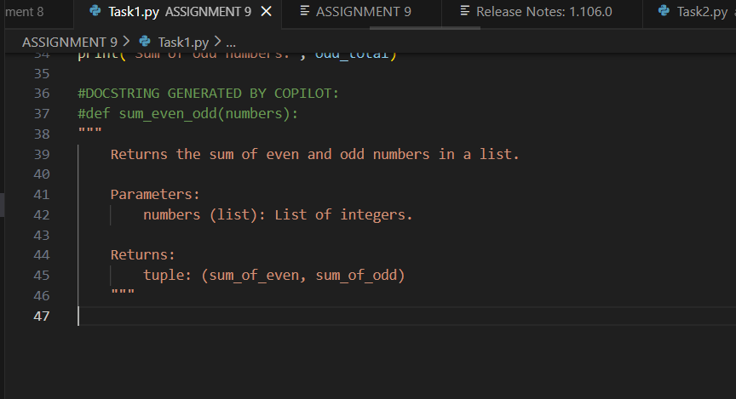  output:  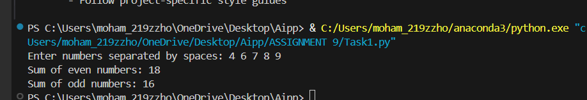  DOCUMENT:  The manually written Google-style docstring is much richer and better organized compared to the AI-generated one. It follows a clear structure with sections like Args, Returns, Raises, and even includes an example. This makes the documentation more informative and beginner-friendly. It clearly specifies input types, potential errors, and demonstrates how the function should be used, which is extremely helpful for anyone reading or maintaining the code.  On the other hand, the AI-generated docstring is brief and quite general. It only mentions the parameters and a simple return statement, without giving deeper context or handling errors. While it is quick and acceptable for basic understanding, it does not follow a formal documentation style and lacks important details.  Overall, the manual docstring demonstrates better documentation skills and is more appropriate for academic or professional codebases. The AI version is minimal and functional, but not as thorough or polished as the manually written one.  Task Description#2 Automatic Inline Comments  - Write python program for sru_student class with attributes like name, roll no., hostel_status and fee_update method and display_details method.  - Write comments manually for each line/code block  - Ask an AI tool to add inline comments explaining each line/step.  - Compare the AI-generated comments with your manually written one.  Expected Output#2: Students critically analyze AI-generated code comments.  PROMPT: Write a phython function for class students of sru with attributes like like  name, roll no., hostel_status and fee_update method and display_details method.  - Write comments manually for each line/code block  - Use AI tool and ask to add inline comments explaining each line/step.  - Compare the AI-generated comments with your manually written one  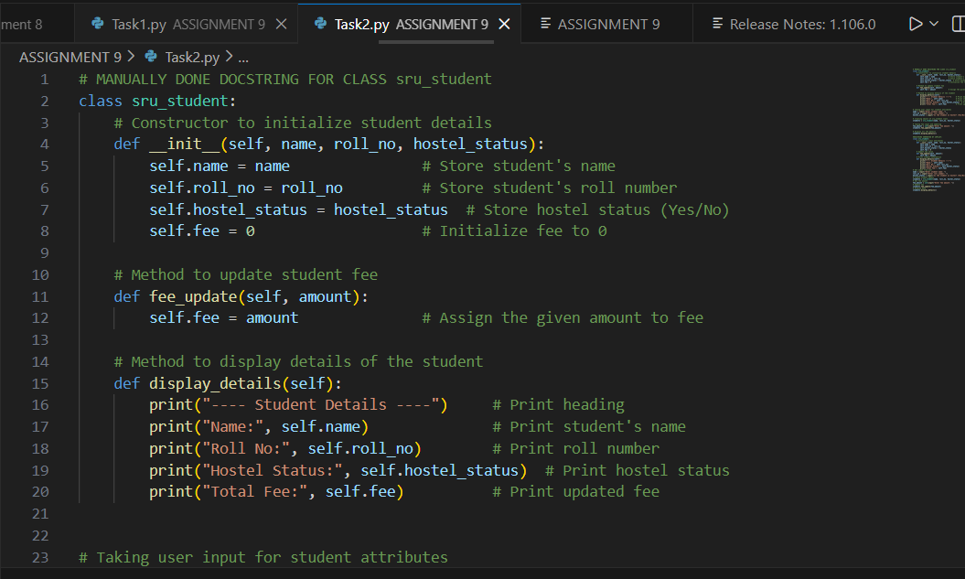 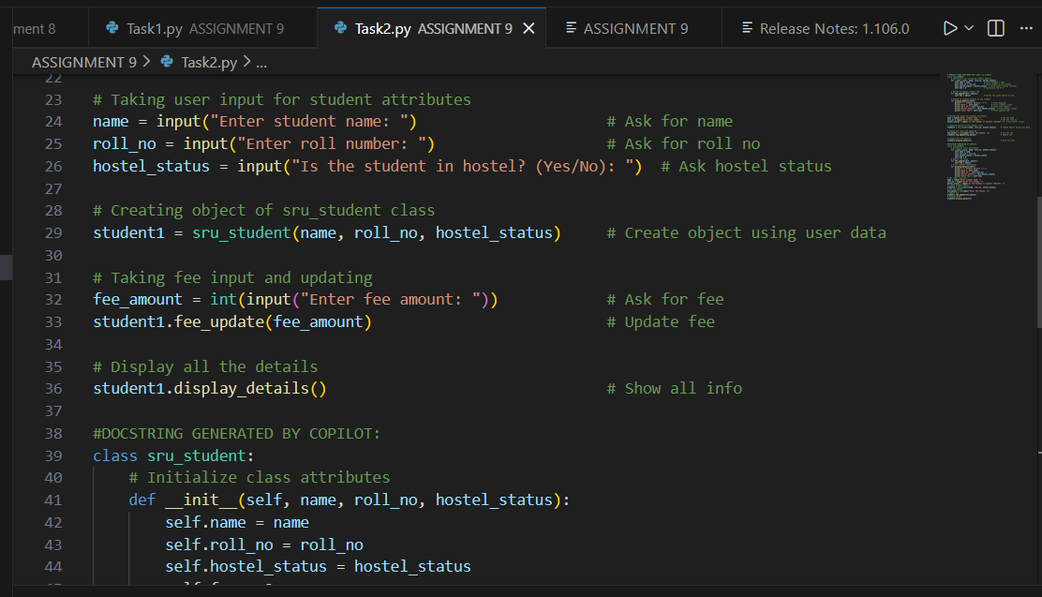 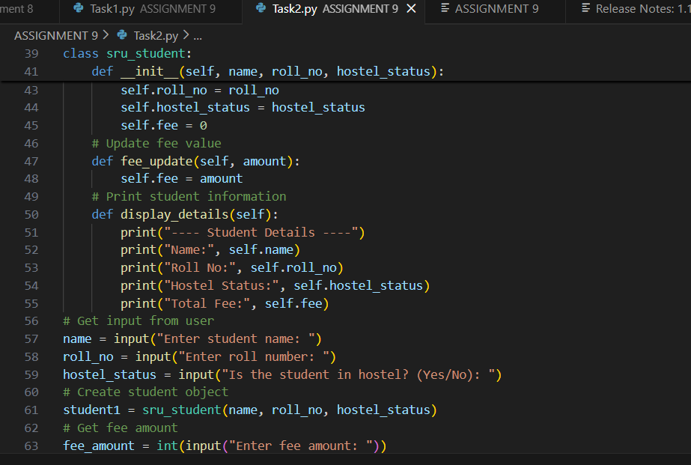 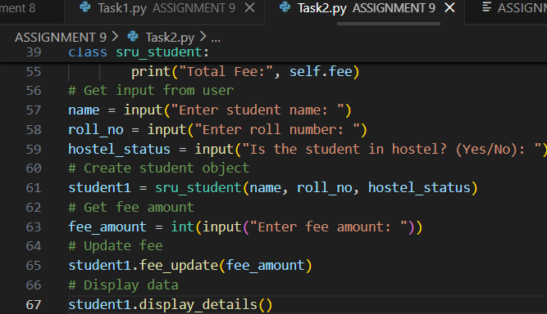 output: 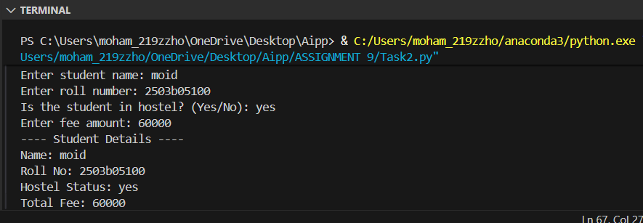 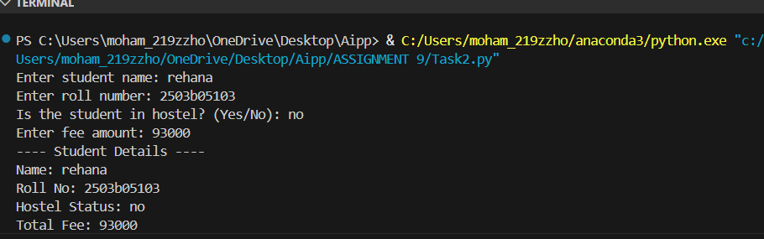  Documentation:  The manually written inline comments offer a detailed, step-by-step explanation of the code, making them highly beneficial for beginners. These comments clearly describe not only what each line of code does but also why it is necessary. This makes the logic behind object creation, method implementation, and the flow of the program much easier to understand. The comments help the reader follow the reasoning behind the operations, which enhances learning and supports deeper comprehension.  In contrast, the AI-generated inline comments tend to be brief and surface-level. They usually restate the function of each line without providing additional context or explaining the underlying purpose. While these comments are concise and neatly formatted, they lack the depth required for educational use. They do not sufficiently guide a novice programmer through the thought process of how and why the code works.  Overall, the manually crafted comments are more thorough, instructional, and effective for learning. The AI-generated comments, although accurate, serve better as quick references rather than teaching tools  Task Description#3  - Write a Python script with 3–4 functions (e.g., calculator: add, subtract, multiply, divide).  - Incorporate manual docstring in code with NumPy Style  - Use AI assistance to generate a module-level docstring + individual function docstrings.  - Compare the AI-generated docstring with your manually written one.  Expected Output#3: Students learn structured documentation for multi-function script  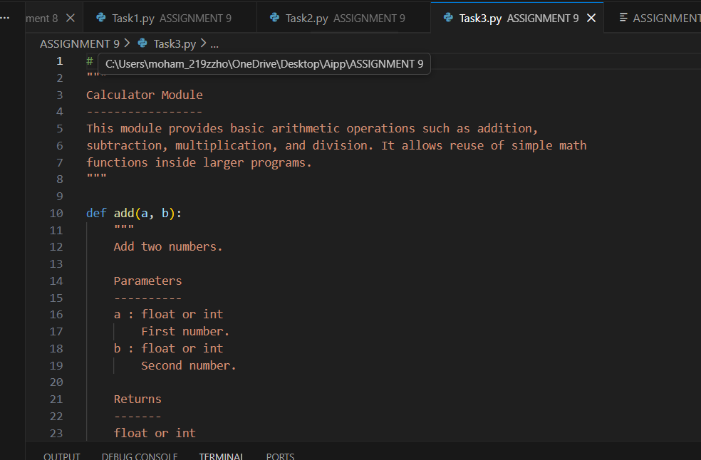  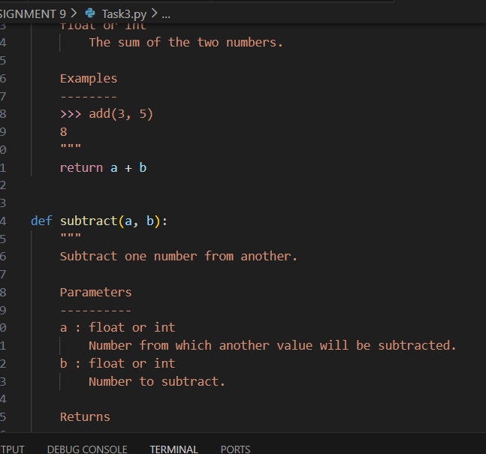  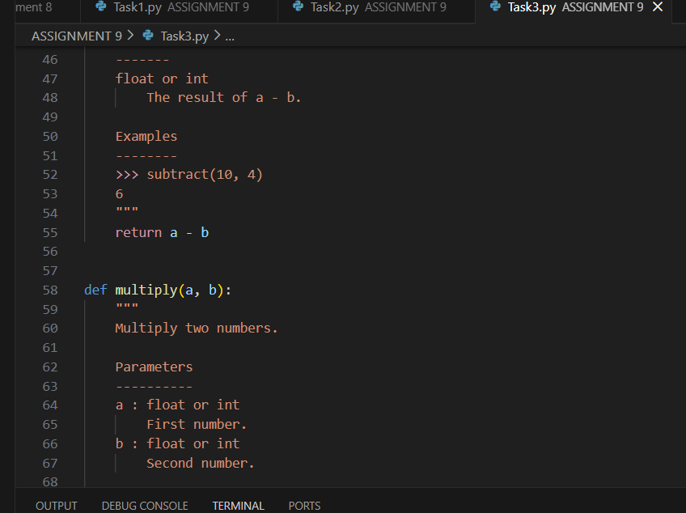 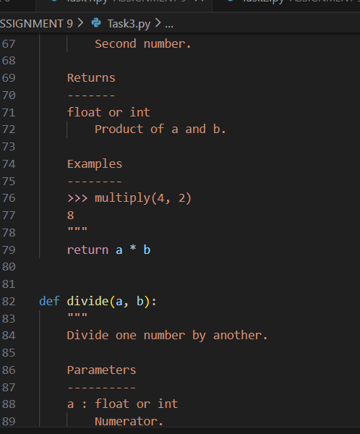 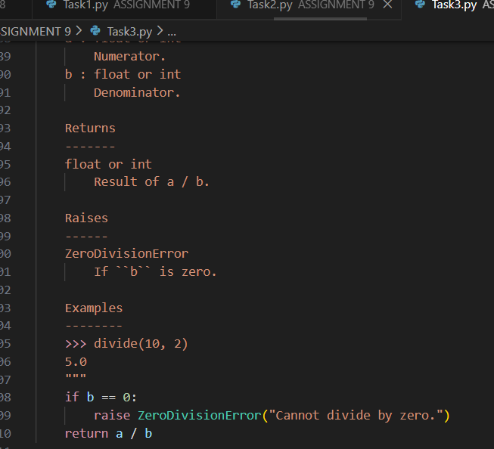 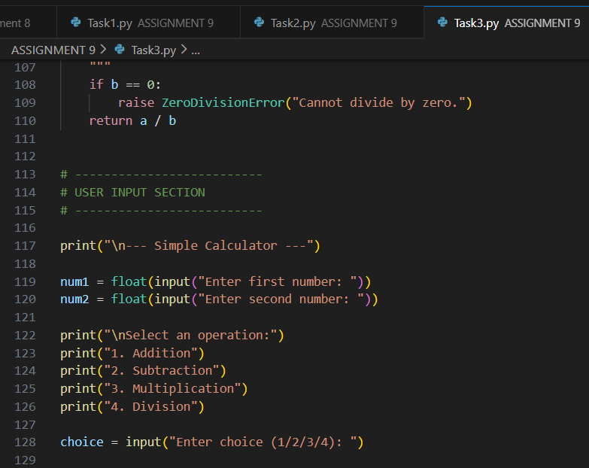 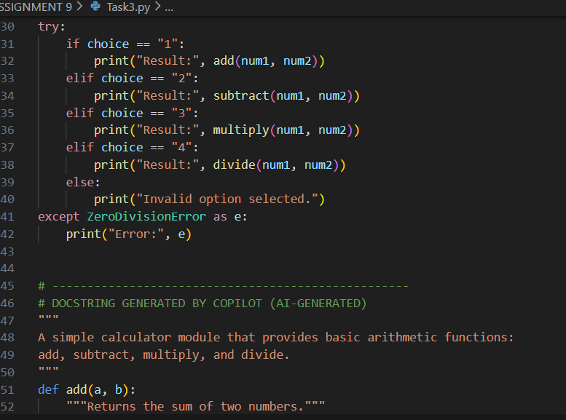 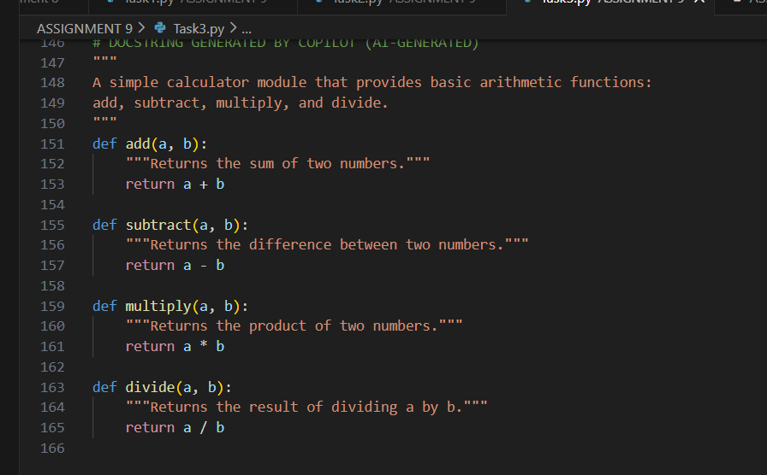output:  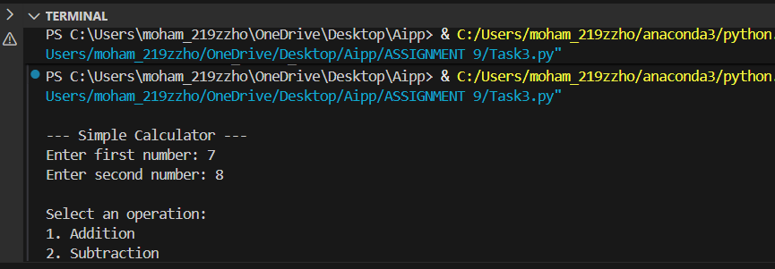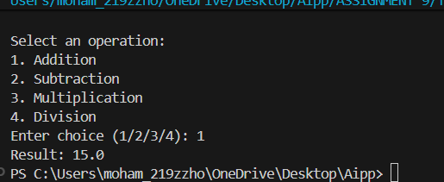  DOCUMENTATION:  The manually written NumPy-style docstrings demonstrate a highly organized and professional documentation format.  They clearly separate important sections such as Parameters, Returns, Raises, and Examples. This structured approach helps readers easily understand how to use each function, what types of arguments are expected, what the function outputs, and under what conditions errors may occur. Such detailed documentation mirrors industry and research-level standards, making the code well-prepared for inclusion in larger projects, libraries, or collaborative environments.  • On the other hand, the AI-generated docstrings are minimal and lack depth.  They provide only a brief one-line explanation of what the function does, without specifying parameter types, return values, exceptions, or usage examples. While these automatically generated docstrings are quick and convenient, they do not meet the completeness or clarity required for high-quality software documentation. As a result, they may be useful for rapid prototyping but are insufficient for production-level modules or educational purposes. |  |  |  |  |  | Week4 - Wednesday

