Roll No: 2505B04105
Set No: 4
Set 4
7. Q1. Create a function to reverse a list in Python. Use an AI tool to suggest alternative
implementations. Test and compare the performance of each version.
code:
import timeit
import random

# -------------------------------
# Reverse List Implementations
# -------------------------------

def reverse_list_slice(lst):
"""Reverse using slicing."""
return lst[::-1]

def reverse_list_builtin(lst):
"""Reverse using the built-in reversed()"""
return list(reversed(lst))

def reverse_list_two_pointer(lst):
"""Reverse using manual two-pointer swap."""
arr = lst[:] # avoid modifying original
left, right = 0, len(arr) - 1
while left < right:
arr[left], arr[right] = arr[right], arr[left]
left += 1
right -= 1
return arr

def reverse_list_inplace(lst):
"""Reverse using list.reverse() but avoid modifying the input."""
arr = lst[:]
arr.reverse()
return arr

def reverse_list_loop(lst):
"""Reverse by manually building a new list."""
result = []
for i in range(len(lst) - 1, -1, -1):
result.append(lst[i])
return result

# -------------------------------
# Benchmarking
# -------------------------------

def run_benchmarks():
# Create a list to test
lst = list(range(10_000))

setup_code = """
from __main__ import (
reverse_list_slice,
reverse_list_builtin,
reverse_list_two_pointer,
reverse_list_inplace,
reverse_list_loop,
lst
)
"""

tests = {
"Slice": "reverse_list_slice(lst)",
"Builtin reversed()": "reverse_list_builtin(lst)",
"Two-pointer": "reverse_list_two_pointer(lst)",
"In-place .reverse()": "reverse_list_inplace(lst)",
"Loop append": "reverse_list_loop(lst)",
}

print("\nBenchmark Results (lower = faster)\n-----------------------------------")
for name, stmt in tests.items():
t = timeit.timeit(stmt, setup=setup_code, number=1000)
print(f"{name:20s}: {t:.5f} seconds")

# -------------------------------
# Main Execution
# -------------------------------

if __name__ == "__main__":
print("Testing correctness...")
test_list = [1, 2, 3, 4]

print("Slice: ", reverse_list_slice(test_list))
print("Builtin reversed(): ", reverse_list_builtin(test_list))
print("Two-pointer: ", reverse_list_two_pointer(test_list))
print("In-place reverse(): ", reverse_list_inplace(test_list))
print("Loop: ", reverse_list_loop(test_list))

run_benchmarks()

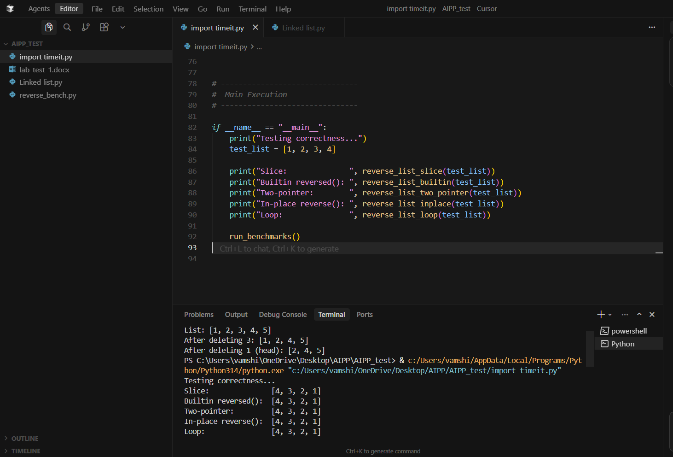
8. Q2. Design a few-shot prompt to guide an AI tool in writing code for a basic linked list
with methods for insert and delete. Analyze the resulting code for correctness and
completeness.
code:
class Node:
def __init__(self, value):
self.value = value
self.next = None

class LinkedList:
def __init__(self):
self.head = None

def insert_at_head(self, value):
new_node = Node(value)
new_node.next = self.head
self.head = new_node

def insert_at_tail(self, value):
new_node = Node(value)
if not self.head:
self.head = new_node
return
curr = self.head
while curr.next:
curr = curr.next
curr.next = new_node

def delete(self, value):
if not self.head:
return False

# Case 1: delete head
if self.head.value == value:
self.head = self.head.next
return True

# Case 2: delete deeper in the list
prev = self.head
curr = self.head.next
while curr:
if curr.value == value:
prev.next = curr.next
return True
prev = curr
curr = curr.next

return False

# Optional helper to view the list
def to_list(self):
result = []
curr = self.head
while curr:
result.append(curr.value)
curr = curr.next
return result

# -------------------
# Example usage
# -------------------
if __name__ == "__main__":
ll = LinkedList()

ll.insert_at_head(3)
ll.insert_at_head(2)
ll.insert_at_head(1)
ll.insert_at_tail(4)
ll.insert_at_tail(5)

print("List:", ll.to_list())

ll.delete(3)
print("After deleting 3:", ll.to_list())

ll.delete(1)
print("After deleting 1 (head):", ll.to_list())

