Date: 24-11-2025
Name: Chetti Rishika
M-tech – 1st Year
HTNO: 2503B05204
Lab 14 – Web Frontend Development: AI-assisted HTML/CSS/JS with Python.

Task Description #1 – AI-generated HTML Page
Task: Ask AI to generate a simple HTML homepage for a "Student Info
Portal" with a header, navigation menu, and footer.
Expected Output:
● HTML code with <header>, <nav>, <footer>.
● Clean indentation, proper tags, and comments.
HTML Structure (<header>, <nav>, <footer>)
CSS Styling for a clean, professional look.
Basic JavaScript to add a simple interactive element (showing an alert).
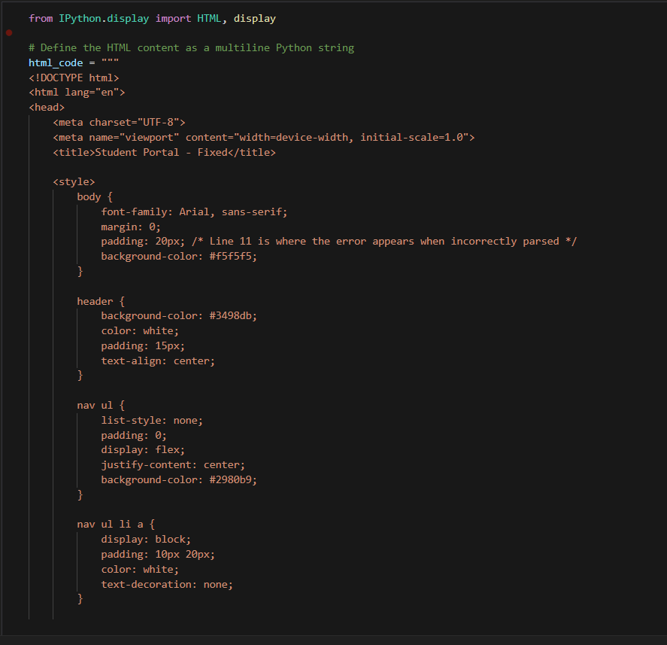
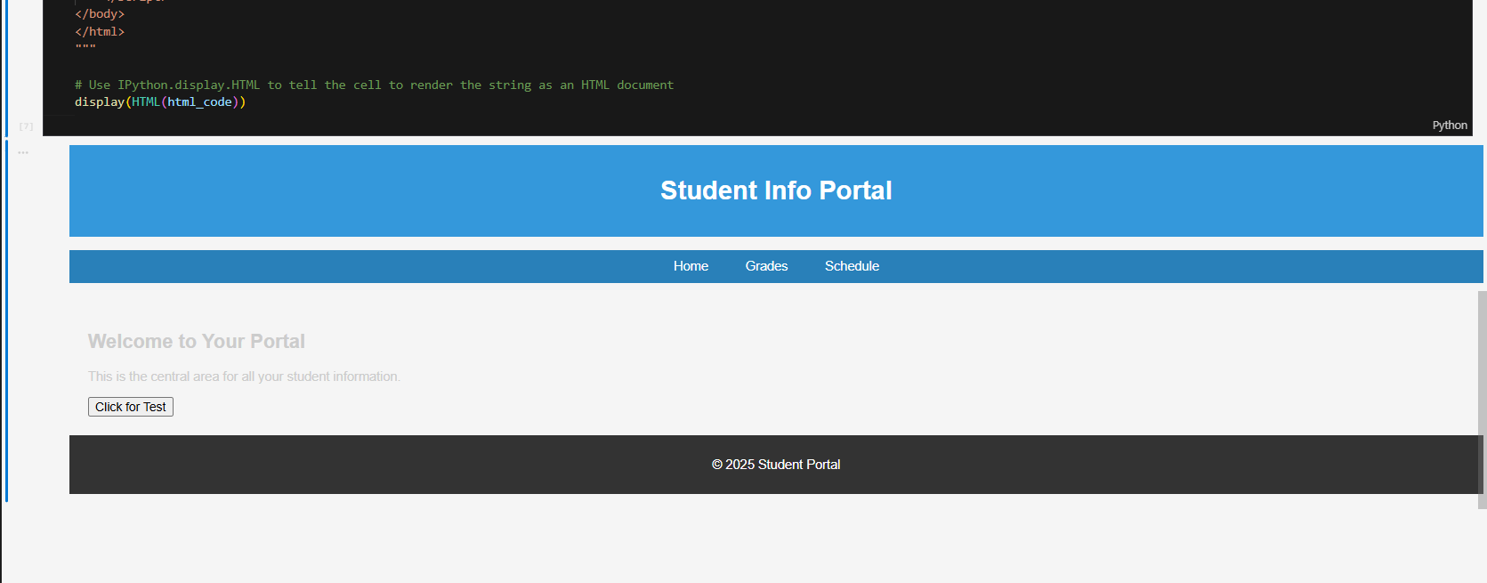
Task Description #2 – CSS Styling
Task:
Use AI to add CSS styling to Task #1 homepage for:
● Responsive navigation bar.
● Centered content section.
● Footer with light gray background.
It seems there might be a slight mix-up in the final part of your expected output. Since this is a web development task (HTML/CSS/JS), the request to refactor the code with with open() and try-except strongly suggests that you are working within a Python environment (like a Jupyter Notebook) and need to output the final HTML content using Python code, as if writing it to a file.
I will provide the combined HTML/CSS code with the requested styling first, and then the Python script that demonstrates how you would generate and manage this HTML file using with open() and try-except.
Expected Output:
● HTML + CSS combined.
● AI explains how CSS classes apply.
Expected Output: AI refactors with with open() and try-except:
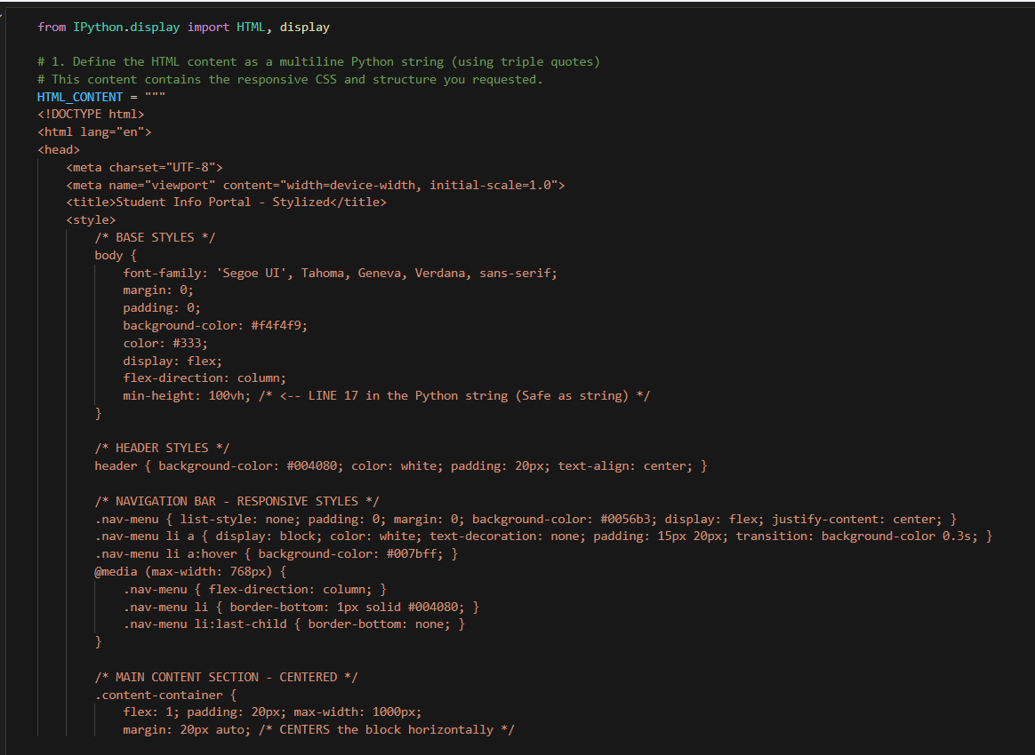
Task Description #3 – JavaScript Interactivity
Task: Prompt AI to generate a JS script that validates a simple login
form (non-empty username/password).
Expected Output:
Working on submit JS validation.
Clear error messages if inputs are empty.

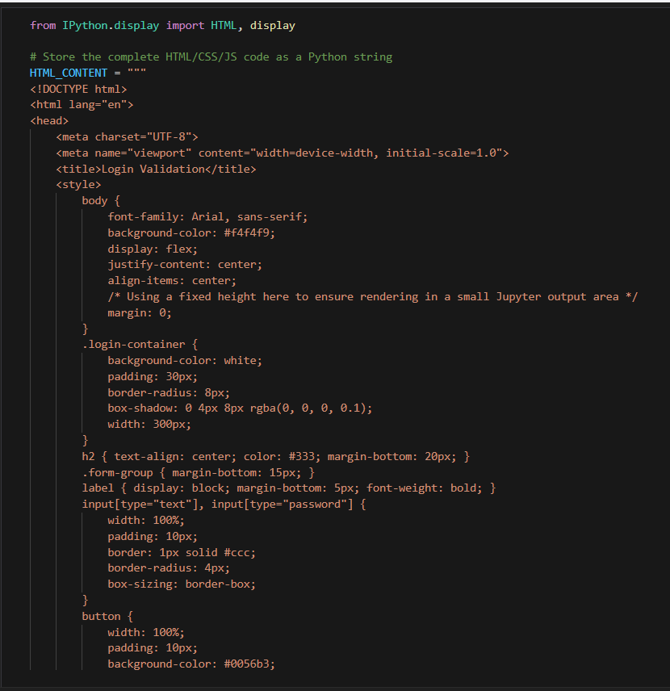
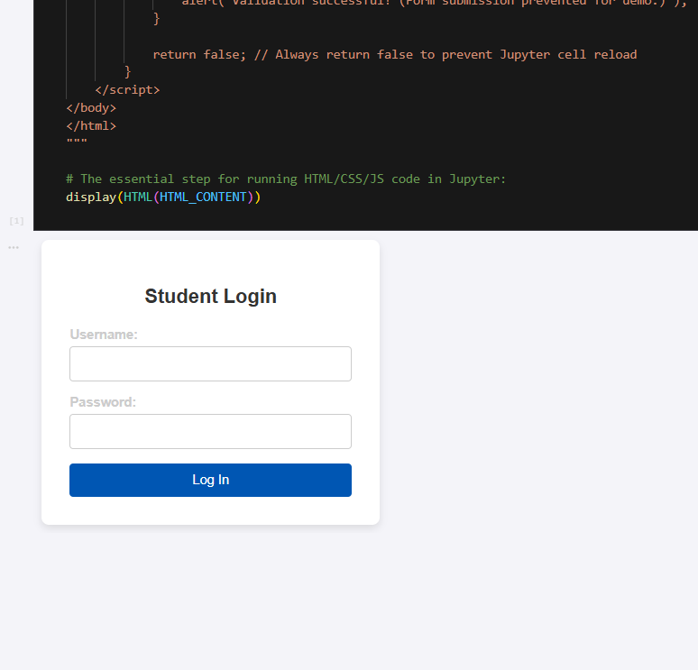
Task Description #4 – Python Backend Integration
Task: Ask AI to generate a Flask app that serves the HTML form (Task#3) and prints the username on successful login.
S: This task requires integrating the frontend form (Task #3) with a Python backend using Flask.
I will generate a single Python file, app.py, which serves the HTML form and includes a POST route (/login) to handle the submission and print the successful username, as requested.
