Week-4
Aim of the experiment
To understand and compare three popular tokenization approaches used in Natural Language Processing (NLP) and Large Language Models (LLMs):
- Byte Pair Encoding (BPE)
- WordPiece
- SentencePiece
Students will evaluate how these tokenizers process English, Telugu and Hindi text and compare their token counts.
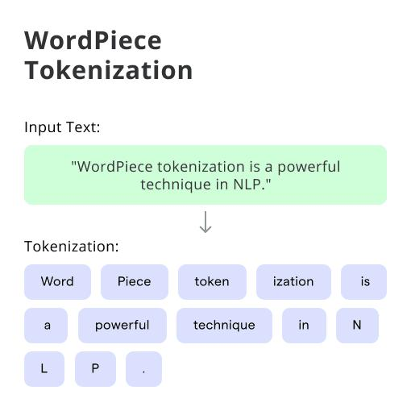
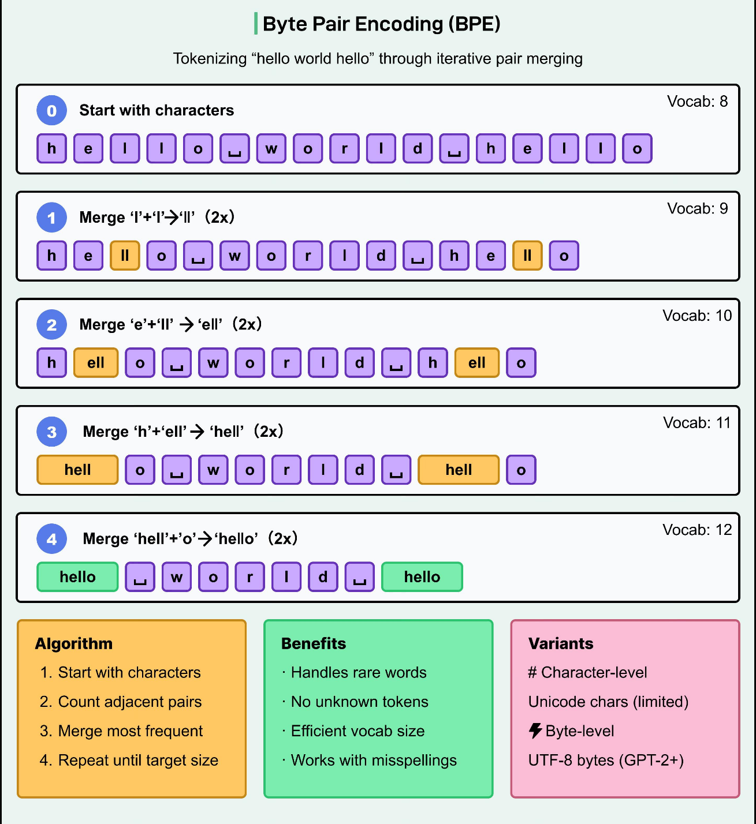

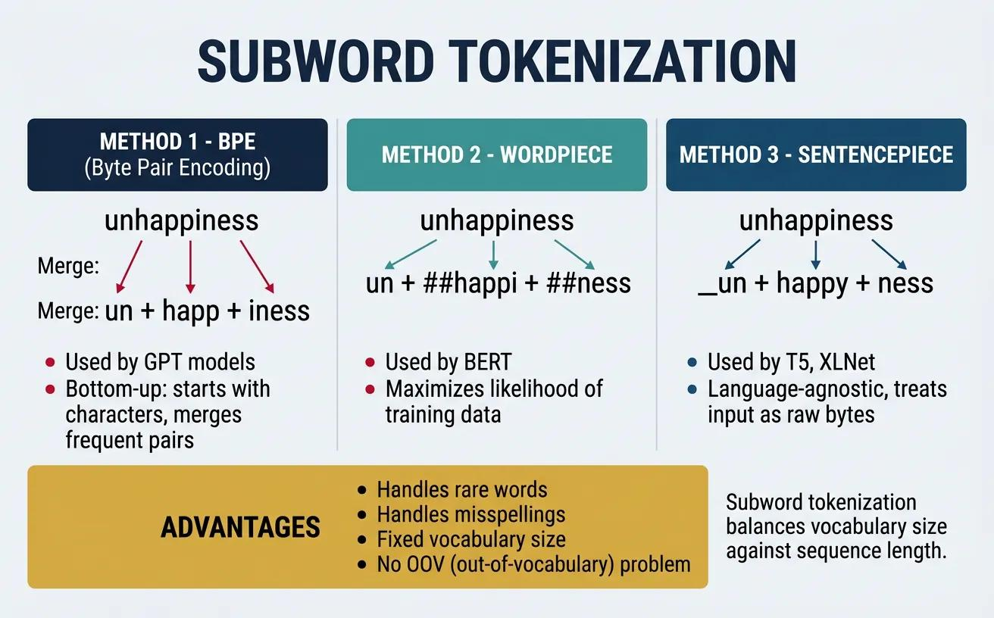

Code Snippets:
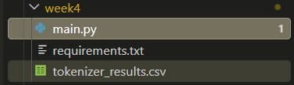

requirements.txt
transformers
sentencepiece
tiktoken
protobuf

Code Snippets
tokenizer_lab.py
# WEEK 4: TOKENIZER COMPARISON LAB
from transformers import AutoTokenizer
import csv
# STEP 1: Input sentences in three languages
sentences = {
"English": "Artificial Intelligence is transforming education and healthcare.",
"Telugu": "కృత్రిమ మేధస్సు విద్య మరియు వైద్య రంగాలను మారుస్తోంది.",
"Hindi": "कृत्रिम बुद्धिमत्ता शिक्षा और स्वास्थ्य सेवा को बदल रही है।"
}
# STEP 2: Select three tokenizer models
tokenizer_models = {
"BPE (GPT-2)": {
"model": "openai-community/gpt2",
"use_fast": True
},
"WordPiece (Multilingual BERT)": {
"model": "google-bert/bert-base-multilingual-cased",
"use_fast": True
},
"SentencePiece (mT5 Unigram)": {
"model": "google/mt5-small",
"use_fast": False
}
}

# STEP 3: Load the tokenizers
loaded_tokenizers = {}
print("\nLoading Tokenizers...")
for name, config in tokenizer_models.items():
print("\nLoading:", name)
tokenizer = AutoTokenizer.from_pretrained(
config["model"],
use_fast=config["use_fast"]
)
loaded_tokenizers[name] = tokenizer
print("Loaded successfully!")
# STEP 4: Tokenize the sentences
results = []
print("\n========== TOKENIZATION RESULTS ==========")
for language, sentence in sentences.items():
print("\n--------------------------------------")
print("Language:", language)
print("Original Sentence:", sentence)
# Count whitespace-separated words
word_count = len(sentence.split())
for tokenizer_name, tokenizer in loaded_tokenizers.items():
# Convert sentence into token IDs
token_ids = tokenizer.encode(
sentence,
add_special_tokens=False
)
# Convert IDs into readable token pieces
tokens = tokenizer.convert_ids_to_tokens(token_ids)
# Count tokens
token_count = len(token_ids)
# Calculate token ratio
token_ratio = token_count / word_count if word_count else 0
print("\nTokenizer:", tokenizer_name)
print("Tokens:", tokens)
print("Token Count:", token_count)
print("Word Count:", word_count)
print("Token Ratio:", round(token_ratio, 3))
# Save results in a list
results.append({
"Language": language,
"Tokenizer": tokenizer_name,
"Word_Count": word_count,
"Token_Count": token_count,
"Token_Ratio": round(token_ratio, 3)
})
# STEP 5: Display comparison table
print("\n\n========== TOKEN RATIO COMPARISON ==========")
print(
f"{'Language':<12}"
f"{'Tokenizer':<35}"
f"{'Words':<10}"
f"{'Tokens':<10}"
f"{'Ratio':<10}"
)
print("-" * 77)

for row in results:
print(
f"{row['Language']:<12}"
f"{row['Tokenizer']:<35}"
f"{row['Word_Count']:<10}"
f"{row['Token_Count']:<10}"
f"{row['Token_Ratio']:<10}"
)
# STEP 6: Export results to CSV
with open(
"tokenizer_results.csv",
"w",
newline="",
encoding="utf-8-sig"
) as file:
fieldnames = [
"Language",
"Tokenizer",
"Word_Count",
"Token_Count",
"Token_Ratio"
]
writer = csv.DictWriter(
file,
fieldnames=fieldnames
)
writer.writeheader()
writer.writerows(results)
print("\nResults saved to tokenizer_results.csv")
print("Week 4 experiment completed successfully!")

Output:


