“Food Donation & NGO Connect App”
A Project Report Submitted in the partial fulfillment of the requirements for the award of the degree of

BACHELOR OF TECHNOLOGY
In

DEPARTMENT OF COMPUTER SCIENCE ENGINNERING
&
DEPARTMENT OF COMPUTER SCIENCE AND INFORMATION TECHNOLOGY
By

FATHIMA QHIBTIYA KHADER 2520030155
PRANAV VARMA 2520030351
T. S. S. S. ANANYA 2520030039

Under the Esteemed Guidance of

Dr S. Spandana
Assistant Professor
Department of Computer Science and Engineering




K L (Deemed to be) University DEPARTMENT OF COMPUTER SCIENCE ENGINEERING
&

DEPARTMENT OF COMPUTER SCIENCE AND INFORMATION TECHNOL

Declaration

The Project Report entitled “Food Donation & NGO Connect App” is a record of Bonafide work of FATHIMA QHIBTIYA KHADER - 2520030155 , PRANAV VARMA - 2520030351, T. S. S. S. ANANYA - 2520030039 submitted in
partial fulfillment for the award of B. Tech in Computer Science and Engineering (or) Computer Science and Information Technology to the K L University. The results embodied in this report have not been copied from any other departments/University/Institute.

FATHIMA QHIBTIYA KHADER – 2520030155
PRANAV VARMA – 2520030351
T.S.S.S.ANANYA – 2520030039

K L (Deemed to be) University

DEPARTMENT OF COMPUTER SCIENCE ENGINEERING

&

DEPARTMENT OF COMPUTER SCIENCE AND INFORMATION TECHNOLOGY

CERTIFICATE

This is certify that the mini project based report entitled “Food Donation & NGO Connect App” is a bonafide work done and submitted by FATHIMA QHIBTIYA KHADER - 2520030155 , PRANAV VARMA - 2520030351, T. S. S. S. ANANYA – 2520030039 in partial fulfillment of the requirements for the award of the degree of BACHELOR OF TECHNOLOGY in Department of Computer Science Engineering, K L (Deemed to be University), during the academic year 2026-2027.

Signature of the Guide

Signature of the Course Coordinator Signature of the HOD

ACKNOWLEDGEMENT
The success in this project would not have been possible but for the timely help and guidance rendered by many people. Our wish to express my sincere thanks to all those who has assisted us in one way or the other for the completion of my project.

Our greatest appreciation to my Course Coordinator Dr Yerragudipadu Subbarayudu, and our guide Dr Spandana, Department of Computer Science which cannot be expressed in words for his/her tremendous support, encouragement and guidance for this project.

We express our gratitude to Dr. P Venkateshwara Rao (CSE), Head of the Department for Computer Science Engineering for providing us with adequate facilities, ways and means by which we are able to complete this project-based Lab.

We thank all the members of teaching and non-teaching staff members, and also who have assisted me directly or indirectly for successful completion of this project. Finally, I sincerely thank my parents, friends and classmates for their kind help and cooperation during my work.

FATHIMA QHIBTIYA KHADER – 2520030155
PRANAV VARMA – 2520030351
T.S.S.S.ANANYA – 2520030039

Abstract

Large quantities of surplus food from restaurants and households go to waste every day, even as many people in the same neighbourhoods face food insecurity. A major barrier is the lack of a simple, trusted channel connecting willing donors with verified NGOs that can collect and redistribute this food quickly and safely. The Food Donation & NGO Connect App addresses this gap by providing a mobile platform, built on Android using Kotlin, that links restaurants and households with nearby NGOs for surplus food pickup.
Donors can list available food items along with quantity, type, and pickup window through a simple Donor Listing feature. NGOs undergo an NGO Registration & Verification process to ensure only credible organisations participate, building trust within the platform. Once a donation is listed, the app uses Geo Matching, powered by the Google Maps SDK, to identify and notify the nearest verified NGOs, while a Pickup Scheduling module allows both parties to coordinate convenient collection times.
A Notification Engine, implemented using Firebase Cloud Messaging (FCM), keeps donors and NGOs updated in real time on listing status, matches, and scheduling changes. All donation records are stored and managed using Firebase, ensuring reliable, real-time synchronisation across users. Finally, an Impact Dashboard visualises key metrics such as total food saved, number of successful pickups, and NGOs served, motivating continued participation.
By streamlining the donation process end-to-end, the app aims to reduce food wastage, support NGOs with a consistent food supply, and strengthen community-level food security.

Index

S.  No. | Chapters | Topics | Page.no
 |  | Acknowledgement
 |  | Abstract
1 | Introduction | - Background of the project  - Problem statement  - Scope of the project  - Objective(s)  - Importance of the application  - Target users/audience | 5-8
2 | System Requirements | - Hardware requirements  - Software requirements  - Development tools and frameworks | 9-10
3 | Technology Stack | - Front-end (Kotlin + XML, Android Studio)  - Back-end (Firebase Backend-as-a-Service)  - Database (Cloud Firestore)  - Version Control (Git, GitHub)  - APIs or External services (Google Maps SDK, FCM) | 11-12
4 | System Architecture | - High-level architecture diagram  - Description of each layer (frontend, backend, database)  - Deployment architecture (e.g., cloud, local, CI/CD  pipelines) | 13-14
5 | Design | 5.1 Donation lifecycle and user flow  5.2 ER Diagram / Database schema | 15-16
6 | Implementation | - Module-wise implementation  - Front-end logic (UI rendering, state management)  - API integration  - Authentication & Authorization | 17-19
7 | Features | - List of main features  - How each feature works (user perspective + technical description) | 20-21
8 | Testing | - Functional and UI testing (frontend/backend)  - Integration testing  - Tools used for testing  - Test cases and results | 22-23
9 | Deployment | - Steps to deploy  - Environment configuration  - Hosting of frontend and backend | 24
10 | Challenges & Limitations | - Issues faced during development  - Solutions applied  - Current limitations or known bugs | 25-26
11 | Future Enhancements | - Planned features  - Possible integrations or optimizations | 27
12 | Conclusion | - Summary of the project  - What was achieved  - Skills learned during development | 28
13 | References | Books, documentation, tools and research sources used | 29

14 | Appendices | - Screenshots of the app  - Sample code snippets  - Installation/setup instructions  - User manual or guide  -Geo Tag photos with guide  -Review forms with guide signatures | 30-31

CHAPTER -1 INTRODUCTION

1.1 Background of the Project
Food waste and food insecurity exist side by side in almost every city. According to the UNEP Food Waste Index Report 2024, roughly a fifth of the food available to consumers worldwide is wasted, most of it at the household, food-service and retail stages, while hundreds of millions of people still go hungry. Restaurants, caterers, hostels, wedding halls and households regularly prepare more food than they can consume, and perfectly edible surplus is discarded simply because there is no quick way to hand it to someone who needs it.
Many NGOs and community kitchens are willing and equipped to collect and redistribute such food. However, the information flow between the two sides is weak. A donor who has surplus food at nine in the evening usually has to search for an NGO contact, make phone calls, and hope that someone can arrive before the food becomes unsafe. NGOs, on the other hand, learn about donations through phone calls, social media groups or word of mouth, which is slow, unstructured and unreliable.
Mobile technology offers a natural way to close this gap. Android smartphones are widely available, location services can identify who is nearby, and cloud platforms such as Firebase make it possible to synchronise data between many users in real time without building a heavy server infrastructure. The Food Donation & NGO Connect App combines these capabilities into a single platform where donors list surplus food, verified NGOs are matched and notified, pickups are scheduled, and the resulting impact is recorded and displayed.
The project draws on several core areas of computer science and software engineering:
- Mobile application development: an Android application written in Kotlin with XML-based user interfaces.
- Cloud and database systems: Firebase Authentication and Cloud Firestore for user management and real-time data synchronisation.
- Location-based services: the Google Maps SDK for Android for location capture, display and distance-based matching.
- Messaging and event-driven design: Firebase Cloud Messaging (FCM) for real-time notifications.
- User-experience design: prototyping in Figma and building simple, role-specific screens for donors and NGOs.

In summary, the background of the project rests on three observations: surplus food is wasted every day while people nearby are food insecure; the coordination between donors and NGOs is manual, slow and unverified; and modern mobile and cloud technology can automate this coordination in a way that is fast, transparent and trustworthy.

1.2 Problem Statement
Donors lack a quick and reliable way to find a nearby NGO that can collect surplus food within its safe pickup window, so usable food is often thrown away. Existing practice relies on individual phone calls, messaging groups and personal contacts. There is no structured process, no confirmation that a request has been seen, and no guarantee that the receiving organisation is genuine.
NGOs face the mirror-image problem. They have no real-time visibility into when and where new donations become available, so they miss opportunities to collect food. Coordinating pickup time and location manually is inefficient and error-prone, which leads to missed collections and wasted effort on both sides. Furthermore, because there is no verification mechanism, some donors hesitate to participate: they cannot be sure that the organisation collecting their food is credible.
Finally, neither donors nor NGOs have visibility into the cumulative impact of their contributions. Without feedback on how much food has been saved or how many people have been served, there is little motivation to remain engaged over time.
The problems addressed by this project can be summarised as follows:
- Donors cannot quickly find a nearby NGO that can collect food within its safe pickup window.
- NGOs have no real-time visibility of new donations in their area.
- There is no mechanism to verify that a receiving NGO is genuine and credible.
- Manual coordination of pickup time and location leads to delays and missed collections.
- There is no record of impact to motivate long-term participation.

1.3 Scope of the Project
The scope of the project is the design and development of an Android mobile application, built in Kotlin, that supports the complete surplus-food donation lifecycle: listing, verification, matching, scheduling, notification and tracking. The application serves two primary roles, donors (restaurants and households) and NGOs, with an administrative role for verifying NGO registrations.
Within scope are the following capabilities: role-based sign-up and login; a donor listing feature capturing food type, quantity, pickup window and location; NGO registration with a verification step; distance-based geo-matching of a new listing to nearby verified NGOs using the Google Maps SDK; pickup scheduling between donor and NGO; real-time notifications through Firebase Cloud Messaging; storage and synchronisation of all records in Firebase; and an impact dashboard showing total food saved, successful pickups and NGOs served.
The following are outside the scope of the current version: an iOS application, AI-based demand prediction, dedicated volunteer or delivery-partner logistics, online payments, and automated legal or food-safety certification of donated food. These are discussed as future enhancements in Chapter 11. The application also assumes that the donor is responsible for the safety and quality of the food that is listed.
The key points defining the scope are:
- An Android application (Android 8.0 and above) developed in Kotlin.
- Two user roles (Donor and NGO) plus an administrator for NGO verification.
- Firebase as the backend for authentication, real-time data storage and messaging.
- Google Maps SDK for location capture and nearest-NGO matching.
- An impact dashboard for transparency and motivation.

1.4 Objectives of the Project
The overall objective of the project is to build a simple, trusted digital channel through which surplus food can be redirected from donors to verified NGOs quickly and safely. The specific objectives are:
- To design and develop an Android application that connects surplus food donors with verified NGOs in real time.
- To implement a simple Donor Listing feature for capturing food type, quantity, and pickup window.
- To build an NGO Registration & Verification workflow that ensures only credible organisations participate.
- To implement Geo Matching using the Google Maps SDK for identifying and notifying the nearest available NGOs.
- To enable Pickup Scheduling so that donors and NGOs can coordinate convenient collection times.
- To set up a real-time Notification Engine using Firebase Cloud Messaging (FCM) for status and schedule updates.
- To provide an Impact Dashboard that visualises food saved, pickups completed, and NGOs served.
- To reduce urban food wastage, support NGOs with a consistent food supply, and strengthen community-level food security.

1.5 Importance of the Application
The importance of the application lies in the speed and trust it brings to a process that is currently slow and informal. Cooked and perishable food has a short safe window; a delay of even a few hours can make it unusable. By notifying the nearest verified NGOs the moment a donation is listed, the application increases the chance that food is collected while it is still safe to eat.
For donors, the app removes the effort of searching for an NGO and gives them confidence that their donation reaches a genuine organisation. For NGOs, it provides a steady and predictable stream of donation opportunities that they can accept with a single action. For the community, it turns food that would have become waste into meals, and the impact dashboard makes this contribution visible, which encourages repeat participation.
The project is also significant from an academic and engineering viewpoint. It integrates several real-world technologies (Android, Firebase, Google Maps and FCM) around a socially meaningful problem and demonstrates how a small team can build a coherent, cloud-connected mobile system using managed services rather than a custom server.
The principal benefits can be summarised as follows:
- Reduces edible food waste by shortening the time between listing and collection.
- Builds trust through NGO verification.
- Saves time for both donors and NGOs through automated matching and scheduling.
- Provides transparency and motivation through impact metrics.
- Supports community-level food security at very low cost to users.

1.6 Target Users / Audience
The primary users of the application are donors and NGOs. Donors include restaurants, cafes, caterers, event organisers, hostel and canteen managers, and individual households who occasionally have surplus cooked or packaged food. They need a fast way to list food and to be assured of a timely, trustworthy pickup.
NGOs form the second primary group. These are registered food-redistribution organisations, community kitchens and charitable trusts that collect surplus food and distribute it to people in need. They need timely information about nearby donations and a simple way to accept and schedule a pickup.
A third, smaller group consists of platform administrators who review NGO registration details and mark organisations as verified. In the longer term, the application could also be useful to local authorities, colleges and corporate cafeterias that wish to track how much food they have diverted from waste.
In essence, the application caters to:
- Restaurants and caterers with regular surplus food.
- Households and individuals with occasional surplus.
- Verified NGOs and community kitchens that redistribute food.
- Administrators responsible for verifying NGOs.

CHAPTER -2 SYSTEM REQUIREMENTS

2.1 Hardware Requirements
Because the application is a native Android app that relies on managed cloud services, the hardware requirements are modest. They are divided into requirements for the development machines used by the team and requirements for the end-user devices on which the application runs.
Development machine
Component | Minimum | Recommended
Processor | Intel Core i5 / AMD Ryzen 5 (4 cores) | Intel Core i7 / AMD Ryzen 7
RAM | 8 GB | 16 GB (smoother emulator and Android Studio)
Storage | 256 GB free space (SSD preferred) | 512 GB SSD
Display | 1366 x 768 | Full HD (1920 x 1080) for UI design work
Network | Stable broadband internet | 10 Mbps or higher for Firebase and Maps testing
Test device | Android emulator | Physical Android phone (Android 8.0+) with GPS

End-user device
- Smartphone running Android 8.0 (Oreo) or above.
- At least 2 GB RAM and around 100 MB of free storage for the application and its cache.
- GPS / location services enabled for location capture and matching.
- Active mobile data or Wi-Fi connection for real-time synchronisation and notifications.

No dedicated server hardware is required, because data storage, authentication and messaging are provided by Firebase and Google Cloud.

2.2 Software Requirements
Software | Purpose
Operating System | Windows / macOS / Linux for development; Android 8.0 (Oreo) and above for the target device.
IDE | Android Studio, with the Android SDK and emulator.
Programming Language | Kotlin (application logic) and XML (layouts).
Backend & Database | Firebase: Cloud Firestore / Realtime Database for data storage and synchronisation.
Authentication | Firebase Authentication for sign-up and login.
Cloud Messaging | Firebase Cloud Messaging (FCM) for real-time notifications.
Maps & Location Services | Google Maps SDK for Android for location display and geo-matching.
Version Control | Git and GitHub.
Design Tools | Figma for UI/UX prototyping.

A Google account is needed to create the Firebase project and to obtain the Google Maps API key. The Maps API key must be restricted to the application's package name and signing certificate to prevent misuse.

2.3 Development Tools and Frameworks
The application is developed as a native Android project in Android Studio. Kotlin is the primary language, chosen because it is the officially recommended language for Android development, is concise and null-safe, and is fully supported by Firebase and Google Maps libraries. User interfaces are defined in XML layout files, using ConstraintLayout for responsive screen structure and Material Components for consistent buttons, text fields, cards and navigation elements. Lists of donations are displayed with RecyclerView so that long lists scroll smoothly.
Firebase provides the backend services. The Firebase Android SDK is added to the project through Gradle, and the project is linked to the Firebase console through a configuration file. Google Play services supply the Maps and Location APIs. Git is used for source control and GitHub for hosting the shared repository, while Figma is used to prepare screen designs and a clickable prototype before implementation.
Tool / Framework | Role in the project
Android Studio | Development, emulator, debugging and build.
Kotlin + XML | Application logic and screen layouts.
Material Components | Consistent UI widgets and theming.
RecyclerView | Efficient lists of donations and NGOs.
Firebase (Auth, Firestore, FCM) | Backend-as-a-Service for identity, data and notifications.
Google Maps SDK | Map display, location and distance calculation.
Git / GitHub | Version control and collaboration.
Figma | UI/UX design and prototyping.

CHAPTER -3 TECHNOLOGY STACK

3.1 Front-End
The front-end is a native Android application written in Kotlin with XML layouts. It is the only component the user interacts with and is organised around a small number of role-specific screens: login and role selection, donor home, create donation, NGO dashboard, donation status and impact dashboard. Native development was chosen over a cross-platform framework because the project depends on device location, push notifications and Google Maps, all of which have first-class support on Android, and because the initial target audience is Android users.
Screens are built with ConstraintLayout and Material Components so that they adapt to different screen sizes. Dynamic content, such as the list of active donations for a donor or the list of nearby donations for an NGO, is displayed in RecyclerView adapters that update automatically when Firestore data changes. Form inputs use standard validation so that a donation cannot be submitted with missing quantity, pickup time or location.

3.2 Back-End
The project does not use a custom server. Instead it uses Firebase as a Backend-as-a-Service. This decision reduces development and maintenance effort, removes the need to host and secure an API server, and provides real-time synchronisation out of the box. The Android application communicates directly with Firebase services through the Firebase SDK, and access is controlled by Firebase Authentication and Firestore Security Rules.
Business rules that must not be trusted to the client, such as updating impact counters or sending notifications to matched NGOs, can be moved to Firebase Cloud Functions as the project grows. For the current version, the client performs these operations under strict security rules.

3.3 Database
Cloud Firestore, a document-oriented NoSQL database, stores all application data. Firestore was selected because it synchronises data to connected clients in real time, works well with hierarchical role-based data, and scales automatically. The main collections are users, ngos, donations, pickups and impact statistics. Each donation document carries its status, which drives what donors and NGOs see on screen. The detailed schema is presented in Chapter 5.

3.4 Version Control
Git is used for version control and GitHub hosts the remote repository. Each team member works on a separate branch for the module assigned to them and merges changes into the main branch through pull requests. Sensitive files such as the Maps API key and local configuration are excluded from the repository using a .gitignore file. Commit messages describe the feature or fix so that the history acts as a project log.

3.5 APIs or External Services
Service | Use in the application
Firebase Authentication | Email/password sign-up and login; user identity for role-based access.
Cloud Firestore | Real-time storage of users, NGOs, donations, pickups and impact data.
Firebase Cloud Messaging (FCM) | Push notifications for new listings, matches, scheduling changes and completion.
Google Maps SDK for Android | Map display, pickup location selection and distance-based matching of NGOs.
Figma | Design and prototyping of screens before implementation.

All external services are accessed over secure HTTPS connections managed by the respective SDKs. API keys are restricted and are not committed to the public repository.

CHAPTER -4 SYSTEM ARCHITECTURE

4.1 High-level architecture diagram
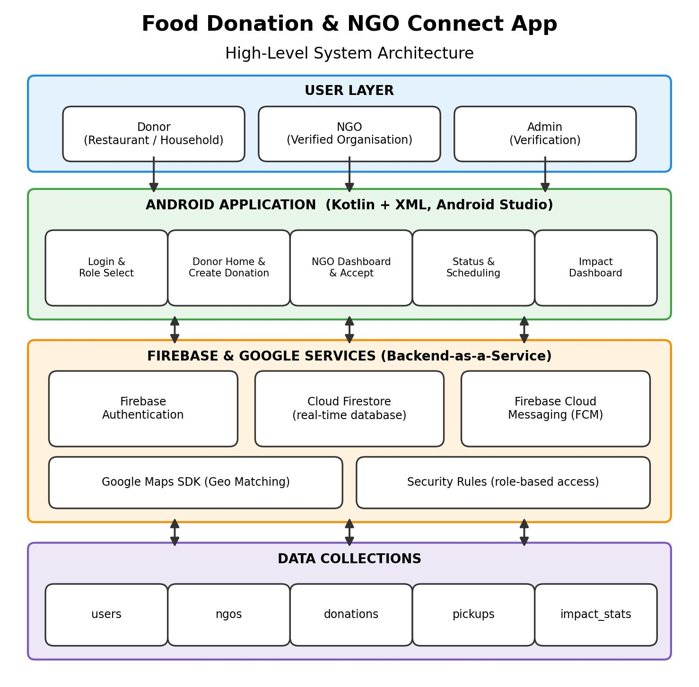

Figure 4.1 shows the high-level architecture. Donors, NGOs and administrators use a single Android application. The application talks directly to Firebase Authentication, Cloud Firestore and Firebase Cloud Messaging, and to the Google Maps SDK for location features. All persistent data is held in Firestore collections.

4.2 Description of Each Layer (Frontend, Backend, Database)
Frontend layer (Android application)
The frontend is the Kotlin and XML Android application. It renders the screens, validates user input, captures the device location and reacts to changes in data. It contains no business data of its own; every list and status shown on screen is read from Firestore through real-time listeners, so that a change made by one user appears on the other user's device almost immediately. The interface is role-aware: after login the user is routed either to the donor home or to the NGO dashboard based on the role stored in their profile.
Backend layer (Firebase services)
The backend layer consists of managed Firebase services rather than a custom server. Firebase Authentication verifies identity. Firestore Security Rules decide which documents each role can read or write; for example, a donor can create and edit only their own donations, while a verified NGO can read open donations and update those it has accepted. Firebase Cloud Messaging delivers push notifications to donors and NGOs when a listing is created, matched, accepted, scheduled or completed. Google Maps services provide the map display and the coordinates used in distance calculations.
Database layer (Cloud Firestore)
Cloud Firestore is the single source of truth. It stores user profiles, NGO records, donation listings, pickup schedules and impact statistics. Because Firestore supports real-time synchronisation and offline caching, the application continues to display the last known data when the connection is weak and updates when connectivity returns.
Data flow
A typical request follows this path: the donor submits a donation in the app; the app writes a donation document to Firestore with status Listed; the matching logic finds verified NGOs within range and updates the donation; FCM notifies those NGOs; an NGO accepts, which updates the status and notifies the donor; the pickup is scheduled and later marked completed; and finally an impact record is created and the dashboard totals are updated.

4.3 Deployment Architecture (Cloud, Local, CI/CD Pipelines)
The deployment architecture is deliberately simple. The application runs locally on the users' Android devices, and the backend runs in Google's cloud through the Firebase project. There is no separate web server or virtual machine to provision.
Environment | Description
Local development | Android Studio with an emulator or physical device, connected to a development Firebase project.
Testing | Separate Firebase project (or emulator suite) with sample donors, NGOs and donations for testing.
Production | Signed release build distributed as an APK/AAB, connected to the production Firebase project.
Source control / CI | GitHub repository; automated build and test pipelines using GitHub Actions can be added as the project matures.

Separating development and production Firebase projects prevents test data from mixing with real donation records and allows security rules to be tested safely before release.

CHAPTER -5 DESIGN

5.1 Donation Lifecycle and User Flow
The design of the application is centred on the lifecycle of a single donation. Every donation moves through a small set of states, and each state determines what is shown to the donor and to the NGO.
Status | Meaning | Triggered by
Listed | Donation is posted and visible for matching. | Donor submits the donation form.
NGO Found / Matched | One or more verified NGOs are nearby and notified. | Geo-matching after listing.
Accepted | An NGO has accepted the donation. | NGO taps Accept.
Pickup Scheduled | Collection time and place are confirmed. | Donor and NGO agree on the pickup window.
Completed | Food has been collected. | NGO / donor confirms pickup.
Impact Recorded | Quantity is added to the impact totals. | System after completion.

The main screens follow this lifecycle: Login and role selection; Donor Home with active donations and a prominent Donate Food action; Create Donation form; NGO Dashboard showing nearby donations with distance, quantity and pickup window; Donation Status; and the Impact Dashboard.

5.2 ER Diagram / Database schema
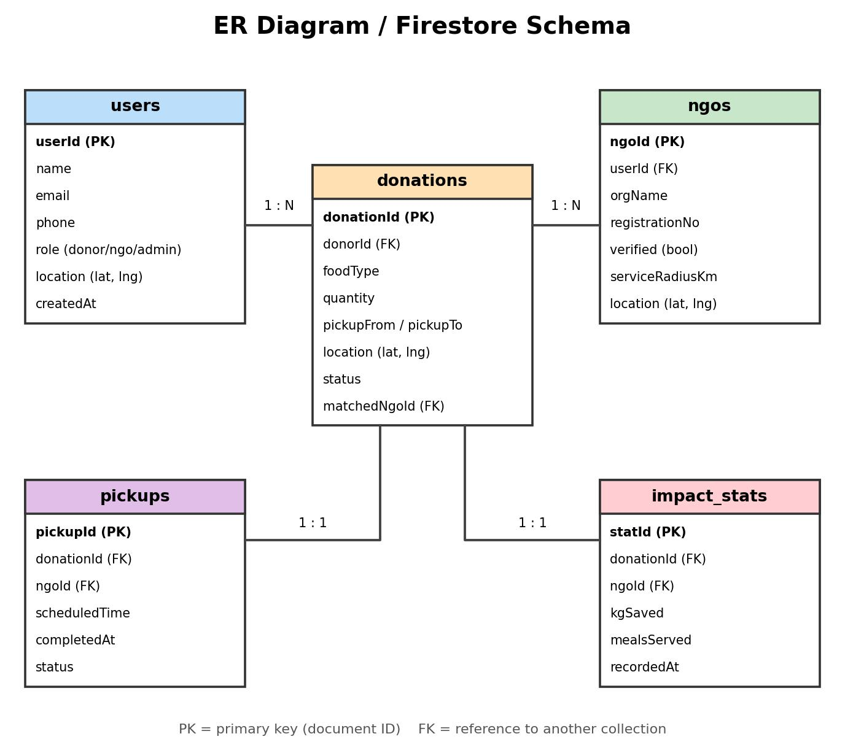

Figure 5.1 shows the entities and relationships. Although Firestore is a NoSQL document database, the data is modelled as related collections so that the design is easy to reason about. A user can create many donations; an NGO can be matched to many donations; each donation has at most one pickup and at most one impact record.
Collection: users
Field | Type | Description
userId (PK) | String | Firebase Authentication UID.
name / email / phone | String | Basic profile details.
role | String | donor, ngo or admin.
location | GeoPoint | Default latitude and longitude.
createdAt | Timestamp | Account creation time.

Collection: ngos
Field | Type | Description
ngoId (PK) | String | Document ID.
userId (FK) | String | Linked user account.
orgName / registrationNo | String | Organisation name and registration number submitted for verification.
verified | Boolean | Set to true by an administrator after checking credentials.
serviceRadiusKm | Number | Maximum distance the NGO is willing to travel.
location | GeoPoint | Base location of the NGO.

Collection: donations
Field | Type | Description
donationId (PK) | String | Document ID.
donorId (FK) | String | User who created the donation.
foodType / quantity | String / Number | Description and amount of food.
pickupFrom / pickupTo | Timestamp | Safe pickup window.
location | GeoPoint | Pickup location.
status | String | Listed, Matched, Accepted, Scheduled or Completed.
matchedNgoId (FK) | String | NGO that accepted the donation.

Collections: pickups and impact_stats
The pickups collection stores the donation and NGO references, the scheduled time, completion time and status. The impact_stats collection stores, for each completed donation, the quantity of food saved and the NGO served; the Impact Dashboard aggregates these records into total food saved, successful pickups and NGOs served.

CHAPTER -6 IMPLEMENTATION

6.1 Module-Wise Implementation
The application is divided into seven modules, each assigned to a team member as shown below. The modules share the same Firebase project and data model, which keeps them loosely coupled.
Module | Assigned to (Roll No.) | Description
Donor Listing | 2520030039 | Lets restaurants and households list surplus food with quantity, type and pickup window.
NGO Registration & Verification | 2520030039 | Onboards NGOs and validates their credentials before granting access.
Geo Matching | 2520030155 | Uses the Google Maps SDK to locate and notify the nearest verified NGOs.
Pickup Scheduling | 2520030155 | Coordinates collection date, time and location between donor and NGO.
Notification Engine | 2520030351 | Sends real-time alerts through FCM for listings, matches and schedule changes.
Data Management | 2520030351 | Stores and synchronises all donation records in real time using Firebase.
Impact Dashboard | 2520030351 | Visualises total food saved, successful pickups and NGOs served.

Donor Listing Module
The donor creates a listing through a form containing food type, quantity, pickup window, pickup location and an optional description. On submission, the entries are validated and saved as a new document in the donations collection with the status Listed. The donor's home screen shows the list of their active donations and their current status.
NGO Registration & Verification Module
An NGO registers with its organisation name, registration number, contact details, base location and service radius. The record is stored with verified set to false. An administrator reviews the submitted details and marks the NGO as verified; only verified NGOs can view and accept donations. This step gives donors confidence that food goes to genuine organisations.
Geo Matching Module
When a donation is listed, its pickup coordinates are compared with the locations and service radii of verified NGOs. The distance between two points is calculated from their latitude and longitude, and NGOs within range are ranked from nearest to farthest. The nearest NGOs are notified first, and the NGO dashboard displays each nearby donation with its distance.
Pickup Scheduling Module
After an NGO accepts a donation, the two parties confirm a pickup time within the donor's safe window. The agreed time and location are stored in the pickups collection, the donation status changes to Pickup Scheduled, and both parties can see the same details on their screens.
Notification Engine
Firebase Cloud Messaging is used to deliver push notifications. Each device registers an FCM token, which is stored against the user's profile. Notifications are sent when a new donation is listed nearby, when an NGO accepts, when a pickup is scheduled or changed, and when a pickup is completed.
Data Management Module
This module defines the collections, document structure and security rules, and attaches real-time listeners so that the interface reflects the latest state. It also handles simple offline caching provided by Firestore.
Impact Dashboard Module
When a pickup is completed, an impact record is created. The dashboard reads these records and shows total food saved, the number of successful pickups and the number of NGOs served, so that users can see the cumulative effect of their participation.

6.2 Front-End Logic (UI Rendering, State Management)
Each screen is an Android Activity or Fragment paired with an XML layout. The logic follows a consistent pattern: the screen obtains the current user, queries or listens to the relevant Firestore data, and renders it into views. When data changes in Firestore, the listener fires and the list adapter refreshes, so the user never needs to manually reload.
The application state that matters most is the user's role and the donation status. After login, the role stored in the user's profile decides whether the donor screens or the NGO screens are shown. The status field of each donation decides which buttons appear: a donor sees a status tracker, while an NGO sees an Accept button for Listed donations and a Schedule or Complete button for accepted ones. Form screens validate every required field before allowing submission and display inline error messages, which prevents incomplete listings.
Layouts are built with ConstraintLayout and Material Components. Long lists use RecyclerView with a view holder per item, and status is shown with clear text and colour cues. Loading indicators are displayed while data is fetched so that the interface stays responsive.

6.3 API Integration
Because Firebase is used as the backend, integration happens through the Firebase and Google Play services SDKs rather than a custom REST API. Firestore reads and writes are asynchronous; results are delivered through listeners or callbacks so that the main thread is never blocked. Google Maps is integrated by adding a map fragment to the layout, requesting location permission at runtime, and reading the device's latitude and longitude. The Maps API key is stored outside the source code and restricted to the application.
Integration | How it is used
Firebase Authentication | createUserWithEmailAndPassword / signInWithEmailAndPassword for registration and login.
Cloud Firestore | Add, update and listen to documents in users, ngos, donations, pickups and impact_stats.
Google Maps SDK | Display map, capture pickup location, compute distance between donor and NGO.
Firebase Cloud Messaging | Register device token and receive push notifications.

Failures such as no network, denied location permission or a rejected write are handled by showing a clear message and allowing the user to retry.

6.4 Authentication & Authorization
Authentication is handled by Firebase Authentication using email and password. At registration the user selects a role (Donor or NGO) and the role is saved in the users collection. NGO accounts additionally create an NGO record that must be verified by an administrator before the NGO can accept donations.
Authorisation is enforced on two levels. In the application, screens and buttons are shown according to the role. More importantly, Firestore Security Rules enforce access on the server, so that a modified client cannot bypass the restrictions. The rules follow the principle of least privilege:
- A user can read and edit only their own profile.
- A donor can create donations and read or modify only their own donations.
- Only verified NGOs can read open donations and update donations they have accepted.
- Only administrators can change the verified flag on an NGO record.

An illustrative rule for the donations collection is shown below.
match /donations/{id} {
allow create: if request.auth != null && request.resource.data.donorId == request.auth.uid;
allow read: if request.auth != null;
allow update: if request.auth.uid == resource.data.donorId
|| get(/databases/$(database)/documents/ngos/$(request.auth.uid)).data.verified == true;
}

CHAPTER -7 FEATURES

7.1 List of Main Features
No. | Feature | Summary
1 | Role-based sign-up and login | Donors and NGOs register and are routed to their own home screens.
2 | Donor Listing | Donors list surplus food with type, quantity, pickup window and location.
3 | NGO Registration & Verification | NGOs register and are approved before they can accept donations.
4 | Geo Matching | Nearest verified NGOs are identified and notified using the Google Maps SDK.
5 | Pickup Scheduling and Status Tracking | Donor and NGO agree a pickup time and follow the donation status.
6 | Real-time Notifications | FCM alerts for listings, matches, scheduling changes and completion.
7 | Impact Dashboard | Total food saved, successful pickups and NGOs served.

7.2 How Each Feature Works (user perspective + technical description)
1. Role-based sign-up and login
User perspective: On first launch the user chooses to register as a Donor or an NGO, enters basic details and creates an account. On later launches the user simply logs in and is taken to the appropriate home screen.
Technical description: Firebase Authentication creates the account. The selected role and profile details are saved in the users collection under the user's UID. On login, the app reads the role and starts the donor or NGO flow.
2. Donor Listing
User perspective: From the donor home screen the user taps Donate Food, fills in food type, quantity, pickup date and time, and location, and submits. The new donation immediately appears in the donor's list with the status Listed.
Technical description: The form is validated on the client and a new document is written to the donations collection with the donor's ID, the entered fields and status Listed. A real-time listener on the donor's donations refreshes the list.
3. NGO Registration & Verification
User perspective: An NGO submits its organisation details and waits for approval. Once verified, the NGO dashboard becomes active and shows nearby donations.
Technical description: The registration creates an NGO document with verified set to false. An administrator reviews the details and updates the flag. Security rules prevent unverified NGOs from accepting donations.
4. Geo Matching
User perspective: The NGO sees a list of nearby donations with distance, quantity and pickup window, ordered from nearest to farthest. Donors see that an NGO has been found for their donation.
Technical description: The donation's coordinates are compared with each verified NGO's location and service radius using the distance between latitude and longitude points. NGOs within range are ranked and notified; the donation status becomes Matched.
5. Pickup Scheduling and Status Tracking
User perspective: After tapping Accept, the NGO confirms a pickup time within the donor's window. Both users see a status tracker that moves from Listed to Matched, Scheduled and Completed.
Technical description: Accepting a donation writes the NGO ID and updates the status; scheduling creates a pickup document with the agreed time; completion updates both the pickup and the donation. All changes are pushed to both devices through Firestore listeners.
6. Real-time Notifications
User perspective: Users receive a notification when something relevant happens: a new donation nearby, an NGO acceptance, a change in pickup time, or completion.
Technical description: Each device's FCM token is stored in the user's profile. When a status change occurs, a message is sent to the token(s) of the affected users through Firebase Cloud Messaging.
7. Impact Dashboard
User perspective: A dashboard screen shows total food saved, the number of successful pickups and the number of NGOs served, giving users a clear picture of the difference they are making.
Technical description: On completion of a pickup an impact record is added to impact_stats. The dashboard queries and aggregates these records, and can be refreshed in real time.

CHAPTER -8 TESTING

8.1 Functional and UI Testing (Frontend/Backend)
Because the application uses Firebase services directly rather than a custom REST API, testing focuses on the behaviour of the Android screens and on the correctness of the data they read from and write to Firebase. Two complementary approaches are used.
Frontend testing verifies that every screen opens, displays the expected elements, validates input and navigates correctly. The login and role selection screen, donor home, create donation form, NGO dashboard, donation status and impact dashboard are each exercised on the Android emulator and on a physical device. Particular attention is paid to form validation, for example rejecting a donation with an empty quantity or a pickup time in the past.
Backend testing verifies that data written by the application appears correctly in Cloud Firestore and that Firebase Authentication and the Security Rules behave as intended. After each action in the app, the corresponding document is inspected in the Firebase console to confirm that the fields, types and status values are correct. Security Rules are tested to confirm that a donor cannot modify another donor's donation and that an unverified NGO cannot accept a donation.
A Postman-style API test suite is not required for the current version, since there is no custom API layer. If Cloud Functions or a REST service are added in the future, Postman can be introduced to test those endpoints.

8.2 Integration Testing
Integration testing checks that the modules work together as a complete flow. The primary scenario is the end-to-end donation lifecycle: a donor logs in, creates a donation, a verified NGO sees it on its dashboard, accepts it, a pickup is scheduled, the pickup is marked completed, and the impact dashboard updates. At each step the tester confirms that the status changes on both devices.
Other integration checks include: login followed by correct role-based routing; location capture on the create donation screen followed by correct distance display on the NGO dashboard; and notification delivery after a status change. The Firebase Emulator Suite can be used to run these scenarios against local copies of Authentication and Firestore without touching production data.

8.3 Tools Used for Testing
Tool | Purpose
Android Studio Emulator and physical device | Running and manually testing the application on different screen sizes and Android versions.
Logcat | Viewing runtime logs and diagnosing errors.
Firebase Console | Inspecting Firestore documents, Authentication users and messaging results.
Firebase Emulator Suite | Testing Authentication, Firestore and Security Rules locally with sample data.
JUnit | Unit tests for logic such as distance calculation and input validation.
Espresso | Automated UI tests for key user flows.
GitHub | Tracking issues and test-related code changes.

8.4 Test Cases and Results
The following table lists the principal test cases designed for the application. The Result column is completed as each case is executed on the build being reviewed.
ID | Test case | Expected result | Result
TC01 | Register as Donor with valid details | Account created; user taken to Donor Home.
TC02 | Register as NGO with valid details | Account created; NGO record saved as unverified.
TC03 | Login with wrong password | Error message shown; user stays on login screen.
TC04 | Create donation with all fields | Donation saved with status Listed; appears in donor list.
TC05 | Create donation with empty quantity | Validation error; donation not saved.
TC06 | Unverified NGO opens dashboard | No accept option available until verified.
TC07 | Verified NGO views nearby donations | Donations shown with distance, quantity and pickup window.
TC08 | NGO accepts a donation | Status changes to Accepted; donor sees update.
TC09 | Schedule pickup | Pickup time saved; status changes to Pickup Scheduled.
TC10 | Mark pickup completed | Status changes to Completed; impact record created.
TC11 | Open Impact Dashboard | Food saved, pickups and NGOs served displayed correctly.
TC12 | Donor edits another donor's donation (rules test) | Request rejected by Security Rules.
TC13 | Location permission denied | App shows message and allows manual location entry.
TC14 | No internet connection | Cached data displayed; clear offline message shown.

Any defects found during execution are logged, fixed, and re-tested so that the final build passes all mandatory cases before demonstration.

CHAPTER -9 DEPLOYMENT

9.1 Steps to Deploy
- Create a Firebase project in the Firebase console and register the Android application using its package name and the SHA-1 signing certificate fingerprint.
- Download the google-services.json configuration file and place it in the app module of the Android project.
- Enable Firebase Authentication (email/password) and create the Cloud Firestore database in the chosen region.
- Publish the Firestore Security Rules after testing them with the emulator.
- Enable the Maps SDK for Android in Google Cloud, create an API key and restrict it to the application's package name and certificate.
- Enable Firebase Cloud Messaging and confirm that device tokens are being registered.
- Build a signed release APK or Android App Bundle from Android Studio.
- Distribute the build to testers through Firebase App Distribution or direct APK sharing, and publish through the Google Play Console when ready for public release.

9.2 Environment Configuration
Two Firebase projects are used: one for development and testing and one for production. Each has its own configuration file, Authentication users and Firestore data, so that test activity never affects real donation records. The Maps API key is stored in the local properties file and injected into the build, and the key file and google-services.json are excluded from the public repository through .gitignore.
Setting | Value / approach
Minimum Android version | Android 8.0 (Oreo), API level 26.
Language / build tool | Kotlin with Gradle in Android Studio.
Firebase projects | Separate development and production projects.
Secrets | Maps API key in local properties; not committed to version control.
Permissions | Internet, fine and coarse location, and notification permission on newer Android versions.

9.3 Hosting of Frontend and Backend
The frontend is a mobile application and is therefore not hosted on a web server. It is installed on users' devices from an APK or from the Google Play Store. The backend is hosted entirely by Firebase and Google Cloud: Authentication, Firestore and Cloud Messaging run as managed services with automatic scaling, backups and high availability. This removes the need for server administration and lets the team concentrate on application features.

CHAPTER -10 CHALLENGES & LIMITATIONS

10.1 Issues Faced During Development
The main challenges identified while designing and developing the application are described below.
- Designing the donation lifecycle: deciding which statuses were needed and which user is allowed to move a donation from one status to the next required careful planning so that the donor and NGO views always stay consistent.
- Role-based flows: donors and NGOs need very different screens from the same application, which required clear separation of navigation and data access after login.
- Firebase and Maps configuration: linking the app to Firebase and Google Maps requires correct package name, signing fingerprint and restricted API keys; mistakes here cause silent failures.
- Location handling: obtaining accurate coordinates and handling denied permissions or disabled GPS needs graceful fallbacks.
- NGO trust: without access to an official registry, deciding how to verify an NGO's credentials was a design question.
- Team coordination: three members working on different modules needed a consistent branching and merging approach in Git.
- Limited time: balancing a complete feature set against a working, demonstrable flow for the review.

10.2 Solutions Applied
- A fixed set of statuses (Listed, Matched, Accepted, Scheduled, Completed) with clear rules on who may change each one, enforced through Firestore Security Rules.
- A role field in every user profile and separate home screens for donors and NGOs.
- A written setup checklist for Firebase and Maps configuration and restricted API keys stored outside version control.
- Permission requests with fallback to manual location entry when location access is denied.
- An administrator-approved verification flag for NGOs, with a plan to check registration numbers against official records in future.
- Separate branches per module, pull requests for merging, and regular team check-ins.
- Prioritising a small, working end-to-end flow over a large number of unconnected screens.

10.3 Current Limitations or Known Bugs
- The application is available only for Android; there is no iOS version.
- NGO verification is a manual administrator step and does not yet check external registries.
- Geo matching uses straight-line distance and does not account for road distance or traffic.
- Push notifications depend on device settings and network availability.
- The application does not verify the quality or safety of donated food; the donor is responsible for accurate listings.
- Impact figures depend on users confirming completed pickups.
- The application is currently in English only.

CHAPTER -11 FUTURE ENHANCEMENTS

11.1 Planned Features
- iOS version: extend the platform to iOS to widen the donor and NGO base beyond Android users.
- AI-based demand prediction: route donations toward the NGOs and areas with the greatest current need.
- Volunteer or delivery-partner support: enable collection for donors and NGOs who cannot arrange transport themselves.
- Regional language support: make the app accessible to a wider range of donors and NGOs.
- Recognition and reward features: badges or certificates for consistent donors to encourage long-term participation.
- Food-safety checklist and expiry reminders: simple guidance when creating a listing.
- Ratings and feedback: allow donors and NGOs to rate each pickup experience.

11.2 Possible Integrations or Optimizations
- Cloud Functions for matching and notifications so that critical logic runs on the server rather than the client.
- Geohash-based queries in Firestore to find nearby NGOs efficiently as the number of users grows.
- Automated NGO verification against official registration records.
- Firebase App Check, Crashlytics and Analytics for security, stability monitoring and usage insights.
- Road-distance and estimated-time calculation using mapping directions services.
- Continuous integration with GitHub Actions to build and test every commit.
- Publication on the Google Play Store and partnerships with local NGOs and restaurant associations.

CHAPTER -12 CONCLUSION

12.1 Summary of the Project
The Food Donation & NGO Connect App gives restaurants, households and NGOs a simple, trusted digital channel to redirect surplus food instead of discarding it. The project set out to remove the delays and uncertainty that currently exist between donors and NGOs, and it does so by combining donor listings, NGO verification, geo-matching, pickup scheduling and real-time notifications in a single Android application built with Kotlin and Firebase.
The application follows a clear architecture: an Android frontend, Firebase Authentication, Cloud Firestore and Cloud Messaging as the backend, and the Google Maps SDK for location. Every donation moves through a defined lifecycle from Listed to Completed, and the Impact Dashboard records the outcome so that the contribution of every donor and NGO is visible.

12.2 What Was Achieved
- A complete design for an end-to-end surplus food donation platform covering seven modules.
- A defined technology stack and system architecture based on Android, Kotlin and Firebase.
- A data model and donation lifecycle that keep donors and NGOs synchronised in real time.
- Role-based screens for donors and NGOs, including login, donor home, donation creation, NGO dashboard, status tracking and the impact dashboard.
- A security approach using Firebase Authentication and Firestore Security Rules to protect data and restrict actions by role.
- A clear roadmap for future enhancements such as iOS support, AI-based demand prediction and volunteer logistics.

12.3 Skills Learned During Development
- Native Android development in Kotlin with XML layouts, RecyclerView and Material Components.
- Using Firebase Authentication, Cloud Firestore and Cloud Messaging in a real project.
- Working with the Google Maps SDK and device location services.
- Data modelling for a NoSQL database and writing role-based security rules.
- UI/UX prototyping in Figma and translating designs into working screens.
- Version control and collaboration using Git and GitHub in a team.
- Requirement analysis, modular design, documentation and presenting a project for review.

Beyond technical skills, the project reinforced the value of designing software for social impact and of delivering a small, coherent, working flow rather than many disconnected features.

CHAPTER -13 REFERENCES
Books
Pressman, R. S., & Maxim, B. R. (2019). Software Engineering: A Practitioner's Approach (8th ed.). McGraw-Hill Education.
Sommerville, I. (2016). Software Engineering (10th ed.). Pearson Education.
Documentation and Tutorials
Android Developers. (2026). Android Developer Documentation. Retrieved from https://developer.android.com
Kotlin Foundation. (2026). Kotlin Documentation. Retrieved from https://kotlinlang.org/docs
Google. (2026). Firebase Documentation: Authentication, Cloud Firestore, Cloud Messaging. Retrieved from https://firebase.google.com/docs
Google. (2026). Maps SDK for Android. Retrieved from https://developers.google.com/maps/documentation/android-sdk
Google. (2026). Material Design. Retrieved from https://m3.material.io
Figma. (2026). Figma Help Center. Retrieved from https://help.figma.com
Research and Reference Material
United Nations Environment Programme. (2024). Food Waste Index Report 2024. Retrieved from https://www.unep.org/resources/publication/food-waste-index-report-2024
Food Safety and Standards Authority of India. Food recovery and distribution initiatives. Retrieved from https://www.fssai.gov.in
Existing Applications Studied
ShareTheMeal. Retrieved from https://www.sharethemeal.org
Food Rescue US. Retrieved from https://foodrescue.us
Careit and Karnaa food-donation applications (studied for comparison of features).

CHAPTER -14 APPENDICES

Screenshots of the app
[Insert screenshots here: Login / Role Selection, Donor Home, Create Donation, NGO Dashboard, Donation Status and Impact Dashboard.]

Sample code snippets
The following snippets illustrate how a donation is saved and how a list is kept in sync. Replace them with the corresponding code from the project repository if they differ.
Saving a donation to Firestore
val donation = hashMapOf(
"donorId" to auth.currentUser?.uid,
"foodType" to foodType,
"quantity" to quantity,
"pickupFrom" to pickupFrom,
"pickupTo" to pickupTo,
"location" to GeoPoint(lat, lng),
"status" to "Listed"
)
db.collection("donations").add(donation)
.addOnSuccessListener { showMessage("Donation submitted") }
.addOnFailureListener { showMessage("Could not submit donation") }

Listening for a donor's active donations
db.collection("donations")
.whereEqualTo("donorId", auth.currentUser?.uid)
.addSnapshotListener { snapshot, error ->
if (error != null) return@addSnapshotListener
adapter.submitList(snapshot?.toObjects(Donation::class.java))
}

Installation/setup instructions
- Install Android Studio and the Android SDK (API level 26 or above).
- Clone the project repository from GitHub and open it in Android Studio.
- Add the google-services.json file from your Firebase project to the app module.
- Add your Google Maps API key to the local properties file as described in the project README.
- Sync Gradle, then run the app on an emulator or a connected Android device.
- Register a Donor account and an NGO account to try the complete donation flow.

User manual or guide
For donors
Register or log in as a Donor. On the home screen tap Donate Food, enter the food type, quantity, pickup window and location, and submit. Track the status of the donation on the home screen until it is completed, and view your contribution on the Impact Dashboard.
For NGOs
Register as an NGO and wait for verification. Once verified, open the NGO dashboard to see nearby donations with distance, quantity and pickup window. Tap Accept on a donation, confirm the pickup time, collect the food, and mark the pickup as completed.

Geo Tag photos with guide
[Insert geo-tagged photographs here, signed or verified by the guide.]

Review forms with guide signatures
[Insert scanned review forms with guide signatures here.]

