STUDENT CASE STUDY EXECUTION REPORT
Department | FED
Subject | DSA-2
Academic Year | I-III Semester (2025-26)
Faculty Name | Balaiah Gudipudi
Student Name | T.S.S.S.Ananya
Roll Number | 2520030039
Branch | CSE
Course Outcome | 3
Case Study Topic: Mumbai distribution grid — N-1 redundancy via bridge analysis.

Work Done Summary
In this case study, we analyzed the design of a power distribution network for a new sector in Mumbai. We first constructed a Minimum Spanning Tree (MST) to obtain the minimum cable installation cost.
Since every edge in an MST is a bridge, the resulting network does not satisfy the N-1 redundancy requirement. To address this, we identified bridge edges and augmented the network with additional low-cost cable connections to create alternative paths.
We then compared the initial MST and the augmented network to ensure that the failure of any single cable would not disconnect any substation from the main substation.

Implementation Details

- Represented substations and cable connections as a weighted graph.
- Applied Kruskal's Algorithm to construct the Minimum Spanning Tree.
- Calculated the total cost of the MST.
- Identified bridge edges in the MST.
- Added the cheapest additional cable connections to create cycles.
- Verified that no single cable failure disconnects the network.

Result: Screenshots / Output
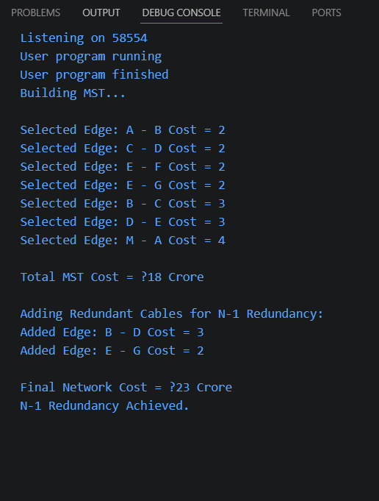
Time Complexity:
- Kruskal's MST: O(E log E)
- Bridge Analysis: O(V + E)
The MST provided the minimum installation cost but failed the N-1 redundancy requirement because every edge acted as a bridge. By adding a small number of low-cost cables, alternative paths were created, eliminating bridge failures and ensuring reliable power distribution with N-1 redundancy.
GitHub Link: https://github.com/tallapragadaananya-a11y/DSA_CaseStudies
Student Signature | Faculty Signature
________________ | ________________

