STUDENT CASE STUDY EXECUTION REPORT
Department | FED
Subject | DSA-2
Academic Year | I-III Semester (2025-26)
Faculty Name | Balaiah Gudipudi
Student Name | T.S.S.S.Ananya
Roll Number | 2520030039
Branch | CSE
Course Outcome | 2
Case Study Topic: Redis ZSET — leaderboard implementation choice between skip list and balanced BST

Work Done Summary
In this case study, we analyzed Redis's ZSET (Sorted Set) implementation and explored why Redis uses a Skip List instead of a Balanced BST for leaderboard operations.
We built a Skip List for 8 game leaderboard scores using a predefined level-promotion sequence to ensure reproducible results.
We then implemented insertion, search, and traversal operations in Java and observed how Skip Lists provide efficient O(log n) expected performance while remaining simpler to implement than balanced trees.

Implementation Details
- Created leader board entries with player names and scores.
- Assigned levels using the given deterministic promotion sequence.
- Inserted players into the Skip List in the specified order.
- Maintained sorted order based on player scores.
- Implemented search functionality to locate players efficiently.
- Traversed the Skip List to display the final leaderboard ranking.

Result: Screenshots / Output
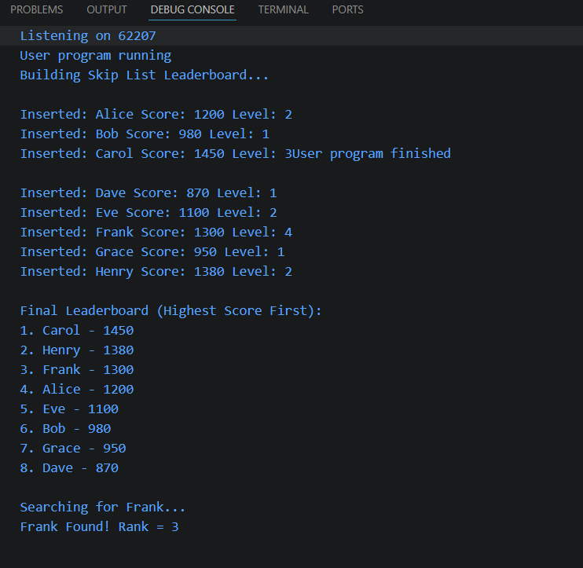Time Complexity:
- ZADD: O(log n) (expected)
- ZRANK: O(log n) (expected)
- ZRANGE: O(log n + k)
The Skip List efficiently maintained the leaderboard in sorted order while supporting fast rank and range queries. Its simpler implementation and expected logarithmic performance make it a practical choice over Balanced BSTs for Redis ZSETs.
GitHub Link: https://github.com/tallapragadaananya-a11y/DSA_CaseStudies

Student Signature | Faculty Signature
________________ | ________________

