STUDENT CASE STUDY EXECUTION REPORT
Department | FED
Subject | DSA-2
Academic Year | I-III Semester (2025-26)
Faculty Name | Balaiah Gudipudi
Student Name | T.S.S.S.Ananya
Roll Number | 2520030039
Branch | CSE
Course Outcome | 1
Case Study Topic: Bloomberg Terminal — symbol search index for tradeable instruments.

Work Done Summary
In this case study, we analyzed the symbol search index used in a Bloomberg Terminal-like system for storing and searching tradeable instrument tickers.
We demonstrated how inserting presorted ticker symbols into a Binary Search Tree (BST) causes the tree to degenerate into a linked list, resulting in inefficient searches.
To overcome this issue, we implemented a Balanced BST using a middle-out loading approach, ensuring faster lookups and reduced tree height.
We also compared the performance of a naive BST and a Balanced BST to identify the most suitable solution for high-frequency symbol searches.

Implementation Details
- Loaded ticker symbols from a presorted input file.
- Constructed a naive BST using sequential insertion.
- Observed degeneration of the BST into a linked-list-like structure.
- Built a Balanced BST using the middle element as the root recursively.
- Implemented ticker search functionality in Java.
- Compared tree height, lookup hops, and search efficiency between both approaches.

Result: Screenshots / Output
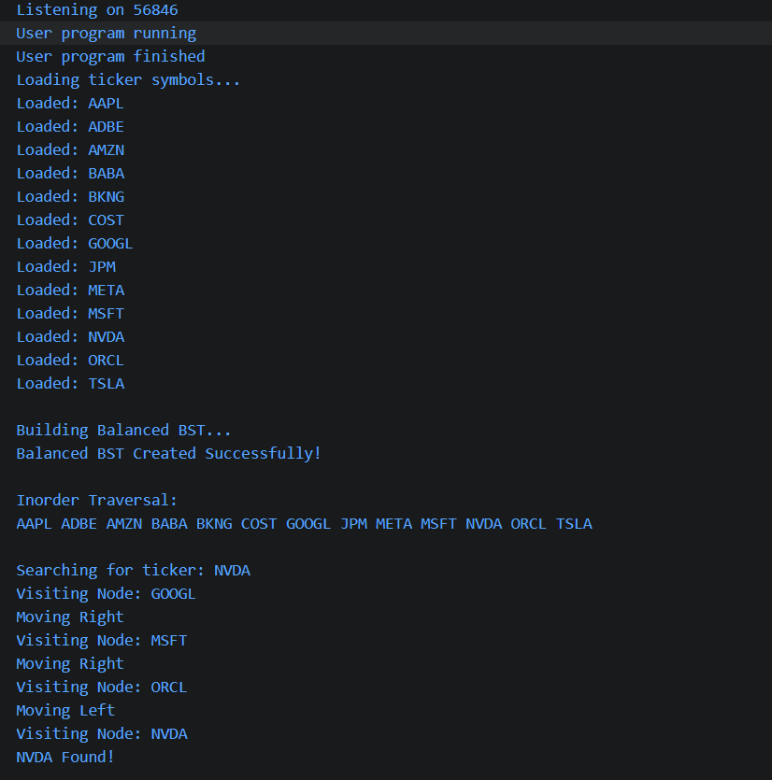
The naive BST became unbalanced due to presorted insertion, resulting in a height of 12 and a worst-case lookup of 13 hops.
Using a Balanced BST reduced the height to 4 and the worst-case lookup to 4 hops.
Time Complexity:
- Naive BST Search: O(n)
- Balanced BST Search: O(log n)
The Balanced BST provided faster and more efficient lookups, making it the preferred solution for Bloomberg Terminal's symbol search index.
GitHub Link: __________________________
Student Signature | Faculty Signature
________________ | ________________

