A CASE-STUDY BASED REPORT
ON
CREDIT CARD FRAUD DETECTION USING LOGISTIC REGRESSION AND ISOLATION FOREST ANOMALY DETECTION
submitted in partial fulfilment of the requirements for the Course
MACHINE LEARNING
BACHELOR OF TECHNOLOGY
in
COMPUTER SCIENCE AND ENGINEERING
A.Y.: 2026-27
by
Bandi Pranavi 2520030026
T.S.S.S. Ananya 2520030039
Under the Esteemed guidance of
Mr. Shaik Asif
Asst. Professor, Dept. of CSE



INDEX
Abstract
Introduction
Background
Motivation for the Project
Overview of the Work Carried Out
Scope and Responsible-Use Statement
Problem Statement
Case-Study Scenario
Central Case-Study Question
Formal Problem Definition
Objectives that Guide the Study
Assumptions and Limitations
Dataset and Exploratory Data Analysis
About the Dataset
Purpose of EDA
Preparation Steps Actually Performed
EDA Exploration – Implementation
Summary of EDA Findings
Algorithm Selection and Implementation
Conclusion
Signature of the Team Members

Abstract
Credit card fraud poses a severe and constantly evolving threat to digital payment systems. Because fraudulent transactions make up only a tiny fraction of all transactions, detecting them is fundamentally a problem of extreme class imbalance, and a model that simply maximizes accuracy can appear to perform well while catching almost no fraud at all. This project presents a hybrid fraud-detection system that combines a supervised classifier, Logistic Regression, with an unsupervised anomaly detector, Isolation Forest, applied to the publicly available Kaggle Credit Card Fraud Detection dataset of 284,807 anonymized European card transactions (492 of which, or 0.173%, are fraudulent). Logistic Regression is trained on labelled historical data to recognize known fraud patterns, while Isolation Forest requires no labels at all and instead flags transactions that are structurally unusual compared with the bulk of the data — allowing it, in principle, to catch fraud patterns that have never been seen before. Following data cleaning, feature scaling, and a stratified train/test split that preserves the original class imbalance, both models were trained and evaluated using accuracy, precision, recall, F1-score, ROC-AUC, and AUC-PR. On the held-out test set, Logistic Regression achieved a high recall of 91.8% (catching 90 of 98 fraud cases) with a ROC-AUC of 0.972, while Isolation Forest achieved a more balanced but lower recall of 30.6% with a ROC-AUC of 0.954. Combining the two models substantially increases the system's ability to flag suspicious activity, though at the cost of additional false positives — a trade-off that is discussed in detail in this report, along with its practical implications for real-world deployment.
Introduction
Background
Digital payments have grown rapidly over the past decade, and credit cards remain one of the most widely used instruments for both online and in-person transactions. This growth has been matched by a corresponding rise in credit card fraud, which causes direct financial losses to banks and customers and erodes trust in digital payment infrastructure. Traditional fraud detection relied heavily on static, rule-based systems — for example, flagging any transaction above a fixed amount, or any transaction from an unfamiliar location. While simple to implement, such rules are brittle: they generate many false alarms, are easy for sophisticated fraudsters to work around, and require constant manual updating as fraud tactics evolve. Machine learning offers an alternative that can learn patterns directly from historical transaction data and adapt as more data becomes available, making it the foundation of most modern fraud-detection systems.
Motivation for the Project
The central challenge in credit card fraud detection is not the modelling technique itself, but the severe class imbalance inherent to the problem — in this dataset, fraudulent transactions make up only 0.173% of all records. A purely supervised model can only ever recognize fraud patterns it has already seen labelled examples of, leaving it blind to genuinely new fraud strategies. A purely unsupervised anomaly detector has no memory of confirmed fraud at all and can generate noisy, unexplained alerts. Recent literature reviews of this field, including Hafez et al. (2025), explicitly identify hybrid approaches that integrate supervised learning with unsupervised outlier detection as an under-explored but promising direction, while Baisholan et al. (2025) note that anomaly detectors such as Isolation Forest remain comparatively rare in the credit-card-fraud literature relative to tree-based and linear supervised models. This project is motivated directly by that gap: to build and evaluate a hybrid Logistic Regression + Isolation Forest system that draws on the complementary strengths of both paradigms.
Overview of the Work Carried Out
The project followed a standard applied machine learning workflow. The Kaggle Credit Card Fraud dataset was first explored to understand its structure, class balance, and feature distributions. The data was confirmed to be free of missing values, after which the two unscaled features, Time and Amount, were standardized (the remaining 28 features, V1 through V28, are already PCA-transformed and centered by the dataset's original creators). A stratified 80/20 train-test split was used to preserve the original 0.173% fraud rate in both partitions. A Logistic Regression model was then trained with class-balanced weighting to counter the imbalance, and an Isolation Forest model was trained without any labels, using a contamination parameter matched to the observed fraud rate. Both models' predictions were combined using a logical-OR rule — a transaction is flagged as suspicious if either model raises an alarm — and all three configurations (Logistic Regression alone, Isolation Forest alone, and the combined hybrid) were evaluated on the held-out test set.
Scope and Responsible-Use Statement
This project is an academic case study carried out as part of the Machine Learning course and is scoped strictly to model development, evaluation, and analysis on a publicly available, already-anonymized dataset; no real customer data, financial institution data, or personally identifiable information was accessed or processed at any point. The results presented here are intended to demonstrate and compare detection methodologies, not to serve as a production-ready fraud detection system. Any real-world deployment of a system like this would need to address additional responsible-use considerations beyond this report's scope — including the customer impact of false positives (a legitimate transaction being wrongly blocked), fairness and bias testing across different customer populations, human review of flagged transactions before any account action is taken, and ongoing monitoring as fraud patterns shift over time.
Problem Statement
Case-Study Scenario
A bank processes a large number of credit card transactions every day. While most transactions are legitimate, a small number are fraudulent, and fraudulent transactions can cause significant financial losses to both customers and the financial institution. The bank's fraud-analysis team wants to develop a data-driven system that can identify suspicious transactions using historical credit card transaction data, rather than relying solely on static, manually defined rules.
Central Case-Study Question
Can a hybrid model that combines a supervised classifier (Logistic Regression) with an unsupervised anomaly detector (Isolation Forest) more effectively identify fraudulent credit card transactions — covering both previously seen fraud patterns and genuinely novel ones — than either technique used on its own, given that fraudulent transactions make up only 0.173% of all transactions in the available data?
Formal Problem Definition
The task is formulated as a binary classification problem. Given a dataset D containing 284,807 credit card transactions, each described by a feature vector x consisting of 30 attributes (Time, the PCA-derived features V1 through V28, and Amount), the objective is to learn a function f(x) → y, where y ∈ {0, 1}, 0 denotes a legitimate transaction, and 1 denotes a fraudulent transaction. Of the 284,807 transactions in the dataset, 492 are labelled fraudulent and 284,315 are labelled legitimate, giving an imbalance ratio of approximately 1 fraudulent transaction for every 578 legitimate ones.
Objectives that Guide the Study
- Explore and characterize the dataset, including its class balance, feature distributions, and correlations, to inform preprocessing decisions.
- Preprocess the data appropriately for both modelling approaches, including feature scaling and a class-imbalance-preserving train/test split.
- Train a Logistic Regression model as an interpretable, supervised baseline capable of learning known fraud patterns.
- Train an Isolation Forest model as an unsupervised anomaly detector capable of flagging structurally unusual transactions without using fraud labels.
- Combine the two models into a single hybrid detection system and evaluate whether the combination improves on either model individually.
- Evaluate all three configurations using metrics appropriate for extreme class imbalance — precision, recall, F1-score, ROC-AUC, and AUC-PR — rather than relying on accuracy alone.
Assumptions and Limitations
This study makes several assumptions: that the dataset's fraud labels are accurate and represent ground truth; that the PCA-transformed features V1 through V28 retain enough statistically useful signal despite being anonymized and semantically unreadable; and that the transaction patterns captured in this specific dataset are broadly representative of the kinds of patterns a fraud-detection model would need to learn. Several limitations follow directly from the data and the chosen evaluation approach. The dataset captures only two days of transactions from European cardholders in September 2013, which limits how confidently its findings generalize to current fraud patterns or other geographies. Because only 492 fraud cases exist in total (98 in the held-out test set), performance estimates for the minority class carry meaningful statistical uncertainty, and the evaluation in this report is based on a single stratified train/test split rather than repeated cross-validation. Because V1 through V28 are PCA components, the resulting models cannot be interpreted in human terms (e.g., “large purchase at an unusual time”) — only in terms of abstract numerical components. Finally, the simple logical-OR combination rule used to merge the two models' outputs is only one of several possible hybrid strategies, and, as later sections of this report discuss, it does not automatically guarantee an improvement over the stronger of the two individual models.
Dataset and Exploratory Data Analysis
About the Dataset
The project uses the publicly available Kaggle Credit Card Fraud Detection dataset, which contains transactions made by European cardholders over two days in September 2013. The dataset comprises 284,807 transactions described by 31 columns: Time (seconds elapsed since the first transaction in the dataset), 28 anonymized features V1 through V28 produced via Principal Component Analysis (PCA) on the original transaction attributes to preserve cardholder confidentiality, Amount (the transaction amount in the original currency), and Class, the binary target label (0 = legitimate, 1 = fraudulent). Of the 284,807 transactions, 284,315 (99.827%) are legitimate and 492 (0.173%) are fraudulent.
Purpose of EDA
Exploratory Data Analysis was carried out to understand the structure and quality of the dataset before any modelling was attempted. Specifically, EDA was used to quantify the severity of the class imbalance, check for missing or inconsistent values, examine the distribution of the Amount and Time features (the only two features not already transformed by the dataset's creators), and identify which features show the strongest relationship with the target label — all of which directly informed the preprocessing and modelling decisions described later in this report.
Preparation Steps Actually Performed
- Checked for missing values across all 31 columns using df.isnull().sum() — none were found; no imputation or row/column removal was necessary.
- Standardized the Time and Amount columns using scikit-learn's StandardScaler, since V1 through V28 are already PCA-transformed and centered around zero.
- Split the dataset into training and test sets using an 80/20 stratified split (227,845 training records with 394 fraud cases; 56,962 test records with 98 fraud cases), ensuring the original 0.173% fraud ratio was preserved in both partitions.
- Trained Logistic Regression with class_weight='balanced' to counteract the imbalance during training, rather than physically resampling the dataset.
- Set the Isolation Forest contamination parameter to 0.173% (the observed training-set fraud rate) so its anomaly threshold reflects the real-world prevalence of fraud.
EDA Exploration – Implementation
The figures below summarize the key exploratory findings.
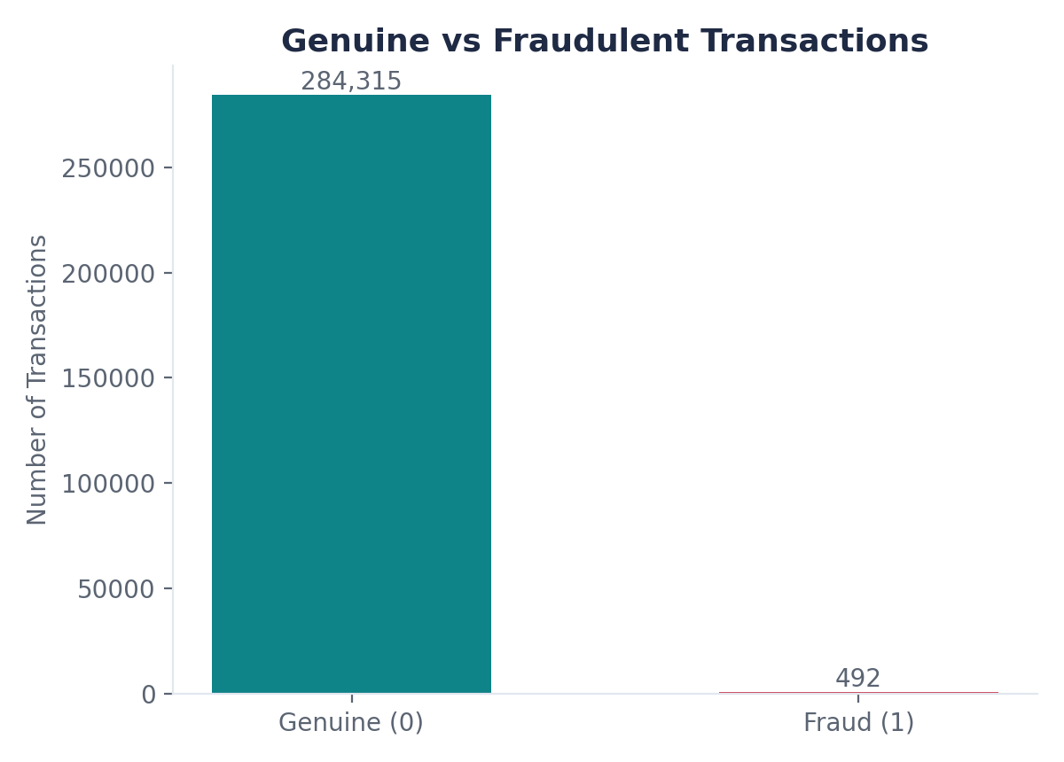
Figure 1: Class distribution — 284,315 genuine vs. 492 fraudulent transactions.
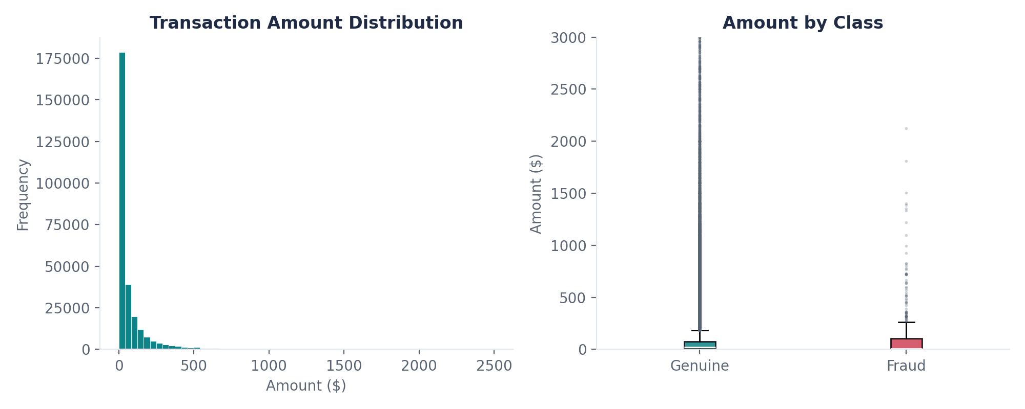
Figure 2: Transaction amount distribution (left) and amount by class (right).
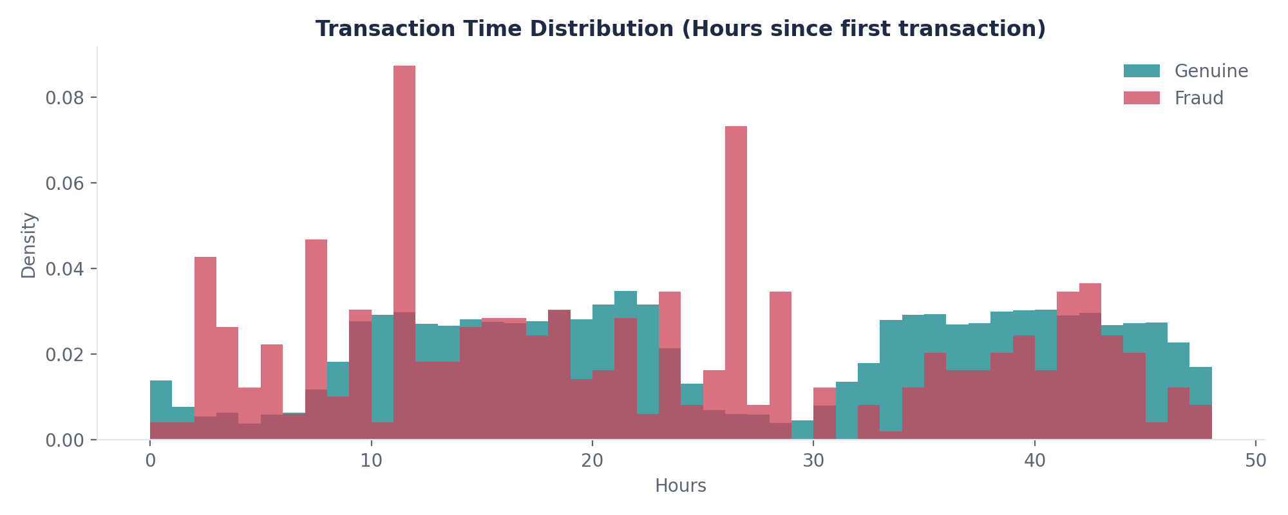
Figure 3: Transaction time distribution (hours since first transaction), by class.
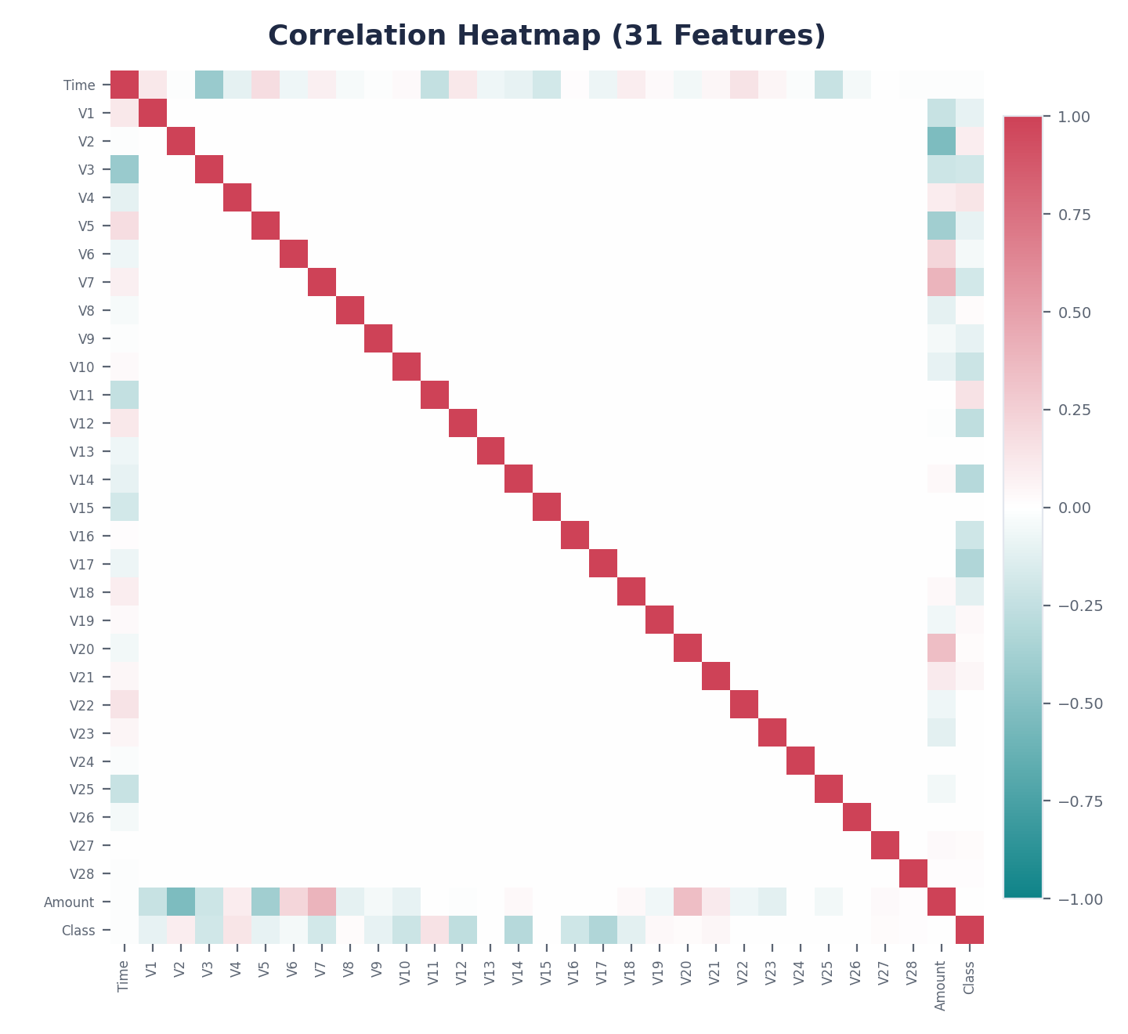
Figure 4: Correlation heatmap across all 31 features.
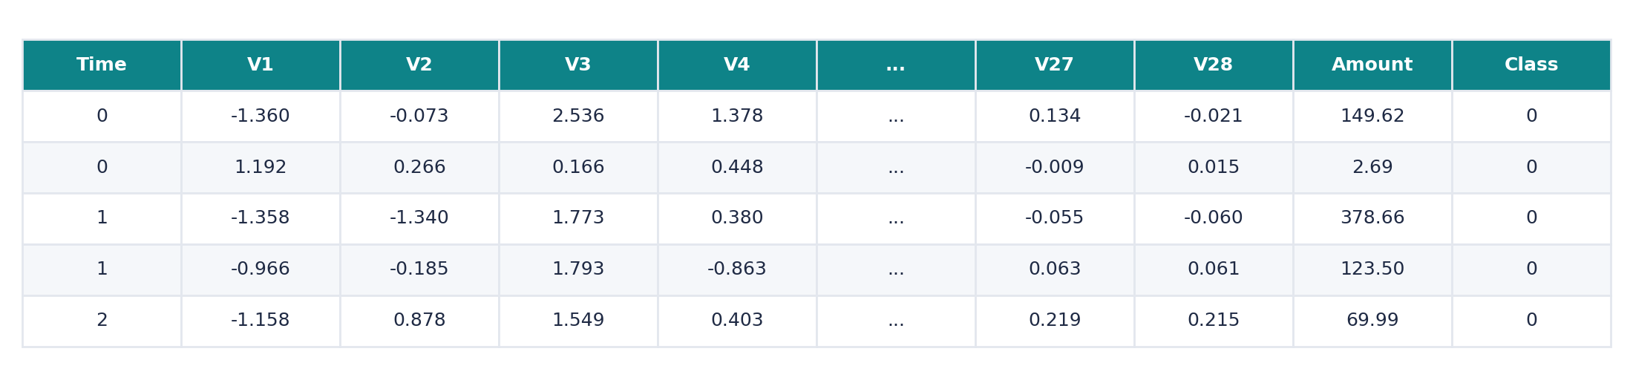
Figure 5: First five rows of the dataset (df.head()).
Summary of EDA Findings
- The dataset is severely imbalanced: 99.827% genuine vs. 0.173% fraudulent transactions.
- Transaction amounts are heavily right-skewed; the median amount is approximately $22, and most transactions are under $100. Fraudulent transactions tend to cluster at smaller amounts.
- Transaction volume follows a visible day/night cycle across the two captured days for genuine transactions, while fraudulent transactions show a flatter, less cyclical pattern.
- V17, V14, V12, and V10 show the strongest correlation with the Class label, though no single feature is strongly predictive on its own — supporting the use of a model that combines multiple weak signals.
- No missing values were found anywhere in the dataset.
Algorithm Selection and Implementation
Two complementary algorithms were selected for this project: Logistic Regression, a supervised linear classifier, and Isolation Forest, an unsupervised anomaly detector. Both are deliberately lightweight choices relative to deep learning alternatives, since the available labelled fraud data (492 examples in total) is far too small to reliably train a deep network, and because interpretability and computational efficiency are priorities for a near-real-time fraud screening task.
Why Logistic Regression
Logistic Regression models the probability that a transaction is fraudulent by applying the sigmoid function, σ(z) = 1 / (1 + e⁻ᶻ), to a linear combination of the input features, z = w·x + b. Its output is a calibrated probability between 0 and 1, and the model is trained by minimizing the binary cross-entropy loss. Because its coefficients (w) directly indicate the direction and strength of each feature's influence on the prediction, Logistic Regression remains interpretable even on PCA-transformed features — a property most deep learning alternatives lack.
Why Isolation Forest
Isolation Forest is an ensemble of random decision trees that isolates each data point by repeatedly splitting the feature space on randomly chosen features and split values. Because anomalies are, by definition, few and different, they tend to be isolated in far fewer splits (a shorter average path length) than normal points. Its anomaly score for a point x is s(x, n) = 2⁻ᴱᐝʰ(ᵫ)ᵞ)/ᵜ(ᵏ), where E(h(x)) is the average path length to isolate x across all trees and c(n) is the average path length of an unsuccessful search in a Binary Search Tree, used to normalize the score. Crucially, Isolation Forest requires no fraud labels during training, which means it can flag transactions that are structurally unusual even if they do not resemble any fraud pattern previously seen in the labelled data — directly addressing the “novel fraud” weakness of a purely supervised approach.
Why Combine Both
Logistic Regression and Isolation Forest were combined using a logical-OR rule: a transaction is flagged as suspicious if either model independently raises an alarm. This was chosen as the simplest possible hybrid strategy, intended to test whether the two models' outputs are complementary (each catching cases the other misses) before considering more sophisticated combination strategies such as weighted scoring or stacked ensembling.
Implementation Summary
- Features: Time and Amount standardized with StandardScaler; V1–V28 used as provided.
- Split: Stratified 80/20 train/test split (227,845 / 56,962 records), preserving the 0.173% fraud ratio in both sets.
- Logistic Regression: scikit-learn LogisticRegression(max_iter=1000, class_weight='balanced').
- Isolation Forest: scikit-learn IsolationForest(n_estimators=200, contamination=0.00173), trained without labels.
- Combination rule: a transaction is classified as fraud if Logistic Regression OR Isolation Forest flags it.
Results on the Held-Out Test Set (56,962 transactions, 98 fraudulent)
Metric | Logistic Regression | Isolation Forest | Hybrid (OR)
Accuracy | 97.55% | 99.75% | 97.48%
Precision | 6.09% | 28.04% | 5.92%
Recall | 91.84% | 30.61% | 91.84%
F1-score | 11.41% | 29.27% | 11.13%
ROC-AUC | 0.972 | 0.954 | —
AUC-PR | 0.719 | 0.172 | —

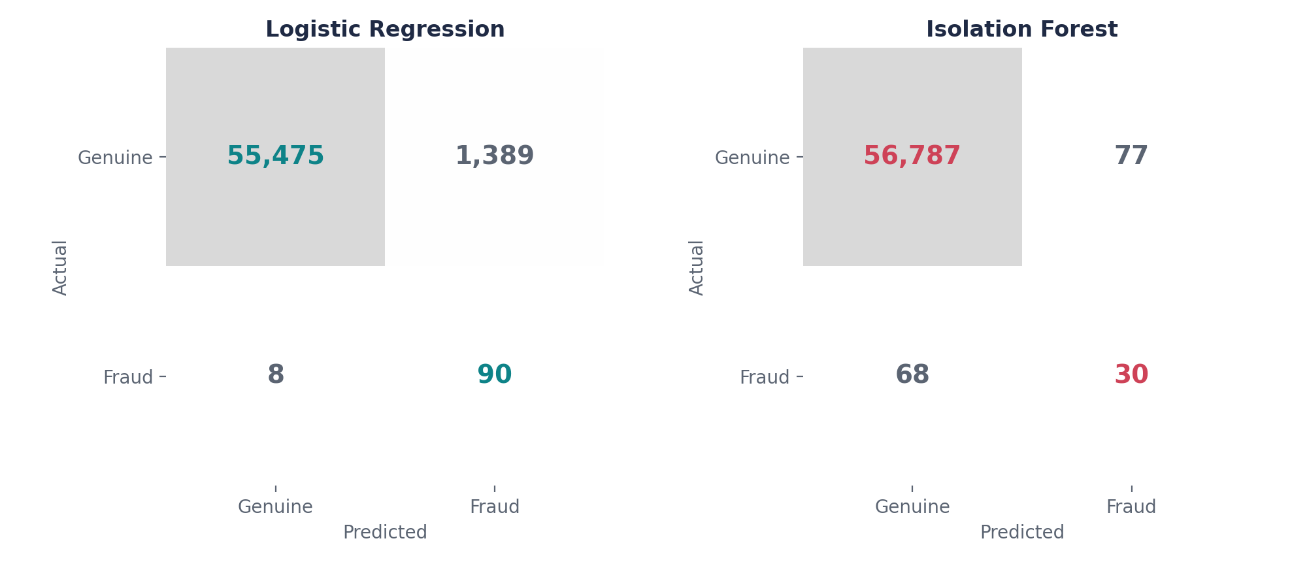
Figure 6: Confusion matrices for Logistic Regression and Isolation Forest.
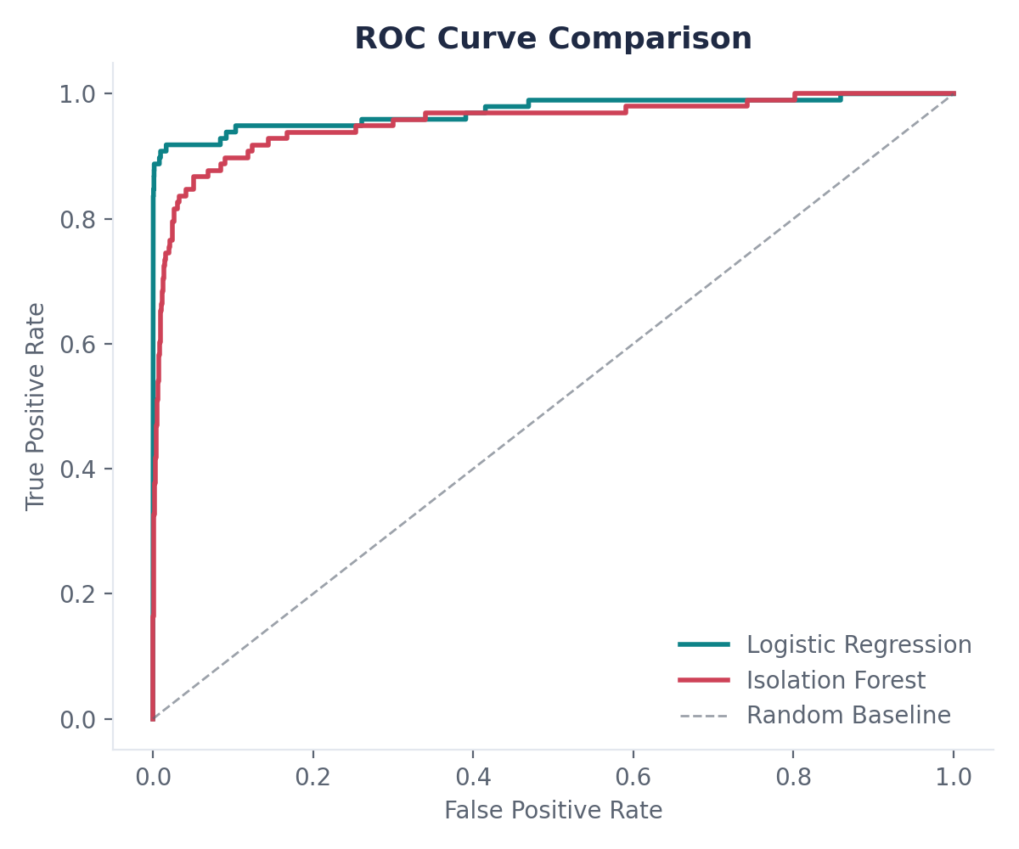
Figure 7: ROC curve comparison.
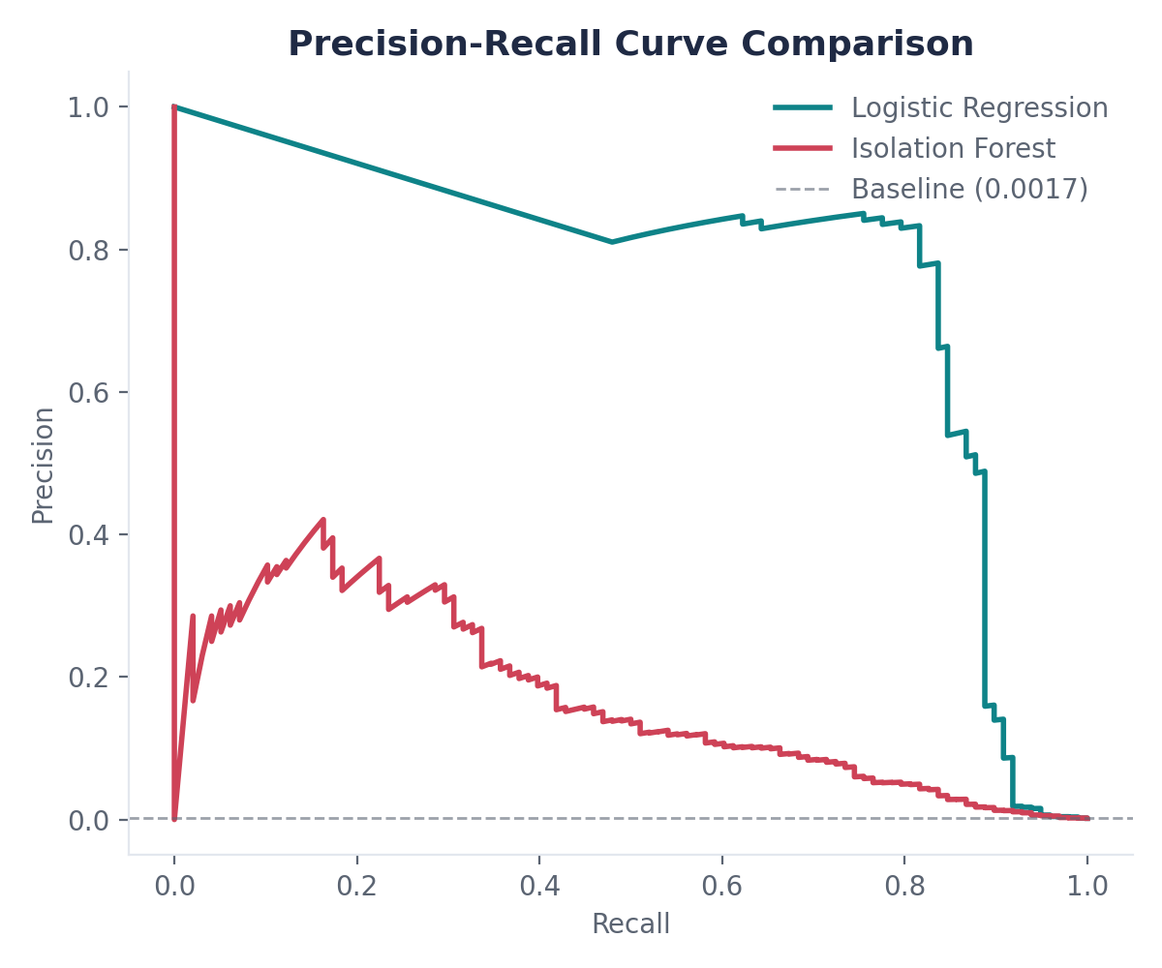
Figure 8: Precision-Recall curve comparison.
Discussion of Results
Logistic Regression, trained with balanced class weighting, achieved a high recall of 91.8%, correctly catching 90 of the 98 fraud cases in the test set, with a strong ROC-AUC of 0.972 and an AUC-PR of 0.719. This came at the cost of precision: only 6.09% of transactions flagged as fraud were actually fraudulent, meaning the model produced 1,389 false positives alongside its 90 true positives. This is a direct and expected consequence of class-balanced weighting, which deliberately shifts the decision boundary to catch more of the rare positive class at the expense of raising more false alarms.
Isolation Forest produced a more balanced but overall weaker result: 30.6% recall and 28.0% precision, for an F1-score of 29.3%. Its ROC-AUC of 0.954 is close to Logistic Regression's, but its AUC-PR of 0.172 is substantially lower — indicating that while Isolation Forest can rank transactions by anomaly fairly well in aggregate, it is considerably less effective than Logistic Regression at the specific precision-recall trade-off that matters most under this level of class imbalance.
A breakdown of exactly which fraud cases each model caught reveals an important and somewhat unexpected finding: of the 90 fraud cases caught by the hybrid system, 30 were caught by both models, 60 were caught by Logistic Regression only, and none were caught by Isolation Forest alone. In other words, on this test set, Isolation Forest did not catch a single fraud case that Logistic Regression missed — its contribution under the simple OR-combination rule was entirely redundant with Logistic Regression's own detections. This is reflected directly in the hybrid system's metrics: its recall (91.84%) is identical to Logistic Regression's alone, while its precision (5.92%) is slightly worse, because the OR rule still adds Isolation Forest's extra false positives without adding any extra true positives. This is an honest and useful negative result: it shows that simply OR-combining two models' binary predictions is not sufficient to guarantee a hybrid improvement, even when the underlying motivation for combining supervised and unsupervised methods is sound. The result points toward more sophisticated combination strategies — for example, using the Isolation Forest anomaly score as an additional input feature to Logistic Regression, or weighting and calibrating the two models' outputs before combining them — as a concrete direction for improving this system, discussed further in the Conclusion.
Across all three configurations, accuracy remains high (97.5–99.8%) and is clearly the least informative metric here, since a model predicting “legitimate” for every transaction would already score 99.83% accuracy while catching zero fraud. ROC-AUC and, in particular, AUC-PR give a far more honest picture of model quality under this level of imbalance, and the gap between Logistic Regression's AUC-PR (0.719) and Isolation Forest's (0.172) is the clearest evidence in this study that the supervised model is substantially stronger on this dataset, with Isolation Forest currently functioning more as a secondary, exploratory signal than as an equal partner in the hybrid system.
Conclusion
This project set out to build and evaluate a hybrid credit card fraud detection system combining a supervised Logistic Regression classifier with an unsupervised Isolation Forest anomaly detector, motivated by a gap explicitly identified in recent literature reviews of this field. On the full 284,807-record Kaggle dataset, Logistic Regression proved to be the stronger of the two individual models, achieving 91.8% recall and an AUC-PR of 0.719, while Isolation Forest achieved a lower but still meaningful 30.6% recall and an AUC-PR of 0.172. The simple logical-OR hybrid combination matched Logistic Regression's recall but did not improve on it, because every fraud case Isolation Forest caught in this test set was already being caught by Logistic Regression — a finding that highlights the importance of the combination strategy itself, not just the choice of underlying models.
Several directions for future work follow directly from these results. First, more sophisticated combination strategies — such as using the Isolation Forest anomaly score as an input feature to Logistic Regression, or a weighted/stacked ensemble — should be tested, since the current OR-rule does not exploit any complementary signal between the two models. Second, resampling techniques such as SMOTE could be compared against the class-weighting approach used here to see whether they shift the precision-recall trade-off more favourably. Third, the current evaluation relies on a single stratified train/test split; k-fold cross-validation would give a more statistically robust estimate of performance given how few fraud examples are available. Finally, threshold tuning — adjusting the probability cutoff used to convert Logistic Regression's output into a fraud/not-fraud decision — offers a direct, low-cost way to trade off recall against precision depending on the operational cost a deploying institution places on missed fraud versus customer friction from false alarms.
Overall, this project demonstrates both the promise and the practical difficulty of hybrid fraud detection under extreme class imbalance: the supervised and unsupervised components are individually sound and well-motivated by the literature, but realizing their full complementary potential requires a more deliberate combination strategy than a simple OR rule — a conclusion that is itself a useful and honest outcome of this case study.

Signature of the Team Members
1. Bandi Pranavi (2520030026) ____________________________
2. T.S.S.S. Ananya (2520030039) ____________________________
Guide: Mr. Shaik Asif, Asst. Professor, Dept. of CSE ____________________________

