LOAN APPROVAL PREDICTION
Submitted by:Talla Sahasra
Internship:Data Science Internship
Date:August 2026

1. Introduction
Loan approval is an important decision-making process for financial institutions. Loan applications are evaluated using several applicant characteristics such as income, education, employment status, credit history, loan amount, and property area. This project uses supervised machine learning to predict whether a loan application will be Approved or Rejected. Multiple classification algorithms were trained and evaluated to identify a model with strong predictive performance.
2. Problem Statement
The objective of this project is to develop a machine learning classification model that predicts loan approval based on applicant information. The project focuses on data cleaning, missing-value handling, categorical encoding, numerical scaling, class imbalance handling, model comparison, evaluation, and business-oriented interpretation.
3. Objectives
Clean and preprocess the loan application dataset.
Handle missing values appropriately.
Encode categorical variables and scale numerical variables.
Handle class imbalance using SMOTE.
Train and compare Logistic Regression, Decision Tree, and Random Forest models.
Evaluate the models using precision, recall, F1-score, and ROC-AUC.
Perform threshold analysis and recommend a deployment threshold.
Provide business-oriented interpretation of model predictions.
4. Dataset Description
The dataset contains 614 loan applications. The target variable is Loan_Status, where Y represents Approved and N represents Rejected. Loan_ID was removed because it is an identifier and does not provide useful predictive information.
Feature | Description
Gender | Applicant gender
Married | Marital status
Dependents | Number of dependents
Education | Education level
Self_Employed | Employment status
ApplicantIncome | Applicant income
CoapplicantIncome | Co-applicant income
LoanAmount | Requested loan amount
Loan_Amount_Term | Loan repayment term
Credit_History | Credit history indicator
Property_Area | Property area
Loan_Status | Loan approval result

5. Data Preprocessing

5.1 Missing Values
Missing values were identified before model training. Categorical missing values such as Gender, Married, Dependents, and Self_Employed were handled using the most frequent category. Numerical missing values such as LoanAmount and Loan_Amount_Term were handled using median imputation. Credit_History was handled using the most frequent value.
5.2 Encoding
Categorical variables were transformed into numerical representations using One-Hot Encoding. The encoder was configured to ignore previously unseen categories during testing.
5.3 Scaling
Numerical features were standardized using StandardScaler. Scaling helps Logistic Regression process numerical variables on comparable scales.
5.4 Train-Test Split
The dataset was divided into 80% training data and 20% testing data. Stratified splitting was used to maintain the class distribution between the training and testing sets.
6. Handling Class Imbalance
The loan approval target contains more applications in one class than the other. To address this imbalance, SMOTE (Synthetic Minority Over-sampling Technique) was applied to the training data within the modeling pipeline. Applying SMOTE only to training data helps prevent information leakage from the test set.
7. Machine Learning Models
7.1 Logistic Regression
Used as a baseline classification model and achieved the strongest overall performance.
7.2 Decision Tree
Used to model non-linear relationships between applicant characteristics and loan approval.
7.3 Random Forest
Used as an ensemble tree-based model consisting of multiple decision trees.
The following charts were generated from the executed Colab model results.
8. Model Evaluation
The models were evaluated using accuracy, precision, recall, F1-score, and ROC-AUC. Precision measures the proportion of predicted approvals that were correct, recall measures the proportion of actual approvals identified by the model, F1-score balances precision and recall, and ROC-AUC measures the model's ability to distinguish between the two classes.
Model | Accuracy | Precision | Recall | F1 Score | ROC-AUC
Logistic Regression | 82.11% | 86.21% | 88.24% | 87.21% | 87.59%
Decision Tree | 75.61% | 80.22% | 85.88% | 82.95% | 70.05%
Random Forest | 78.05% | 82.22% | 87.06% | 84.57% | 81.52%
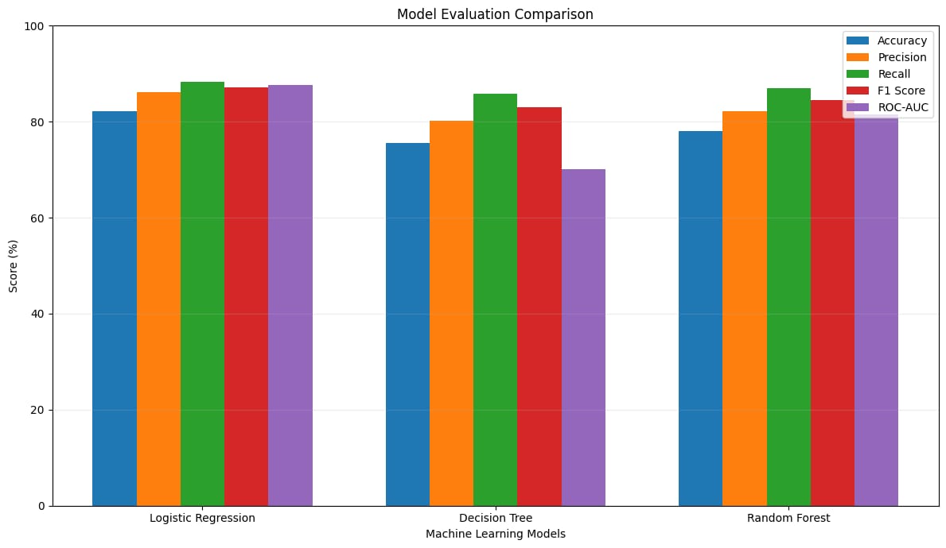
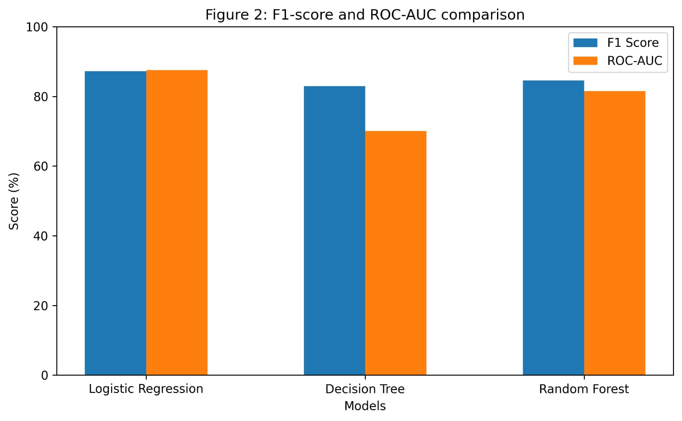
Figure 2: F1-score and ROC-AUC comparison
9. Model Comparison
Logistic Regression achieved the best performance across all major evaluation metrics. It achieved 82.11% accuracy, 86.21% precision, 88.24% recall, 87.21% F1-score, and 87.59% ROC-AUC. Random Forest performed better than the Decision Tree, while the Decision Tree had the lowest ROC-AUC of 70.05%. Based on the evaluation results, Logistic Regression was selected as the final model.
10. Threshold Analysis
The Logistic Regression model produces a probability of loan approval. Different classification thresholds were evaluated to understand the trade-off between precision and recall. Thresholds of 0.30, 0.40, 0.50, 0.60, and 0.70 were considered. The recommended deployment threshold should be selected using the threshold that provides the best balance between precision and recall, with F1-score used as the primary selection criterion.
Recommended deployment threshold: [ENTER THE VALUE FROM YOUR COLAB OUTPUT]
11. Business Interpretation
The proposed model can be used as a decision-support tool for financial institutions. It can help loan officers prioritize applications and identify applications with a higher predicted probability of approval. A lower threshold may classify more applications as approved, potentially improving access to loans but increasing the risk of incorrect approvals. A higher threshold provides a more conservative approval strategy but may reject some potentially eligible applicants. Therefore, threshold selection should consider the institution's risk tolerance and the relative costs of false approvals and false rejections. The model should support human decision-making rather than completely replace it.
12. Feature Interpretation
Logistic Regression coefficients were examined to identify features with stronger associations with the predicted loan approval outcome. Positive coefficients generally push predictions toward approval, while negative coefficients push predictions toward rejection. These coefficients represent model associations and should not be interpreted as proof that a feature causes loan approval.
13. Limitations
The dataset contains a relatively small number of loan applications.
Model performance may change when applied to a different population.
Historical approval patterns may contain biases.
The available features do not represent every factor used in real-world lending decisions.
The model should be combined with human review and organizational lending policies.
14. Conclusion
This project successfully developed a supervised machine learning solution for loan approval prediction. The workflow included data cleaning, missing-value treatment, categorical encoding, numerical scaling, class imbalance handling using SMOTE, model training, model comparison, and threshold analysis. Logistic Regression was selected as the final model because it achieved the strongest overall performance, with 82.11% accuracy and 87.59% ROC-AUC. Threshold analysis provides a way to adjust the model's operating point according to business risk requirements. Overall, the model demonstrates how machine learning can support more consistent and data-driven loan application assessment while retaining appropriate human oversight.
15. Tools and Technologies
Python
Pandas
NumPy
Matplotlib
Seaborn
Scikit-learn
imbalanced-learn (SMOTE)
Google Colab
16. Deliverables
The project deliverables include the Google Colab notebook containing the complete preprocessing and modeling pipeline, evaluation metrics, ROC curve, confusion matrix, threshold analysis, and business interpretation, together with this short internship report.
Google collab notebook link
https://colab.research.google.com/drive/14bg-bOfzVvgTHGSr3hrQQHX28hKVO1tL?usp=sharing

Github respository link
https://github.com/tallasahasra/Loan-Approval-Prediction.git

