https://github.com/tallbreadstick/IT342-Ramos-CbsiSchoolManagementSystem
SUPABASE_PASSWORD=zmcCNIlrlA10VwVk
JWT_SECRET=BA6do76icSHBhEcEh4Q4f6tKiBrNLnPLqueUXpvUw+c=

Last commit hash: 9982655396a50071c87bdf1d694d1421f5b14653
User Registration
All accounts should be created from the admin-facing side. I will later hide this interface behind a more secure channel, but for now this shows the required info. The admin must provide user info into the form, and the system should generate a school ID for the user (staff or student with their own conventions) and should send them an email containing their initial login credentials. They must later change their password on their first time logging in. Later on, I plan to add a spreadsheet input method so that admins can register accounts to users by batch.
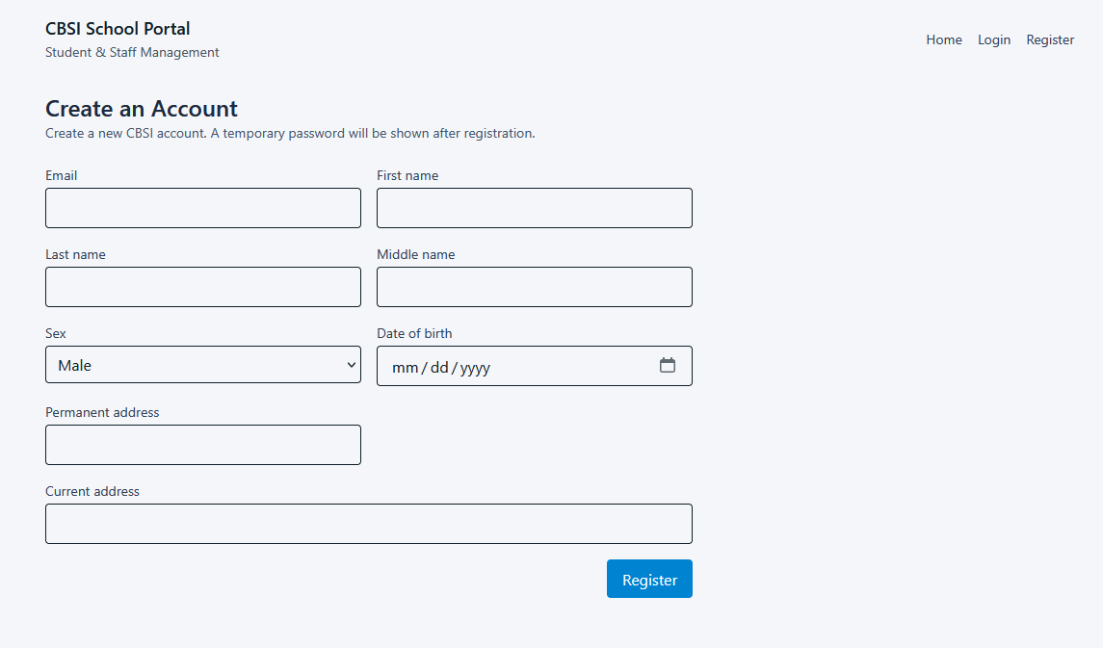

User Login
Users can only login to accounts registered by an admin or staff with the right permissions. They must change their password on their first log in to update the password_changed field in the database, which must be verified before granting access to any personal data or app functionality. User validation on the client side is verified through json web tokens.

CREATE TABLE users (
-- database-generated id
id SERIAL PRIMARY KEY,

-- primary human-readable identifiers
school_id VARCHAR(20) NOT NULL UNIQUE,
email VARCHAR(255) NOT NULL UNIQUE,

-- personal information
first_name VARCHAR(255) NOT NULL,
last_name VARCHAR(255) NOT NULL,
middle_name VARCHAR(255),
sex sex_type NOT NULL,
date_of_birth DATE NOT NULL,
permanent_address TEXT,
current_address TEXT,

-- security and metadata
password_hash VARCHAR(255) NOT NULL,
password_changed BOOLEAN NOT NULL DEFAULT FALSE,
date_created TIMESTAMPTZ NOT NULL DEFAULT CURRENT_TIMESTAMP,
date_updated TIMESTAMPTZ NOT NULL DEFAULT CURRENT_TIMESTAMP,

-- account status
account_status account_status_type NOT NULL DEFAULT 'PENDING',
last_login TIMESTAMPTZ
);

CREATE OR REPLACE FUNCTION update_timestamp()
RETURNS TRIGGER AS $$
BEGIN
NEW.date_updated = CURRENT_TIMESTAMP;
RETURN NEW;
END;
$$ LANGUAGE plpgsql;

CREATE TRIGGER set_timestamp
BEFORE UPDATE ON users
FOR EACH ROW
EXECUTE FUNCTION update_timestamp();

This is our database table for users, which should include a system-generated school ID, a serial database ID, personal info such as names, sex, address, DoB, etc. For security, passwords will be hashed in argon2, users must change their password after first login. Admins and staff should be able to update the account status of other users.

