RAMOS, Jeremiah T.
IT342 – G1
March 28, 2026

GitHub Repository Link: https://github.com/tallbreadstick/IT342-Ramos-CbsiSchoolManagementSystem
Supabase Password: BNrdjoR35SmLr8Wx
Swap this out for the field within application.properties labelled <password>

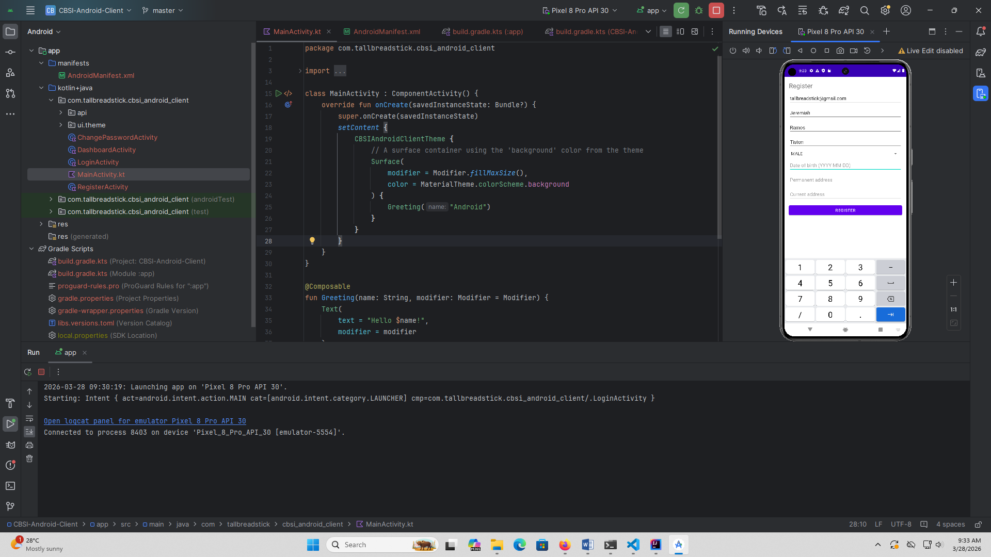

Here we have the basic login/register layout. Like the web interface, accounts are created and approved by the admin or account approval staff. Registration here is simply a mockup, and sign ins cannot be verified until account verification is set up.

